Supplementary Material
Synthesis of hematite

The synthesis of the hematite was carried out according to Berrones et. al []. NaOH solution (3 M) was added dropwise to a solution of FeCl₃•6H₂O until it stops precipitating. The formed solid was then dried and heated at 500 y 600°C to form hematite.

The spectrum of the sample without thermal treatment (Figure S1) contains tensions of the OH bond in the wavelength range of 3000 to 3500 cm⁻¹, also it shows three characteristic Fe-OH tension bands corresponding to the iron(III) hydroxide located in 750, 860 and 1300 cm⁻¹. Both bands disappear under a heat treatment at 500°C. Once the disappearance of the iron (III) hydroxide is confirmed, thermal treatments with different temperatures were carried out, in order to avoid formation of a mixture of phases, with the hematite is the desired phase.

Figure S2 shows the diffractogram of hematite, formed under thermal treatment at 500 and 600ºC. In both diffractograms it can be observed how each of the signals agree with the signals obtained from the data of the diffraction sheet of the hematite. The treatment at 500ºC seems more effective than the treatment at 600ºC, although variations in the intensities of the planes (104) and (110) can be observed, due to the increase of the cristal size. The X-ray diffraction analysis corroborates the obtaining hematite with good crystallinity. All the the data are corroborated with the ICDD data card number 00-001-1053, confirming a trigonal phase with network parameters a = 5,028Å, b = 5,028, c = 13,730Å, α = 90, β = 90 and γ = 120.
Fig. S1. Infrared spectra of the hematite and its precursor.

(300)
(116)
(214)
(024)
(110)
(104)
(012)
Fig. S2. Diffractograms of the hematite, synthesized under thermal treatment at 500 and 600ºC for 2 h.
Synthesis of nickel(II) oxide

The nickel oxide was synthesized as mentioned by Berrones et. al [1]. NaOH solution (3 M) was added dropwise to a solution of NiCl₂•6H₂O until it stops precipitating. The formed solid was then dried and heated at 500 y 600°C to form nickel oxide. Its IR-spectrum (Figure S3), for the sample before thermal treatment, contains typical bands corresponding to OH bonds of nickel hydroxide, in the wavelengths at 3600 cm⁻¹ the bands of stretch OH and 1300 cm⁻¹ the bending bands. The bands at 1000 and 1100 cm⁻¹ correspond to NiO tension bands. Under heating treatment, the disappearance of the hydroxide characteristic bands takes place, in addition to the appearance of the characteristic band of nickel(II) oxide. However, the spectrum shows two bands of OH bonds that correspond to water. Despite performing the thermal treatments, nickel oxide still retains moisture on its surface due to hydroscopic properties, so both samples at both 600 and 500ºC show these bands.

Fig. S3. IR-spectra of NiO after heating treatment at 500 and 600ºC and its precursor.
Figure S4 shows the diffractograms of NiO, formed after thermal treatments at 500 and 600ºC. In both treatments, the signals corresponding to the nickel(II) oxide are observed; however, the treatment at 500ºC shows an impurity in the angle 31 2θ. This impurity disappears when receiving the treatment at 600 ºC; in addition, an increase in the intensity of the signals in the treatment at higher temperature, this is due to the fact that crystallinity is favored with this thermal treatment. The analysis of X-ray diffraction corroborates the formation of product. Under both thermal treatments, the nickel oxide(II) with good crystallinity was obtained. All data are corroborated with the ICDD data card number 00-001-1239, thus obtaining a trigonal phase, with network parameters a = 4.171 Å, b = 4.171 Å, c = 4.171 Å and α = β = γ = 90º. The analysis indicates that the most efficient treatment in this case is 600ºC due to the impurity in the treatment of 500ºC and a higher crystallinity at 600ºC.

(222)
(311)
(220)
(200)
(111)
Fig. S4. Diffractograms of nickel(II) oxide, synthesized under thermal treatment at 500 and 600ºC for 2 h.
Synthesis of mixed oxide

Two different compounds that work as fuels, urea and glycine. The diffractograms (800ºC, Fig. 4 in main article) shows that the impurity known as buncenite is not observed, as well as nickel oxide or hematite do not appear as impurities in the system. In both experiments at 600 ºC (Fig. S5) it is observed that the intensity of the plane (110) in the angle 18 2θ is too low; in addition, in the case of the glycine under thermal treatment at 600ºC, an impurity is observed that agrees with a signal of the hematite. In the case of treatments at 800 ºC it can be seen that all the signals agree with all the planes of the trevorite; however, the intensities vary significantly in the case of 800ºC using urea. This is because the signal is overlapped with the plane (200) of the nickel oxide, which causes that signal located in the angle 37 2θ. In the case of the synthesis at 800ºC using glycine as a fuel, all the signals agree in both intensity and angle. Glycine seems to be the best option to generate mixed oxide, this is because glycine needs less energy to start self-ignition, thanks to not allowing nickel ions in the solution to become nickel oxide.
Fig. S5. Difractograms of the mixed oxide synthesized by self-combustion. U6006h and U6004h correspond to the syntheses using urea as a fuel under heat treatment at 600°C for 6 and 4 h, respectively. G6006h and G6004h correspond to the experiments using glycine as a fuel for 6 and 4 h, respectively.

SEM images of metal oxides (Fig. S6)
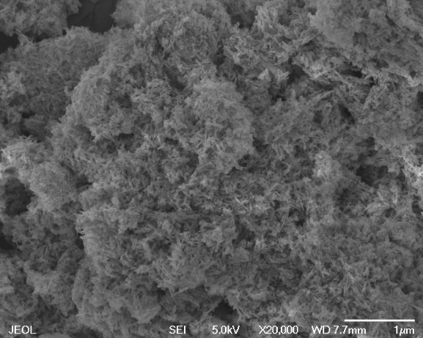 | 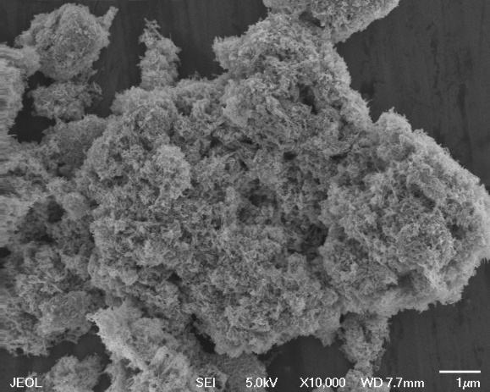
Hematite (needle width 41 nm)
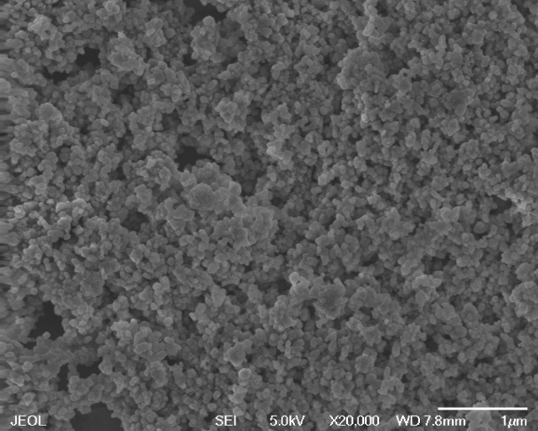 | 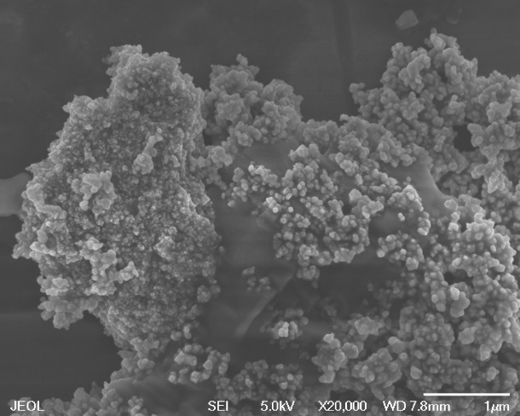
Nickel oxide (average diameter 112 nm)
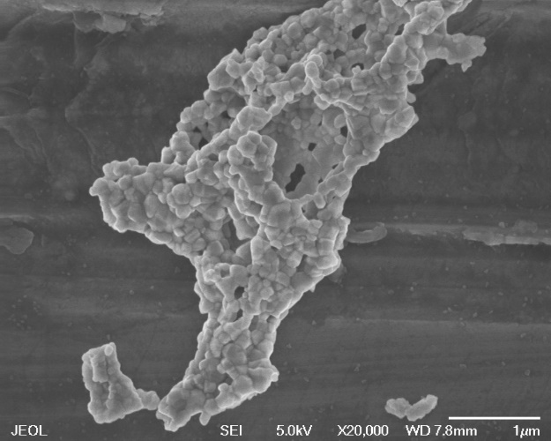 | 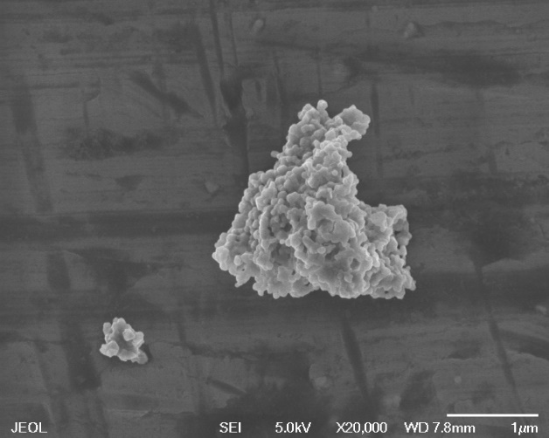
Mixed oxide (average diameter 128 nm)

Asphaltene adsorption capacities (Fig. S7)

The UV-Vis spectroscopy method was used to measure the concentrations. Before carrying out the measurements, calibration curves were made for both types of asphaltene by diluting the solutions until they were measurable in the equipment. It should be noted that the greatest differences are observed in the 1000 ppm solutions. In addition, the solutions that were put in contact with the mixed oxide presented a clearer coloration in comparison to the other two adsorbents.

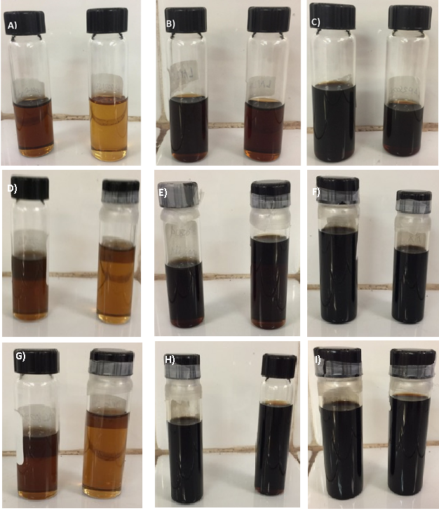

Fig. S7. Liqueurs obtained before (left) and after (right) adsorption, respectively, from the tests for the adsorption capacity of: mixed oxide, A) 1000 ppm, B) 3000 ppm and c) 5000 ppm; hematite D) 1000 ppm, E) 3000 ppm and F) 5000 ppm; and nickel oxide G) 1000 ppm, H) 3000 ppm.

Fig. S8. Calibration curves for the UV-visible spectra, using asphaltene solutions at concentrations of 1000, 2000, 3000, 4000 and 5000 ppm in toluene.
b)
a)
a)
b)
AP2 asphaltene adsorption test
AP1 asphaltene adsorption test
Fig. S9. UV-visible spectra of asphaltenes at concentration of 3000 pm in toluene solutions, where a) is the solutions before the treatment with adsorbent and b) already treated solutions.

Table S1. Standard deviations of adsorption for AP1 and AP2 in toluene.
AP1 |  |  | AP2
Adsorbent | Asphaltene concentration | Standard deviation | Adsorbent | Asphaltene concentration | Standard deviation
Mixed oxide | 5000 | 14.6149 | Mixed oxide | 5000 | 9.1642
 | 3000 | 14.9749 |  | 3000 | 1.3768
 | 1000 | 9.6642 |  | 1000 | 2.0626
Hematite | 5000 | 21.8749 | Hematite | 5000 | 20.6184
 | 3000 | 6.6409 |  | 3000 | 17.6779
 | 1000 | 1.8888 |  | 1000 | 20.219
Nickel oxide | 5000 | 11.7196 | Nickel oxide | 5000 | 5.5698
 | 3000 | 16.645 |  | 3000 | 6.6982
 | 1000 | 5.9345 |  | 1000 | 3.5397

Table S2. Constantes and correlations, obtained by adjusting the kinetics to equations of pseudo-first order y pseudo-second order.
AP1
Oxides | Temperature  (K) | C₀ (mg/L) | Pseudo-first order |  | Pseudo-second order
 |  |  | K₁ | R² | K₂ | R²
Mixed oxide | 298 | 1000 ppm | 0.1122 | 0.9447 | 0.0024 | 0.9654
Hematite | 298 | 1000 ppm | 0.1156 | 0.9106 | 0.0025 | 0.9587
Nickel oxide | 298 | 1000 ppm | 0.1431 | 0.8974 | 0.0044 | 0.9681
AP2
Oxides | Temperature  (K) | C₀ (mg/L) | Pseudo-first order |  | Pseudo-second order
 |  |  | K₁ | R² | K₂ | R²
Nickel oxide | 298 | 1000 ppm | 0.1612 | 0.9681 | 0.0284 | 0.8818
Mixed oxide | 298 | 1000 ppm | 0.2474 | 0.5482 | 0.5516 | 0.8036
Hematite | 298 | 1000 ppm | 0.0650 | 0.9954 | 0.0021 | 0.9924

References

Berrones, M., Lascano, L. Síntesis de nanopartículas de hematita por el método de precipitación controlada. Rev. Politécnica 30, 91–99 (2009).

