Electronic supplementary information

Peculiarities of NMR Relaxation in Micellar Gels of Pluronic F-127

Anatoly Butakov,ª Andrei Filippov,^{b,c*} Roustam Gimatdinov^{d} and Vladimir Chernovª
ªRadiophysics and Electronics, Chelyabinsk State University, Chelyabinsk 454001, Russia
^{b}Chemistry of Interfaces, Luleå University of Technology, Luleå SE-97187, Sweden
^{c}Institute of Physics, Kazan Federal University, 420008, Kazan, Russia
^{d}Medical and Biological Physics, Kazan Medical University, 420012, Kazan, Russia
*Corresponding author, Andrey.Filippov@kpfu.ru

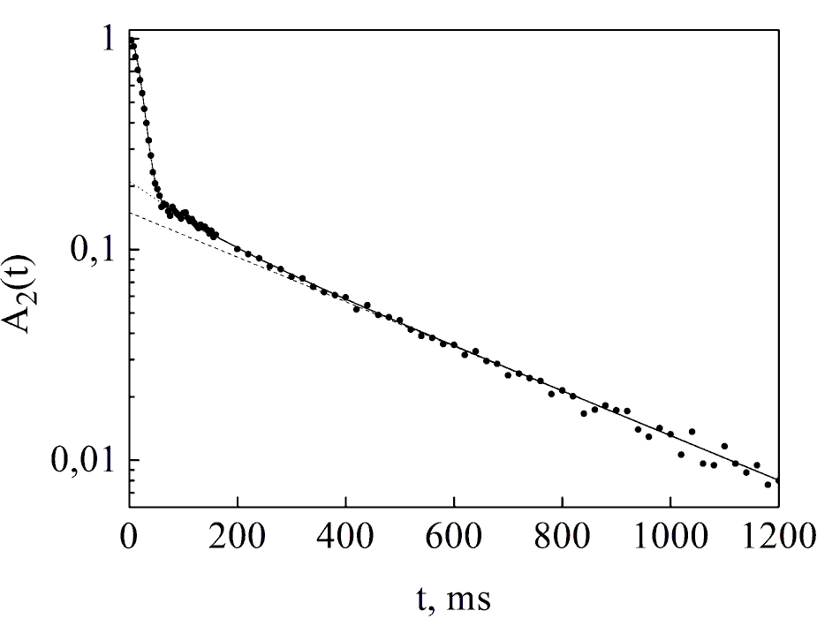
Figure S1 Decay of transverse magnetization for Sample 2 at 40° С (rigid gel-phase). The solid line is the approximation of the whole decay, the dashed line corresponds to the slowly-relaxing component, and the dotted line is the sum of intermediate-relaxing and slowly-relaxing components.

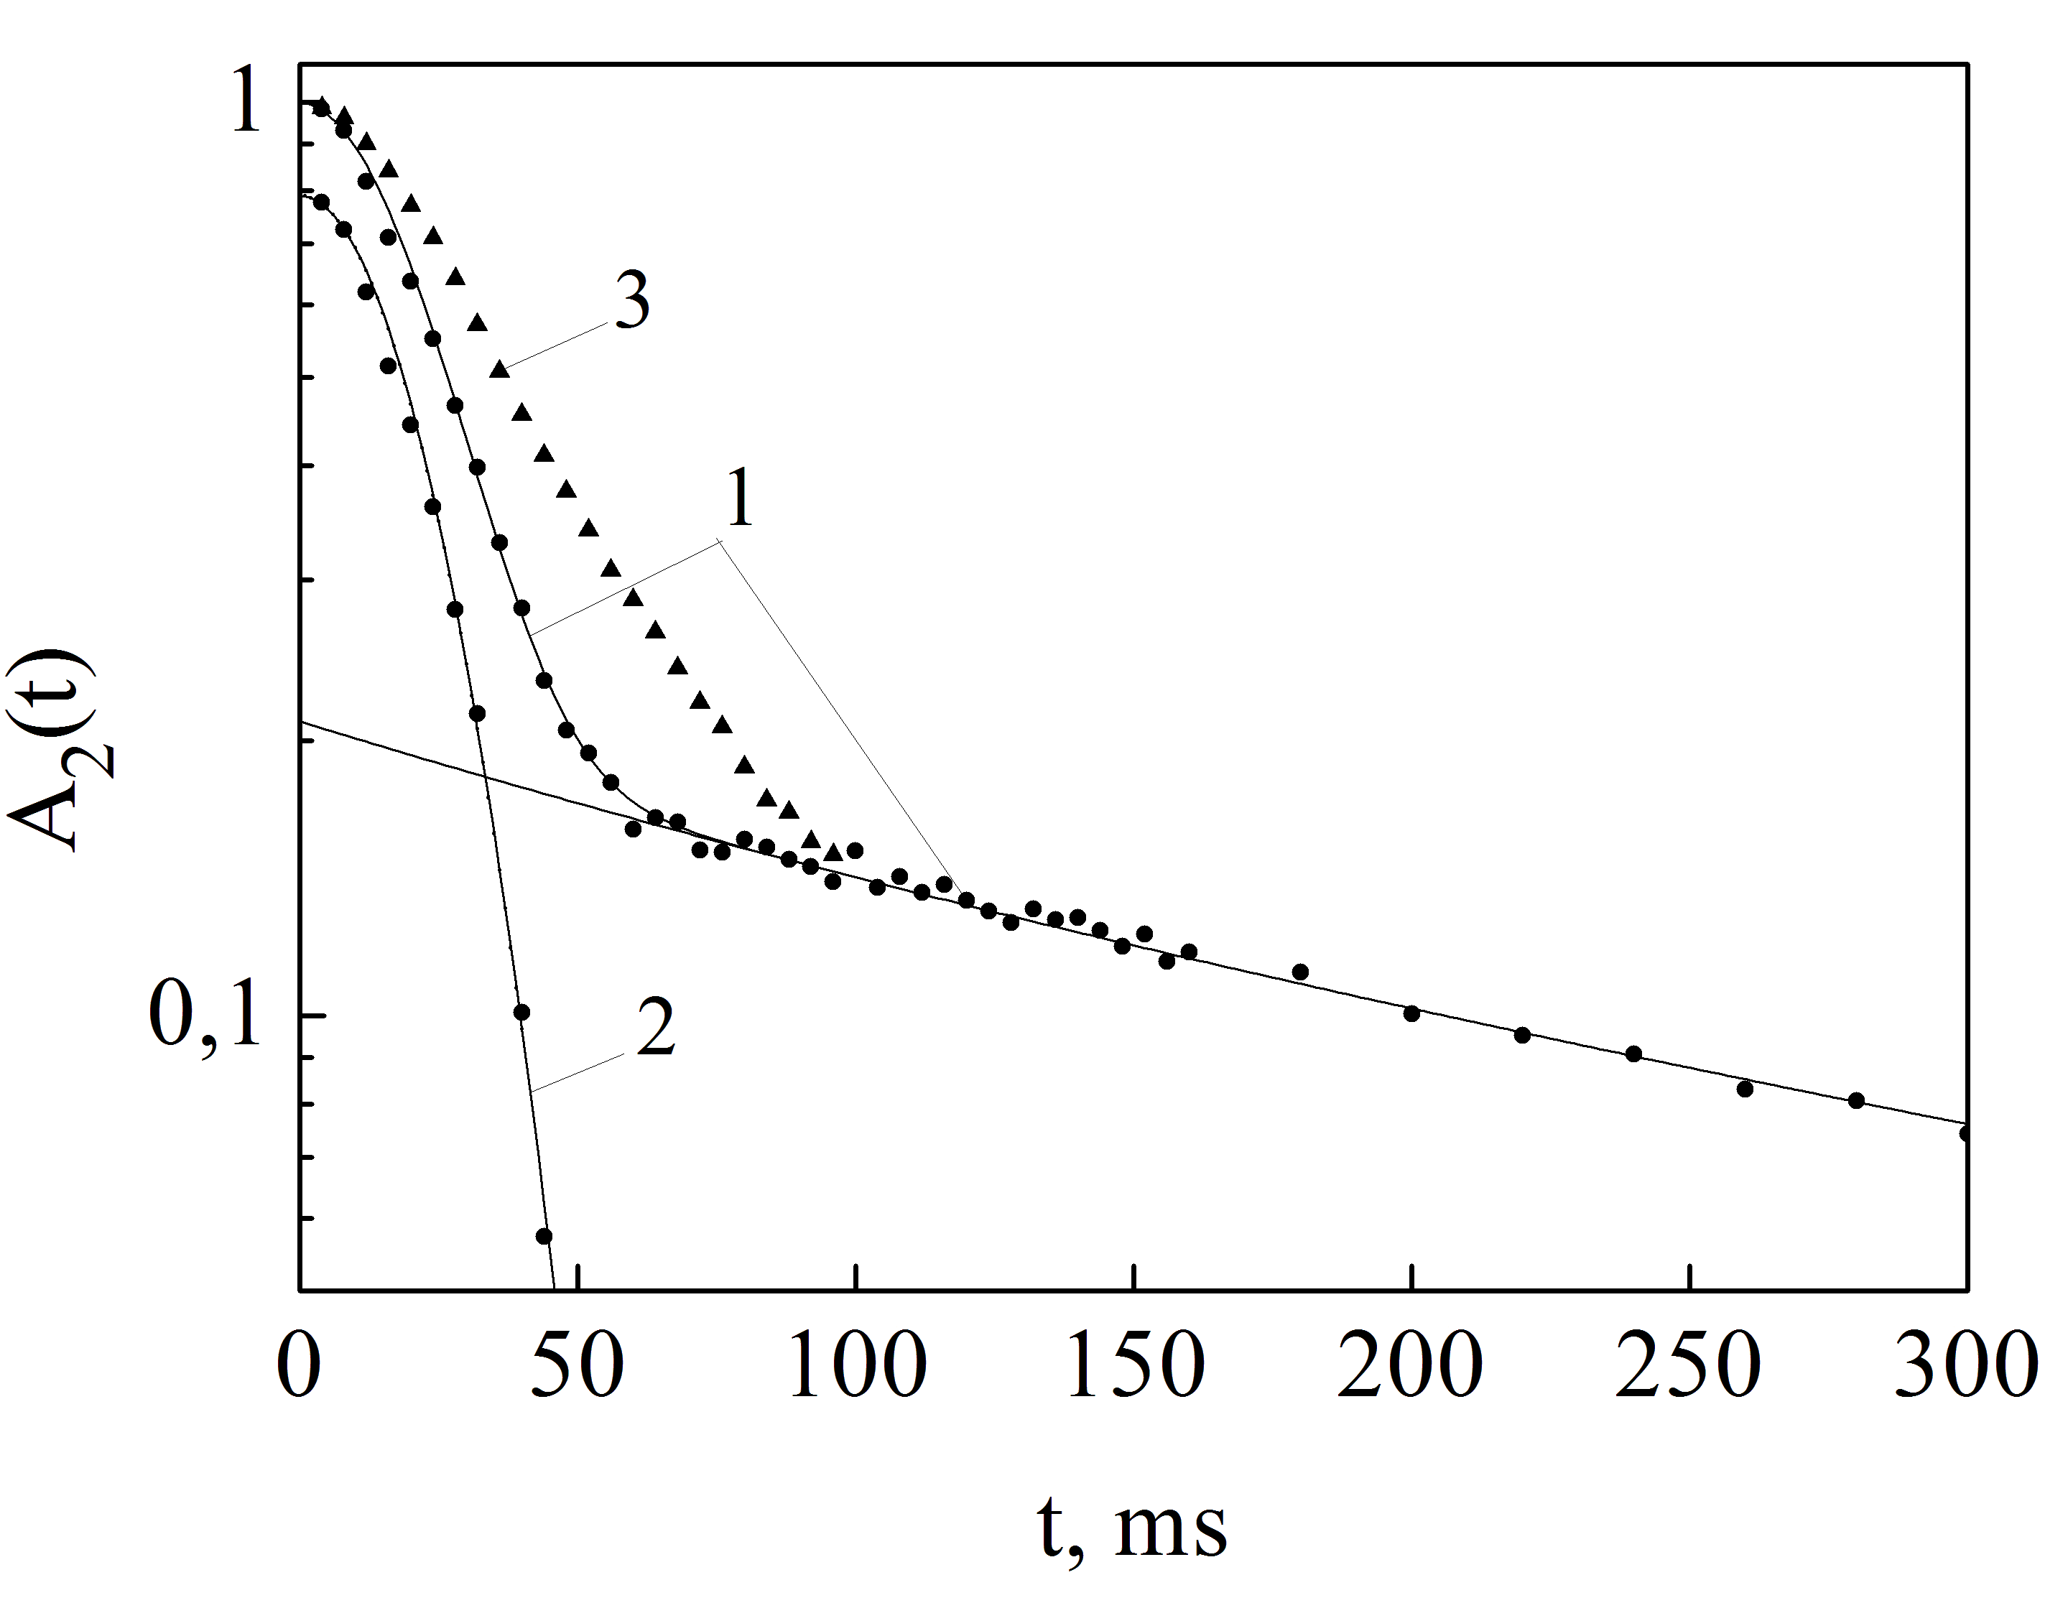

Figure S2 Initial part of the transverse magnetization decay (1), fast-relaxing Gaussian component of the decay obtained after subtraction of slowly-relaxing and intermediate-relaxing components from the initial decay (2) and envelope of signal of solid-echo (3) for Sample 2 at 40 °С (rigid gel-phase).

