Supplementary Data

Copper(II) and cobalt(II) complexes of 5-methyl pyrazole-3-carboxylic acid: Synthesis, X−ray crystallography, thermal analysis and in vitro antimicrobial activity

ANANYAKUMARI SANTRA, PAULA BRANDAO, HAREKRISHNA JANA, GOPINATH MONDAL, PRADIP BERA, ABHIMANYU JANA and PULAKESH BERA*

Table S1. Hydrogen bonding parameters of 1-3.
Compounds | D–H···A | d(D–H) Å | d(H···A) Å | d(D···A) Å | ˂D-H-A[°] | Symmetry
1 | O1‒H1A···O5 | 0.74 | 2.04 | 2.7856(2) | 176.00 | -x,-y,1-z
 | N2‒H2···O6 | 0.76 | 2.01 | 2.7781(2) | 173.00
 | N4‒H4···O1 | 0.77 | 2.03 | 2.7931(2) | 170.00
 | O6‒H6A···O3 | 0.79 | 2.03 | 2.7793(2) | 163.00
 | O7‒H7A···O3 | 0.86 | 2.07 | 2.8818(2) | 175.00
2 | N2‒H2···O100 | 0.90 | 1.84 | 2.7237(1) | 168.00 | -1+x, y, z
 | N4‒H4···O4 | 0.89 | 1.84 | 2.7266(1) | 176.00
3 | O3‒H1A···O2 | 0.83 | 1.86 | 2.6691(2) | 165.00 | 1-x+y, 1-x, z
 | O3‒H1B···O2 | 0.83 | 2.09 | 2.9174(3) | 168.00
 | N2‒H2A···O2 | 0.94 | 1.92 | 2.8422(3) | 166.00

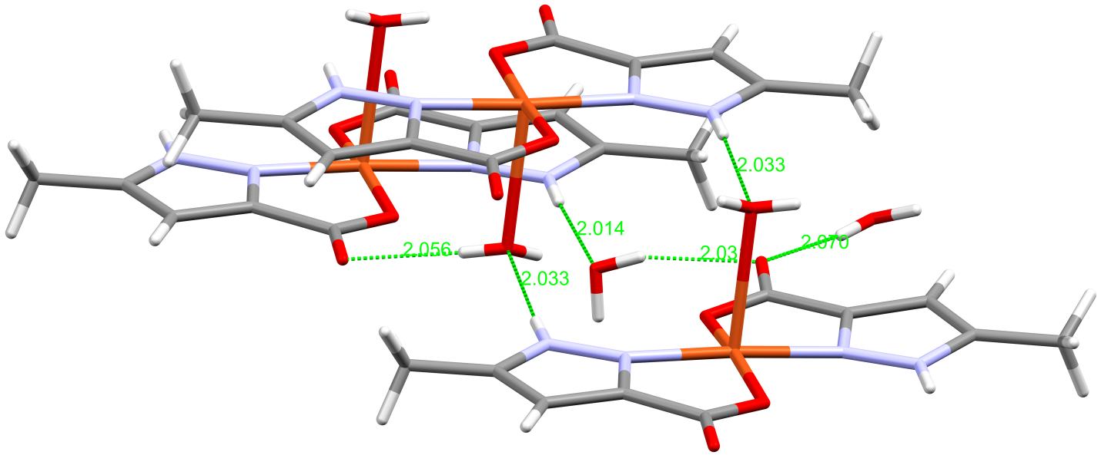
Figure S1. H bond interaction of 1.

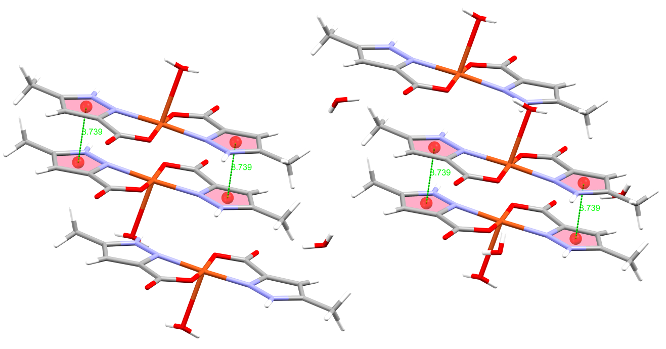
Figure S2. π−π interaction of 1.

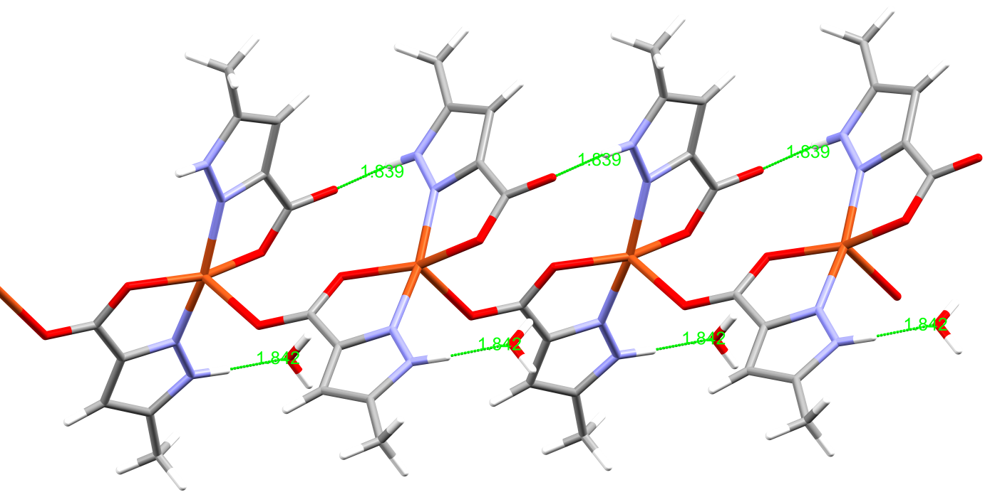
Figure S3. H bonding interaction of 2.

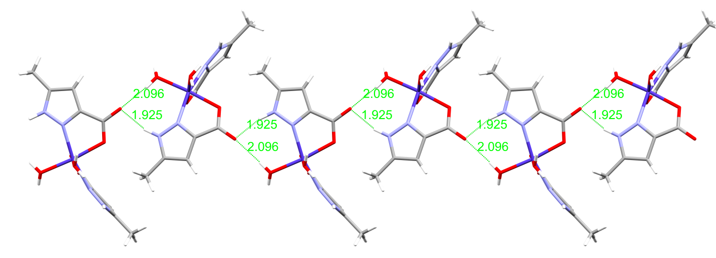
Figure S4. H bond interaction of 3.

Scheme S1. Thermal decomposition scheme of 1, 2 and 3.

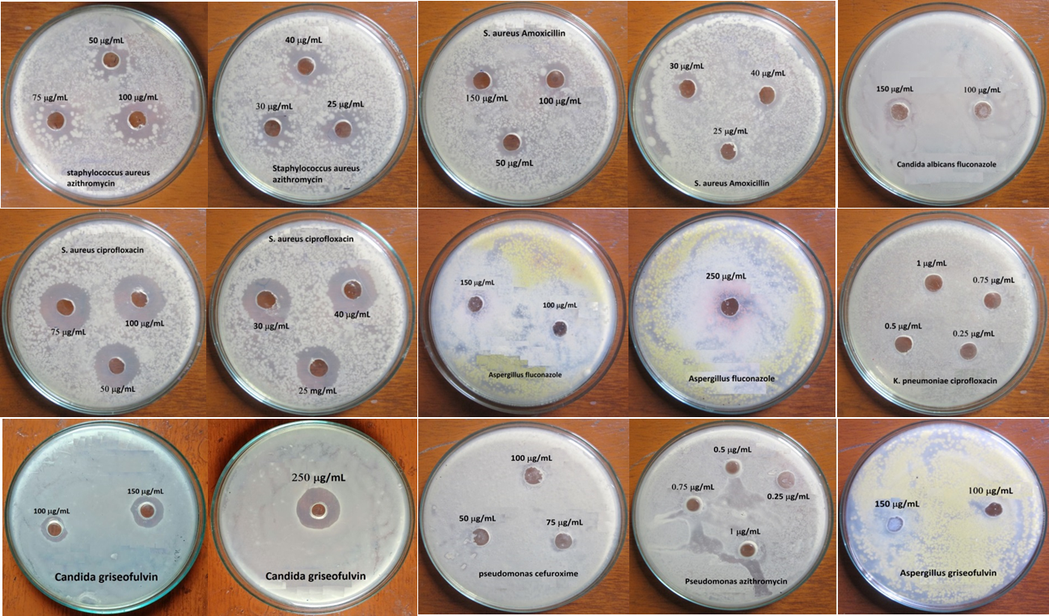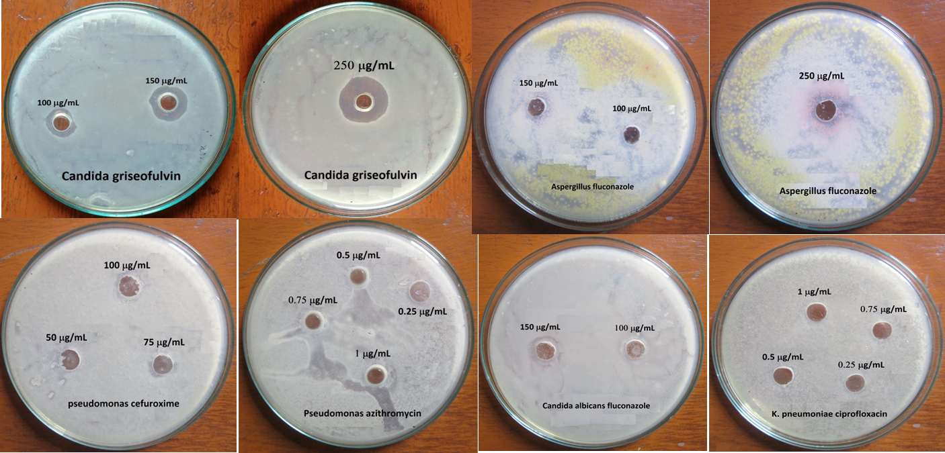
Figure S5. Camera view of the agar experiment for MIC value determination.

