Supplementary Appendix

Supplement to: Syngelaki A, Sequeira M, Roberge S, Andrade W, Nicolaides KH. Diet and exercise for preeclampsia prevention in overweight and obese pregnant women: systematic review and meta-analysis.

Contents

Figure S1..………………………………………………………………………………………. | 3
Figure S2.………………………………………………………..……………………………… | 4
Figure S3…………………………………………………………………..……………………. | 5
Figure S4………………………………………………………..………………………………. | 6
Table S1..….……………………………………………………………………………………. | 7

Supplementary Figure 1. Funnel plot of trials of intervention vs. control on the risk of hypertensive disorders. The risk ratios are plotted against the standard error (Log risk ratio).

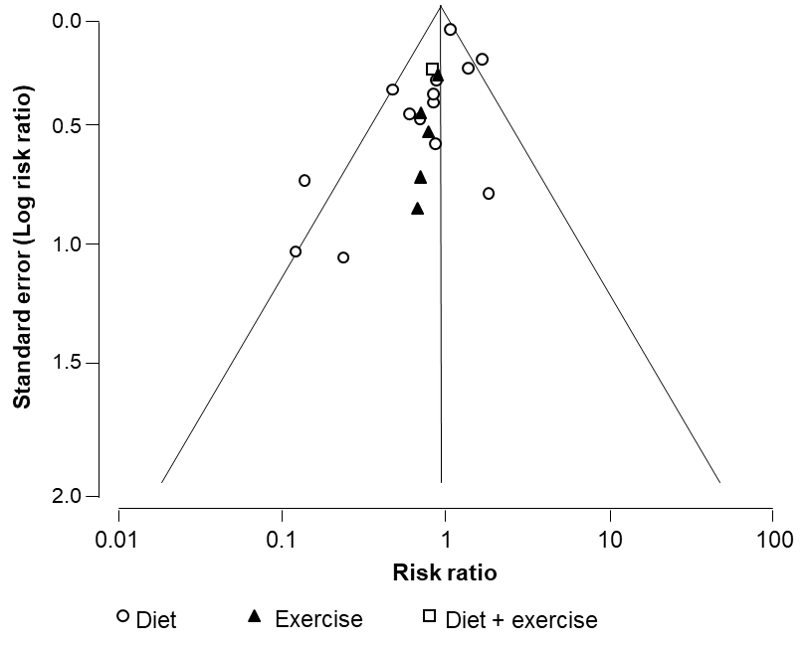

Supplementary Figure 2. Forest plots of the risk of hypertensive disorders: comparison between interventions vs. control groups.

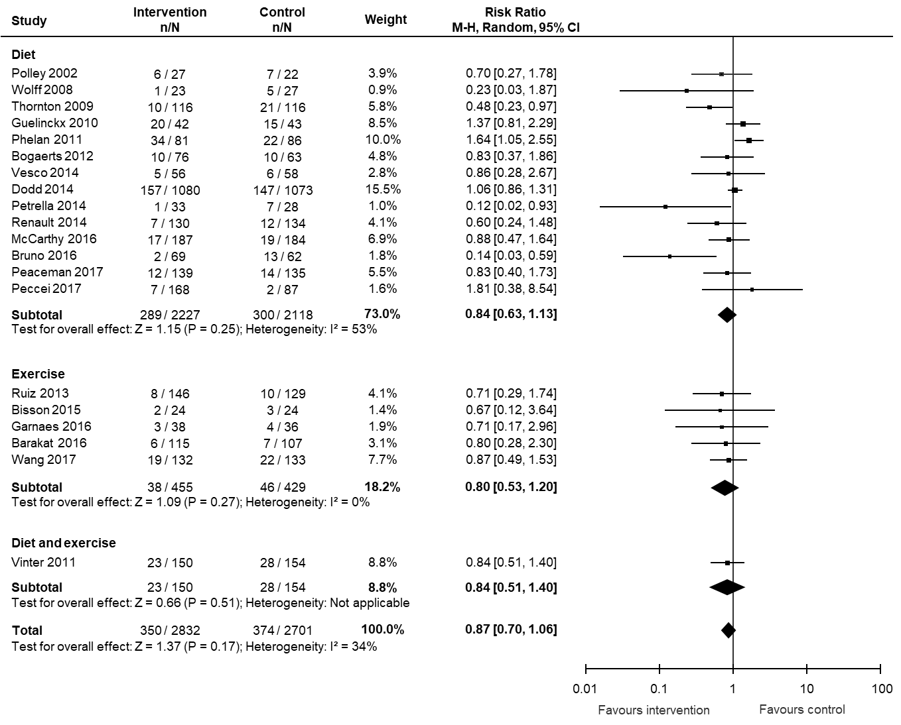
Supplementary Figure 3. Forest plots of gestational weight gain: comparison between interventions vs. control groups.

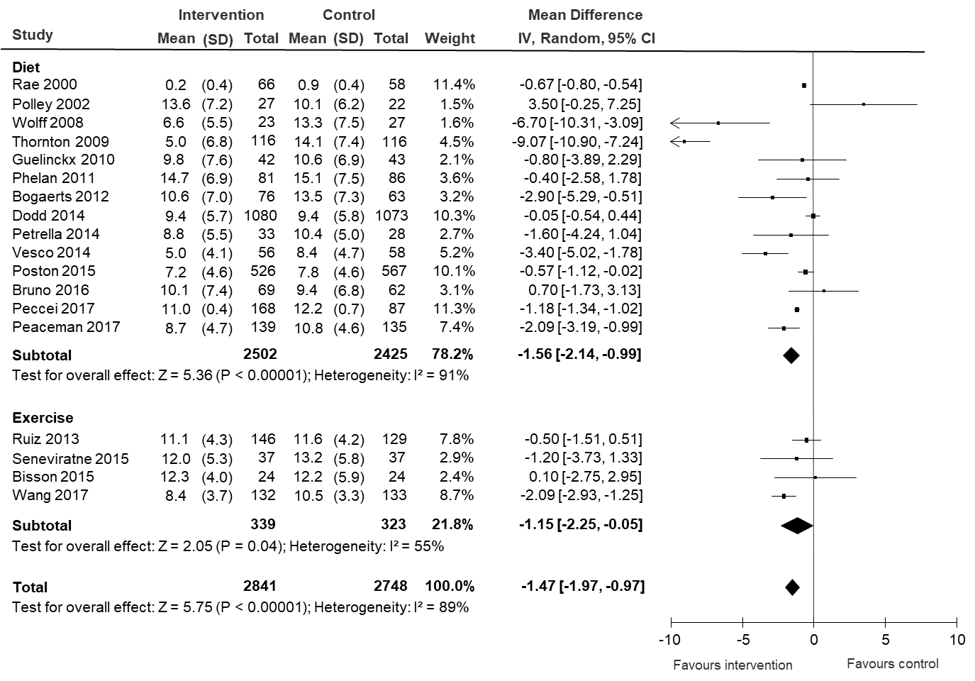
Supplementary Figure 4. Meta-regression on the association of gestational weight gain and the risk of preeclampsia (right) and hypertensive disorders (left).

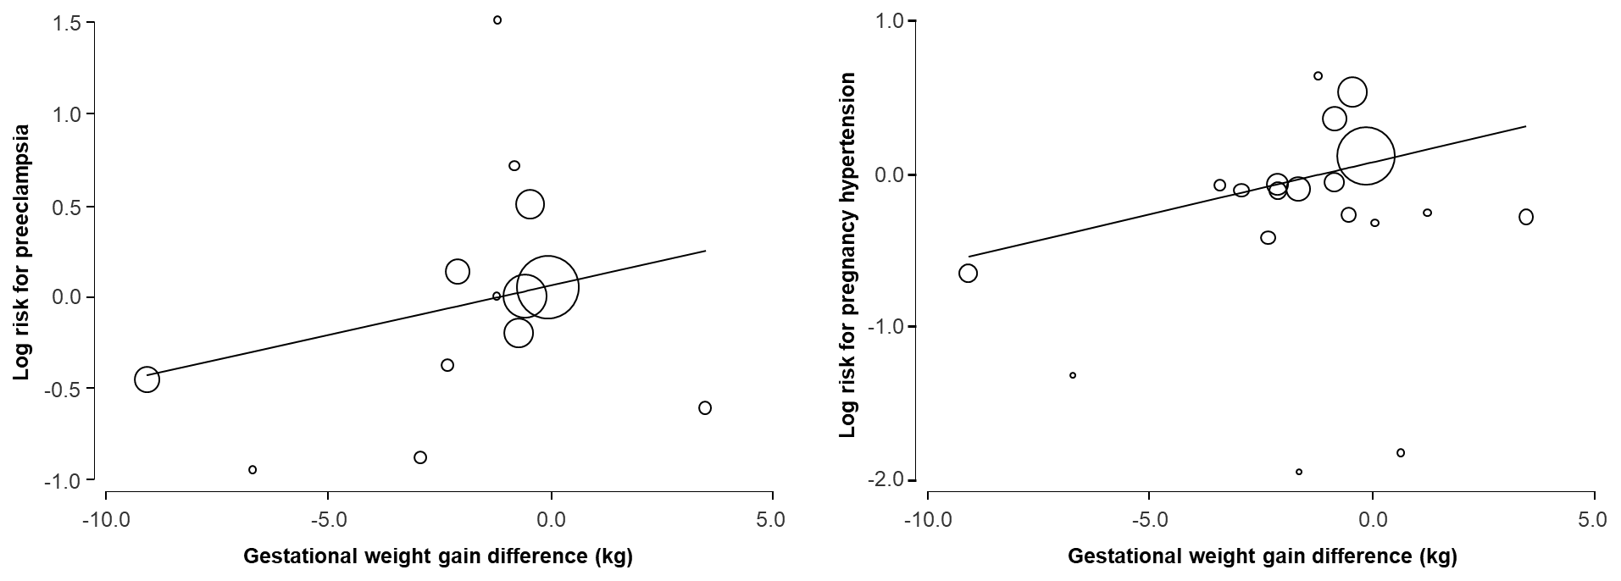

Supplementary Table 1. Characteristics of the included trials.

Author | Inclusion criteria | Exclusion criteria | Intervention | 1ry outcome | Definitions
Rae et al.,  2000 | BMI >25 kg/m²  GA 8-35 weeks  GDM | Not reported | Diet: instruction on energy restricted diabetic diet. | Need for insulin therapy | PE: definition not given  GWG: weight difference between randomization and delivery.
Polley et al.,  2002 | Age >18 years  BMI >25 kg/m²  GA <20 weeks  Singleton pregnancy | Chronic medical disorders, previous pregnancy complications, drug abuse. | Diet: written and oral information on appropriate weight gain, healthy eating and exercise during pregnancy. Weight was measured in each visit and if above the recommended level further advice was given. | GWG | PE: definition not given  GH: definition not given  GWG: weight difference between self-reported pre-pregnancy weight and measured at last visit before delivery.
Wolff et al.,  2008 | Age 18-45 years  BMI >30 kg/m²  GA <16 weeks  Singleton pregnancy  Caucasian race | Medical conditions affecting fetal growth or contraindicate limitation of weight gain, smoking. | Diet: 10 consultations with dietitian. | GWG | PE: definition not given  GH: definition not given  GWG: weight difference between self-reported pre-pregnancy weight and measured at delivery.
Thornton et al.,  2009 | BMI >30 kg/m²  GA 12-18 weeks  Singleton pregnancy | Chronic medical disorders. | Diet: prescription of nutritional regimen and asked to record daily food consumption. | Perinatal  outcome | PE: definition not given  GH: definition not given  GWG: weight difference between randomization and delivery.
Guelinckx et al.,  2010 | BMI >29 kg/m²  GA <15 weeks  Singleton pregnancy | Chronic medical disorder, GDM. | Diet: 3 group sessions with nutritionist. | GWG | PE: BP >140/90 mmHg >20 weeks and proteinuria.  GH: BP >140/90 mmHg >20 weeks without proteinuria.  GWG: weight difference between self-reported pre-pregnancy weight and measured at delivery.
Phelan et al.,  2011 | Age >18y  BMI >25 kg/m²  GA 10-16weeks  Singleton pregnancy | Chronic medical disorders, weight loss during pregnancy, history of 3 miscarriages, smoking. | Diet: 1 consultation with an interventionist to discuss appropriate weight gain, physical activity and calorie goals. 3 phone calls with dietician. Weekly emails to prompt healthy eating and exercise habits. | GWG | PE: definition not given  GH: definition not given  GWG: weight difference between self-reported pre-pregnancy weight and measured at last visit before delivery.
Vinter et al.,  2011 | Age 18-40 years  BMI 30-45 kg/m²  GA 10-14 weeks | Chronic medical disorders, previous pregnancy complications | Diet and exercise: 4 sessions with dietitian, weekly exercise classes with physiotherapists for 6 months, 4-6 group sessions with physiotherapist to improve integration of physical activities in daily life. | GWG | PE: BP >140/90 mmHg on >1 occasion plus proteinuria.  GH: BP >140/90 mmHg on >1 occasion without proteinuria.  GWG: weight difference between first prenatal visit and last visit before delivery
Bogaerts et al.,  2012 | BMI >29 kg/m²  GA <15 weeks  Singleton pregnancy Dutch speaking | Diabetes, primary need for nutritional advice. | Diet: 4 lifestyle intervention sessions to raise awareness on healthy eating and physical activity. | GWG | PE: BP >140/90 mmHg on >1 occasion >20 weeks’ gestation plus proteinuria.  GH: BP >140/90 mmHg on >1 occasion >20 weeks’ gestation without proteinuria.  GWG: weight difference between self-reported pre-pregnancy weight and measured at delivery.
Ruiz et al.,  2013 | BMI >25 kg/m²  GA 5-6 weeks  Singleton pregnancy | Contraindication to exercise, complicated pregnancies, high risk of preterm delivery | Exercise: structured, supervised, intervention program 3 days per week. | GWG | HD: definition not given  GWG: weight difference between first prenatal visit and last visit before delivery
Dodd et al.,  2014 | BMI >25 kg/m²  GA 10-20 weeks  Singleton pregnancy | Diabetes | Diet: 6 consultations with dietitian or research assistants. | BW >90th percentile | PE: BP >140/90 mmHg on >1 occasion >20 weeks’ gestation plus proteinuria or renal insufficiency, liver disease, neurological problems, hematological disturbance or fetal growth restriction.  GH: BP >140/90 mmHg on >1 occasion >20 weeks’ gestation.  GWG: weight difference between first prenatal visit and last visit before delivery
Pertrella et al.,  2014 | Age >18 years  BMI >25 kg/m²  GA 12-13 weeks  Singleton pregnancy | Chronic medical disorders, previous GDM, smoking, bariatric surgery, women who just engaged in regular physical activity, dietary supplements or herbal products. | Diet: 1 consultation with dietician. | GWG | HD: definition not given  GWG: weight difference between randomization and delivery
Renault et al.,  2014 | Age >18 years  BMI >30 kg/m²  GA <16weeks  Singleton pregnancy | Diabetes, diseases limiting level of physical activity, bariatric surgery, alcohol or drug abuse, fetal defect. | Diet: consultations with dietitian every 2 weeks. | GWG | PE: BP >140/90 mmHg on >1 occasion >20 weeks’ gestation plus proteinuria.  GH: BP >140/90 mmHg on >1 occasion >20 weeks’ gestation without proteinuria.  GWG: weight difference between self-reported pre-pregnancy weight and measured at 36-37 weeks’ gestation.
Vesco et al.,  2014 | Age >18 years  BMI >30 kg/m²  GA <21 weeks | Medical conditions requiring specialized nutritional care | Diet: 2-individual and 16 group sessions with dietician for dietary and exercise recommendations. | GWG | HD: definition not given  GWG: weight difference between randomization and 34 weeks’ gestation
Bisson et al.,  2015 | Age >18 years,  BMI >30 kg/m²  GA <15 weeks  Singleton pregnancy | Diabetes, chronic hypertension | Exercise: 1 supervised and 2 unsupervised sessions per week for 12 weeks. | Time spent at physical activity at 36 weeks’ gestation | HD: definition not given  GWG: weight difference between 14 and 36 weeks’ gestation
Poston et al.,  2015 | Age >16years  BMI >30 kg/m²  GA 15-18 weeks Singleton pregnancy | Chronic medical disorders, taking metformin | Diet: 1 session per week for 8 weeks with health trainer. | GDM | PE: BP >140/90 mmHg on >1 occasion plus proteinuria.  GWG: definition not given
Seneviratne et al.,  2015 | Age 18-40 years  BMI ≥25 kg/m²  GA <20 weeks  Singleton pregnancy | Smoking, contraindications to antenatal exercise. | Exercise: home-based structured programme utilising magnetic stationary bicycles from 20 to 35 weeks’ gestation for 3-5 times per week. Participants were visited at home at the beginning of the intervention by an exercise physiologist. | BW | PE: BP >140/90 mmHg on >1 occasion >20 weeks’ gestation plus proteinuria.  GH: BP >140/90 mmHg on >1 occasion >20 weeks’ gestation without proteinuria.  GWG: weight difference between first prenatal visit and last visit before delivery.
Bruno et al.,  2016 | Age >18 years  BMI ≥25 kg/m²  GA 9-12 weeks  Singleton pregnancy | Smoking, bariatric surgery, previous GDM, medical disorders limiting physical activity, dietary supplements that might affect body weight. | Diet: 1 consultation with dietician. | GDM | HD: definition not given
Garnaes et al.,  2016 | BMI ≥28 kg/m²  GA <18 weeks  Singleton pregnancy | High risk for preterm delivery, diseases that could interfere with participation, exercise training (> 2 per week) in the period before randomisation. | Exercise: 3 supervised and 1 unsupervised sessions per week. | GWG | HD: definition not given  GWG: weight difference between randomization and delivery.
McCarthy et al.,  2016 | Age >18 years  BMI >25 kg/m²  GA <20 weeks  Singleton pregnancy  English speaking | Diabetes, major fetal defect. | Diet: 1 consultation with midwife who provided simple dietary advice, target weight gain of 5–9 kg and encouraged serial self-weighing and recording. | Perinatal  outcome | PE: BP >140/90 mmHg >20 weeks’ gestation plus proteinuria or renal insufficiency, liver disease, neurological problems, hematological disturbance, pulmonary edema, abruption or fetal growth restriction.  GH: BP >140/90 mmHg >20 weeks’ gestation.
Barakat et al.,  2017 | GA 9-11 weeks  BMI >25 kg/m²  Singleton pregnancy | Diseases limiting level of physical activity, diabetes, GDM, history or risk of preterm delivery. | Exercise: 3 supervised sessions per week. | HD | HD: BP >140/90 mmHg on >1 occasion >20 weeks’ gestation with or without proteinuria.
Peaceman et al.,  2017 | BMI 25-40 kg/m²  GA <16 weeks  Singleton pregnancy | Diabetes, bariatric surgery, IVF conception. | Diet: individualized dietitian-prescribed diet, physical activity, internet-based self-monitoring of diet adherence, and weekly coaching calls, with opportunities for group visits, webinars, and podcasts. | GWG | HD: definition not given  GWG: Weight difference between randomisation and 36 weeks’ gestation.
Peccei et al.,  2017 | Age 18-49 years  BMI 25-40 kg/m²  GA <16 weeks  Singleton pregnancy | Diabetes, history of eating disorders. | Diet: consultations with dietitian every 2 weeks throughout pregnancy. | GWG | PE: definition not given  GH: definition not given  GWG: Weight difference between randomization and last visit before delivery.
Wang et al.,  2017 | Age >18 years  BMI >24 kg/m²  GA <13 weeks  Singleton pregnancy | Smoking, history of cervical insufficiency, medications for serious medical disorders, taking metformin or corticosteroids. | Exercise: supervised cycling program >3 sessions per week. | GDM | PE: BP >140/90 mmHg >20 weeks’ gestation plus proteinuria or renal insufficiency, liver disease, neurological problems, hematological disturbance, or pulmonary edema.  GH: BP >140/90 mmHg >20 weeks’ gestation.  GWG: definition not given

BMI = body mass index; GA = gestational age; GDM = gestational diabetes mellitus; GWG = gestational weight gain; PE = preeclampsia; GH = gestational hypertension; HD = hypertensive disorder; BW = birth weight; BP = blood pressure.

