Supplementary Material
Table S1 – AIC and BIC statistics for alternate parametric distributions for modeling ToT
Fitted Function | Pembrolizumab + Chemotherapy |  | Chemotherapy
 | AIC | BIC | AIC | BIC | BIC
Exponential | 2620.7 | 2624.7 | 1445.8 | 1449.1
Weibull | 2621.1 | 2629.2 | 1441.9 | 1448.5
LogNormal | 2683 | 2691 | 1485.3 | 1491.9
LogLogistic | 2638.1 | 2646.1 | 1461.1 | 1467.7
Gompertz | 2622.7 | 2630.7 | 1446 | 1452.7
GenGamma | 2619.5 | 2631.5 | 1440.5 | 1450.4

Table S2 – AIC and BIC statistics for alternate parametric distributions for modeling PFS
Fitted Function | Pembrolizumab + Chemotherapy |  | Chemotherapy
 | AIC | BIC | AIC | BIC | BIC
Exponential | 427 | 430 | 577.7 | 580.3
Weibull | 421.8 | 427.8 | 568.8 | 574.1
LogNormal | 421.8 | 427.8 | 579.2 | 584.5
LogLogistic | 422.1 | 428.1 | 575.6 | 580.9
Gompertz | 425.2 | 431.2 | 577.5 | 582.8
GenGamma | 423.5 | 432.5 | 568.3 | 576.3

Table S3 – AIC and BIC statistics for alternate parametric distributions for modeling OS
Fitted Function | Pembrolizumab + Chemotherapy |  | Pembrolizumab + Chemotherapy
 | AIC | AIC | AIC | BIC
Exponential | 682.2 | 686 | 377.6 | 380.5
Weibull | 684.2 | 691.8 | 376.9 | 382.7
LogNormal | 681.2 | 688.8 | 374.0 | 379.7
LogLogistic | 683.1 | 690.7 | 375.8 | 381.5
Gompertz | 682.8 | 690.5 | 374.1 | 379.8
GenGamma | 683.1 | 694.5 | 375.3 | 384

Table S4 - Pre-medication Costs
Pre-medications | Form | Strength | # of doses | Average cost per cycle
In cycles containing carboplatin
Fosaprepitant (anti-emetic) | IV | 150 mg | 1 | $302.22
Ondansetron (anti-emetic) | IV | 24 mg | 1 | $8.80
Dexamethasone (steroid) | Oral | 4 mg | 3 | $0.36
In cycles containing cisplatin
Fosaprepitant (anti-emetic) | IV | 150 mg | 1 | $302.22
Dexamethasone (steroid) | Oral | 4 mg | 13* | $1.56
Ondansetron (anti-emetic) | Oral | 8 mg | 2 | $1.06
In cycles containing pemetrexed
Vitamin B12 injection† | Oral | 1000 mcg | 1 | $10.87
Dexamethasone (steroid) | Oral | 4 mg | 6‡ | $0.72
*3 doses on day 1, 2 on day 2, and 4 each on days 3-4; † Administered every 3rd cycle that pemetrexed is given
The usage of pre-medications for chemotherapy is included in the model. Unit costs are obtained from the Analysource database¹ and based on WACs for generic formulations of each drug where available.

Table S5: Distribution of post-discontinuation therapies in model
Post-discontinuation regimen | Pembrolizumab + Chemotherapy | Chemotherapy
% receiving subsequent therapy in discontinued patients | 45.8% | 56.5%
distribution of 2nd line therapies
carboplatin + pemetrexed | 17.9%
docetaxel | 66.1% | 13.5%
nivolumab | 8.8% | 14.6%
pembrolizumab | 7.2% | 71.9%
% receiving 2nd line maintenance therapy in discontinued patients | 2.2% | 0.0%
distribution of 2nd line maintenance therapy
pemetrexed | 100.0% | 100.0%

The percentage of patients who receive subsequent lines of therapy after treatment discontinuation (45.8% for pembrolizumab + chemotherapy and 56.5% for chemotherapy) was estimated from the KN189 trial.
The estimated distribution of specific treatments post-discontinuation from the trial data is shown in Table S5. For simplicity, only 2nd line treatments used by at least 5% of patients in each trial arm are explicitly modeled. For post-discontinuation use of pembrolizumab and nivolumab, given the relatively higher cost of these therapies, the exact proportion of patients with any use of each these treatments as subsequent therapy is modeled. The percentages of patients receiving any other specific treatment are redistributed among the remaining most frequently used treatments to ensure that the total proportion receiving subsequent therapy in each arm is aligned with the trial data. A small percentage of patients utilized treatments post-discontinuation which represented a component of the combined therapy to which they were randomized within the trial (e.g,, carboplatin + pemetrexed, or pembrolizumab for the pembrolizumab + chemotherapy arm). As this treatment use occurred outside of the receipt of trial study drug, and the time on treatment for the randomized therapy specified within the model, the duration and costs were thus captured within these post-discontinuation analyses. While the costs of subsequent therapies are separately included in the model, OS and PFS impacts are assumed to be already reflected within the OS and PFS Kaplan-Meier data from the KN189 trial.
The modelled number of days of use of additional therapies following discontinuation of initial treatment (either pembrolizumab + chemotherapy, or chemotherapy) is shown in Table S6. With a median duration of follow-up in KN189 of 13.0 months, the duration of post-discontinuation treatment would be under-estimated due to right-censoring. For example, an average of just 66 days and 88 days of post-discontinuation anti-PD1 therapy use were observed for the pembrolizumab + chemotherapy and chemotherapy arms, respectively. Therefore, the average treatment duration for each second line plus regimen is instead estimated from the phase 2 KN021G trial of pembrolizumab + carboplatin + pemetrexed vs. carboplatin + pemetrexed (May 31, 2017 data cut-off), reflecting the initial trial from which pembrolizumab in combination with chemotherapy was approved for metastatic non-squamous NSCLC patients in the U.S.² With a median follow-up of 18.7 months, as seen in the table, a more extensive duration of second-line use of anti-PD1 therapies could be observed. In the case of maintenance therapy, due to insufficient numbers of patients within this post-discontinuation category in the KN021G trial, treatment duration was estimated from KN189, though values are likely conservative.
Table S6: Duration (in days) of 2nd line-plus treatment regimens
Post-discontinuation regimen | Pembrolizumab + chemotherapy arm (days) | Chemotherapy arm (days)
Second line
Anti-PD-1 | 196 | 185
Other treatments | 146 | 72
Maintenance therapy | 88 | 52
NA = Not applicable

Considering the duration of subsequent lines of therapy from Table S6 and distribution of patients receiving each therapy from Table S5, Table S7 shows the post-discontinuation treatment cost per comparator. The main factor affecting post-discontinuation treatment costs is the use of 2nd line anti-PD1 therapies. Since not every patient completed all subsequent treatments as of the data cut-off date, the difference in associated costs between the pembrolizumab + chemotherapy and chemotherapy groups may still be conservatively estimated. The cost was incorporated in the model as a one-off cost upon treatment discontinuation.
For pembrolizumab monotherapy, the ratio of post-discontinuation costs between pembrolizumab monotherapy and the chemotherapy arm in KN024 was applied to chemotherapy arm post-discontinuation treatment costs in KN189 to estimate a post-discontinuation cost for pembrolizumab monotherapy. Because patient characteristics may differ between patients in KN024 and KN189, rather than incorporating KN024 post-discontinuation costs directly, this approach preserves the relationship observed between chemotherapy and pembrolizumab post-discontinuation costs in KN024, while normalizing to values observed for the KN189 trial chemotherapy arm. Based on this method, a one-time post-discontinuation therapy cost of $12,283 was estimated for pembrolizumab monotherapy.

Table S7: Total post-discontinuation treatment costs
 | Pembrolizumab + Chemotherapy | Chemotherapy
Total post-discontinuation treatment costs | 12,831 | 40,325
Drug costs | 12,314 | 39,691
Administration costs | 518 | 634

Table S8: Risk of Hospitalization for Grade 3+ Adverse Events
Adverse event | Risk of Hospitalization in KN 189
Anaemia | 18.6%
Asthenia | 15.6%
Diarrhea | 63.0%
Dyspnea | 34.6%
Fatigue | 10.7%
Febrile neutropenia | 87.1%
Hyponatremia | 25.0%
Neutropenia | 11.4%
Pneumonia | 94.9%
Pneumonitis | 100.0%
Thrombocytopenia | 37.0%

Table S9: Costs of Modeled Grade 3+ Adverse Events
Adverse event | DRG Codes Applied | Cost per event  (2018 USD)
Anaemia | DRG 808, 809, 810 Major Hematologic/Immunologic Diagnoses Except Sickle Cell Crisis and Coagulation with MCC/CC and w/o MCC/CC | $1,654
Asthenia | DRG 947, 948 Signs and symptoms with MCC/Without MCC | $978
Diarrhea | DRG 391, 392 Esophagitis, Gastroenteritis and miscellaneous digestive disorders with and w/o MCC | $3,813
Dyspnea | DRG 204 Respiratory signs and symptoms | $1,646
Fatigue | DRG 947, 948 Signs and symptoms with MCC/Without MCC | $694
Febrile neutropenia | DRG 808, 809, 810 Major Hematologic/Immunologic Diagnoses Except Sickle Cell Crisis and Coagulation with MCC/CC and w/o MCC/CC | $7,473
Hyponatremia | DRG 642 Inborn and other disorders of metabolism | $1,940
Neutropenia | DRG 808, 809, 810 Major Hematologic/Immunologic Diagnoses Except Sickle Cell Crisis and Coagulation with MCC/CC and w/o MCC/CC | $1,043
Pneumonia | DRG 193, 194, 195 Simple pneumonia and pleurisy with MCC/CC/withour MCC & CC | $5,754
Pneumonitis | DRG 177, 178, 179 Respiratory infections and inflammations with MCC/CC/Without MCC&CC | $8,188
Thrombocytopenia | DRG 951 Other factors influencing health status | $1,814
Source: https://www.cms.gov/Medicare/Medicare-Fee-for-Service-Payment/AcuteInpatientPPS/FY2018-IPPS-Final-Rule-Home-Page.html

Table S10 - Deterministic Sensitivity Analysis Parameter Ranges for the Primary Analysis
Model Parameter | Base-Case Value | DSA Range
OS – pembrolizumab + chemotherapy | KM in year 1, followed by RR applied to chemotherapy arm OS to year 5, followed by SEER mortality risks | 95% CI limits of RR  +/- 20% of SEER mortality risks
OS - chemotherapy | KM in year 1, followed by SEER mortality risks | +/- 20% of SEER mortality risks
PFS – pembrolizumab + chemotherapy | KM39+ weibull following | 95% CI limits of the parameter estimates in the weibull function
PFS – chemotherapy | KM21+ weibull following | 95% CI limits of the parameter estimates in the weibull function
ToT – pembrolizumab + chemotherapy | exponential model | 95% CI limits of the parameter estimates in the exponential function
ToT - chemotherapy | Gompertz model | 95% CI limits of the parameter estimates in the Gompertz function
Utilities | By time to death (days)  0.834 (≥ 360)  0.765 [180-360)  0.709 [30-180)  0.563 (<30) | +/- 20%
Disease management cost in PF state | Year 1 - $1,232/week  Year 2- $567/week  Year 3- $478/week  Years 4-5 - $388/week  Years 6+ - $144/week | +/- 25%
Disease management cost in PD state | Year 1 - $1,236/week  Year 2- $969/week  Year 3- $856/week  Years 4-5 - $804/week  Years 6+ - $802/week | +/- 25%
Cost of subsequent therapies – pembrolizumab + chemotherapy | $12,831 | +/- 25%
Cost of subsequent therapies - chemotherapy | $40,325 | +/- 25%
Terminal care cost | $14,633 | +/- 25%
AE management cost – pembrolizumab + chemotherapy | $2,020 | +/- 50%
AE management cost - chemotherapy | $1,573 | +/- 50%
AE = adverse event; CI = confidence interval; KM = Kaplan-Meier; OS = overall survival; PFS = progression-free survival; RR = relative risk; SEER = Surveillance Epidemiology and End Results; ToT = time on treatment
Note: Modeled drug acquisition costs for pembrolizumab are based on a published list price, which does not vary within the U.S., and thus this cost is not varied in the sensitivity analysis.
Table S11: Base-case Parameter Value and PSA Distribution Models
Model Parameter | Base-Case Value |  | PSA Distribution
Primary Analysis Comparators
OS – pembrolizumab + chemotherapy |  | RR applied to chemotherapy arm OS during years 2-5  0.58 | Lognormal
OS – pembrolizumab + chemotherapy |  | SEER mortality risks beyond year 5 | Lognormal
OS – chemotherapy |  | SEER mortality risks beyond year 1 | Lognormal
PFS – pembrolizumab + chemotherapy |  | KM39+ weibull following | Multivariate normal
PFS – chemotherapy |  | KM21+ weibull following | Multivariate normal
ToT – pembrolizumab + chemotherapy |  | Exponential model | Multivariate normal
ToT - chemotherapy |  | Gompertz model | Multivariate normal
Utilities |  | By time to death (days)  0.834 (≥ 360)  0.765 [180-360)  0.709 [30-180)  0.563 (<30) | Beta distributions using the SE estimated from the KN189 trial
Disease management cost in PF state |  | Year 1 - $1,232/week  Year 2- $567/week  Year 3- $478/week  Years 4-5 - $388/week  Years 6+ - $144/week | Lognormal distribution with the SE set at 20% of the base-case value
Disease management cost in PD state |  | Year 1 - $1,236/week  Year 2- $969/week  Year 3- $856/week  Years 4-5 - $804/week  Years 6+ - $802/week | Lognormal distribution with the SE set at 20% of the base-case value
Cost of subsequent active therapies – pembrolizumab + chemotherapy |  | $12,831 | Lognormal distribution with the SE set at 20% of the base-case value
Cost of subsequent active therapies - chemotherapy |  | $40,325 | Lognormal distribution with the SE set at 20% of the base-case value
Terminal care cost |  | $14,633 | Lognormal distribution with the SE set at 20% of the base-case value
AE management cost – pembrolizumab + chemotherapy |  | $2,020 | Lognormal distribution with the SE set at 20% of the base-case value
AE management cost - chemotherapy |  | $2,573 | Lognormal distribution with the SE set at 20% of the base-case value
Parameters Specific to Indirect Treatment Comparison to Pembrolizumab Monotherapy
Utility ratios for pembrolizumab monotherapy compared to chemotherapy |  | By time to death (days)  1.041 (≥ 360)  1.021 (180-360)  0.965 (30-180)  1.187 (<30) | Lognormal distribution with the SE set at 20% of the base-case value
Cost of subsequent active therapies – pembrolizumab + monotherapy |  | $12,283 | Lognormal distribution with the SE set at 20% of the base-case value
PFS - HR |  | 1.45 | Lognormal
OS - HR |  | 1.54 | Lognormal
ToT for pembrolizumab monotherapy (variation from base case KM value) |  | ±10% | Normal
AE management cost – pembrolizumab monotherapy |  | $807 | Lognormal distribution with the SE set at 20% of the base-case value
AE = adverse event; CI = confidence interval; HR = hazard ratio; KM = Kaplan-Meier; OS = overall survival; PFS = progression-free survival; PSA = probabilistic sensitivity analysis; SE = standard error; ToT = time on treatment

Table S12 - ICERs Varying Distributions for Modeling of OS, PFS and ToT
Analysis | Distribution Modeled | ICER (US$/QALY)
Base Case | KM in year 1, followed by SEER mortality risks, with RR applied for Pembro + Chemo to year 5 (OS), KM 39 + Weibull (PFS-Pembro + Chemo), KM 21 + Weibull (PFS-Chemo), Exponential (ToT-Pembro + Chemo), Gompertz (ToT-Chemo) | $104,823
OS (Both trial comparators) | KM 31 + Exponential to year 5, followed by SEER mortality risks | $140,019
PFS Pembrolizumab plus chemo | KM 39 + Log normal (Pembro + Chemo), KM 21 + Generalized Gamma (Chemo) | $87,879
ToT (Both trial comparators) | Weibull | $111,129
KM = Kaplan-Meier; OS = overall survival; PFS = progression-free survival; ToT = time on treatment

Figure S1 – KM Data and Extrapolated ToT Based On Weibull Distribution for Chemotherapy Trial Arm (Not modeled in base case)
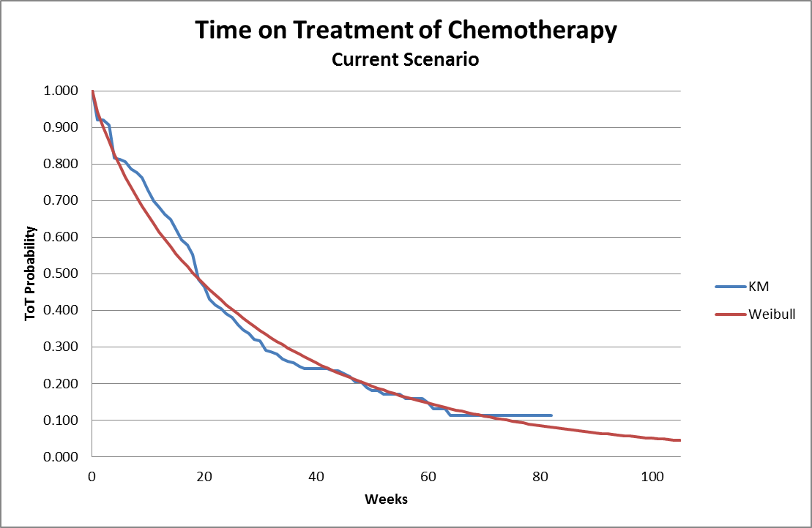
Figure S2 – KM Data and Extrapolated ToT Based On Gompertz Distribution for Chemotherapy Trial Arm (base case distributional assumption)
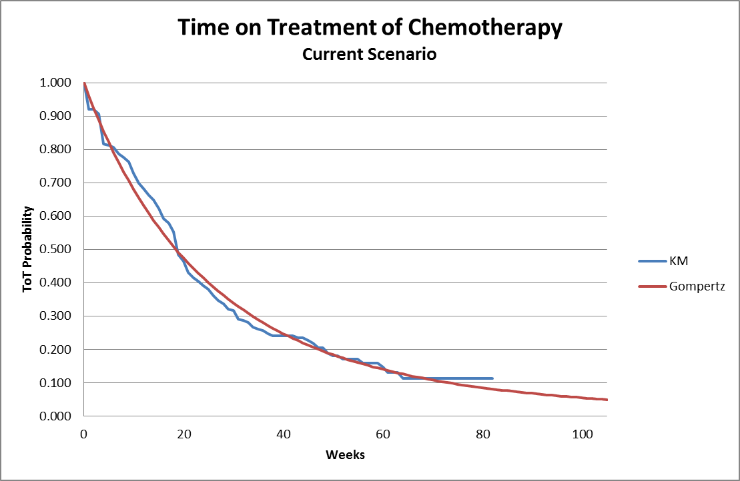
Figure S3 - Chow test plot of PFS (BICR) for pembrolizumab + chemotherapy
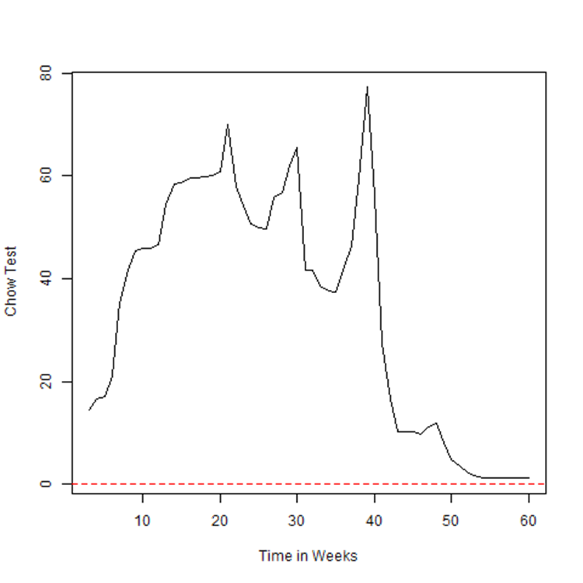

Figure S4 – Chow test plot of PFS (BICR) for chemotherapy
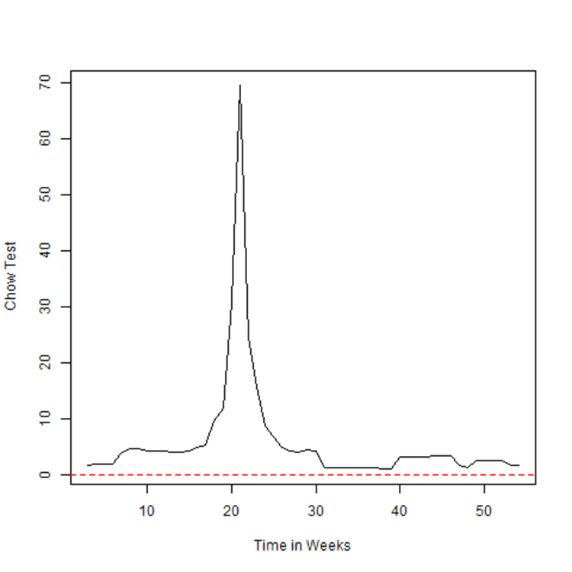
Figure S5 – Cumulative hazard plot for PFS (BICR)
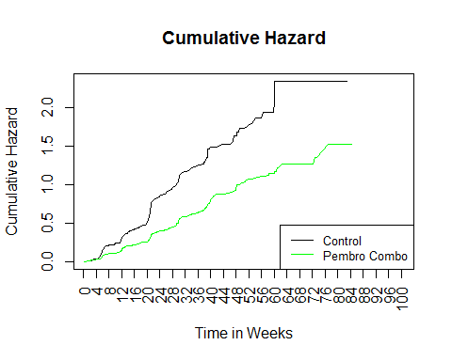
Figure S6 – Chow test plot of OS for pembrolizumab + chemotherapy
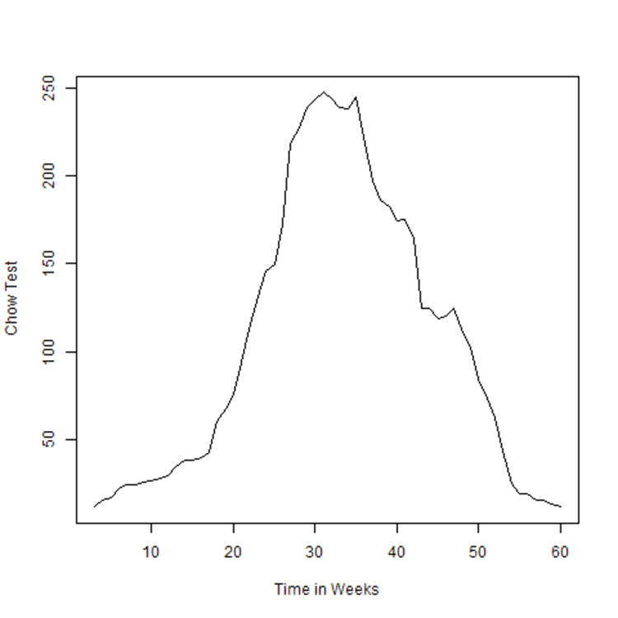

Figure S7 – Chow test plot of OS for chemotherapy
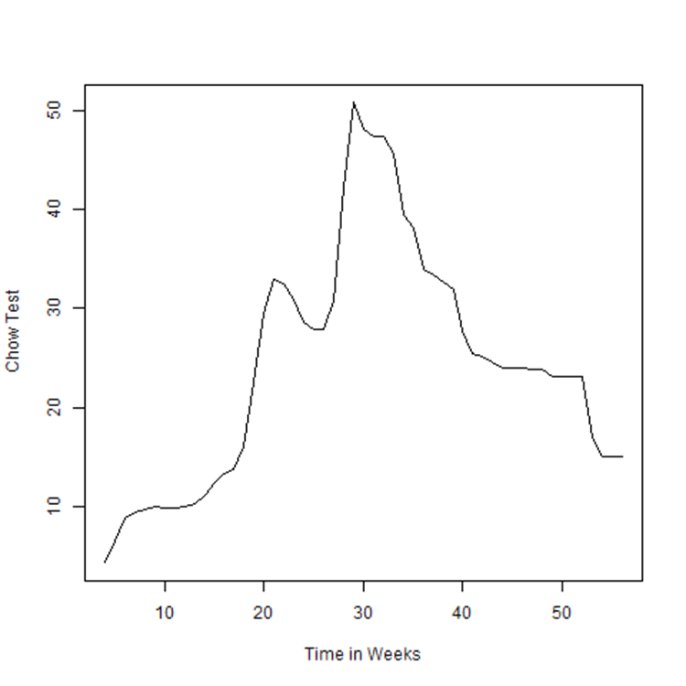

Reference List

1. www.analysource.com, February 2018.

2. Langer CJ, Gadgeel SM, Borghaei H et al. Carboplatin and pemetrexed with or without pembrolizumab for advanced, non-squamous non-small-cell lung cancer: a randomised, phase 2 cohort of the open-label KEYNOTE-021 study. Lancet Oncol 2016;17(11):1497-1508.

