Supplementary Material

Supplementary Table 1: Cohort 2 was killed on GD19 for extraction of placentae and fetuses from n=5 dams. Presented are the n of placentae and fetuses from each Dam and treatment group; Dom: Dominant; Sub: Submissive; PRS: prenatal restraint stress.

|  |  |  |  |  |  |  |
| --- | --- | --- | --- | --- | --- | --- |
|  | Total n | Dam1 | Dam2 | Dam3 | Dam4 | Dam5 |
| Dom Naive | 69 | 13 | 14 | 13 | 15 | 14 |
| Dom PRS | 59 | 9 | 14 | 9 | 12 | 15 |
| Sub Naïve | 58 | 13 | 12 | 13 | 9 | 11 |
| Sub PRS | 57 | 9 | 15 | 12 | 11 | 10 |

Supplementary Table 2: Cohort 3 gave birth, after which litters were culled to equal size (8 pups. Presented are each Dam’s original litter size (before culling to 8) and sex distribution of pups (after culling to 8); Dom: Dominant; Sub: Submissive; PRS: prenatal restraint stress.

|  |  |  |  |  |  |  |  |  |  |  |  |  |  |  |  |  |  |  |
| --- | --- | --- | --- | --- | --- | --- | --- | --- | --- | --- | --- | --- | --- | --- | --- | --- | --- | --- |
|  | Total n born | Male after culling | Female after culling | Dam1 | m | f | Dam2 | m | f | Dam3 | m | f | Dam4 | m | f | Dam5 | m | f |
| Dom Naive | 62 | 20 | 20 | 12 | 3 | 5 | 10 | 5 | 3 | 16 | 4 | 4 | 11 | 4 | 4 | 13 | 4 | 4 |
| Dom PRS | 59 | 21 | 19 | 11 | 5 | 3 | 13 | 3 | 5 | 9 | 5 | 3 | 14 | 4 | 4 | 12 | 4 | 4 |
| Sub Naïve | 44 | 20 | 20 | 12 | 4 | 4 | 9 | 4 | 4 | 12 | 4 | 4 | 11 | 4 | 4 | 10 | 4 | 4 |
| Sub PRS | 41 | 21 | 19 | 8 | 5 | 3 | 11 | 4 | 4 | 13 | 4 | 4 | 9 | 4 | 4 | 12 | 4 | 4 |



Supplementary Figure 1: Beta actin immunoblot analysis of placental protein from Naïve and PRS Dom and Sub mice. Comparison between naïve mice of each strain (A), and between Naive and PRS Sub (B) or Dom (C) mice revealed no significant differences in beta actin signal intensity (n=5 per group, in technical duplicate). Dom: Dominant; Sub: Submissive; PRS: prenatal restraint stress..

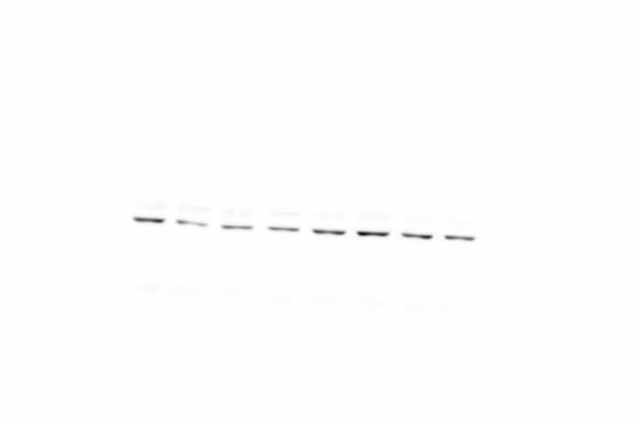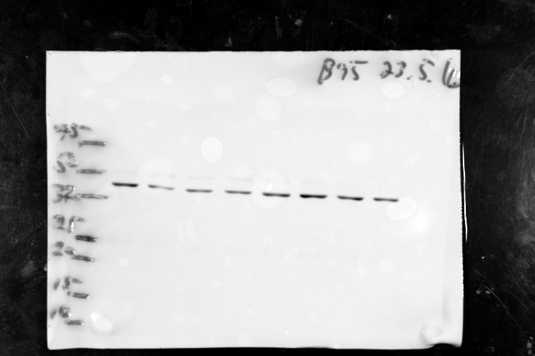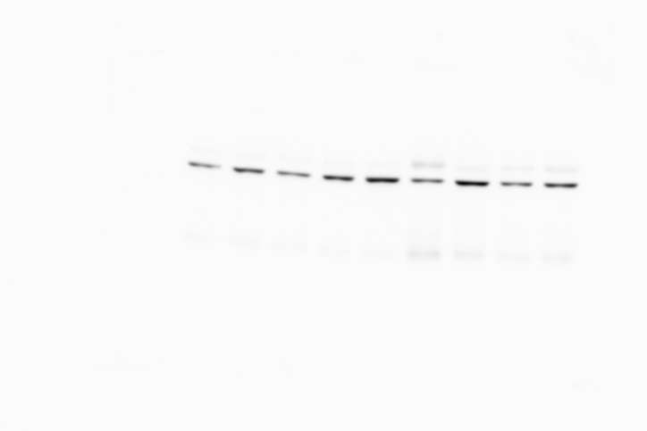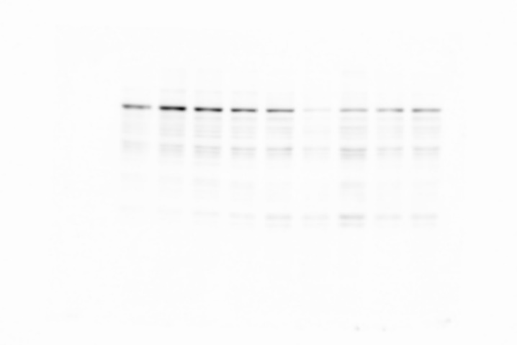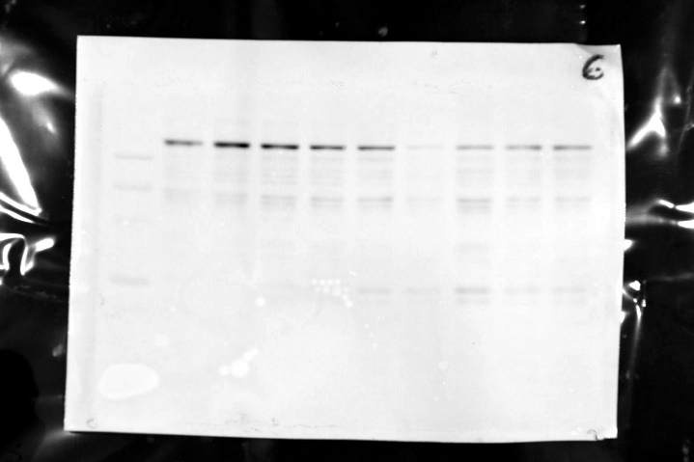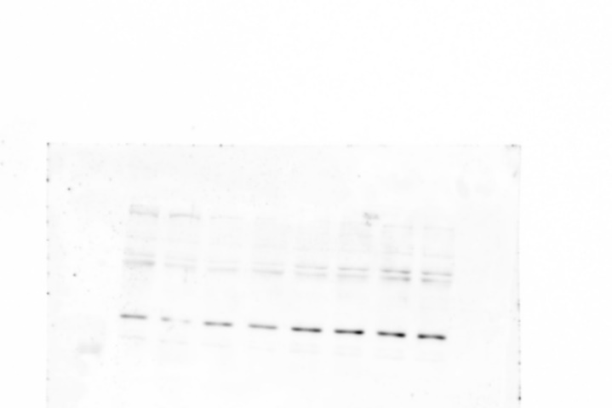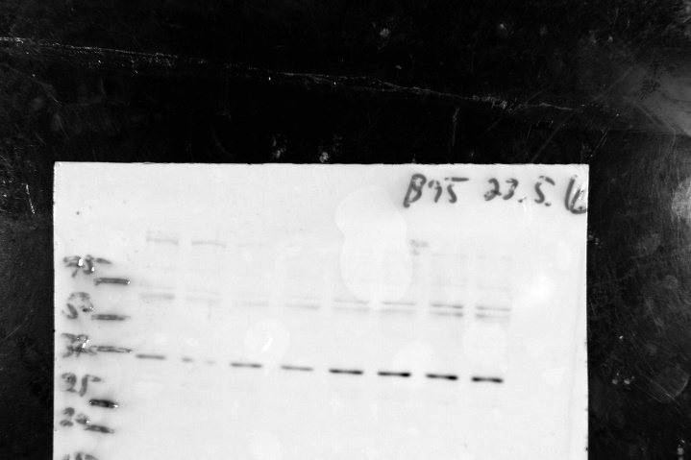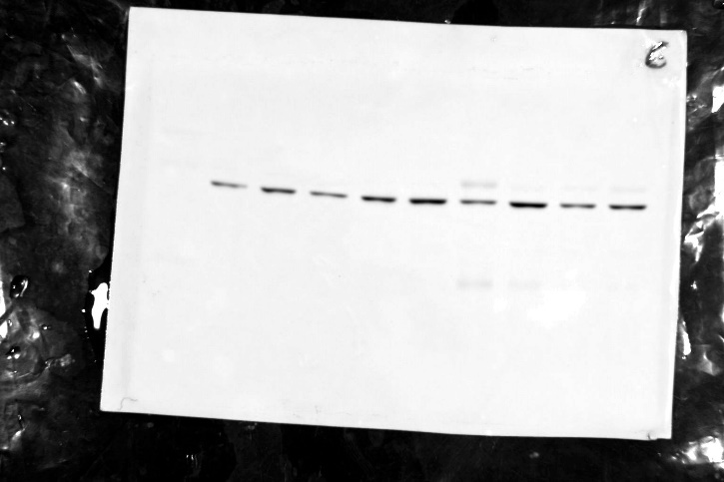

**A**

**B**

**C**

**D**

**E**

**F**

**G**

**H**

Supplementary Figure 2. Representative immunoblot images. A. Epifluorescence-.only; B. blended epifluorescenece-visual light images of membrane after incubation with anti-GR antibody. The prominent band at 94 kD corresponding to the alpha GR isoform appeared within the same dynamic range as βActin appearing at 42 kD (C,D), enabling the normalization of densitometric data to the loading control. The 11βHSD2 signal appeared at ~36 kD (E,F), with a suspected dimer visible at ~72 kD. Different animal sources of anti-11βHSD2 (rabbit) and βActin (G,H; mouse) enabled separability of the two signals. Each lane represents two placentae.



Supplementary Figure 3: Pup weights by sex. Weight reduction due to prenatal restraint stress (PRS) was evident among both strains on PND4, at which time the influence of sex was evident among Dom, but not Sub pups (A). On PND14, significant effects of PRS were evident among Sub mice (B). Sexual dimorphism became evident in pup weights of both Dom and Sub on PND24, alongside sustained influence of PRS among Sub mice. Data are presented as mean ±SEM, with independent variables contributing to statistical significance by two-way ANOVA indicated as: sex effect &&&(*p*<0.0001), &( *p*<0.05); strain effect ####(*p*<0.0001); PRS effect ++++(*p*<0.0001), +++(*p*<0.001), ++ (*p*<0.01), +(*p*<0.05); interaction between strain and PRS ^(*p*<0.05), ^^(*p*<0.01). Bonferroni post-hoc pairwise comparisons within each strain or treatment indicated as *(*p*<0.05), **(*p*<0.01), ***(*p*<0.001), ****(*p*<0.0001); n=20 male, 20 female (Naïve); n=21 male, 19 female (PRS).