Supplementary Material
Effects of β-cyclodextrin-based Schiff-base Zn(II) complexes: Synthesis, physicochemical characterization and their role in alleviating oxidative stress related disorder

ANANYA DAS, SOMIT DUTTA and BISWAJIT SINHA*

Figure S1. FTIR spectra of mono-6-deoxy-6-(p-tosylsulfonyl)-β-cyclodextrin (β-CDOTs) (1) and Mono-6-deoxy-6-(toluene-3,4-diamino)-β-cyclodextrin (2).

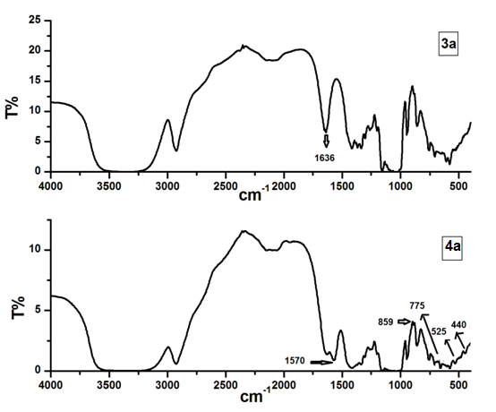
Figure S2. FTIR spectra of mono-6-deoxy-6-(4-(5-chloro-2-hydroxybenzylideneamino)-3,4-diaminotolune)-β-cyclodextrin (3a) and Zn complex of mono-6-deoxy-6-(4-(5-chloro-2-hydroxybenzylideneamino)-3,4-diaminotolune)-β-cyclodextrin (4a).

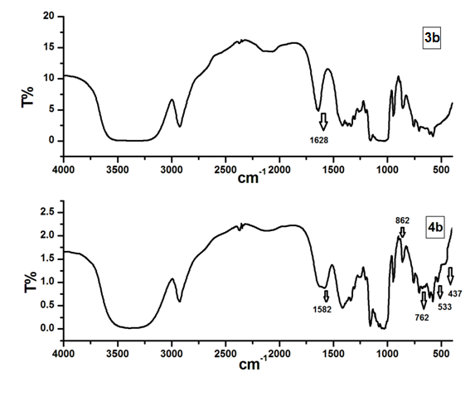
Figure S3. FTIR spectra of mono-6-deoxy-6-(4-(5-nitro-2-hydroxybenzylideneamino)-3,4-diaminotolune)-β-cyclodextrin (3b) and Zn complex of mono-6-deoxy-6-(4-(5-nitro-2-hydroxybenzylideneamino)-3,4-diaminotolune)-β-cyclodextrin (4b).

Figure S4. ¹H-NMR of mono-6-deoxy-6-(p-tosylsulfonyl)-β-cyclodextrin (β-CDOTs) (1).
Figure S5. ¹H-NMR of mono-6-deoxy-6-(toluene-3,4-diamino)-β-cyclodextrin (2).

Figure S6. ¹H-NMR of mono-6-deoxy-6-(4-(5-chloro-2-hydroxybenzylideneamino)-3,4-diaminotolune)-β-cyclodextrin (3a).

Figure S7. ¹H-NMR of mono-6-deoxy-6-(4-(5-nitro-2-hydroxybenzylideneamino)-3,4-diaminotolune)-β-cyclodextrin (3b).

Figure S8. ¹H-NMR of Zn complex of mono-6-deoxy-6-(4-(5-chloro-2-hydroxybenzylideneamino)-3,4-diaminotolune)-β-cyclodextrin (4a).
Figure S9. ¹H-NMR of Zn complex of mono-6-deoxy-6-(4-(5-nitro-2-hydroxybenzylideneamino)-3,4-diaminotolune)-β-cyclodextrin (4b).

Figure S10. ¹³C-NMR of mono-6-deoxy-6-(p-tosylsulfonyl)-β-cyclodextrin (β-CDOTs) (1).

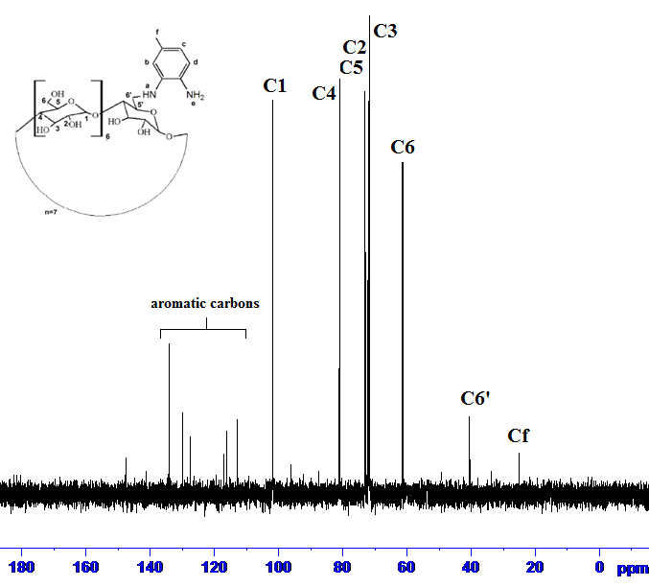
Figure S11. ¹³C-NMR of mono-6-deoxy-6-(toluene-3,4-diamino)-β-cyclodextrin (2).
Figure S12. ¹³C-NMR of mono-6-deoxy-6-(4-(5-chloro-2-hydroxybenzylideneamino)-3,4-diaminotolune)-β-cyclodextrin (3a).

Figure S13. ¹³C-NMR of mono-6-deoxy-6-(4-(5-nitro-2-hydroxybenzylideneamino)-3,4-diaminotolune)-β-cyclodextrin (3b).

Figure S14. ¹³C-NMR of Zn complex of mono-6-deoxy-6-(4-(5-chloro-2-hydroxybenzylideneamino)-3,4-diaminotolune)-β-cyclodextrin (4a).

Figure S15. ¹³C-NMR of Zn complex of mono-6-deoxy-6-(4-(5-nitro-2-hydroxybenzylideneamino)-3,4-diaminotolune)-β-cyclodextrin (4b).
Figure S16. Absorption spectra of mono-6-deoxy-6-(toluene-3,4-diamino)-β-cyclodextrin (2).

Figure S17. Absorption spectra of (a) mono-6-deoxy-6-(4-(5-chloro-2-hydroxybenzylideneamino)-3,4-diaminotolune)-β-cyclodextrin (3a) and (b) Zn complex of mono-6-deoxy-6-(4-(5-chloro-2-hydroxybenzylideneamino)-3,4-diaminotolune)-β-cyclodextrin (4a).

Figure S18. Absorption spectra of (a) synthesis of mono-6-deoxy-6-(4-(5-nitro-2-hydroxybenzylideneamino)-3,4-diaminotolune)-β-cyclodextrin (3b) and (b) Zn complex of Mono-6-deoxy-6-(4-(5-nitro-2-hydroxybenzylideneamino)-3,4-diaminotolune)-β-cyclodextrin (4b).

Figure S19. UV–Vis spectra of the ligand (3a) (1×10⁻⁵ mol·L⁻¹) in the presence of increasing concentrations of Zn(II) ions. Inset: absorbance plot for the ligand (3a) with Zn(II) ion against cM:cL.

Figure S20. UV–Vis spectra of the ligand (3b) (1×10⁻⁵ mol·L⁻¹) in the presence of increasing concentrations of Zn(II) ions. Inset: absorbance plot for the ligand (3b) with Zn(II) ion against cM:cL.

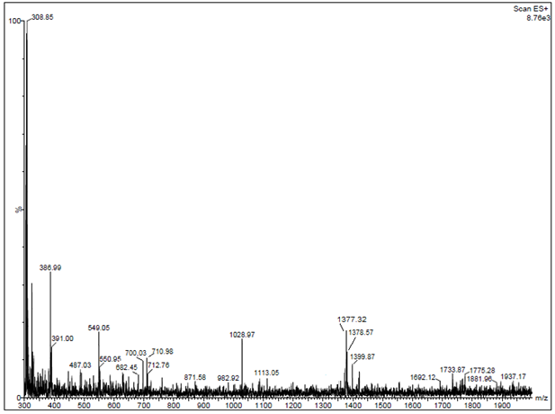
Figure S21. ESI-MS spectra of mono-6-deoxy-6-(4-(5-chloro-2-hydroxybenzylideneamino)-3,4-diaminotolune)-β-cyclodextrin (3a).

Figure S22. ESI-MS spectra of mono-6-deoxy-6-(4-(5-nitro-2-hydroxybenzylideneamino)-3,4-diaminotolune)-β-cyclodextrin (3b).

Figure S23. ESI-MS spectra of Zn complex of mono-6-deoxy-6-(4-(5-chloro-2-hydroxybenzylideneamino)-3,4-diaminotolune)-β-cyclodextrin (4a).

Figure S24. ESI-MS spectra of Zn complex of mono-6-deoxy-6-(4-(5-nitro-2-hydroxybenzylideneamino)-3,4-diaminotolune)-β-cyclodextrin (4b).

