Sustained release of sodium deoxycholate from PLGA-PEG-PLGA thermosensitive polymer used for localized fat dissolution
Parisa Nasrollahi¹, Khosro Khajeh ^{*1,2}, Elnaz Tamjid ¹, Mohammad Taleb ³, Masoud Soleimani ⁴, Guangjun Nie^{* 3}
^{[1]} Department of Nanobiotechnology, Faculty of Biological Sciences, Tarbiat Modares University, Tehran, Iran
^{[2]} Department of Biochemistry, Faculty of Biological Sciences, Tarbiat Modares University, Tehran, Iran
^{[3]} Department of Biomedical Effect of Nanomaterial and Nanosafety, National Center for Nanoscience and Technology, Beijing, China
^{[4]} Department of Hematology, Faculty of Medical Sciences, Tarbiat Modares University, Tehran, Iran
*Corresponding authors:
Prof. Khosro Khajeh, Tel: +982182884717, E-mail: khajeh@modares.ac.ir
Prof. Guangjun Nie, Tel: 86-10-82545529, E-mail: niegj@nanoctr.cn

A
B
C

Fig SI-1. (A) H-NMR spectra of the copolymer PLGA-PEG-PLGA in chloroform (CDCl₃) (A) CH of LA; (B) CH₃ of LA; (C) CH₂ of GA; (D and E) CH₂of ethylene glycol. (B) The Tg of copolymer was determined by DSC (Tg =-1 °).

Figure SI-2. Eﬀects of NaDC on loss modulus G″ and viscosity η of PLGA-PEG-PLGA (22% w/v) solution in PBS (pH 7.4) at diﬀerent temperatures. Drug loading concentration: 1% w/v, heating rates: 0.5 °C/min, oscillatory frequency: 10 rad/s.

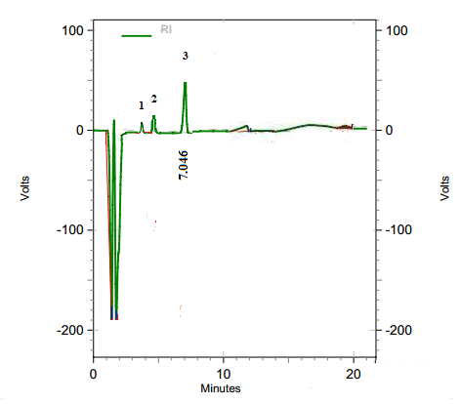  A | 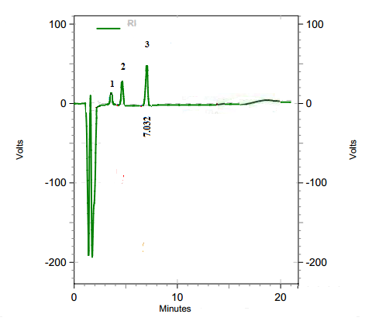  B

Figure SI-3. Chromatogram of RP-HPLC of release of NaDC from PLGA-PEG-PLGA copolymer in PBS (pH 7.4) at 37 °C after 2 h (A) and 24 h (B). (1) Glycolic acid; (2) Lactic acid; (3) NaDC. A mobile phase composed of acetonitrile: methanol: 20 mM sodium acetate (pH 4.3 with acetic acid) in the proportion of 60:05:35 at flow rate of 1 mL/min. NaDC was detected by RI detector.

A | 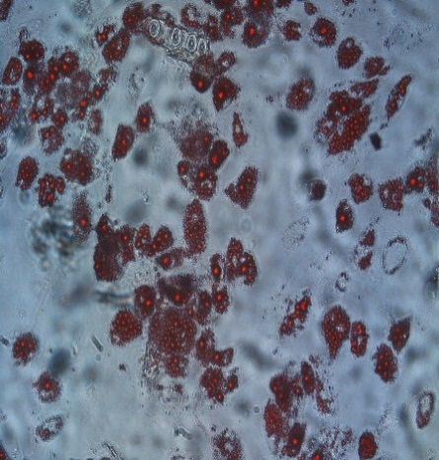 | B

Figure SI-4. Adipocyte primary culture and viability. (A) Images of Oil Red O-stained human adipocytes. (B) Viability of cultured human adipocytes after treatment with NaDC after 2h.

 | 1 | 2 | 3 | 4
A | Control NaDC 0.1% Copolymer Copolymer / NaDC
 | 1 | 2 | 3 | 4
B | Control NaDC 0.1% Copolymer Copolymer / NaDC
C |  |  | D

Figure SI-5. Microscopic images of human breast cancer cell line MDA-MB-231 (A) after 2 h and (B) 24 h of incubation. (1) Control; (2) NaDC 0.1% w/v; (3) Copolymer; (4) Copolymer / NaDC. Viability of cultured human breast cancer cell after treatment with copolymer / NaDC after (C) 2h and (D) 24h.

