Appendix A. Design of experiments: OFAT and CCD
The experimental design for the coagulation diagrams is shown in Table A.1. Graphical representation of the classical CCD experimental points is shown in Figure A.1.

Table A.1. Coagulation diagram experimental setup

Al₂O₃  (mg L⁻¹) | Initial pH
 | 5.5 | 6.0 | 6.3 | 6.6 | 7.0 | 7.5 | 8.0
2.60 | J01 | J13 | J25 | J37 | J49 | J61 | J73
3.25 | J02 | J14 | J26 | J38 | J50 | J62 | J74
3.90 | J03 | J15 | J27 | J39 | J51 | J63 | J75
4.55 | J04 | J16 | J28 | J40 | J52 | J64 | J76
5.20 | J05 | J17 | J29 | J41 | J53 | J65 | J77
5.85 | J06 | J18 | J30 | J42 | J54 | J66 | J78
6.50 | J07 | J19 | J31 | J43 | J55 | J67 | J79
7.15 | J08 | J20 | J32 | J44 | J56 | J68 | J80
7.80 | J09 | J21 | J33 | J45 | J57 | J69 | J81
8.45 | J10 | J22 | J34 | J46 | J58 | J70 | J82
9.10 | J11 | J23 | J35 | J47 | J59 | J71 | J83
10.4 | J12 | J24 | J36 | J48 | J60 | J72 | J84

Figure A.1. Classical CCD for two variables, X₁ and X₂, distributed into three spatial components: four square vertices (red rings), which describe the variable interactions; four axial points (blue rings), which define the response surface curvature as quadratic coefficients; and four replicates of the central point (green ring), which provide a pure error estimative.
Appendix B. CCD_A
The matrices used to obtain the six preliminary coefficients through CCD_A are shown in Tables from B.1 to B.6.

Table B.1: Matrix X_{12x6}
 | x₀ | x₁ | x₂ | x₁² | x₂² | x₁x₂
 | 1 | -1 | -1 | 1 | 1 | 1
 | 1 | 1 | -1 | 1 | 1 | -1
 | 1 | -1 | 1 | 1 | 1 | -1
 | 1 | 1 | 1 | 1 | 1 | 1
 | 1 | -1.414 | 0 | 2 | 0 | 0
X_{12x6}= | 1 | 1.414 | 0 | 2 | 0 | 0
 | 1 | 0 | -1.414 | 0 | 2 | 0
 | 1 | 0 | 1.414 | 0 | 2 | 0
 | 1 | 0 | 0 | 0 | 0 | 0
 | 1 | 0 | 0 | 0 | 0 | 0
 | 1 | 0 | 0 | 0 | 0 | 0
 | 1 | 0 | 0 | 0 | 0 | 0

Table B.2: The transpose of matrix X, or X^{T}_{6x12}
1 | 1 | 1 | 1 | 1 | 1 | 1 | 1 | 1 | 1 | 1 | 1
-1 | 1 | -1 | 1 | -1.414 | 1.414 | 0 | 0 | 0 | 0 | 0 | 0
-1 | -1 | 1 | 1 | 0 | 0 | -1.414 | 1.414 | 0 | 0 | 0 | 0
1 | 1 | 1 | 1 | 2 | 2 | 0 | 0 | 0 | 0 | 0 | 0
1 | 1 | 1 | 1 | 0 | 0 | 2 | 2 | 0 | 0 | 0 | 0
1 | -1 | -1 | 1 | 0 | 0 | 0 | 0 | 0 | 0 | 0 | 0

Table B.3: Matrix X^{T}X_{6x6}
12 | 0 | 0 | 8 | 8 | 0
0 | 8 | 0 | 0 | 0 | 0
0 | 0 | 8 | 0 | 0 | 0
8 | 0 | 0 | 12 | 4 | 0
8 | 0 | 0 | 4 | 12 | 0
0 | 0 | 0 | 0 | 0 | 4

Table B.4: The inverse of X^{T}X_{6x6}, or (X^{T}X)⁻¹_{6x6}
0.250 | 0 | 0 | -0.13 | -0.125 | 0
0 | 0.125 | 0 | 0 | 0 | 0
0 | 0 | 0.125 | 0 | 0 | 0
-0.125 | 0 | 0 | 0.156 | 0.031 | 0
-0.125 | 0 | 0 | 0.031 | 0.156 | 0
0 | 0 | 0 | 0 | 0 | 0.250

Table B.5: Matrix X^{T}y_{6x1}
51.9
-4.6
-6.4
29.5
60.3
-10.9

Table B.6: Matrix b_{6x1}. containing the second order model coefficients
1.75
-0.571
-0.799
0.0063
3.86
-2.73

Aiming to verify whether all coefficients are relevant and necessary, the variances may be estimate by using MS_{Residual} when the model does not present lack-of-fit, or using MS_{Lack-of-fit} when the model present lack-of-fit. Actually, both MS may be tested in order to achieve the best agreement with the real data. Each individual variance is obtained multiplying the main diagonal of the matrix (X^{T}X)⁻¹ (Figure B.4) by each MS, and the errors (standard deviation) are easily deduced. At the present case, MS_{Residual} provides the more appropriate ANOVA (Table B.2) even with an initial lack-of-fit. A Student's t test for the 6 coefficients implies a critical t value of 2.571 (DF = 5, p = 0.05) and the confidence interval (CI) for each coefficient is the product between the errors and the t value; if the coefficient ± CI value encompasses the zero, there is no significance and the coefficient must be removed from the model (Figure B.1).

Table B.7. Initial significance evaluation for the CCD_Aª coefficients
Coefficient |  | SD^{b} (X^{T}X)⁻¹ | Variance | Error | DF^{c} (t) | CI^{d} | Significant
b₀ | 1.75 | 0.250 | 0.34463 | 0.58705 | 5 | 1.509 | YES
b₁ | -0.571 | 0.125 | 0.17234 | 0.41514 |  | 1.067 | NO
b₂ | -0.799 | 0.125 | 0.17234 | 0.41514 |  | 1.067 | NO
b₁₁ | 0.0063 | 0.156 | 0.21540 | 0.46411 |  | 1.193 | NO
b₂₂ | 3.86 | 0.156 | 0.21540 | 0.46411 | t_{critical} | 1.193 | YES
b₁₂ | -2.73 | 0.250 | 0.34463 | 0.58705 | 2.571 | 1.509 | YES
CCD_A: central composite design A; ^{b}SD: standard deviation; ^{c}DF: degree of freedom; ^{d}CI: confidence interval

Figure B.1. CCD_A coefficients and their respective confidence intervals.

Thus, the optimized matrix X (12x3) was constructed only with the significant coefficients (b₀, b₂₂, and b₁₂), as well as the derived matrices X^{T}X_{3x3}, (X^{T}X)⁻¹_{3x3}, X^{T}y_{3x1} e b_{3x1} with help of the Bluebit online matrix calculator.

Table B.8. Optimized matrix X (12x3)
 | b₀ | b₂₂ | b₁₂
 | 1 | 1 | 1
 | 1 | 1 | -1
 | 1 | 1 | -1
 | 1 | 1 | 1
 | 1 | 0 | 0
X_{12x3} = | 1 | 0 | 0
 | 1 | 2 | 0
 | 1 | 2 | 0
 | 1 | 0 | 0
 | 1 | 0 | 0
 | 1 | 0 | 0
 | 1 | 0 | 0

Table B.9. Optimized matrices X^{T}X (3x3). X^{T}y (3x1) e b (3x1)
 | 12 | 8 | 0 |  | 0.15 | -0.1 | 0 |  | 51.9 |  | 1.76
X^{T}X_{3x3}: | 8 | 12 | 0 | (X^{T}X)⁻¹_{3x3}: | -0.1 | 0.15 | 0 | X^{T}y_{3x1}: | 60.3 | b_{3x1}: | 3.86
 | 0 | 0 | 4 |  | 0 | 0 | 0.25 |  | -10.9 |  | -2.73

Regarding the amount of information that can be explained, analysis based on the sum of squares (SS) provides the R² parameters. R² is the percentage of the total SS that is related to the regression model SS. For instance, CCD_A present R² = 0,9429. If there were no data to estimate the pure error SS (replicates of CCD central point), the maximum explained percentage would be R_{max} = 0.9994. After the optimization, CCD_A presented R² = 0.8896 and R²_{max} = 0.8934. In spite of the lower R values after the optimization, it is possible to say the model is still consistent based on the analysis of F factors.
Therefore, it is possible simulated the residual turbidity through optimized CCD_A.

Table B.10. Residual turbidity values predicted by optimized CCD_A .
 |  | pH (encoded)
 |  | -1.414 | -1.010 | -0.606 | -0.202 | 0.202 | 0.606 | 1.010 | 1.414
Coagulant (values) | 0.0 | 4.0 | 5.6 | 7.1 | 8.7 | 10.3 | 11.8 | 13.4 | 14.9 | -1.414 | Coagulant (encoded)
 | 0.7 | 1.8 | 2.9 | 4.0 | 5.1 | 6.3 | 7.4 | 8.5 | 9.6 | -1.010
 | 1.3 | 0.8 | 1.5 | 2.2 | 2.8 | 3.5 | 4.2 | 4.8 | 5.5 | -0.606
 | 2.0 | 1.1 | 1.4 | 1.6 | 1.8 | 2.0 | 2.3 | 2.5 | 2.7 | -0.202
 | 2.7 | 2.7 | 2.5 | 2.3 | 2.0 | 1.8 | 1.6 | 1.4 | 1.1 | 0.202
 | 3.4 | 5.5 | 4.8 | 4.2 | 3.5 | 2.8 | 2.2 | 1.5 | 0.8 | 0.606
 | 4.0 | 9.6 | 8.5 | 7.4 | 6.3 | 5.1 | 4.0 | 2.9 | 1.8 | 1.010
 | 4.7 | 14.9 | 13.4 | 11.8 | 10.3 | 8.7 | 7.1 | 5.6 | 4.0 | 1.414
 |  | 7.8 | 8.0 | 8.2 | 8.4 | 8.6 | 8.8 | 9.0 | 9.2
 |  | pH (values)

Appendix C. CCD_B
The surface response and simulation with a dataset is presented.
The preliminary algebraic model obtained is presented in Equation (C.1), and the optimized model (with the significant coefficients only) can be shown in Equation (C.2).

$$\hat{y}=1.58-1.66 x_{1}+0.709 x_{2}+1.77 x_{1}^{2}+2.92 x_{2}^{2}+0.125 x_{1}x_{2}$$ | (C.1)
$$\hat{y}=2.92 x_{2}^{2}$$ | (C.2)
(± 2.071)
The surfaces obtained when Equation C.1 is used can be seen in figures C.1. and C.2. Figures C.3 and C.4 are simulations based on Equation C.2.
Figure C.1. Three-dimensional response (surface) for the CCD_B (all coefficients)

Figure C.2. Two-dimensional response (contour surface) for the CCD_B (all coefficients)
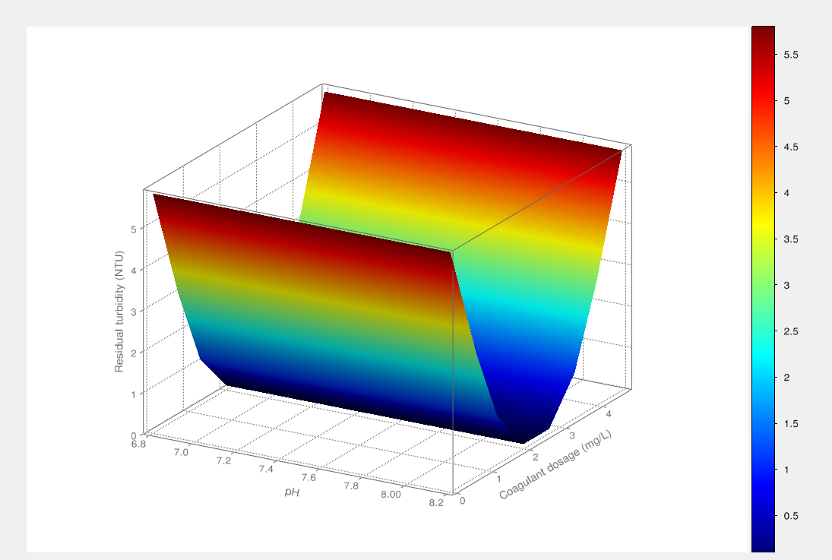
Figure C.3. Simulation of three-dimensional response (surface) for the CCD_B, using equation C.2

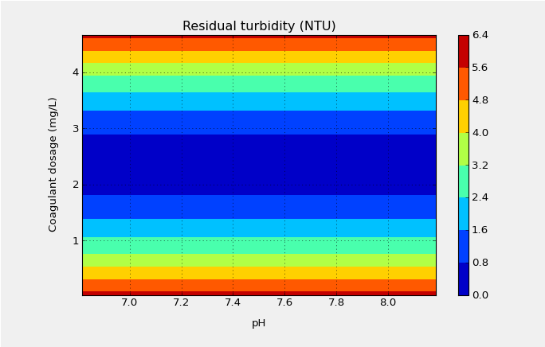
Figure C.4. Simulation of contour plot for the CCD_B, using equation C.2

Appendix D. CCD_C
The 2D response surface for CCD_C is shown.
Figure D.1. Two-dimensional response (contour surface) for the CCD_C

Appendix E. Response surface for CCD_D.
Figure E.1. Three-dimensional response (surface) for the CCD_D (only for significant coefficients)

Figure E.2. Two-dimensional response (contour surface) for the CCD_D (only for significant coefficients).

