Supporting Information

Four Ln-coordination polymers: Synthesis, crystal structure, fluorescent sensing of nitrobenzene and Tb³⁺, and catalytic properties

YU-YUAN TANG, SHUANG CHENª, CUI-JUAN WANG*, ZI-XIN ZHU and DONG-NING LIU

a: co-first author

Figure S1. The coordination environment of Eu1 (a) and Eu2 (b) in 1.

Figure S2. The 2D structure of 1.

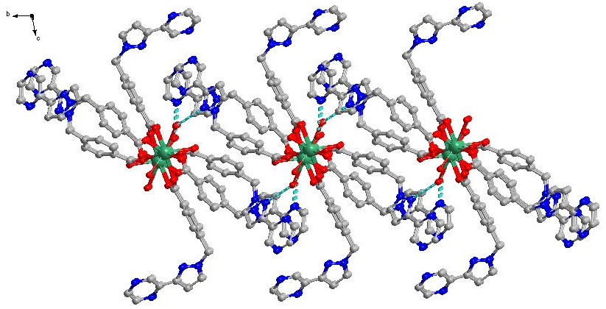
Figure S3. The 2D structure of 2.

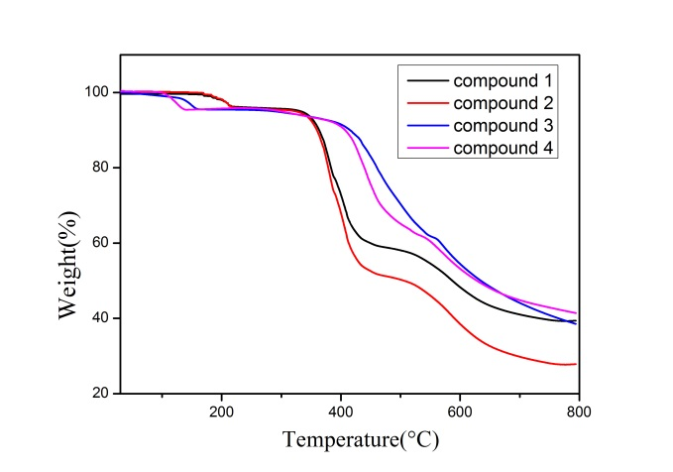
Figure S4. Thermal gravimetric analysis of 1-4.
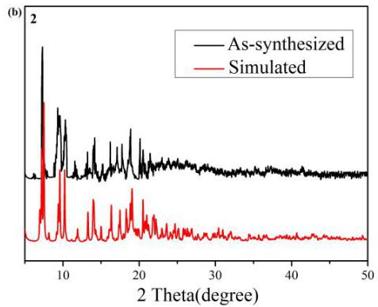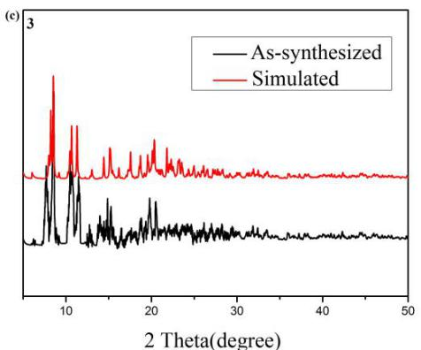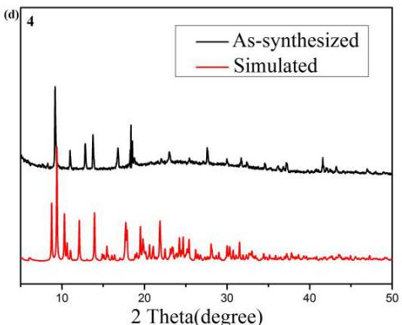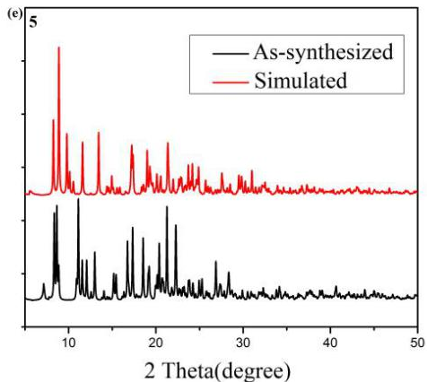
Figure S5. The comparison of PXRD pattern of the obtained sample and simulate pattern from single crystal data of 1-4.

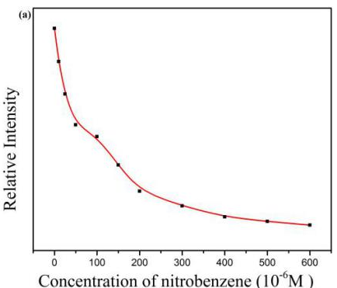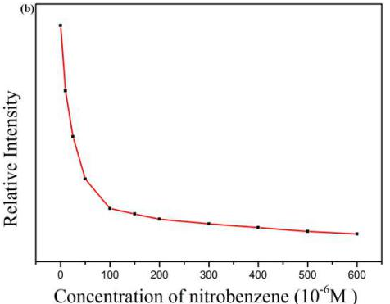
Figure S6. The relative fluorescence intensity at 618 nm of 1 (a) and at 546 nm of 2 (b) treated with various concentrations of nitrobenzene.

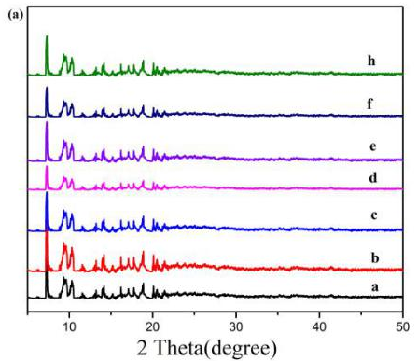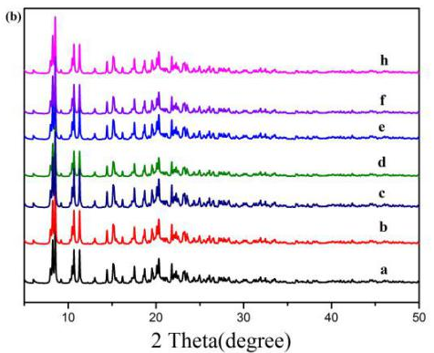
Figure S7. Powder X-ray diffraction patterns of 1 (a) and 2 (b) after being immersed in different organic solvents (a: H₂O, b: MeOH, c: EtOH, d: DMF, e: DMA, f: ACN: h: NA).

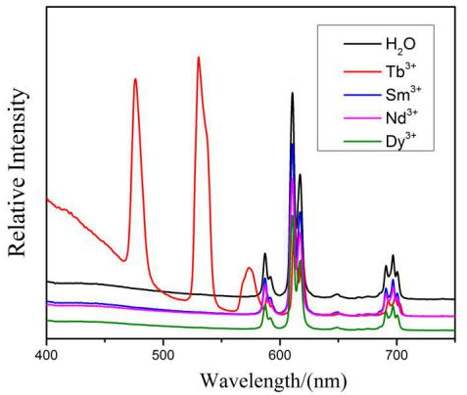
Figure S8. The fluorescence intensities of 1 with various Ln³⁺ ions.

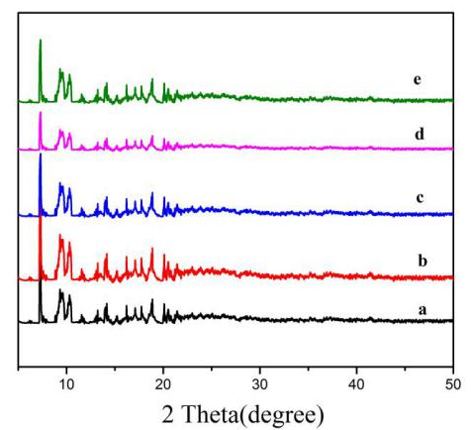
Figure S9. Powder X-ray diffraction patterns of 1 (a) after being immersed in different Ln³⁺ ions (a: H₂O, b: Sm³⁺, c: Tb³⁺, d: Nd³⁺, e: Dy³⁺).

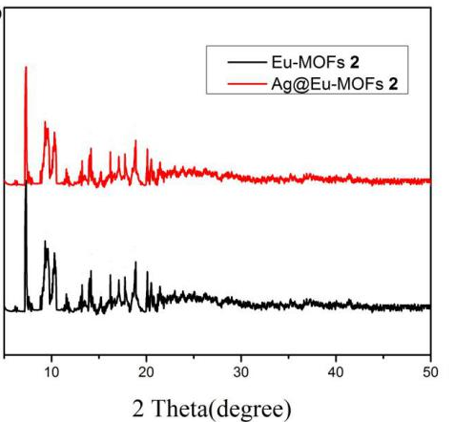
Figure S10. Powder X-ray diffraction patterns of Ag@ compound 1 and compound 1.

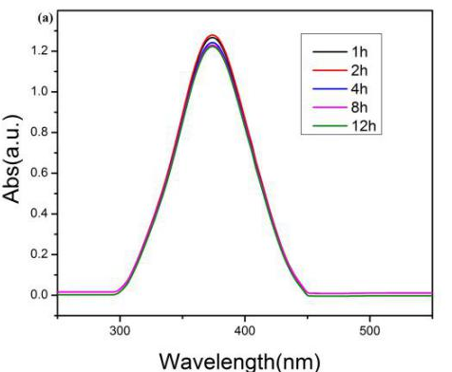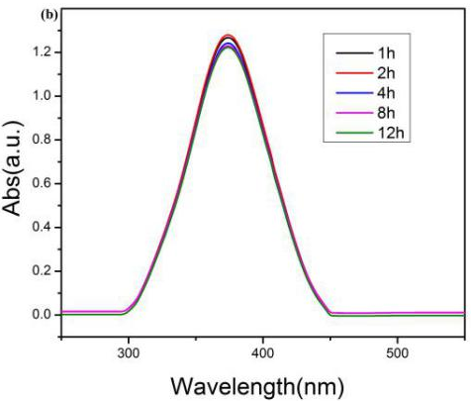
Figure S11. Catalytic performance of no catalysts (a) and 1 (b).

Table S1. Selected bond lengths (Å) and angles (deg) of 1-4.
Compound 1
Eu1-O1 | 2.309(7) | Eu1-O6 | 2.323(6) | Eu1-O8 | 2.3337(6)
Eu1-O3 | 2.3726) | Eu1-O16 | 2.397(6) | Eu1-O15 | 2.430(6)
Eu1-O13 | 2.430(6) | Eu1-O14 | 2.472(6) | Eu2-O5 | 2.276(6)
Eu2-O7 | 2.287(6) | Eu2-O4^{i} | 2.289(6) | Eu2-O2^{i} | 2.322(6)
Eu2-O10 | 2.425(6) | Eu1-O11 | 2.442(7) | Eu1-O12 | 2.492(7)
Eu2-O9 | 2.530(7)
O8-Eu1-O14 | 73.2(2) | O2i-Eu2-O10 | 126.5(2) | O5-Eu2-O12 | 78.3(2)
O3-Eu1-O14 | 145.3(2) | O5-Eu2-O11 | 129.6(2) | O7-Eu2-O12 | 72.8(2)
O16-Eu1-O14 | 74.1(2) | O8-Eu1-O14 | 73.2(2) | O4i-Eu2-O12 | 123.5(2)
O15-Eu1-O14 | 117.6(2) | O3-Eu1-O14 | 145.3(2) | O2i-Eu2-O12 | 83.8(2)
O13-Eu1-O14 | 141.2(2) | O16-Eu1-O14 | 74.1(2) | O10-Eu2-O12 | 138.2(2)
O5-Eu2-O7 | 94.1(2) | O15-Eu1-O14 | 117.6(2) | O11-Eu2-O12 | 52.5(2)
O5-Eu2-O4i | 158.2(2) | O13-Eu1-O14 | 141.2(2) | O5-Eu2-O9 | 87.0(2)
O7-Eu2-O4i | 91.4(2) | O1-Eu1-C16 | 94.1(2) | O7-Eu2-O9 | 126.0(2)
O5-Eu2-O2i | 82.4(2) | O6-Eu1-C16 | 138.7(2) | O4i-Eu2-O9 | 72.7(2)
O7-Eu2-O2i | 156.5(3) | O8-Eu1-C16 | 94.3(2 | O2i-Eu2-O9 | 77.3(2)
O4i-Eu2-O2i | 100.5(2) | O7-Eu2-O11 | 82.1(2) | O10-Eu2-O9 | 52.4(2)
O5-Eu2-O10 | 78.4(2) | O4i-Eu2-O11 | 72.1(2) | O11-Eu2-O9 | 134.9(2)
O7-Eu2-O10 | 74.9(2) | O2i-Eu2-O11 | 82.4(2) | O12-Eu2-O9 | 157.4(2)
O4i-Eu2-O10 | 82.7(2) | O10-Eu2-O11 | 145.3(2)
Compound 2
Sm1-O6 | 2.365(5) | Sm1-O3 | 2.421(5) | Sm1-O8 | 2.476(5)
Sm1-O2 | 2.412(4) | Sm1-O1ii | 2.441(5) | Sm1-O7 | 2.502(5)
Sm1-O4i | 2.416(5) | Sm1-O5i | 2.445(5)
O6-Sm1-O2 | 148.02(18) | O6-Sm1-O5i | 121.67(17) | O1ii-Sm1-O8 | 69.91(17)
O6-Sm1-O4i | 71.13(17) | O2-Sm1-O5i | 78.07(16) | O5i-Sm1-O8 | 134.99(17)
O2-Sm1-O4i | 138.04(16) | O4i-Sm1-O5i | 90.59(18) | O6-Sm1-O7 | 136.56(16)
O6-Sm1-O3 | 76.98(17) | O3-Sm1-O5i | 74.39(17) | O2-Sm1-O7 | 70.56(16)
O2-Sm1-O3 | 86.08(15) | O1ii-Sm1-O5i | 140.41(17) | O4i-Sm1-O7 | 67.52(16)
O4i-Sm1-O3 | 129.86(16) | O6-Sm1-O8 | 75.31(17) | O3-Sm1-O7 | 142.16(17)
O6-Sm1-O1ii | 91.37(17) | O2-Sm1-O8 | 73.40(17) | O1ii-Sm1-O7 | 68.81(17)
O2-Sm1-O1ii | 84.10(15) | O4i-Sm1-O8 | 133.45(18) | O5i-Sm1-O7 | 71.97(17)
O4i-Sm1-O1ii | 79.50(16) | O3-Sm1-O8 | 69.65(17) | O8-Sm1-O7 | 126.92(17)
O3-Sm1-O1ii | 139.53(16)
Compound 3
Nd1-O3 | 2.411(4) | Nd1-O5 | 2.454(4) | Nd1-O8 | 2.513(5)
Nd1-O6i | 2.436(4) | Nd1-O2ii | 2.469(4) | Nd1-O7 | 2.534(5)
Nd1-O1 | 2.439(4) | Nd1-O4i | 2.481(4) | Nd1-O3i | 2.967(5)
O6i-Nd1-O1 | 138.48(15) | O2ii-Nd1-O4i | 139.48(15) | O2ii-Nd1-O7 | 68.75(16)
O3-Nd1-O5 | 76.23(15) | O3-Nd1-O8 | 75.94(16) | O4i-Nd1-O7 | 71.35(15)
O6i-Nd1-O5 | 130.35(14) | O6i-Nd1-O8 | 132.52(16) | O8-Nd1-O7 | 126.47(15)
O1-Nd1-O5 | 85.86(14) | O1-Nd1-O8 | 72.96(15) | O3-Nd1-O3i | 75.84(15)
O3-Nd1-O2ii | 92.51(15) | O5-Nd1-O8 | 69.77(15) | O6i-Nd1-O3i | 72.33(14)
O6i-Nd1-O2ii | 79.32(15) | O2ii-Nd1-O8 | 69.13(15) | O1-Nd1-O3i | 119.81(13)
O1-Nd1-O2ii | 83.66(14) | O4i-Nd1-O8 | 134.79(15) | O5-Nd1-O3i | 64.16(14)
O5-Nd1-O2ii | 138.88(16) | O3-Nd1-O7 | 136.74(15) | O2ii-Nd1-O3i | 151.52(13)
O3-Nd1-O4i | 122.11(15) | O6i-Nd1-O7 | 67.58(15) | O4i-Nd1-O3i | 46.43(13)
O6i-Nd1-O4i | 92.03(16) | O1-Nd1-O7 | 70.98(15) | O8-Nd1-O3i | 130.22(13)
O1-Nd1-O4i | 77.03(14) | O5-Nd1-O7 | 142.60(16) | O7-Nd1-O3i | 101.98(14)
O5-Nd1-O4i | 75.13(15)
Compound 4
Nd1-O4 | 2.353(9) | Nd1-O5 | 2.425(9) | Nd1-O2 | 2.522(9)
Nd1-O6i | 2.364(10) | Nd1-O7 | 2.501(9) | Nd1-O1 | 2.511(10)
Nd1-O3ii | 2.415(9) | Nd1-O8 | 2.509(10)
O4-Nd1-O6i | 153.1(3) | O4-Nd1-O8 | 135.6(3) | O7-Nd1-O2 | 150.5(3)
O4-Nd1-O3ii | 103.0(3) | O6i-Nd1-O8 | 70.6(3) | O8-Nd1-O2 | 128.3(3)
O6i-Nd1-O3ii | 81.8(3) | O3ii-Nd1-O8 | 85.4(3) | O4-Nd1-O1 | 73.2(3)
O4-Nd1-O5 | 82.6(3) | O5-Nd1-O8 | 77.9(3) | O6i-Nd1-O1 | 82.5(3)
O6i-Nd1-O5 | 101.7(3) | O7-Nd1-O8 | 69.1(3) | O3ii-Nd1-O1 | 76.5(3)
O3ii-Nd1-O5 | 160.6(3) | O4-Nd1-O2 | 82.9(3) | O5-Nd1-O1 | 122.8(3)
O4-Nd1-O7 | 70.8(3) | O6i-Nd1-O2 | 72.9(3) | O7-Nd1-O1 | 128.0(3)
O6i-Nd1-O7 | 135.3(3) | O3ii-Nd1-O2 | 123.8(4) | O8-Nd1-O1 | 149.5(3)
O3ii-Nd1-O7 | 76.5(3) | O5-Nd1-O2 | 75.0(3) | O2-Nd1-O1 | 51.5(3)
O5-Nd1-O7 | 88.2(3)
Symmetry codes: (i) 1+x, y, z; (ii) -1+x, y, z

