Supplementary Material

Outliers
Ten precipitation events were classified as outliers, and their data are presented in Table SM1.
Five events occurred on Tuesdays and 3 events on Fridays. Hence, it seems possible that an external event could have influenced the local rainwater composition during these events. No additional information was available, but some of these outliers could be related to some periodic event in Barcarena harbor.
Table SM-1: Outliers data.
Date | Cations  (µeq L⁻¹) | Anions  (µeq L⁻¹) | Volume  (mL) | Precipitation  (mm) | Weekday
Jan 24, 2012 | 233 | 132 | 45 | 255 | Tuesday
Jan 27, 2012 | 213 | 447 | 340 | 1,925 | Friday
Feb 03rd 2012 | 894 | 243 | 480 | 2,718 | Friday
May 29, 2012 | 40 | 139 | 142 | 807 | Tuesday
Apr 4, 2012 | 96 | 183 | 410 | 2,321 | Wednesday
Apr 20, 2012 | 114 | 203 | 305 | 1,727 | Friday
Jun 13, 2012 | 185 | 102 | 140 | 793 | Saturday
Jun 26, 2012 | 241 | 64 | 400 | 2,265 | Tuesday
Jul 03, 2012 | 232 | 128 | 295 | 1,670 | Tuesday
Jan 08, 2013 | 110 | 187 | 190 | 1,076 | Tuesday

Figure SM-1 presents the cation sum versus the anion sum, including outlier results.
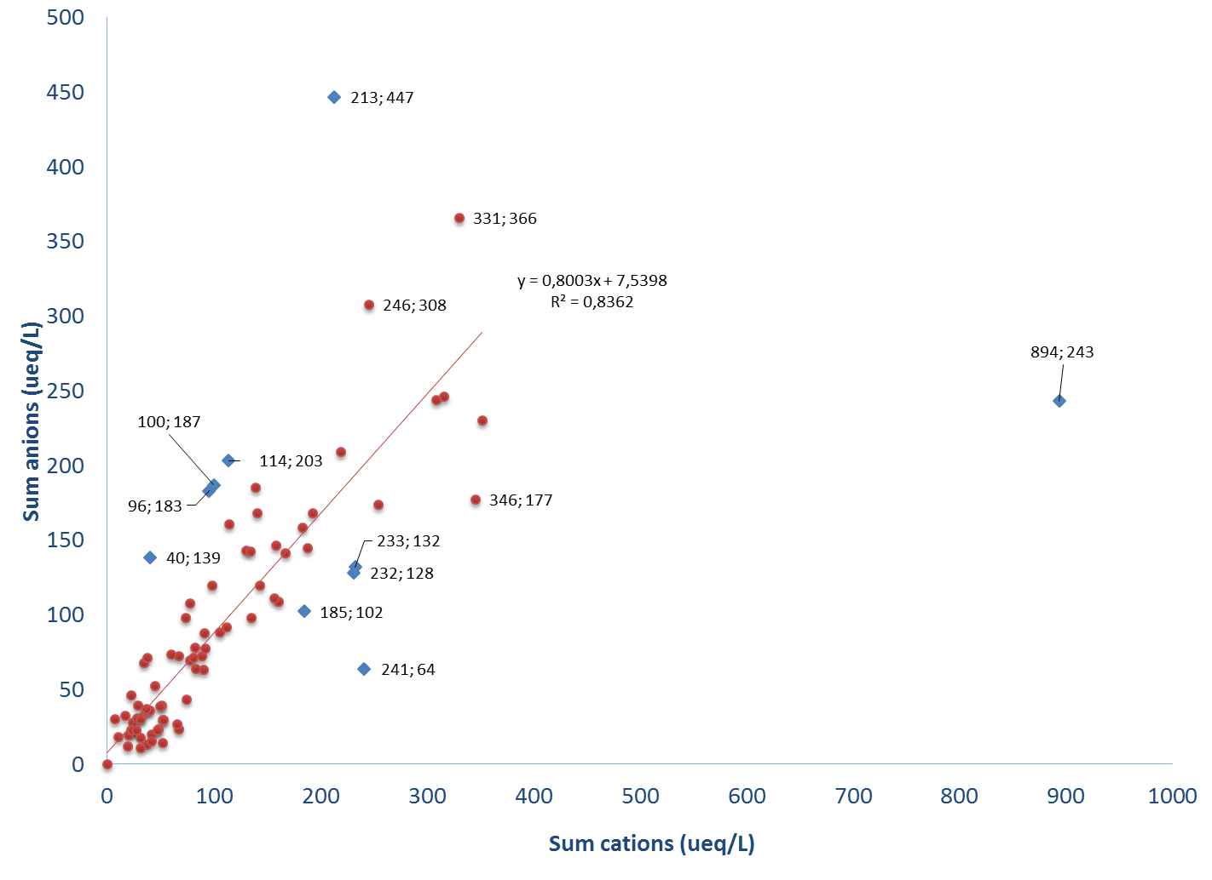
Figure SM-1: Plot of cation sum versus anion sum, including outlier samples.

Estimation of sulfur deposition due to coal burning
According BARROS (2013), in 2012, Barcarena harbor received 650,000 t of coal. Considering the area of Barcarena is 1,311 km² and sulfur content in w/w% ranges from low (0.6%) to high (3%) as proposed by YUO, 2010, the sulfur emission in the region was estimated as presented in Table SM-2
Table SM-2: Sulfur emission estimate for Barcarena in 2012.
Sulfur content | S  (w/w%) | S*  (kg) | S deposition**  (g m⁻²) | SO₄⁻² deposition  (mg m⁻²)
Low | 0.6 | 3,900,000 | 2,975 | 8,900
High | 3.0 | 19,500.000 | 14,874 | 44,600
* present in 650,000 ton of coal.
** over 1,311 km².

References:
[1] BARROS P H da C, “Eficiência na operação do porto de Vila do Conde,” Universidade Federal de Santa Catarina, 2013.
[2] BRETUJ W, FLESZYĔSKI J, AND WIECZOREK K, “Influence of Composite Insulator Inclination on Its Properties Degradation in Rain Conditions,” pp. 4–7, 2011.
[3] CHIDAMBARAM S, PARAMAGURU P, PRASANNA M V, KARMEGAM U, AND MANIKANDAN S, “Chemical characteristics of coastal rainwater from Puducherry to Neithavasal, Southeastern coast of India,” Environ. Earth Sci., vol. 72, no. 2, pp. 557–567, 2014.
[4] VET R., ARTZ R S, CAROU S, SHAW M, RO C U, AAS W, BAKER A, BOWERSOX V C, DENTENER F, GALY-LACAUX C, HOU A, PIENAAR J J, GILLETT R, FORTI M C, GROMOV S, HARA H, KHODZHER T, MAHOWALD N M, NICKOVIC S, RAOP S P, and REID N W, “A global assessment of precipitation chemistry and deposition of sulfur, nitrogen, sea salt, base cations, organic acids, acidity and pH, and phosphorus,” Atmos. Environ., vol. 93, pp. 3–100, 2014.
[5] YOU C F and XU X C, “Coal combustion and its pollution control in China,” Energy,

