Supporting information

SI1. Physicochemical characterization along the lifecycles of the investigated materials: CuO used in acrylic timber preserving coating and Cu₂(OH)₂CO₃ used in wood protecting impregnation
Table SI_1: Physicochemical characteristics of pristine CuO (SYNTHESIS).
Parameter | Technique | Results
Primary size distribution Min- Max (average)  Mode (1st quartile … 3rd quartile)  [nm] | TEM | 3‐35 (12)  10 (9.2.14)
Shape | TEM | Semi-spherical particles
Average crystallite size [nm] | XRD | 9.3
Crystallite phases (%) | XRD | Tenorite 100%
Dispersability in water: D₅₀  [nm]; average agglomeration number (AAN) | DLS | 139.5 ± 4.6;  346
Dispersability in modified MEM provided by the Heriot ‐Watt University: D₅₀ [nm]; average  agglomeration number (AAN) | DLS | 85.2±2.7;  77
Z potential in UP water [mV] | ELS | +28.1 ± 0.6
Isoelectric point [pH] | ELS | 10.3
Photocatalysis: photon  efficiency [unitless] | Methylene blue | 1.5x10⁻⁴
Specific Surface Area [m² g⁻¹] | degradation BET | 47.0 ± 1.7
Pore sizes [nm] | BET | 13.5 ± 1.6 _{(BJH)}  23.0 ± 0.9 _{(AVG)}
Surface chemistry [atomic fraction] | XPS | Cu = 0.46±0.05  O = 0.47±0.05  C= 0.07±0.01
Structure | FT-IR and/or RAMAN | Match with CuO database
Chemical impurities [mg kg⁻¹] | ICP-MS | Na: 505±30  Pb: 36±2 Ag: 13±4

Pristine nano-sized CuO was obtained as a black powder from PlasmaChem, GmbH Berlin. The crystalline material had particle size of 15-20 nm, Brunauer–Emmett–Teller specific surface area (BET) of 47 m²/g and density of 6.3 g/cm³ according to the datasheet of the manufacturer. To check consistency with the supplier’s data, detailed physicochemical characterisation was performed by the methods described below. The results are presented in Table SI_1.
Dispersion procedures
To measure properties like dispersability in water and in biological media as well as Z- potential, samples have to be in the form of a liquid suspension or a dispersion. Since the pristine CuO samples were provided as dry powders they were dispersed according to the following procedure.
A stock solution, with nominal concentration of 1 mg/mL for water dispersion and 10 mg/mL for biological media dispersion, was prepared by weighting 50 and 500 mg respectively of nano‐powder into a 100 ml glass. Few drops of 18 mΩ UP water were added in order to pre‐ wetted the particles: particles and liquid media were gently kneaded and molded by a glass rod in order to substitute the particle-air interface with liquid and facilitate the dispersion. Sample was brought to final volume (50 ml) and tip sonicated (MISONIX ultrasonic processor S-4000, Qsonica) in an ice-water bath for 20 minutes (80% pulse on time, 50 W, 45 KJ). Dispersion was transferred to a screw top amber vial and stored in dark at room temperature.
Working solutions for DLS and Z potential analysis both in water and in buffered media at pH=7 were prepared by properly diluting the stock solutions (previously cup-horn sonicated if not fresh) in the final media, in order to yield a final concentration in the range 5-20 ppm. Before use, these solutions were bath sonicated for reaching the equilibrium. Working solutions for DLS analysis in biological media were prepared following the Standard Operating Procedure (SOP) reported by NIST in its Special Publication 1200-4 (Taurozzi et al. 2012). Dispersions were prepared in C3A cell culture medium (Minimum Essential Medium Eagle) following the instructions provided by the Heriot Watt University: 70 ml were removed from Minimum Essential Medium Eagle 500 ml bottle (Sigma M2279, with Earle’s salts and sodium bicarbonate, without L-glutamine, liquid, sterile-filtered). To the remaining 430 mL, the following were added:
- 50ml of Sigma F7524: Fetal Bovine Serum (non-USA origin, sterile-filtered, suitable for cell culture);
- 5ml of Sigma P0781: Penicillin-Streptomycin (with 10,000 units penicillin and 10 mg streptomycin per mL in 0.9% NaCl, sterile‐filtered, BioReagent, suitable for cell culture);
- 5ml of Sigma G7513: L‐Glutamine solution (200 mM, solution, sterile‐filtered, BioXtra, suitable for cell culture);
- 5ml of Sigma S8636: Sodium pyruvate solution (100 mM, sterile-filtered, BioReagent, suitable for cell culture);
- 5ml of Sigma M7145: MEM Non-essential Amino Acid Solution (100×) (without L‐ glutamine, liquid, sterile-filtered, BioReagent, suitable for cell culture).
Primary size distribution and shape
Techniques: TEM
Instrument: FEI Tecnai 12 G2
Sample preparation procedures were the same as those used for DLS analysis (NANOVALID WP3, Task 3.1 and NANOGENOTOX protocols) and integrated with standards ISO 13322-1 2004, ISO 9276-3 2008, ISO 9276-1 1998, ASTM E766, which provide instructions for sample preparation, instrument preparation, instrument calibration and image analysis.
1 to 10 µl of a sample solution (prepared as for the DLS analysis) at the concentration of 10 to 100 mg/l was deposited on carbon, formvar or formvar + carbon grids and left to dry overnight (in case of low nanoparticle concentrations) or the excess should be blotted away after 60 s (in case of high NP concentrations). The microscope was calibrated for magnification using cross line grating replica (2160 lines/mm) for low/medium magnifications and negatively stained catalase crystals for high magnifications. Magnifications for each sample were chosen in order to have a relatively large number of representative particles with minimum particle area of 100 pixels. The microscope was operated under standard bright field mode and images should be recorded on a camera from evenly distributed regions across the whole grid. Several grids should be examined during several days for uncertainty estimations. The image analysis should comprise semi-automatic or manual methods implemented in ImageJ, which include image filtration (when necessary), thresholding, particle segmentation, particle selection and measurement of size and shape (most importantly area equivalent circular diameters, where applicable). The mode of number-based measurand distributions should be obtained by lognormal fitting.
Crystallite size and phases
Techniques: XRD
Instrument: Philips PW 1830
High angle: X-ray diffraction measurements were performed with a vertical goniometer connected to a highly stabilized generator. A focusing graphite monochromator and a proportional counter with a pulse-height discriminator were used. Nickel-filtered Cu Ka radiation and a step-by-step technique were employed (steps 0.05° 2θ), with collection times of 100 s step-1.
The size distribution of the crystallites was determined by the Warren–Averbach’s method, based on the analysis of the Fourier coefficients of the XRD profile peak shapes.
Small-angle X-Ray scattering (SAXS): SAXS measurements were carried out using a Kratky camera equipped with an electronic step scanner under 'quasi-infinite' primary-beam geometry. Nickel-filtered Cu Kα radiation, a pulse-height discriminator and a proportional counter were used.
Ultracentrifugation procedure (8400 g) was employed to separate solid TiO2 Nanoparticles from liquid in both suspensions, in order to carry out X-ray diffraction analysis.

Dispersability in water and in biological medium
Technique: DLS
Instrument: Malvern Zsizer Nano
Procedures applied for these analyses were the same as used in NanoValid (WP3, Task 3.1) and as reported by Nanogenotox protocol. A well mix of the sample suspension was assured by a sonication procedure; then 1.5 mL of the suspension were added in the cuvette for measurement. The analysis was performed at 25 ⁰C with an equilibrium time of 2 minutes. A minimum of 6 replicates with 3 measurements per replicate was used. Instrument performances were evaluated by standard polystyrene dispersion analysis.
Z-pot in ultrapure water and at pH 7
Technique: ELS
Instrument: Malvern Zsizer Nano
Procedures applied for these analyses were the same as used in NanoValid (WP3, Task 3.1) and as reported by Nanogenotox protocol. Zeta cells (folded capillary cell) were rinsed thoroughly before use with water, followed by ethanol, and finally water again. As recommended, a minimum of 1 mL of each rinsing solvent was flushed through each port to thoroughly rinse each electrode. Zeta cells were used once per sample and then disposed of. For Z-potential analyses in ultrapure water, samples were prepared as described for DLS analysis.
For Z-potential analyses at pH 7, a proper aliquot from the stock solution (nominal concentration 1 g L-1) was dispersed in ultrapure water the background buffered electrolyte solution (40 mM KCl, 9.36 g L-1 KH2PO4, 32.73 g L-1 Na₂HPO₄) in order to achieve an optimum concentration in the intensity range > 20 kcps, which depends on several factors such as optical properties, particles size and polydispersity.
Final pH of the suspension was determined after vortex mixing and eventually adjusted with
0.1 M HCl or NaOH. From the working solution, the appropriate amount of sample was weighed and added to a glass vial. Sonication was performed to ensure a well mix of the suspension, as reported for DLS measurements. Afterwards, the sample was transferred with a 1 mL disposable syringe, by dislodging any air bubbles, to the zeta cell.
The analysis was performed at 25 ⁰C with an equilibrium time of 2 minutes. A minimum of 10 replicates with 3 measurements per replicate was used.
Depending on the measured samples conductivity, in order to reduce the electrodes degradation and improve the data quality, different applied voltages (V), corresponding to different analysis mode, was automatically selected by the instrument (measured conductivity greater than 5 or greater than 30 mS cm-1 correspond to a default applied voltage of 50 or 10 V respectively). Instrument performances were evaluated by standard polystyrene dispersion analysis.
Isoelectric point
Techniques: ELS
Instrument: Nicomp 380 ZLS
Procedures according to the Nanogenotox protocol – SOP for characterization of the selected manufactured materials types. Samples for zeta potential measurements at different pH values were prepared. Ionic strength (monovalent salt) was kept constant at 0.036 mol L-1. Dispersions were prepared by dilution of concentrated sonicated stock suspensions of 10 g L-1 into pH and ionic strength controlled “buffers”. General procedure employed was already described as for Z-pot at pH 7 measurements, extending the measurements in the range from pH 1.5 to pH 12.5.
Photocatalytic activity
Techniques: Methylene blue degradation
Instrument: Ocean Optics spectrometer USB4000
The adopted method closely follows DIN 52980:2008-10. The materials were dispersed at c = 5 mg l-1 concentration in an aqueous solution containing methylene blue, which has the known extinction coefficient ε = 7.402 m² mol-1. Before irradiation, the 5 mg l-1 dye solution has an optical absorbance of ΔA = 0.92 at 664 nm wavelength. The effective particulate surface is hence given by c*BET and is in the range of 10-4 m² ml-1 for typical nanomaterials. Beakers of 20 ml suspension were placed in the irradiation chamber (MRC Systems GmbH) which maintained a constant UV intensity of E = 0.1 mW cm-2 at λ = 365 nm. Under constant stirring, the remaining dye absorption ΔA at Δt = 0h – 2h – 6h – 22h was measured by spectrometer on aliquots in d = 1 cm thick cuvettes outside of the irradiation chamber. Suspensions of identical composition but kept in dark beakers defined the negative control ΔAdark at the same time intervals. Following the DIN standard, we calculate the unit-less photon efficiency ξ: As further negative control a dye solution without nanoparticles was UV-irradiated and showed no measurable degradation over 22h.
Specific Surface Area and pore sizes
Technique: BET
Instrument: Quantachrome Autosorb iQ
Procedures applied for these analyses were the same as used in NanoValid (WP3, Task 3.1) and as reported by Nanogenotox protocol. Specific surface area and pore size distribution were determined respectively with BET, average pore size calculation and DTF methods (ISO 1590-1:2007), recording the nitrogen adsorption and desorption isotherm at 77 K for 35 points (21 adsorption and 14 desorption) between 0 and 1 P/P0. Moreover, 11 relative pressure points between 0.05 and 0.3 P/P0 were acquired for the adsorption branch for accurate multipoint bet surface area determination. For all points, equilibration and tolerance parameters were respectively set to 3 and 0.
Powder samples were weighted with a 5-digit analytic balance (Mettler Toledo) in the designed cells (9 mm stem with large bulb cell). Sample mass was adjusted in order to achieve at least 15 – 20 m2 in the cell. For unknown samples 500 mg of sample were weighted in the cell.
Samples where outgassed under vacuum at the maximum temperature allowed (90-300 °C) for at least 6 hours up to 12 hours depending on their physical proprieties, such as melting point, with a slow temperature ramp of 1 °C min-1 to avoid any sample surface or structure changes. At the end of the degassing, cells were cooled at room temperature, backfilled with nitrogen, weighted again to measure the final degassed sample mass and then loaded on the analysis stations. Samples volumes were determined by He measure. Any materials were analysed 3 times. Unknown samples were firstly processed by a fast-single point BET in order to roughly evaluate the amount of sample to be introduced into the cell.
Instrument performances were evaluated by analysing Surface Area Reference Materials (SARM2005 - 100 m2 g-1 and SARM 2001 - 14 m2 g-1).
Average Agglomeration number
As defined by NIST Special Publication 960-3, the average agglomeration number (AAN) is an estimation of the degree of agglomeration in a suspension. AAN is the average number of primary particles contained within an agglomerate. AAN is calculated as the ratio of the median particle size, as determined by light scattering technique, and the average equivalent spherical volume (VBET) given by the BET gas adsorption method, such that:
where V50 is the equivalent spherical volume calculated from the median diameter (µm3), D50 is the size that splits the distribution with half above and half below this diameter (μm), SSA is the specific surface area (m2 g-1) and ρ is the particle density (g cm-3).
Surface chemistry
Techniques: XPS
Instrument: Perkin Elmer® 5600ci
Samples were analysed using non-monochromatic Al Kα radiation (E=1486.6 eV) in the 10−6 Pa pressure range. Surface charging was corrected by assuming the binding energy (BE) the adventitious carbon C1s band to be 248.6 eV. All the BE values are referred to the Fermi level. The uncertainties of the BE values are 0.1-0.3 eV; those of the calculated atomic fraction of the different elements are lower than 5-10%. The values of BE or kinetic energy (KE) of the signals, as well as the calculated value of the parameter α, were compared to the values reported in the literature and/or in dedicated databases, in order to allow different chemical assignments.
Structure: Fundamental vibrations and associated rotational-vibrational structure
Techniques: FT-IR
Instrument: Spectrum One Perkin Elmer (Waltham, MA, USA)
The samples in the powder state were ground to a very fine powder and pressed into KBr pellets and mounted in the holder of the IR cell. Each analysis was performed in triplicate.
Structure: Vibrational, rotational and other low-frequency modes
Techniques: Raman
Instrument: Xantus-1TM
The samples in the powder state were ground to a fine powder and insert in the holder of the Raman cell. Excitation laser diode emitted at 785 nm.
Inorganic Impurities of toxicological concern
Technique: ICP-MS/OES
Instrument: Perkin Elmer NexION 300D; Perkin Elmer Optima 2100
The procedures applied are the same as those used in the projects NanoValid (Chemical purity of materials, WP2 Task 2.2) and Nanogenotox, although sample preparation methods (kind and amount of acids, temperature and pressure program of the microwave) are strongly dependent on the chemical nature of the material to be digested and on the elements to be determined.
Three aliquots from every batch of Nanoparticles were collected and treated each one of them as an independent sample. In order to solubilize the material, every sample underwent an acid digestion process. The acid mixture employed (acids of suprapur grade) depends on the material. In some cases, different number of samples and different kind of digestion procedures were tested. Furthermore, in order to evaluate the possible environmental contamination of the samples, at least three blank solutions (reagents without any sample) per digestion process were prepared.
To provide a fingerprint of the elements present in the materials and their approximate concentration, a semi-quantitative analysis of the samples was carried out by ICP-MS in standard conditions. The elements seeming more relevant were fully quantified by external calibration method with multi-points curves by ICP-OES or ICP-MS (standard, KED or Dynamic Reaction Cell Mode according to the element investigated). Acceptance criterion for the calibration curves was R2≥0.999. The calibration levels varied according to the expected concentration of the element in the samples.
Table SI_2: Physicochemical characteristics of CuO acrylate coating and micronized Cu₂(OH)₂CO₃ suspension (FORMULATION).
 | CuO acrylate coating | Micronized Cu₂(OH)₂CO₃ suspension
Nanomaterials content (w/w) | 1.5% | 54%
Cu content (w/w) | 1.2% | 30%
Cu ion content (w/w) | N/A | 0.5%
Other particulate content (w/w) | 52% acrylic binder  43% non-nano TiO2 | -
Nanomaterials agglomerate size | range 30 to 100 nm in volume metrics | Median 124 nm in volume metrics, median 34 nm in number metrics.
Nanomaterials content and organic binder were determined gravimetrically (w/w = weight fraction), and Cu content derived from the previously determined nanomaterials composition. Cu ion content was determined by hard centrifugation (2h, 150.000 g) and ICP-MS analysis of the remaining supernatant. Nanomaterials agglomerate sizes were determined by Analytical Ultracentrifugation (AUC). In short, AUC is a fractionating technique that characterizes polydisperse size distributions via the distribution of sedimentation velocities, observed during centrifugation by radially imaging interference optics that are synchronized with the rotor (Walter et al. 2014, Wohlleben 2012) The specific protocols for data evaluation and conversion from mass to number metrics have been successfully validated recently (Babick et al. 2016).
Table SI_3: Physicochemical characteristics of CuO coated and micronized Cu₂(OH)₂CO₃ impregnated woods (USE).
 | CuO acrylate coating on wood | Micronized Cu₂(OH)₂CO₃ impregnated wood
Cu content related to  specimen surface | 1.7 g/m² | N/A
Cu content related to specimen mass | - g/m³ | 1 kg/m³  2 kg/m³
Application | Wet brushing | Pressure treatment

The standard pine wood blocks dimensions for acrylate coatings were 35 x 35 x 11 mm³ with the weight of 8.4 ± 0.4 g and wood fiber orientation to the smaller facets. The control coating was applied to all sides except one of the larger facets, where the CuO formulation was applied. By gravimetry of each wood block after drying, the CuO mass on the one surface was determined to be 2.1 ± 0.3 mg (corresponding to 1.7 g/m² or 0.16 kg/m³). The one CuO containing surface faced upwards in irradiation/weathering tests, so that the release could be unequivocally assigned. All surfaces together, the wood specimen contained white pigment TiO2 at 118 ± 10 mg. The acrylic composition was described in more detail previously (Tiarks et al. 2003). For effectiveness testing, all surfaces were covered by the 15 kg/m³ CuO acrylic barrier coating, resulting in a nominal Cu content of 0.42 kg/m³, averaged across the entire specimen.
For the impregnation with micronized Cu and Cu-Amine, EN 113 wood specimens were used. Briefly, Pine sapwood (Pinus sylvestris L.) air dried samples (moisture content of 10 %) of the size of 50 x 25 x 15 mm3 with the weight of 9.34 ± 0.54 g, and wood fiber orientation to the smaller facets were used. Impregnation was carried out by applying a vacuum of 10 mbar for 30 min., following by flooding and 60 min. immersion of the treatment dilution at atmospheric pressure. After four weeks drying at ambient air, the ends (small facets) were end-sealed with an epoxide resin.
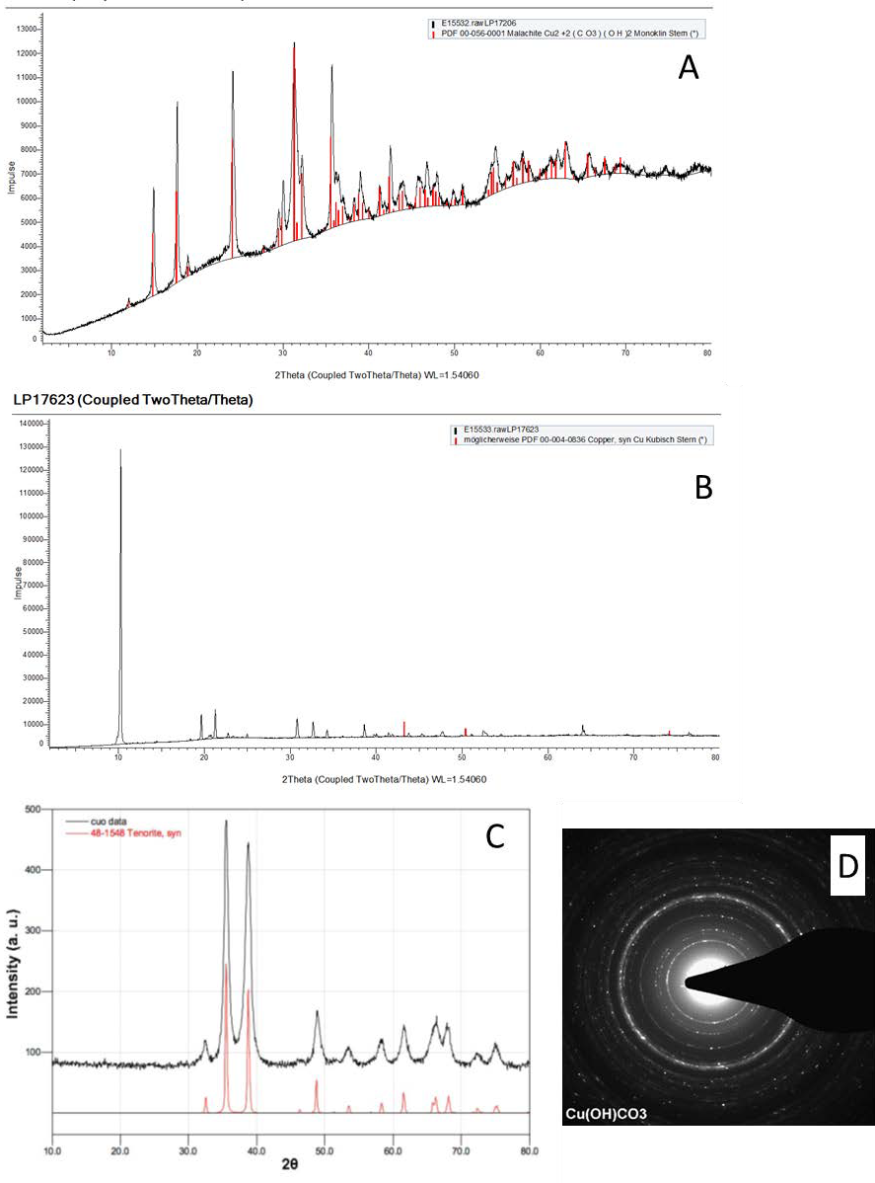
Figure SI_1: X-ray diffraction analysis of micronized Cu (A), Cu amine (B) and pristine CuO (C). Finally, selected area diffraction (D) analysis of micronized Cu. Information on the crystal structure of small sample regions was collected by Selected Area Electron diffraction (SAD), an operation mode of TEM. Diffraction images were aligned, and the intensity was radially integrated. The resulting diffractograms were assigned to crystalline phases using a XRD structure database (Bruker Eva, Karlsruhe, Germany), and confirm that the platelets in the micronized Cu formulation consist of basic Cu₂(OH)₂CO₃

SI2. Experimental set-ups to measure release and exposure
Experimental setup to characterize particle emissions from sanding and drilling
Release experiments were performed inside an aerosol chamber (0.15 m³) equipped with a drilling machine (Bosch, GBS 21-2 RCT Professional) (cf. Figure SI_2). As only the drilling head was inside the chamber, a contribution to the aerosol from the drilling machine itself can be excluded. The drilling head was either equipped with a sanding support (disc diameter 115 mm, sanding paper with grit size 80, Starcke GmbH&Co.KG) or a steel drill with a diameter of 8 mm. The material sheets to be investigated were mounted onto a fixed holder which did not rotate during the experiments. A contact force of 17 N was applied by using a spring with a diameter of 4 mm. A rotation speed of 1550 rpm was realized during all sanding experiments, whereas different speeds were applied (1550 and 1880 rpm) during the drilling experiments. Sanding was performed four times, drilling three times, for each material. Based on these replicates, arithmetic means and standard deviations of release rates were calculated and used for modelling of exposure levels.
Before starting a sanding/drilling experiment, the whole aerosol chamber was wiped first by using wet tissues followed by cleaning with a HEPA filter-equipped vacuum cleaner. After chamber cleaning, the material sheet to be sanded/drilled was fixed to the sample holder and the chamber was closed and kept closed during the whole experiment. After cleaning, the chamber was evacuated by a pump through a HEPA filter to reduce the background particle concentration coming from ambient air. After every sanding/drilling event the chamber was evacuated again to reduce particle concentration to ground level.
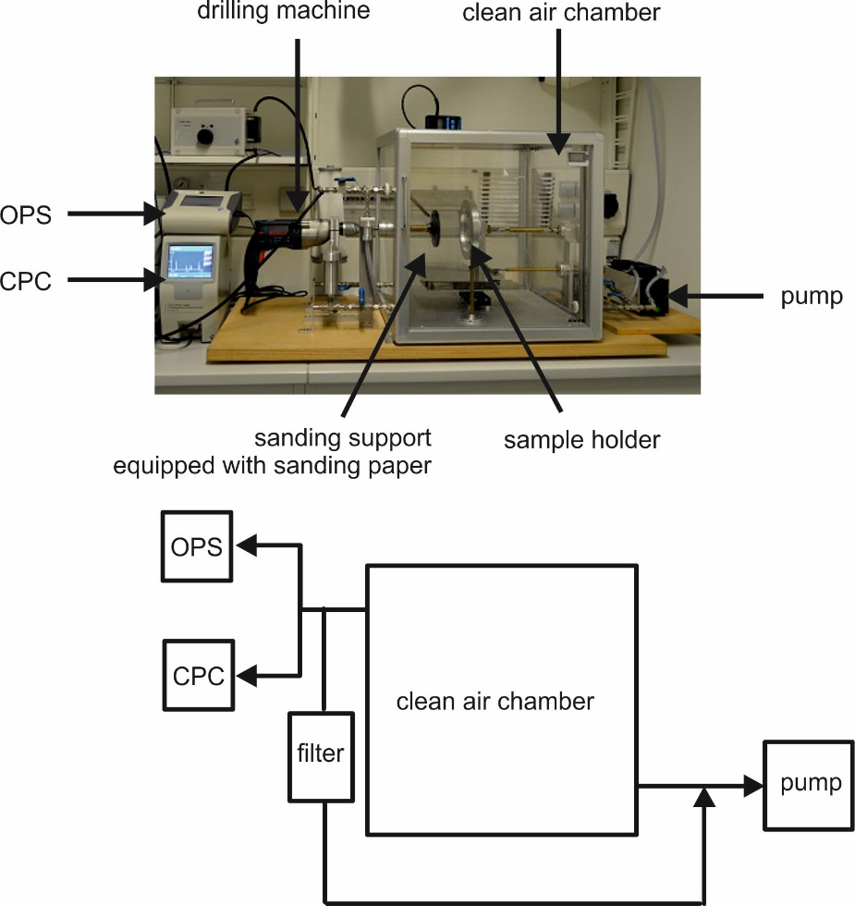
Figure SI_2 Schematic of the clean air chamber set-up used for material processing by sanding and drilling.
Dermal transfer tests
Hand exposure was assessed by conducting dermal transfer tests in the SUN project by means of the surface wiping method, following the NIOSH guideline Elements on Wipes: Method 9102 (NIOSH 2003). The wiping tests were conducted on freshly painted dry paint and on a paint surface that was subjected to accelerated wear-and-tear (sanding by hand) (Mackevica et al.). Painted wooden blocks with sizes of 35 x 35 x 11 mm were used as provided by BASF SE, Ludwigshafen, Germany. The blocks were covered with CuO-containing paint on all sides with final CuO content of around 1.5% in the dried paint (final concentration of 5.7 ± 0.2 mg CuO per wooden block, or 0.14 ± 0.01 mg CuO/cm²). The CuO embedded in the paint had pristine particle sizes of 30-50 nm according to the information provided by the manufacturer (PlasmaChem GmbH, Germany). Blocks covered with CuO-free paint were used as control samples. Wipes used for the dermal transfer testing were a blend of 48% wool, 47% cotton and 5% polyamide, cut into 5x5 cm pieces. Before the execution of wiping tests, each 5x5 cm wipe was wetted with 0.5 mL of artificial sweat, which was prepared according to the ISO 105-E04 guideline (ISO 2013).
Four wooden blocks were taped together as one sample, resulting in surface area of 49 cm². The surface of the sample was wiped by hand, using fingertips held together and applying firm pressure and using an overlapping “S” pattern covering the entire surface with both horizontal and vertical strokes. The wipe was then put in a plastic container (Falcon® 50mL Conical Centrifuge Tubes) with 20 mL deionized water, which was subsequently sonicated in the ultrasonicator bath (Retsch, UR 1) for 10 min and then immediately analysed by Single Particle Inductively Coupled Plasma Mass Spectrometry (spICP-MS) (Perkin Elmer, NEXion 350D).
The potential for CuO transfer from surfaces to wipes was markedly higher for sanded paint surfaces, whereas non-sanded surfaces had negligible CuO release. The maximum nano-CuO release from a single wiping event was 0.5 million CuO particles per cm², corresponding to around 1.2 ng CuO/cm², observed when wiping the sanded paint surface. After three wiping events, the total observed CuO NP release was 2 x10⁴ particles/cm² (0.885 ng/cm²) from non-sanded paint, 1.4 x10⁶ particles/cm² (2.5 ng/cm²) from sanded paint. The mean sizes of the released CuO particles, as determined by spICP-MS, were 84 nm and 79 nm for non-sanded and sanded surfaces, respectively, and the most frequent sizes were 61 nm and 54 nm without and with sanding, respectively.

SI3. Uncertainty assessments
Uncertainty contribution to RCR by each involved factor was estimated through a Monte Carlo approach with 10.000 trials. At each trial, the RCR was numerically estimated by randomly sampling 10.000 elements from the PoD distribution, exposure distribution(s), and from each EF’s distribution, and then computing the resulting RCR. The contribution to uncertainty of each factor was quantified by assessing the (normalized to 100) level of correlation between the factor and the resulting RCR by means of squared Spearman’s rank correlation coefficient. Curve statistics of Exposure(s), PoD and EFs’s distributions are summarized in Table SI_5 (Inhalation route of exposure of ES2), Table SI_6 (Inhalation route of exposure, for both Consumers and Workers of ES4), Table SI 7 (Perioral route of exposure, for both Consumers and Workers of ES4), and Table SI 8 (Oral route of exposure, children aged 8 to 36 months).Resulting distributions for each source of uncertainty are presented in Figure SI_5 (Inhalation route of exposure of ES2), Figure SI_6 (Inhalation route of exposure, for both Consumers and Workers of ES4), Figure SI_7 (Peri-oral route of exposure, for both Consumers and Workers of ES4), and Figure SI_8 (Oral route of exposure, children aged 8 to 36 months), together with the corresponding curve statistics. The contribution of each EF was selected as the arithmetic mean of each resulting curve. All the computations were performed using an internally developed script in R language, with resulting pictures generated thanks to the ggplot2 package. SUNDS, on the other hand, integrates an approximation of this analysis, where only the uncertainties of $HD_{M}^{I}$ and $EXP_{i}$ with respect to the resulting RCR are performed as described above. An approximation of the Uncertainty analysis of PoD and UFs with respect to $HD_{M}^{I}$ distribution is indeed provided by the APROBA tool included in our DSS, thus in SUNDS such contributions are normalized to the uncertainty of $HD_{M}^{I}$ with respect to the RCR.
Table SI_5: Curve statistics for Exposure, PoD and EFs for Inhalation route of exposure of ES2. Mean and SD was computed for Normally distributed factors, while mean, GeoMean and GeoSD factor was computed for Lognormally distributed factors.
 | Exposure | PoD | Interspecies TKTD | Intraspecies extrap. | Duration extrap.
Distribution | Normal | Lognormal | Lognormal | Lognormal | Lognormal
5% | 1.30E-02 | 4.00E-02 | 3.33E-01 | 1.77E+00 | 6.25E-01
95% | 3.90E-02 | 7.30E-02 | 3.00E+00 | 1.40E+01 | 4.00E+01
50% (Median) | 2.60E-02 | 5.40E-02 | 9.99E-01 | 4.98E+00 | 5.00E+00
Mean | 2.60E-02 | 5.49E-02 | 1.25E+00 | 6.07E+00 | 1.11E+01
SD | 7.90E-03 | --- | --- | --- | ---
GM | --- | 5.40E-02 | 9.99E-01 | 4.98E+00 | 5.00E+00
GSD | --- | 1.20E+00 | 1.95E+00 | 1.88E+00 | 3.54E+00

Table SI_6: Curve statistics for Exposure, PoD and EFs for Inhalation route of exposure of ES4, for both consumers and workers. Mean and SD was computed for Normally distributed factors, while mean, GeoMean and GeoSD factor was computed for Lognormally distributed factors.
 | Exposure | PoD | Interspecies TKTD | Intraspecies extrap. | Duration extrap.
Distribution | Normal | Lognormal | Lognormal | Lognormal | Lognormal
5% | 1.60E-02 | 4.00E-02 | 3.33E-01 | 1.77E+00 | 6.25E-01
95% | 4.80E-02 | 7.30E-02 | 3.00E+00 | 1.40E+01 | 4.00E+01
50% (Median) | 3.20E-02 | 5.40E-02 | 9.99E-01 | 4.98E+00 | 5.00E+00
Mean | 3.20E-02 | 5.49E-02 | 1.25E+00 | 6.07E+00 | 1.11E+01
SD | 9.73E-03 | --- | --- | --- | ---
GM | --- | 5.40E-02 | 9.99E-01 | 4.98E+00 | 5.00E+00
GSD | --- | 1.20E+00 | 1.95E+00 | 1.88E+00 | 3.54E+00

Table SI_7: Curve statistics for Exposure, PoD and EFs for Perioral route of exposure of ES4, for both consumers and workers. Mean and SD was computed for Normally distributed factors, while mean, GeoMean and GeoSD factor was computed for Lognormally distributed factors.
 | Exposure | NOAEL to BMD | Interspecies TK/TD | Interspecies scaling | Intraspecies extrap. | Duration extrap.
Distribution | Normal | Lognormal | Lognormal | Lognormal | Lognormal | Lognormal
5% | 2.35E-06 | 7.09E-02 | 3.33E-01 | 4.43E+00 | 1.77E+00 | 6.25E-01
95% | 9.87E-06 | 1.57E+00 | 3.00E+00 | 7.01E+00 | 1.40E+01 | 4.00E+01
50% (Median) | 6.11E-06 | 3.33E-01 | 9.99E-01 | 5.57E+00 | 4.98E+00 | 5.00E+00
Mean | 6.11E-06 | 5.19E-01 | 1.25E+00 | 5.63E+00 | 6.07E+00 | 1.11E+01
SD | 2.29E-06 | --- | --- | --- | --- | ---
GM | --- | 3.33E-01 | 9.99E-01 | 5.57E+00 | 4.98E+00 | 5.00E+00
GSD | --- | 2.56E+00 | 1.95E+00 | 1.15E+00 | 1.88E+00 | 3.54E+00

Table SI_8: Curve statistics for Exposure, PoD and EFs for Oral route of exposure of ES11, involving children aged 8 to 36 months. Mean and SD was computed for Normally distributed factors, while mean, GeoMean and GeoSD factor was computed for Lognormally distributed factors.
 | Exposure | Children weights | NOAEL to BMD | Interspecies TK/TD | Interspecies scaling | Intraspecies extrap. | Duration extrap.
Distrib. | Normal | Mixture of Gaussians | Lognormal | Lognormal | Lognormal | Lognormal | Lognormal
5% | 3.70E-01 | 7.60E+00 | 7.09E-02 | 3.33E-01 | 2.36E+00 | 2.24E+00 | 6.25E-01
95% | 1.11E+00 | 1.47E+01 | 1.57E+00 | 3.00E+00 | 3.08E+00 | 4.19E+01 | 4.00E+01
50% (Median) | 7.40E-01 | 1.08E+01 | 3.33E-01 | 9.99E-01 | 2.70E+00 | 9.69E+00 | 5.00E+00
Mean | 7.40E-01 | 1.09E+01 | 5.19E-01 | 1.25E+00 | 2.70E+00 | 1.44E+01 | 1.11E+01
SD | 2.25E-01 | 2.18E+00 | --- | --- | --- | --- | ---
GM | --- | --- | 3.33E-01 | 9.99E-01 | 2.70E+00 | 9.69E+00 | 5.00E+00
GSD | --- | --- | 2.56E+00 | 1.95E+00 | 1.08E+00 | 2.44E+00 | 3.54E+00

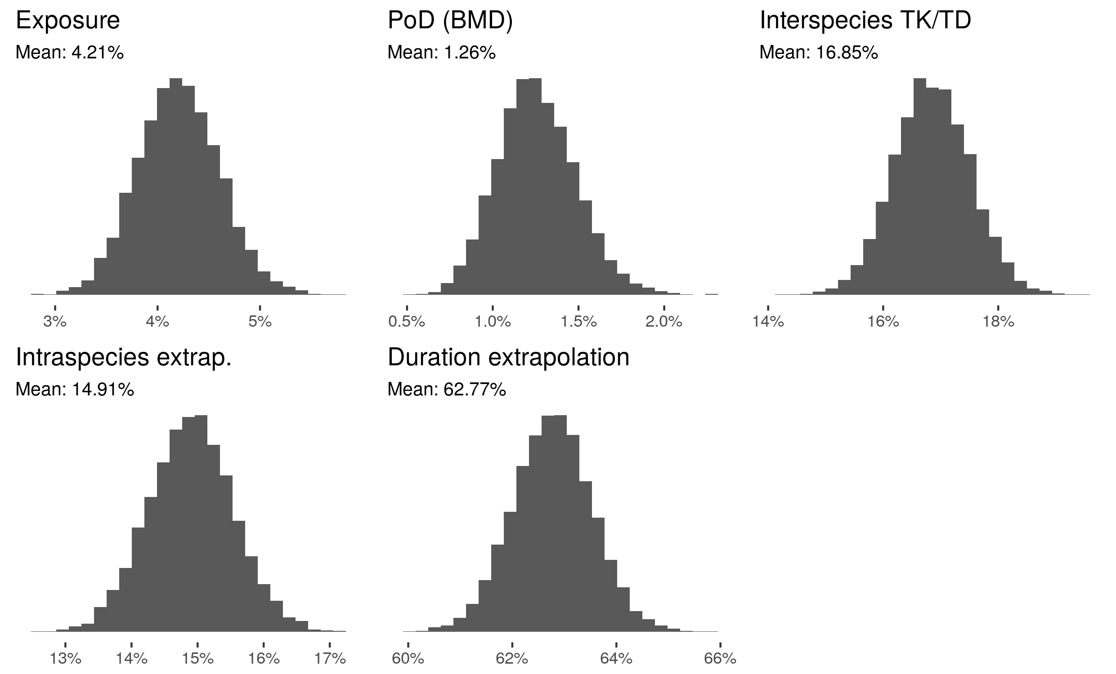
Figure SI_5: distributions of uncertainties in ES2 Inhalation scenario, numerically derived after 10.000 Monte Carlo simulations. The corresponding curve statistics are summarized in Table SI_9.
Table SI_9: Curve statistics of distribution of uncertainty of each factor in ES2 Inhalation scenario, quantified by the (normalized to 1) level of correlation between the factor and the resulting RCR by means of squared Spearman’s rank correlation coefficient.
cap | Exposure | PoD | Interspecies TK/TD | Intraspecies extrapolation | Duration extrapolation
5% | 3.55E-02 | 8.97E-03 | 1.58E-01 | 1.39E-01 | 6.15E-01
95% | 4.88E-02 | 1.64E-02 | 1.79E-01 | 1.59E-01 | 6.40E-01
50% (Median) | 4.20E-02 | 1.24E-02 | 1.69E-01 | 1.49E-01 | 6.28E-01
Mean | 4.20E-02 | 1.25E-02 | 1.69E-01 | 1.49E-01 | 6.28E-01
SD | 4.01E-03 | 2.27E-03 | 6.59E-03 | 6.38E-03 | 7.63E-03

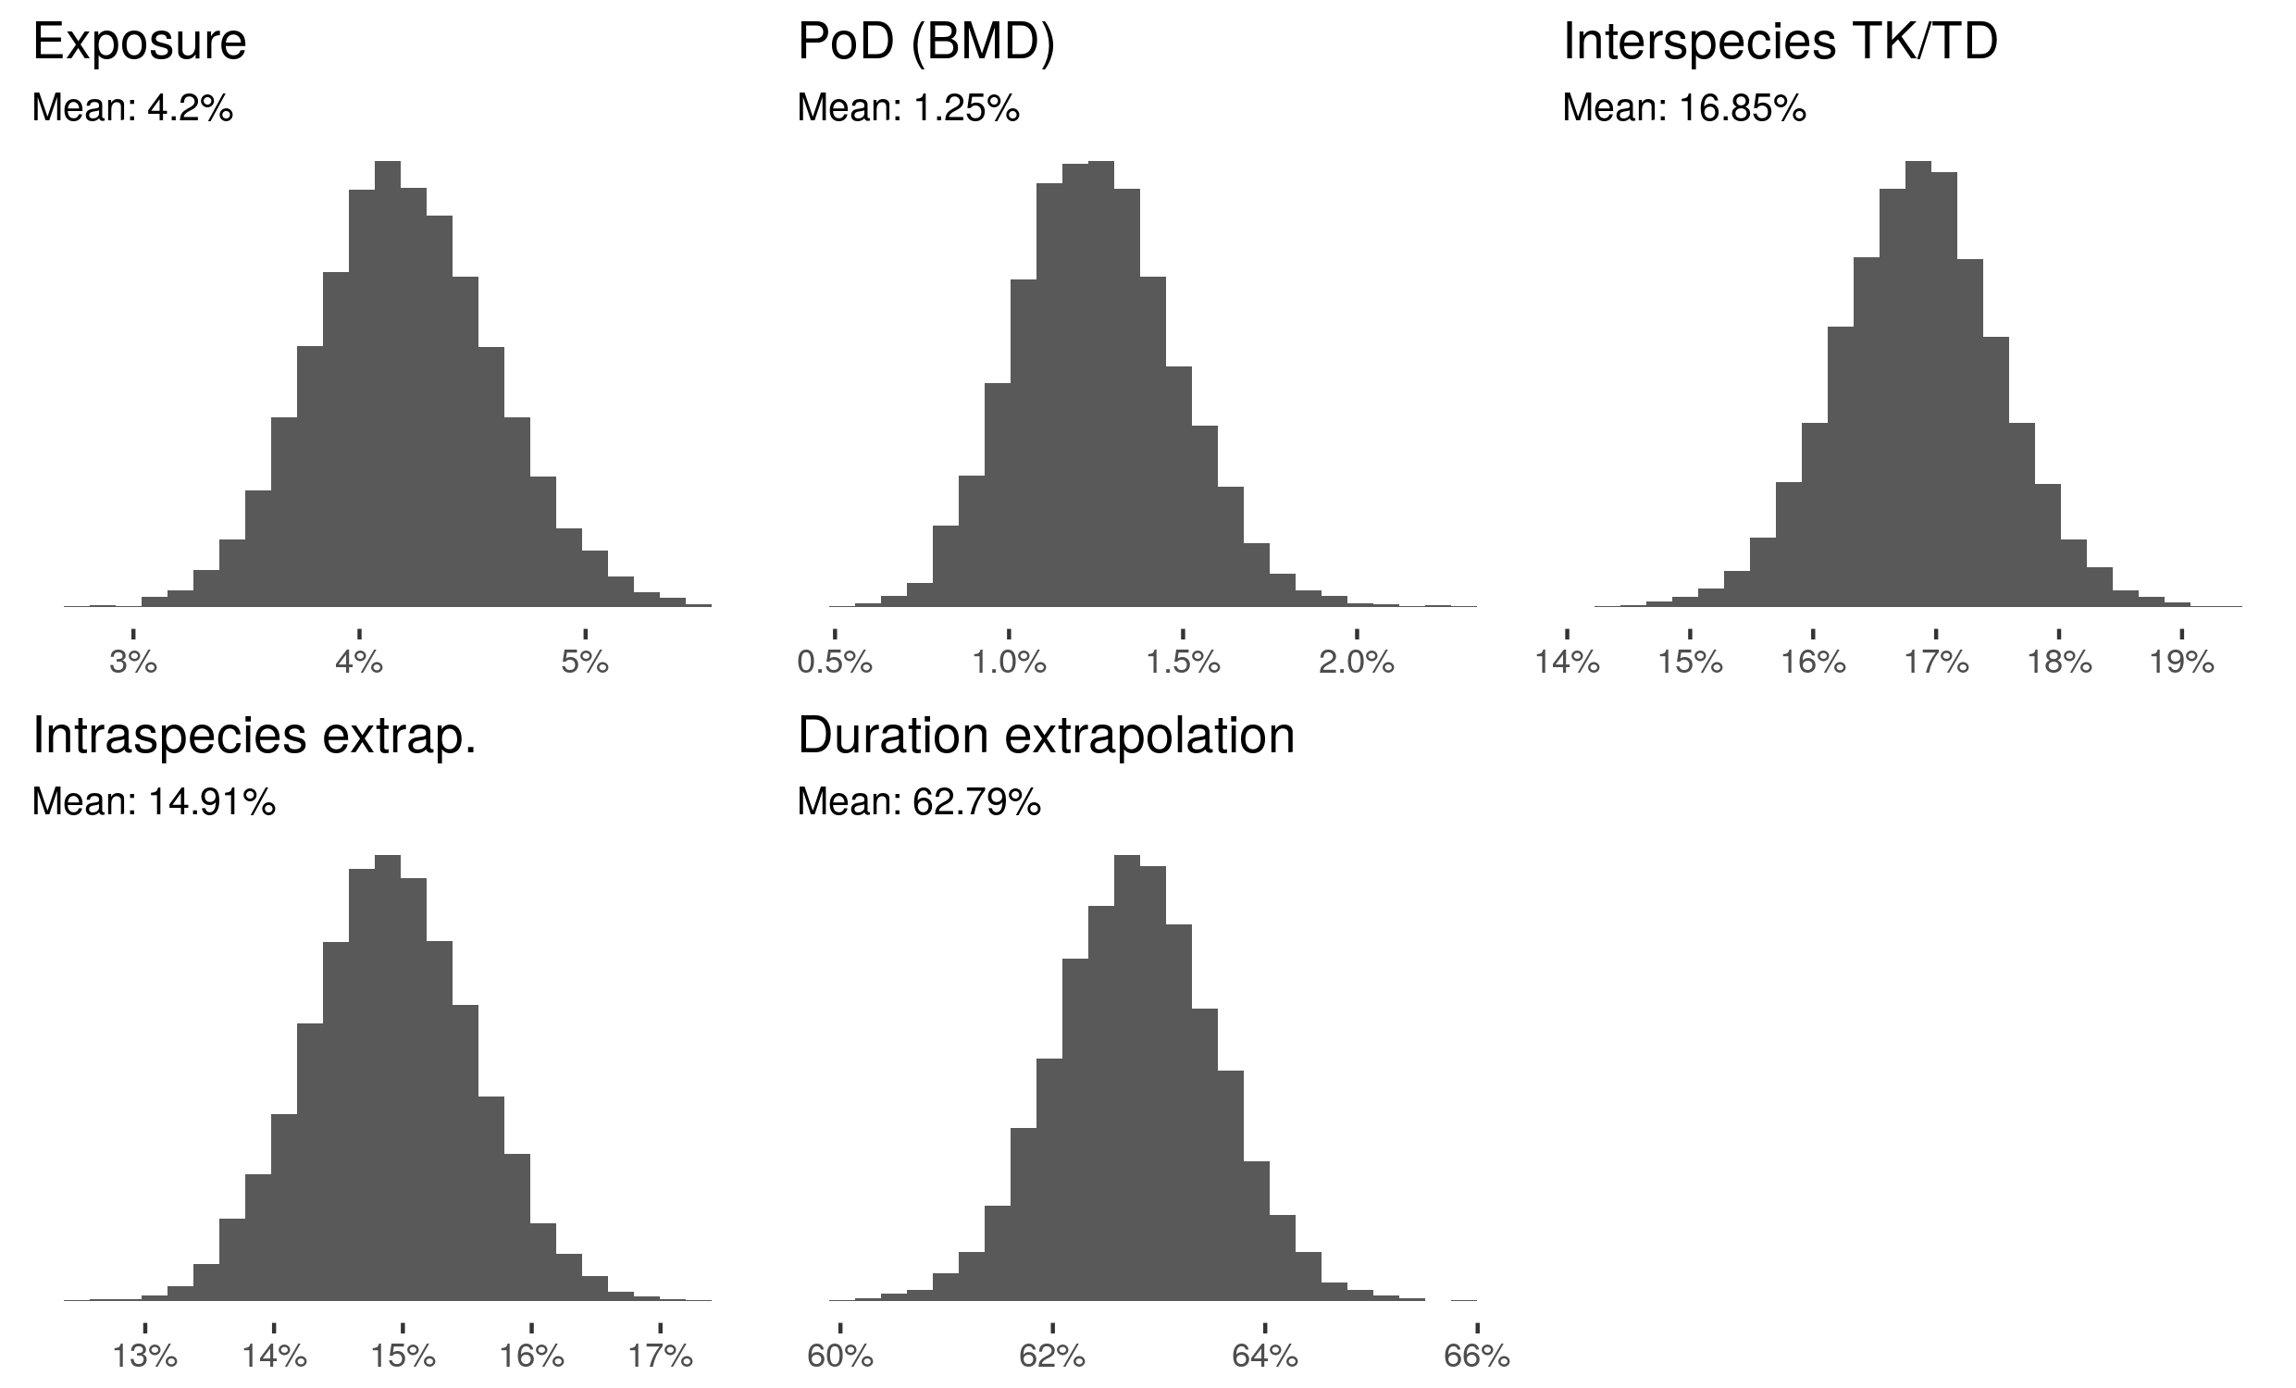
Figure SI_6: distributions of uncertainties in ES4 Inhalation scenario, numerically derived after 10.000 Monte Carlo simulations. The corresponding curve statistics are summarized in Table SI_10.
Table SI_10: Curve statistics of distribution of uncertainty of each factor in ES4 Inhalation scenario, quantified by the (normalized to 1) level of correlation between the factor and the resulting RCR by means of squared Spearman’s rank correlation coefficient.
 | Exposure | PoD | Interspecies TK/TD | Intraspecies extrapolation | Duration extrapolation
5% | 3.57E-02 | 9.04E-03 | 1.58E-01 | 1.38E-01 | 6.16E-01
95% | 4.88E-02 | 1.63E-02 | 1.79E-01 | 1.60E-01 | 6.40E-01
50% (Median) | 4.19E-02 | 1.25E-02 | 1.68E-01 | 1.49E-01 | 6.28E-01
Mean | 4.20E-02 | 1.25E-02 | 1.69E-01 | 1.49E-01 | 6.28E-01
SD | 4.00E-03 | 2.24E-03 | 6.64E-03 | 6.40E-03 | 7.60E-03

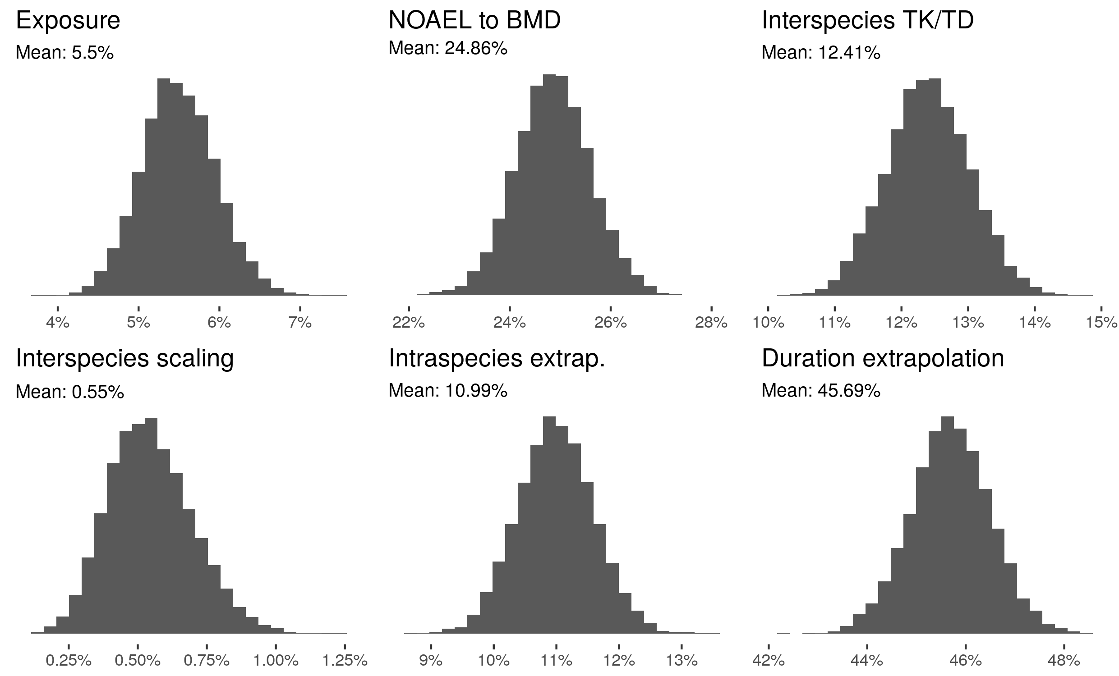
Figure SI_7: distributions of uncertainties in ES4 Peri-oral scenario, for both consumers and workers, numerically derived after 10.000 Monte Carlo simulations. The corresponding curve statistics are summarized in Table SI_11.
Table SI_11: Curve statistics of distribution of uncertainty of each factor in ES4 Perioral scenario, quantified by the (normalized to 1) level of correlation between the factor and the resulting RCR by means of squared Spearman’s rank correlation coefficient.
 | Exposure | NOAEL to BMD | Interspecies TK/TD | Interspecies scaling | Intraspecies extrapolation | Duration extrapolation
5% | 4.76E-02 | 2.36E-01 | 1.14E-01 | 3.13E-03 | 1.00E-01 | 0.443371
95% | 6.28E-02 | 2.61E-01 | 1.34E-01 | 8.16E-03 | 1.20E-01 | 4.70E-01
50% (Median) | 5.48E-02 | 2.49E-01 | 1.24E-01 | 5.37E-03 | 1.10E-01 | 4.57E-01
Mean | 5.50E-02 | 2.49E-01 | 1.24E-01 | 5.46E-03 | 1.10E-01 | 4.57E-01
SD | 4.62E-03 | 7.53E-03 | 6.21E-03 | 1.53E-03 | 6.00E-03 | 8.08E-03

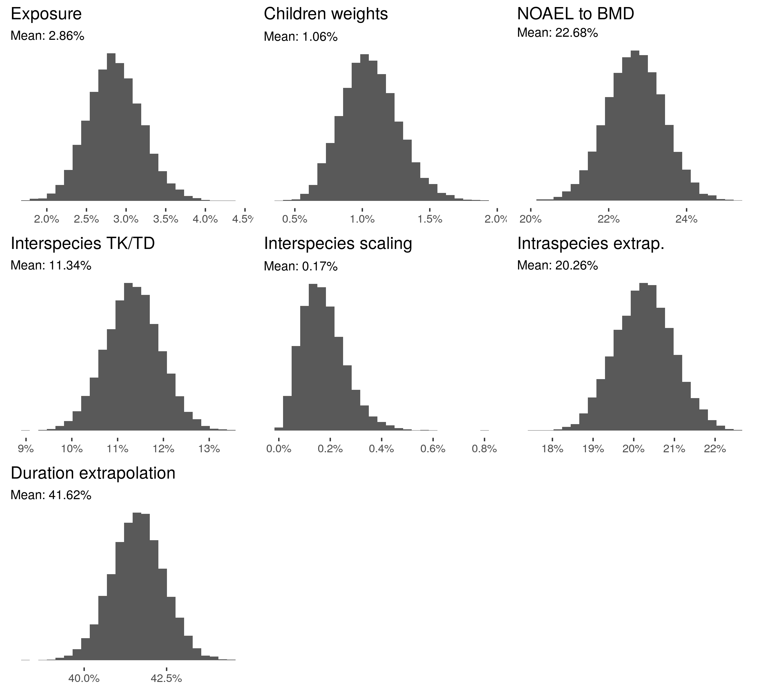
Figure SI_8: distributions of uncertainties in ES11 Oral scenario, for children (girls) aged 8 to 36 months, numerically derived after 10.000 Monte Carlo simulations. The corresponding curve statistics are summarized in Table SI_12.
Table SI_12: Curve statistics of distribution of uncertainty of each factor in ES11 Oral scenario, quantified by the (normalized to 1) level of correlation between the factor and the resulting RCR by means of squared Spearman’s rank correlation coefficient.
 | Exposure | Children weights | NOAEL to BMD | Interspecies TK/TD | Interspecies scaling | Intraspecies extrapolation | Duration extrapolation
5% | 2.32E-02 | 7.36E-03 | 2.15E-01 | 1.03E-01 | 5.59E-04 | 1.91E-01 | 4.03E-01
95% | 3.44E-02 | 1.42E-02 | 2.39E-01 | 1.23E-01 | 3.33E-03 | 2.15E-01 | 4.29E-01
50% (Median) | 2.85E-02 | 1.05E-02 | 2.27E-01 | 1.13E-01 | 1.65E-03 | 2.03E-01 | 4.16E-01
Mean | 2.86E-02 | 1.06E-02 | 2.27E-01 | 1.13E-01 | 1.75E-03 | 2.03E-01 | 4.16E-01
SD | 3.41E-03 | 2.10E-03 | 7.33E-03 | 6.00E-03 | 8.63E-04 | 7.23E-03 | 7.90E-03

SI4. Expert elicitation workshop
Table SI_13: List of experts that took part in the elicitation workshop to formulate exposure scenarios.
Name | Surname | Affiliation | Country
Maxim | Anisimov | Voronezh State University of Forestry and Technologies | Russia
Sviatoslav | Avilov | Voronezh State University | Russia
Gianpietro | Basei | Ca' Foscari University of Venice | Italy
Chiara | Civardi | EMPA | Switzerland
Joerg | Habicht | BASF | Germany
John | Horton | Koppers Performance Chemicals | USA
Danail | Hristozov | Ca' Foscari University of Venice | Italy
Keith | Killpack | SCS Global Services | United States
Elena | Kuznetsova | Institute of Physical Chemistry and Electrochemistry | Russia
Antonio | Marcomini | Ca' Foscari University of Venice | Italy
Liudmila | Novikova | Voronezh State University of Forestry and Technologies | Russia
Bernd | Nowack | EMPA | Switzerland
Lisa | Pizzol | Ca' Foscari University of Venice | Italy
Ivan | Pytskiy | Institute of Physical Chemistry and Electrochemistry | Russia
Janeck James | Scott-Fordsmand | Aarhus University | Sweden
Jan | Sedlack | Technical University of Zvolene | Slovakia
Elena | Semenzin | University Ca' Foscari of Venice | Italy
Sergei | Starodubov | Voronezh State University of Forestry and Technologies | Russia
Michael | Steinfeldt | University of Bremen | Germany
Michael | Tsang | University of Bordeaux | France
Steve | Uphill | Koppers Performance Chemicals | UK
Dmitrii | Zhukalin | Voronezh State University | Russia

References
Babick, F., Mielke, J., Wohlleben, W., Weigel, S. and Hodoroaba, V.-D. (2016) 'How reliably can a material be classified as a nanomaterial? Available particle-sizing techniques at work', Journal of Nanoparticle Research, 18(6), 158.

ISO (2013) 105-E04: 2013 - Textiles: Tests for colour fastness. Part E04 - Colour fastness to perspiration, International Organization for Standardization.

Mackevica, A, Olsson, M., Mines, P., Heggelund, L. and Hansen, S. 'Estimation of dermal transfer of nanoparticles from consumer articles by wipe sampling', In preparation.

NIOSH (2003) 'Elements on wipes: Method 9102' in NIOSH Manual of Analytical Methods, National Institute for Occupational Safety and Health.

Taurozzi, J. S., Hackley, V. A. and Wiesner, M. R. (2012) NIST Special Publication 1200-4. Preparation of Nanoscale TiO2 Dispersions in Biological Test Media for Toxicological Assessment, Gaithersburg, MD: National Institute of Standards and Technology.

Tiarks, F., Frechen, T., Kirsch, S., Leuninger, J., Melan, M., Pfau, A., Richter, F., Schuler, B. and Zhao, C. L. (2003) 'Formulation effects on the distribution of pigment particles in paints', Progress in Organic Coatings, 48(2), 140-152.

Walter, J., Löhr, K., Karabudak, E., Reis, W., Mikhael, J., Peukert, W., Wohlleben, W. and Cölfen, H. (2014) 'Multidimensional Analysis of Nanoparticles with Highly Disperse Properties Using Multiwavelength Analytical Ultracentrifugation', ACS Nano, 8(9), 8871-8886.

Wohlleben, W. (2012) 'Validity range of centrifuges for the regulation of nanomaterials: from classification to as-tested coronas', Journal of Nanoparticle Research, 14(12), 1300.

