Supplementary section

TABLE T1
Apparent amylose contents (AAC) of selected rice varieties
Rice variety | AAC (%)
TDK8 | 3.77±0.07
TDK11 | 3.72±0.15
DG | 19.71±0.59

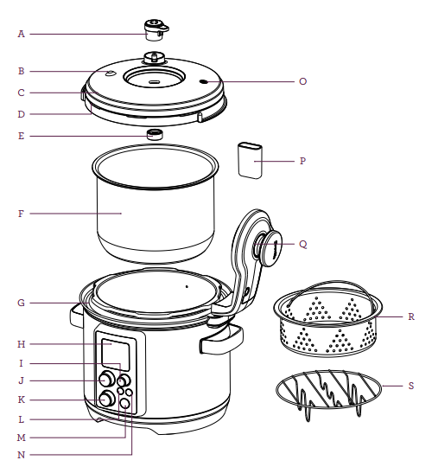
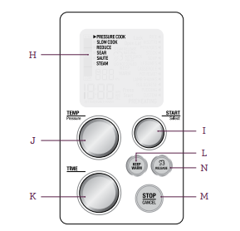
FIGURE S1 Labelled diagram of pressure cooker ((Breville, VIC, Australia)) used for parboiling; (A) Pressure Release Valve, (B) Pressure Safety Valve, (C) Dishwasher Safe Removable Lid, (D) Silicone Lid Seal, (E) Sealing Nut, (F) Removable Cooking Bowl, (G) Easy Clean Moat, (H Interactive LCD, (I) Start/Select Dial, (J) Temperature/Pressure Dial, (K) Time Dial, (L) Keep Warm, (M) Stop/Cancel, (N) Steam Release, (O) Safety Locking Pin, (P) Condensation Drip Cup, (Q) Lid Arm, (R) Stainless Steamer, and (S) Stainless Trivet (https://s.productreview.com.au/products/manuals/316271_56564e59ba9b1.pdf).
.

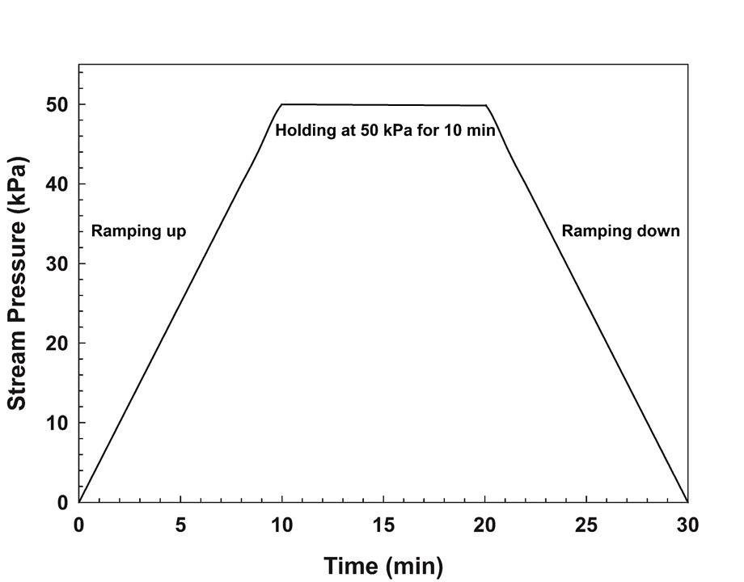
FIGURE S2 Time-pressure profile during steaming process

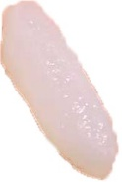
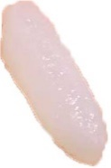
FIGURE S3 Trigonal pattern of cooked grains placement on the flat stage of TA-XTplus during TPA
35 mm diameter

