SUPPORTING INFORMATION
Biodistribution and biocompatibility of passion fruit-like nano-architectures in zebrafish

S1
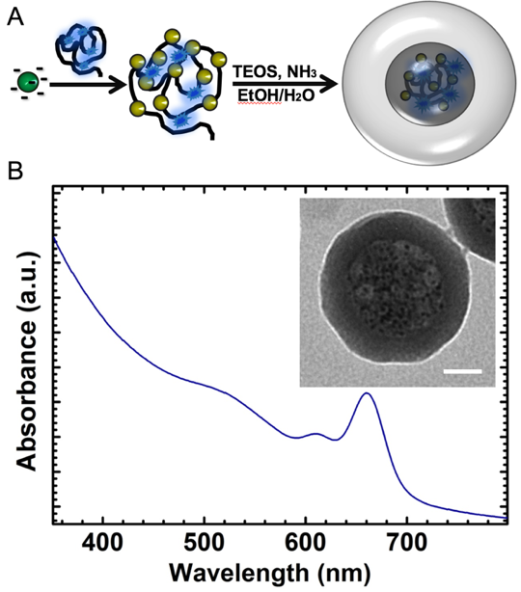

Figure S1. A) General scheme for the production of all-in-one NAs: negatively charged gold USNPs are assembled in aggregates employing dye-modified poly(L-lysine) (black line). The dye (blue clouds) is AlexaFluor647. The aggregates are employed for the formation of hollow silica nanocapsules by employing a modified Stöber method. B) UV-vis spectrum in PBS buffer of NAs. C) typical TEM image of NAs. Scale bar 25 nm.

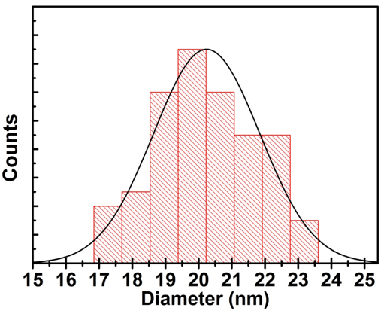
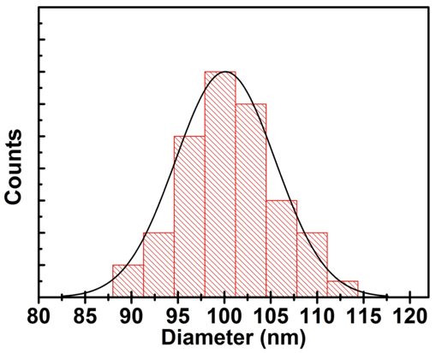
S2
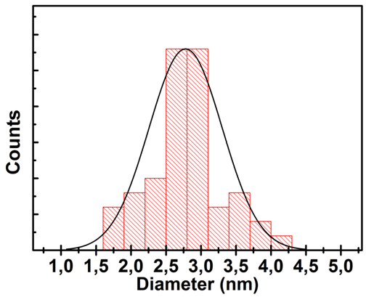
Figure S2. Size distribution histograms of gold USNPs (left), NAs (center), and NAs shell thickness (right) made on diameter measurements of at least 100 nanoparticles observed by TEM.

S3

Figure S3. Typical wide-area TEM image of NAs.

Figure S4. Development defects observed in zebrafish incubated with NAs, affecting head (A), tail (B), heart (C), yolk sac (D). Scale bars: 1 mm.

