Supplementary Material

Fluorescence quantum yield of CDOM in coastal zones of the Arctic seas

Anastasia N. Drozdovaa, Marina D. Kravchishinaa, Daria A. Khundzhuab,

Mikhail P. Freidkinb and Svetlana V. Patsaevab

aShirshov Institute of Oceanology, Russian Academy of Sciences, Moscow, Russia;

bFaculty of Physics, Lomonosov Moscow State University, Moscow, Russia

* Correspondence:

Anastasia N. Drozdova, Shirshov Institute of Oceanology, Russian Academy of Sciences, Moscow, Russia; *adrozdova@ocean.ru*

**Supplementary data for the Section 2.3.**

1. **Absorption measurements**

Absorption spectra in the range from 200 to 900 nm were detected using Solar PB2201 spectrophotometer in quartz cuvettes with an optical path length of 1, 3 or 5 cm.



**Figure S1. Absorption spectrum for one of the samples measured in the cell of 3 cm path length.**

1. **Fluorescence measurements and correction for inner-filter effect**

Fluorescence emission spectra were recorded with the help of Solar CM2203 luminescence spectrometer in standard quartz cuvettes for fluorimetry with excitation wavelengths altering in the range from 240 to 550 nm, while special attention was paid to recording emission spectra with excitation at 270, 310 and 355 nm. This choice of certain excitation wavelengths is associated with our previous studies, which showed the most important features in CDOM fluorescence spectra (Patsayeva and Reuter 1995; Milyukov et al. 2007).

To avoid inner filter effect the correction of fluorescence spectra was performed using absorbances at the excitation wavelength and within the wavelength range of registration. For this purpose, the detected fluorescence intensity at each emission wavelength was multiplied by ${10}^{0.5\left(D_{ex}+D_{em}\right)}$ ${10}^{0.5\left(D_{ex}+D_{em}\right)}$, where *D*ex and *D*em represent absorbances at the wavelength of excitation and emission, respectively, related to optical path of 1 cm. We modified the formulae from (Wünsch 2016) taking into account that the path lengths of excitation and emission beams inside the cell are 0.5 cm.



**Figure S2. Fluorescence emission spectra excited at 3 wavelengths for one of the samples and corrected for the inner-filter effect.**

In case of low fluorescence signals (relative to water Raman scattering) the emission spectra were measured twice and averaged data were used for further calculations.

Under excitation at 270 nm one can see so called protein-like fluorescence (Coble 2007; Trubetskaya, Richard, and Trubetskoj 2016). We express that protein-like fluorescence in natural waters with maximum around 300-350 nm could be caused not only by proteinous material, but could be resulted from aromatic amino-acids and phenols as well (Patsayeva and Reuter 1995).

To separate roughly contributions of protein-like and humic-like fluorescence bands excited at 270 nm we summarized fluorescence intensities in two spectral regions, below and above 370 nm. Overall fluorescence measured at *λ*ex = 270 nm was divided into two components, *IF*(UV) and *IF*(humic), corresponding to intensities integrated over 280-370 nm and 370-700 nm. Since it is not possible to separate contributions of different fluorophores into absorption spectra, we calculated FQY under excitation at 270 nm as two additive parts using the same absorbance at 270 nm, namely *Φ*(UV) and *Φ*(humic), which in total give *Φ*(*λ*ex = 270 nm).

1. **Fluorescence quantum yield calculation**

Calculation of the fluorescence quantum yield (FQY) was carried out by the method of reference compound used earlier in our works for CDOM samples of natural water (Milyukov et al. 2007; Shubina et al. 2010; Drozdova, Patsaeva, and Khundzhua 2017) and commercial humic preparations (Gosteva et al. 2012; Yakimenko et al. 2016).

The well-established photoluminescence quantum yield standard, an aqueous solution of quinine sulfate dehydrate, was used as the reference compound, since its fluorescence quantum yield is known and emission band resembles the humic-type fluorescence of CDOM in regards to its spectral shape and the position of maximum. The quinine sulfate dehydrate solution has the absolute fluorescence quantum yield 0.546 in aqueous 0.05 M solution of Н2SO4 (Velapoldi and Mielenz 1981). The standard solution was checked against Rhodamine G and Rhodamine B, and got the relative accuracy of 5% for the absolute FQY estimation for the quinine sulfate dehydrate solution.

The CDOM absorbance and fluorescence intensity depend on the sample origin. Better accuracy of FQY estimation was achieved for CDOM samples influenced by freshwater runoff with higher CDOM absorbances and smaller FQY values. Using replicates we estimated the relative FQY accuracy as 5% for those samples (Northern Dvina River). However for the open sea water samples with low FQY values about 1% (Stations 5226 and 5607) the relative accuracy was about 10%, which gives FQY accuracy at maximum around 0.1%. Even if we take FQY estimation relative error as 10%, the variation of FQY between samples and through the excitation wavelength range exceeds the FQY error.

1. **Fluorescence quantum yield for the White Sea water with salinity gradient along the Northern Dvina River plume.**

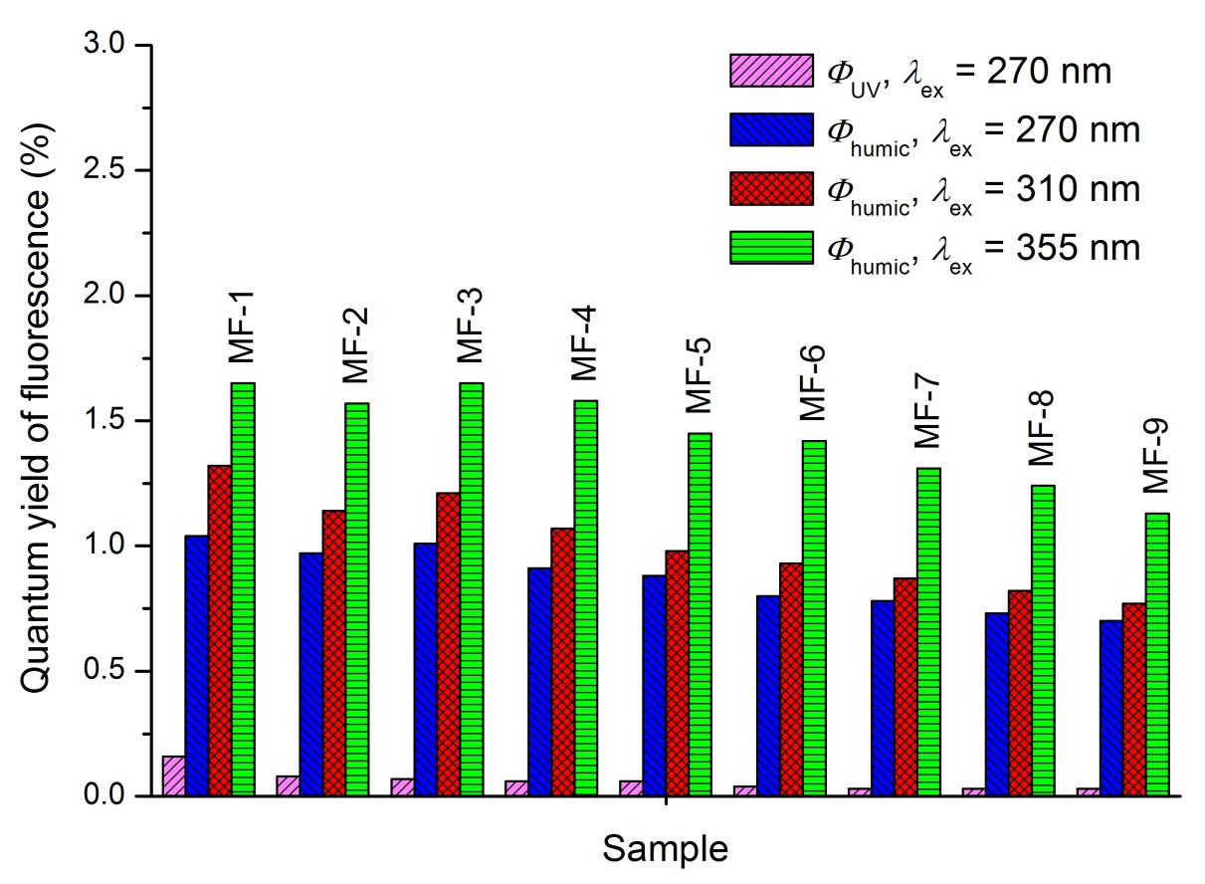

**Figure S3. FQY of CDOM measured at excitation wavelengths 270 nm, 310 nm, and 355 nm.**

The salinity of samples changed from 24.5 (MF-1) to 0 (MF-9).