Supplementary Material

Synthesis, crystal structure, fluorescence and electrochemical properties of two Ag(I) complexes based on 2-(4'-pyridyl)-benzoxazole/SPPh₃ ligands

SHANSHAN MAO, XINTONG HAN, CHUANG LI, GUOZHEN HUANG, KESHENG SHEN, XINKUI SHI and HUILU WU*

Content
Table S1. Selected hydrogen bonding distances (Å) and angles (°) for complex 2.

Figure S1. IR spectrum of complexes 1 and 2.

Figure S2. Photographic images of ligands and the complexes under ambient light and UV light irradiation.

Figure S3. UV-vis absorption and photoluminescence spectra of 4-PBO and complex 1 in the solid state.

Figure S4. UV-vis absorption and photoluminescence spectra of SPPh₃ and complex 2 in the solid state.

Table S1. Selected hydrogen bonding distances (Å) and angles (°) for complex 2.
D-H…A | d(D-H) | d(H...A) | d(D...A) |  | ∠(DHA)
C(6)-H(6)...O(2)#2 | 0.93 | 2.51 |  | 3.279(11) | 140.6
C(25)-H(25)...O(4)#3 | 0.93 | 2.49 |  | 3.275(12) | 141.7
Symmetry transformations used to generate equivalent atoms: #2 -x+1,-y+1,-z+1; #3 x,y+1,z

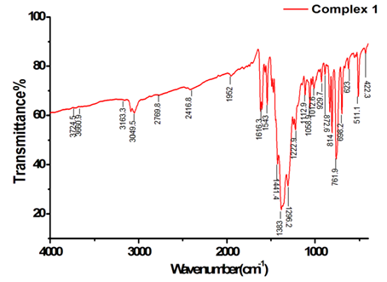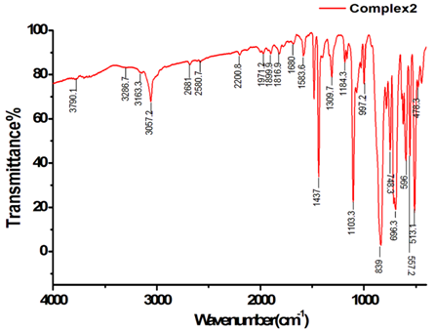
Figure S1. IR spectrum of complexes 1 and 2.

Figure S2. Photographic images of ligands and the complexes under ambient light and UV light irradiation.

Figure S3. UV-vis absorption and photoluminescence spectra of 4-PBO and complex 1 in the solid state.

Figure S4. UV-vis absorption and photoluminescence spectra of SPPh₃ and complex 2 in the solid state.

