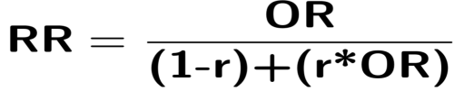
Supplementary equation: Formula linking OR and RR. RR=relative risk, OR=Odds ratio, r=AS rate for the population

