SUPPLEMENTARY FIGURES

LGE% (n=3)
AVC (n=4)

Reference group

MF (n=4)
ECV (n=2)

Supplementary Figure 1: Network graph for the effects of biomarkers on outcomes of Aortic stenosis. n =number of studies

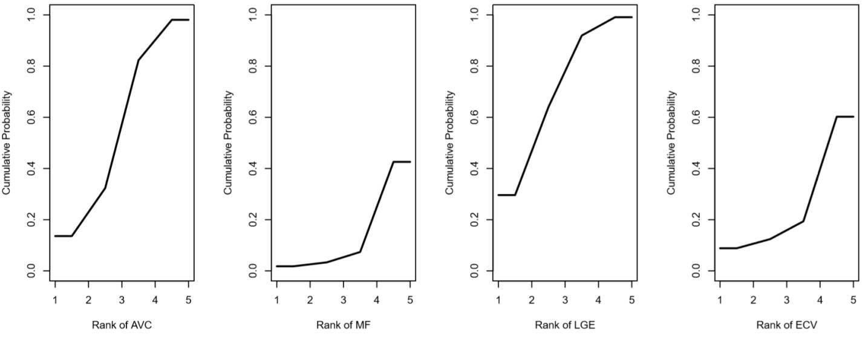
Supplementary Figure 2: SUCRA curve for the effect of biomarker of outcomes of AS. AVC: sucra=53%, Midwall Fibrosis: sucra=13%, LGE%: sucra=64%, ECV: sucra=23%

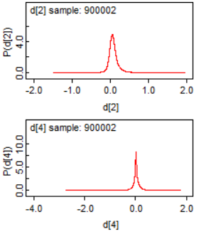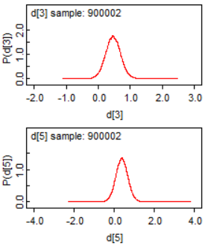
Supplementary Figure 3: Diagnostic density plots of Hedges’ g for each biomarker. d2=AVC, d3=Midwall fibrosis, d4=LGE%, d5=ECV

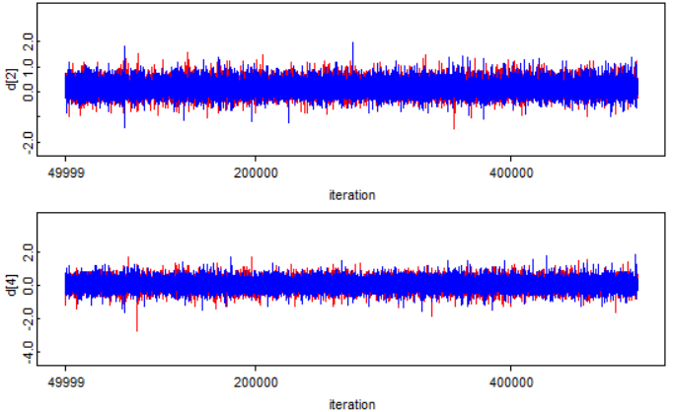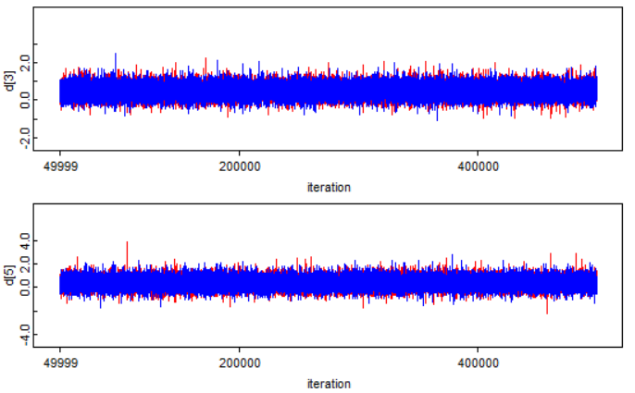
Supplementary Figure 4: History plots for convergence diagnostics

