Supplementary Table 1 Mean C_{t} values of 7 candidate reference genes in different samples of Cannabis
Gene | Different organs  of wild Cannabis  Mean Ct±SD | Different organs  of cultivated Cannabis  Mean Ct±SD | Leaves(of five  development stages) of wild Cannabis  Mean Ct±SD | Leaves(of five  development stages)of cultivated Cannabis  Mean Ct±SD | All samples  Mean Ct±SD
ACT2 | 17.96±0.90 | 18.17±0.82 | 18.24±0.62 | 18.11±0.32 | 18.12±0.69
18S rRNA | 21.24±0.92 | 21.33±0.35 | 20.83±0.50 | 21.11±0.51 | 21.13±0.62
GAPDH | 17.34±5.32 | 17.85±5.52 | 13.76±0.83 | 13.91±0.73 | 15.68±4.16
UBQ | 17.86±0.87 | 17.66±0.51 | 18.99±0.32 | 18.27±0.30 | 18.19±0.74
TUB | 17.39±2.23 | 17.68±1.49 | 19.90±0.67 | 20.05±0.58 | 18.75±1.85
PP2A | 19.02±0.58 | 19.28±0.56 | 20.22±0.50 | 20.05±0.31 | 19.64±0.70
EF1α | 19.77±0.47 | 19.74±0.41 | 20.11±0.46 | 19.96±0.33 | 19.89±0.44
SD: standard deviation.

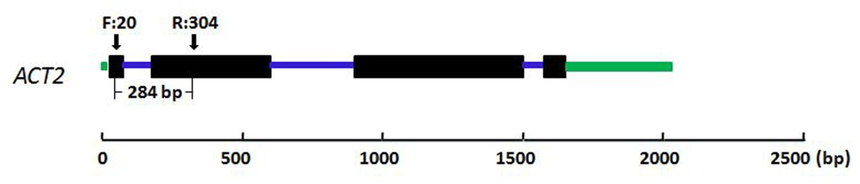
Figure S1 Exon-intron organization of ACT2 in the study. The black boxes, blue and green lines in the gene structure diagram represent exons, introns and UTR, respectively. The arrows indicate the position of forward and reverse primers, and follow their number on behalf of the gene location of primer. The numbers below the gene structure refer to the size of the genomic PCR products.

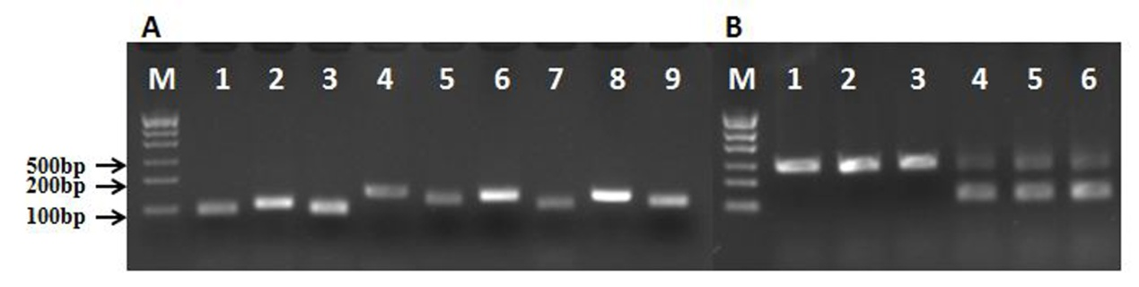
Figure S2 Amplification results of candidate genes with cDNA and genomic DNA of Cannabis, respectively. (A) Agarose electrophoresis analysis of the PCR products of seven reference genes and two target genes in Cannabis. M: Trans DNA Marker; Lane :1 EF1α, 2 UBQ, 3 PP2A, 4 ACT2, 5 18S rRNA, 6 TUB, 7 GAPDH, 8 OLS, 9 MDS; (B) Amplification results of ACT2 with 6 samples to assay RNA extraction quality. M: Trans DNA Marker; 1-3: genomic DNA as templates; 4-6: cDNA added 10ng genomic DNA as templates.

A:
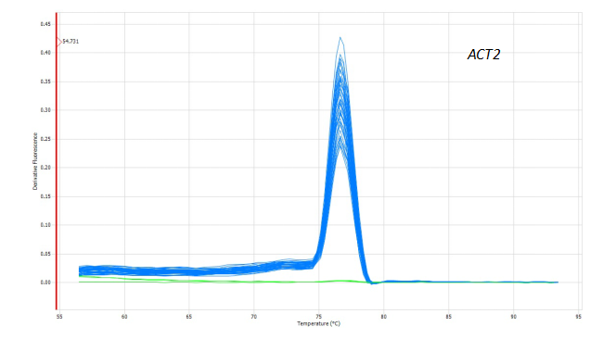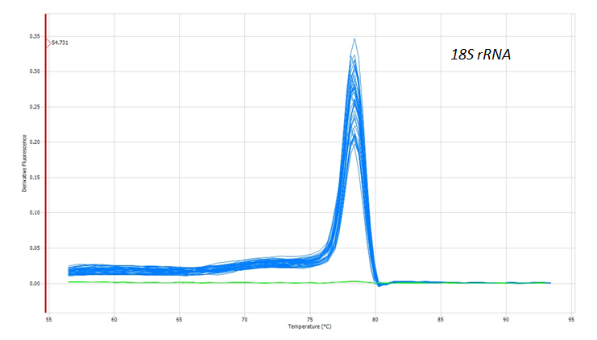
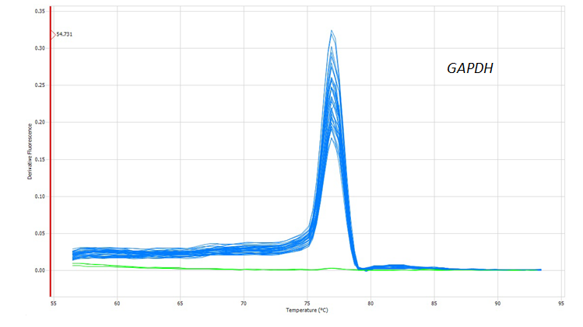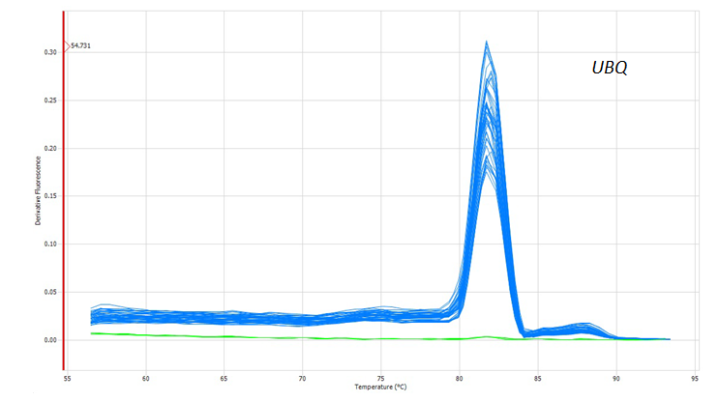
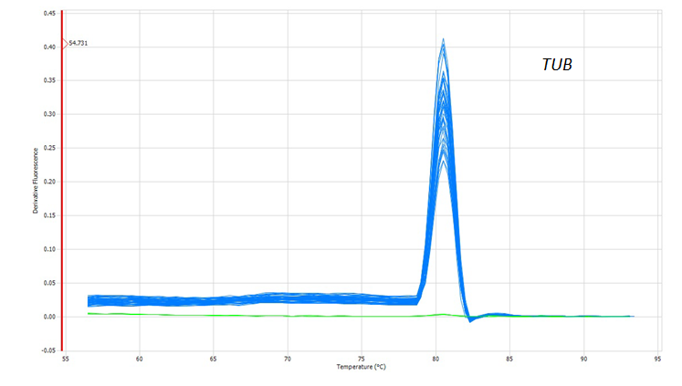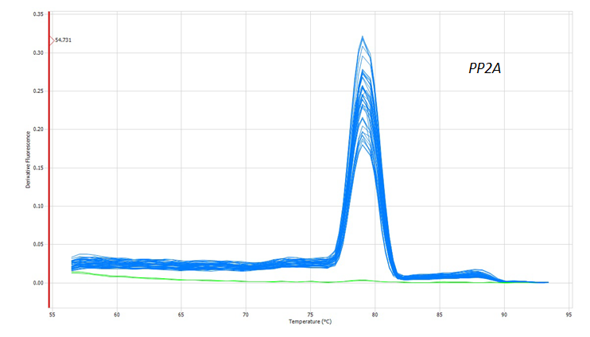
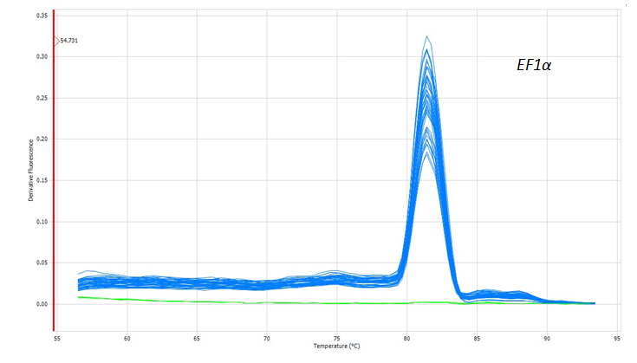
B:
Gene | ACT2 | 18S rRNA | GAPDH | UBQ | TUB | PP2A | EF1α
Dissociation temperature | 76.9 | 78.4 | 76.6 | 82.0 | 80.2 | 79.3 | 81.4

Figure S3 Dissociation curve of seven candidate reference genes(A) and temperature (B) of candidate reference genes.

