**SUPPLEMENTARY FIGURES**

**Effects of Inert and Energetic Nanoparticles on Burning Liquid Ethanol Droplets**

Hyung Sub Sim*1, Miguel A. Plascencia1, Andres Vargas1, John W. Bennewitz2, Owen I. Smith1, and Ann R. Karagozian*1

1Department of Mechanical and Aerospace Engineering

University of California, Los Angeles, Los Angeles, CA 90095

2ERC Inc., Air Force Research Laboratory, Building 8451, Edwards AFB, CA 93524

*Corresponding author emails: [hys5109@ucla.edu](mailto:hys5109@ucla.edu), ark@seas.ucla.edu

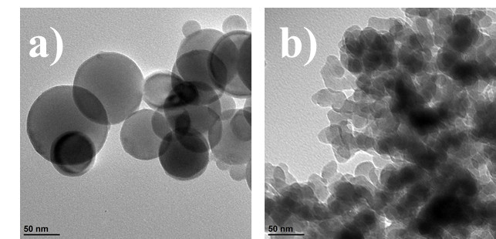

Figure S1. TEM images of as-received nanoparticles: (a) nAl and (b) nSiO2.



Figure S2. Temporal evolution of the normalized flame distance for neat fuel and fuel loaded with nAl and nSiO2 (case I experiments). The lines in the figure represent linear fits of the data for a given scaled time.



Figure S3. Transient profile of the normalized OH* chemiluminescent intensities for neat fuel and fuel loaded with nAl and nSiO2 (case I experiments). The lines in the figure represent polynomial fits to the data for a given normalized time.