Supplemental Data

Supplementary Table 1. Survey participants who screened out
Number of physicians
screened out at each question
N=186*
n (%)
Low current volume of B-cell ALL patients (fewer than 5) | 98 (53%)
Lack of appropriate board certification | 46 (25%)
Does not currently use MRD testing for ALL patients | 31 (17%)
Not enough years in practice | 8 (4%)
Not enough time spent in direct patient care | 7 (4%)
Hematology or oncology not primary specialty | 6 (3%)
Affiliation with pharmaceutical company | 6 (3%)
Primary hospital affiliation | 3 (2%)
*Counts not mutually exclusive

Supplementary Figure 1. MRD Tests Used by Adult and Pediatric Treaters
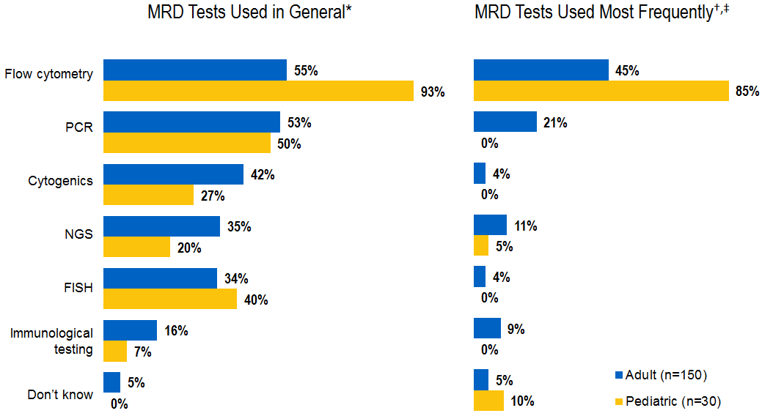
% of physicians
*Multiple responses were allowed
†Only one response allowed
‡Base: Adult treater (n=97); Pediatric treater (n=20)

