Supplemental Information

Aerosol Size Distribution Measurement of Electronic Cigarette Emissions Using Combined Differential Mobility and Inertial Impaction Methods. Smoking Machine and Puff Topography Influence.
Vladimir B. Mikheevª, Alexander Ivanovª, Eric A. Lucasª, Patrick L. Southª, Hendrik O. Colijn^{b}, and Pamela I. Clark^{c}.

ª Battelle Memorial Institute, Columbus, OH, USA
^{b} Center for Electron Microscopy and Analysis, Ohio State University, Columbus, OH, USA
^{c} University of Maryland, College Park, MD, USA

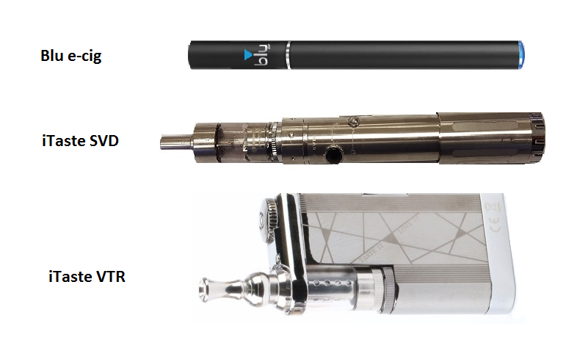
Figure S1. E—cigarettes used for the study.
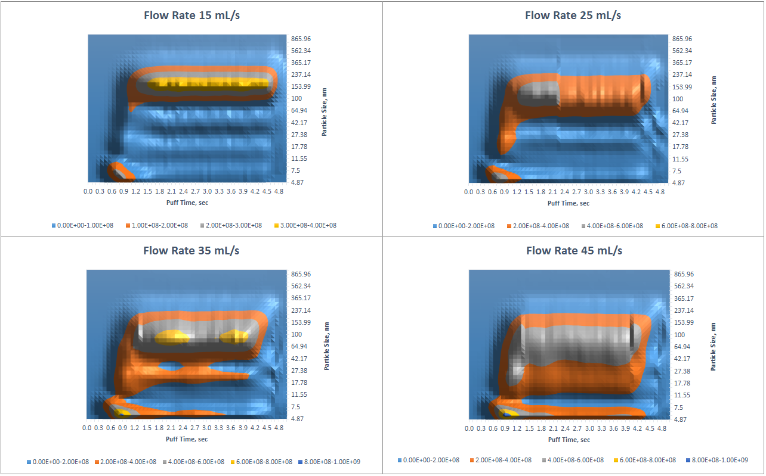
Figure S2. Aerosol Size Distribution, blu Classic Tobacco mid-nicotine. 5 s puff. Flow Rates 15, 25, 35, and 45 mL/s. Contour Plots.

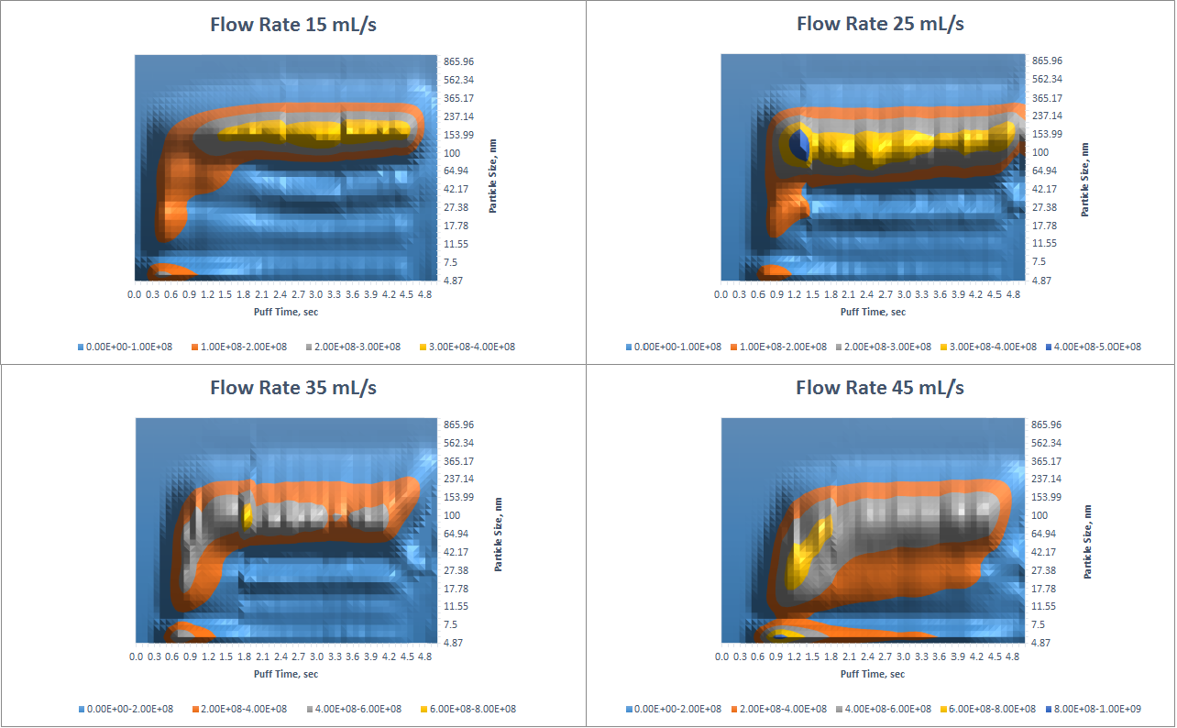
Figure S3. Aerosol Size Distribution, iTaste SVD, PG/VG=50/50, 5 V, 1.8 ohm. 5 s puff. Flow Rates 15, 25, 35, and 45 mL/s. Contour Plots.
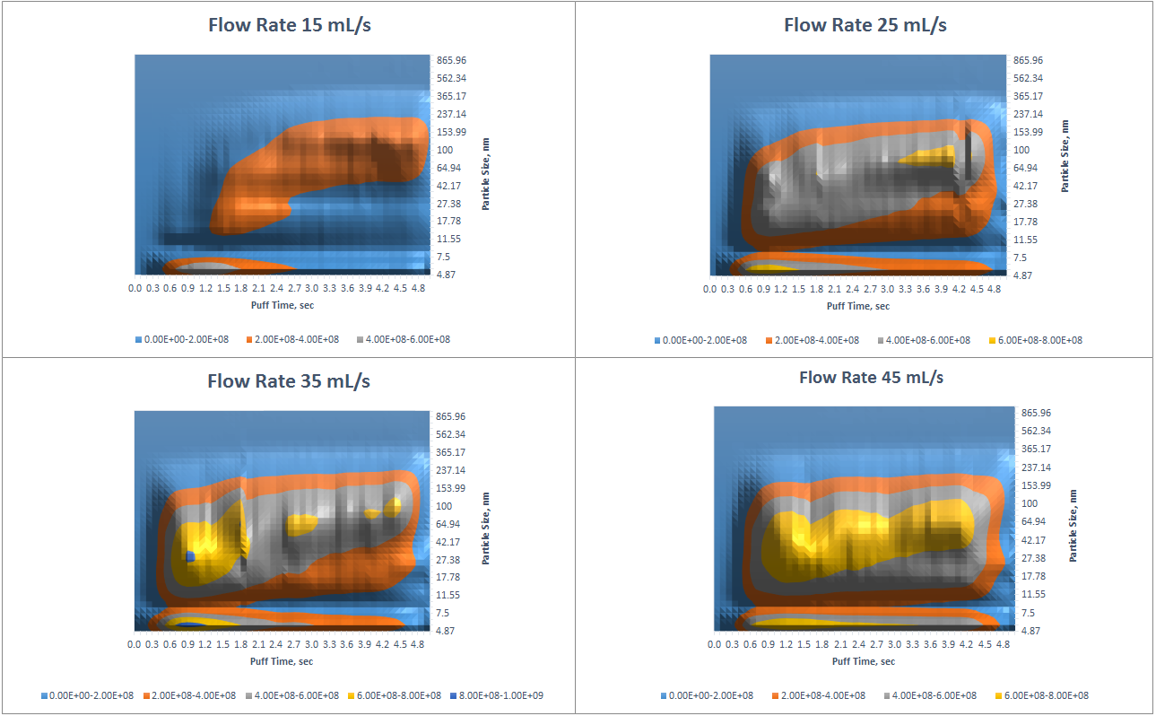
Figure S4. Aerosol Size Distribution, iTaste VTR, PG/VG=50/50, 4 V, 2.1 ohm. 5 s puff. Flow Rates 15, 25, 35, and 45 mL/s. Contour Plots.
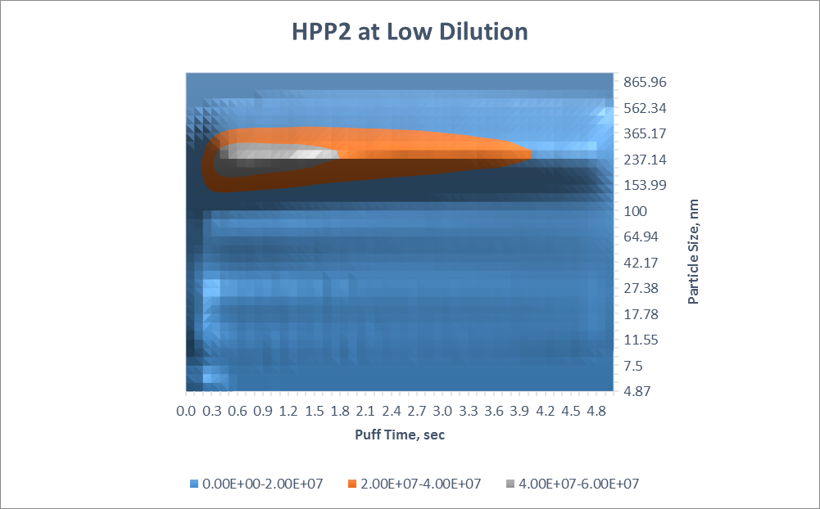
Figure S5. Aerosol Size Distribution, HPP2, blu Classic Tobacco mid-nicotine. 5 s puff. Flow Rate 25 mL/s. Contour Plot.
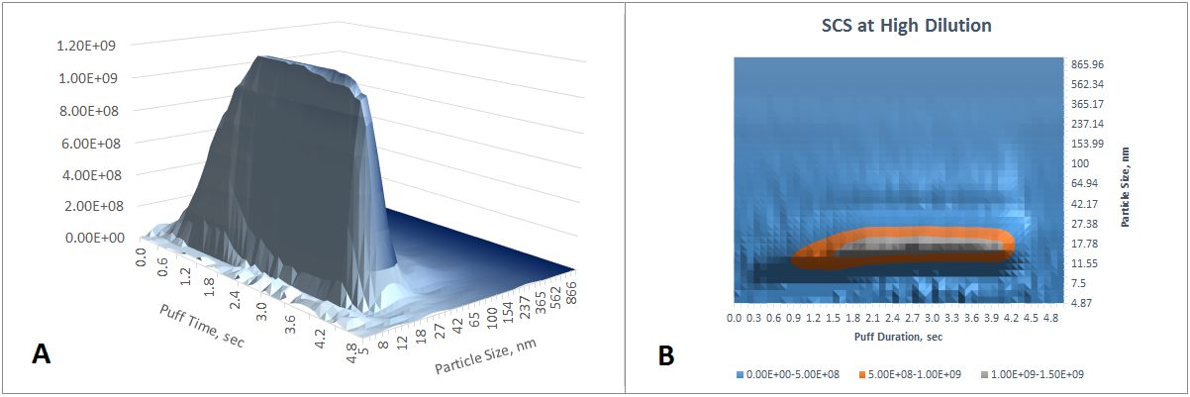
Figure S6. Aerosol Size Distribution, SCS, blu Classic Tobacco mid-nicotine. 5 s puff. Flow Rate 25 mL/s. Extra 1/500 Dilution. A -3D image generated by DMS500 software, B – is a contour plot.
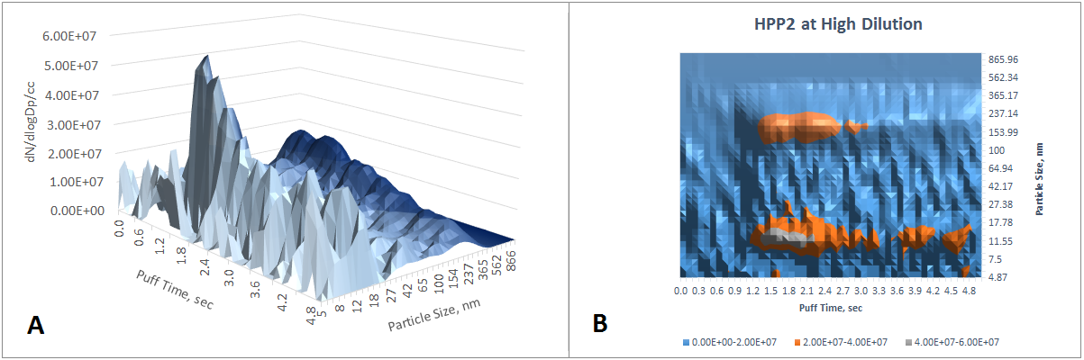
Figure S7. Aerosol Size Distribution, HPP2, blu Classic Tobacco mid-nicotine. 5 s puff. Flow Rate 25 mL/s. Extra 1/500 Dilution. A -3D image generated by DMS500 software, B – is a contour plot.

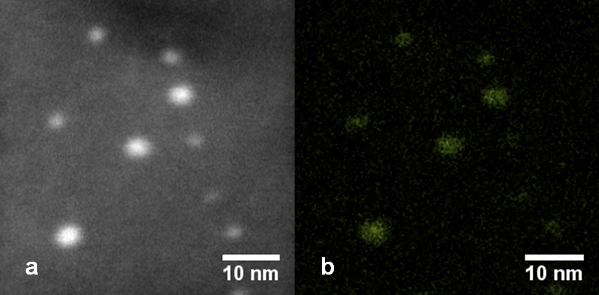
Figure S8. (a) HAADF STEM image of metallic nanoparticles collected on ELPI stage #5 (cut-off size ~93 nm). (b) STEM EDX map indicating the distribution of copper.

Table S1. LC-TOFMS Instrument Conditions
LC-HRMS System  UPLC  Mass Spectrometer | Waters Acquity I-class  AB Sciex TripleTOF 5600
Mass Spectrometer Source | DuoSpray: includes TurboIonSpray and APCI probes
Scan Ranges | TOF MS: 50-1000 m/z  IDA: 20-1000 m/z [High Resolution]
Mass Spec software | Analyst TF v 1.6
Analytical Column | GL Sciences InertSustain C18; 2.1 × 150 mm, 3 µm
Column Temperature | 60°C
Autosampler Temperature | 5°C
Mobile Phase Components | A: 0.1% (v/v) acetic acid in water  B: 0.1% (v/v) acetic acid in methanol
Gradient Profile | Time, min %B Flow rate, mL/min  0 10 0.2  0.5 10 0.2  15 100 0.2  20 100 0.2  20.01 10 0.2  30 10 0.2  All changes linear with respect to time.
Injection Volume | 10 µL
Run Time | 30 min

Table S2. Newly formed organic compounds detected in blu e-cig aerosol by LC-TOFMS method.
Flavors | Observed m/z | LC column retention time, min | Mass Spectrometer Signal Intensity | Candidate Formula
Both CC and PC | 213.07322 | 5.15 | 20005 | C8H11O3F3
 | 287.13655 | 5.98 | 38596 | C10H19N6O2P
 | 291.13381 | 7.33 | 59950 | C15H18N2O4
 | 215.11858 | 8.57 | 63037 | C13H14N2O
 | 215.11779 | 9.06 | 57964 | C13H14N2O
 | 239.08879 | 9.25 | 95246 | C8H20N2P2S
 | 295.14427 | 12.29 | 527691 | C18H18N2O2
 | 309.16 | 13.25 | 203073 | C19H20N2O2
CC | 241.06821 | 5.35 | 35704.5 | C9H11O4F3
 | 225.07326 | 7.05 | 16081.5 | C7H16N2O2S2
 | 211.08645 | 8.04 | 48740.75 | C13H10N2O
 | 255.07644 | 8.22 | 17532.5 | C14H10N2O3
 | 293.12834 | 14.61 | 83302.5 | C18H16N2O2
PC | 297.15932 | 6.62 | 31673 | C18H20N2O2
 | 289.10661 | 11.78 | 30544 | C14H18O2F2S

