Quality of ONSD measurement

Patient Number : |__| |__| Expert Number : ……………………

2D – Mode. yes No

Linear Probe 7,5 Mhz (Hight frequency) yes No

Use Vascular system yes No

Depth 4cm yes No

Positioning the probe : horizontal (transverse plane) yes No

0.3 cm from the retina, parallel to the longitudinal axis
of the NO yes No

Measurement in the perpendicular axis of NO yes No

Measurement of both eyes yes No

Mean ONSD measurement : ………….mm

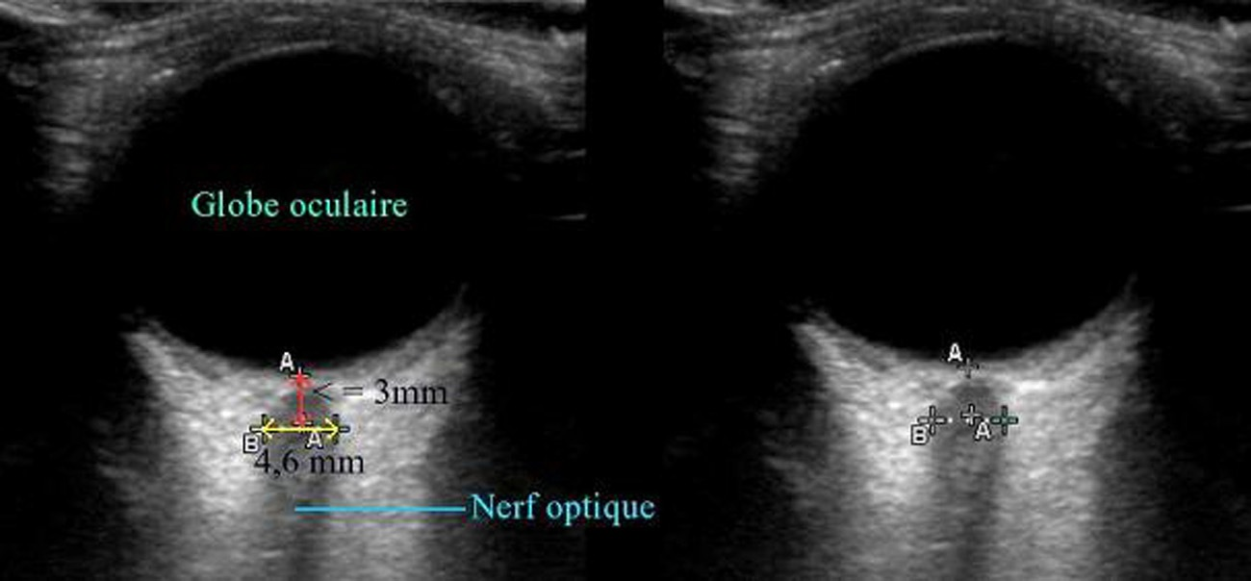
Measurement validated Yes No

