Supporting Information
Self-Supporting Soft Carbon Fibers as Binder-free and Flexible Anodes for High-Performance Sodium-Ion Batteries
Xueping Gao^{a#}, Yongling An^{a#}, Wenshu Zhangª, Menglan Yuª, Lijie Ciª, Jinkui Fengª*
ªSDU & Rice Joint Center for Carbon Nanomaterials, Key Laboratory for Liquid–Solid Structural Evolution & Processing of Materials (Ministry of Education), School of Materials Science and Engineering, Shandong University, Jinan 250061, China.
*Corresponding author: Jinkui Feng, E-mail: jinkui@sdu.edu.cn
#These authors contributed equally to this work

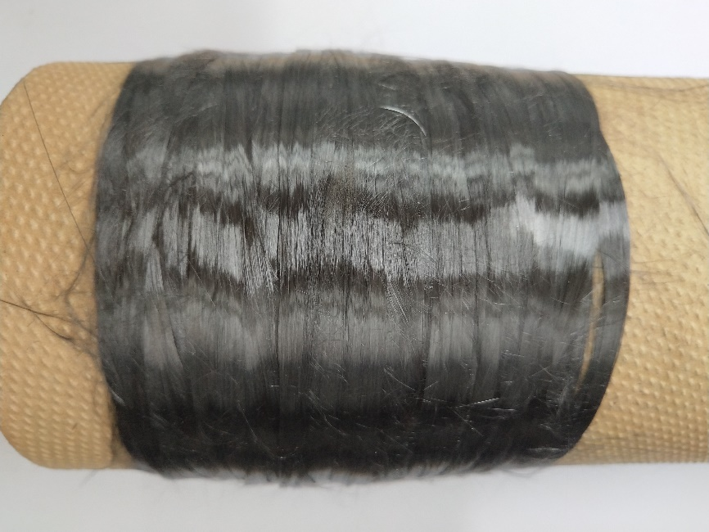
Figure S1. Photo of the carbon fiber.

Figure S3. TGA curves of PAN precursor.
Figure S3. Nitrogen adsorption−desorption isotherm of the carbon fiber at 800 ºC (a), 1200 ºC (b) and 2300 ºC (c).

