**Curcumin-Loaded PLGA-PEG Nanoparticles conjugated with B6 Peptide for Potential Use in Alzheimer’s disease**

Shengnuo Fan a, 1, Yuqiu Zheng a, 1, Xuan Liu b, Wenli Fang a, Xiaoyu Chen a, c, Wang Liao a, Xiuna Jing a, Ming Lei a, Enxiang Tao a, Qiulan Ma d, Xingmei Zhang e, Rui Guo b, *, Jun Liu a, f, g, **

a Department of Neurology, Sun Yat-sen Memorial Hospital, Sun Yat-sen University, 107 Yanjiang West Road, Guangzhou, 510120, China

b Key Laboratory of Biomaterials of Guangdong Higher Education Institutes, Department of Biomedical Engineering, Jinan University, Guangzhou 510632, China

c Zhongshan City People’s Hospital, Zhongshan City, Guangdong Province, 528400, China

d Department of Neurology, University of California, Los Angeles, California 90095, USA.

e Applied Immunology and Immunotherapy, Department of Clinical Neuroscience, Karolinska Institute, Center for Molecular Medicine, Karolinska University Hospital at Solna, CMM L8:04, Karolinska Sjukhuset, S-171 76 Stockholm, Sweden

f Laboratory of RNA and Major Diseases of Brain and Heart, Sun Yat-sen Memorial Hospital, Sun Yat-sen University, Guangzhou, 510120, China

g Guangdong Province Key Laboratory of Brain Function and Disease, Zhongshan School of Medicine, Sun Yat-sen University, Guangzhou 510080, China

**\*** Corresponding author. Key Laboratory of Biomaterials of Guangdong Higher Education Institutes, Department of Biomedical Engineering, Jinan University, Guangzhou 510632, China.

**\*\*** Corresponding author. Department of Neurology, Sun Yat-sen Memorial Hospital, Sun Yat-sen University, 107 Yanjiang West Road, Guangzhou, 510120, China.  
E-mail addresses for corresponding authors: guorui@jnu.edu.cn (R. Guo), docliujun@hotmail.com (J. Liu).

1 These two authors contributed equally to this work.

**Table. S1 M**olecular weight of PLGA-PEG, acrylated PLGA-PEG, PLGA-PEG-B6 and PLGA-PEG-B6/Cur determined by GPC analysis.

|  |  |  |  |
| --- | --- | --- | --- |
| Samples | Mn | Mw | Mw/Mn |
| PLGA-PEG | 12000 | 25000 | 2.08 |
| acrylated PLGA-PEG | 12800 | 25600 | 2.00 |
| PLGA-PEG-B6 | 13200 | 26000 | 1.96 |
| PLGA-PEG-B6/Cur | 13600 | 26600 | 1.95 |

**Table. S2** Clotting kinetics parameters of human whole blood mixed with aqueous PLGA-PEG-B6 solutions at different concentrations

|  |  |  |  |  |
| --- | --- | --- | --- | --- |
| samples | R (min) | K (min) | α (deg) | MA (mm) |
| Normal range | 5-10 | 1-3 | 53-72 | 50-70 |
| PBS control | 5.1 | 3.0 | 51.9 | 53.5 |
| 0.01 mg/mL | 5.0 | 3.2 | 52.2 | 53.0 |
| 0.05 mg/mL | 5.0 | 4.8↑ | 40.8↓ | 51.4 |
| 0.1 mg/mL | 6.1 | 5.6↑ | 37.1↓ | 46.2↓ |

**Figure legends:**

**Fig. S1** Particle sizes of PLGA-PEG-B6 and PLGA-PEG-B6/Cur. The mean diameter of PLGA-PEG-B6 particles were less than 100 nm and curcumin encapsulation slightly increase the particle size.

**Fig. S2** Release profiles of curcumin from PLGA-PEG-B6/Cur micelles. The cumulative release of curcumin initially shifted to 29.60% in the first hour, followed by a sustained release for a period of 72 h. Each point represents mean ± SD.

**Fig. S3** The HPLC of B6 peptide

**Fig. S4** The Maldi Toff MS of B6 peptide

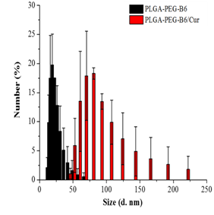

**Fig. S1**.



**Fig. S2**.

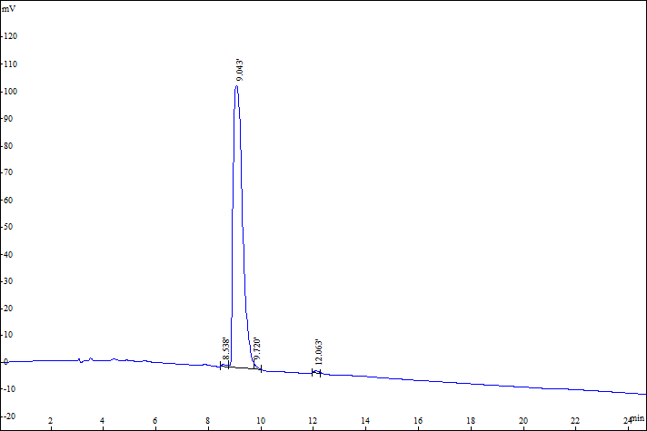

**Fig. S3**



**Fig. S4**