Supplementary Material

Linking seasonal pattern of microbial diversity to long-term increase in winter temperature in waters of a Patagonia fjord
Marcelo H. Gutiérrez*, Diego Narváez, Giovanni Daneri, Paulina Montero, Iván Pérez-Santos, Silvio Pantoja
* Correspondence: Dr. Marcelo H. Gutiérrez: magutier@udec.cl

Supplementary Figures and Tables

Supplementary Figures
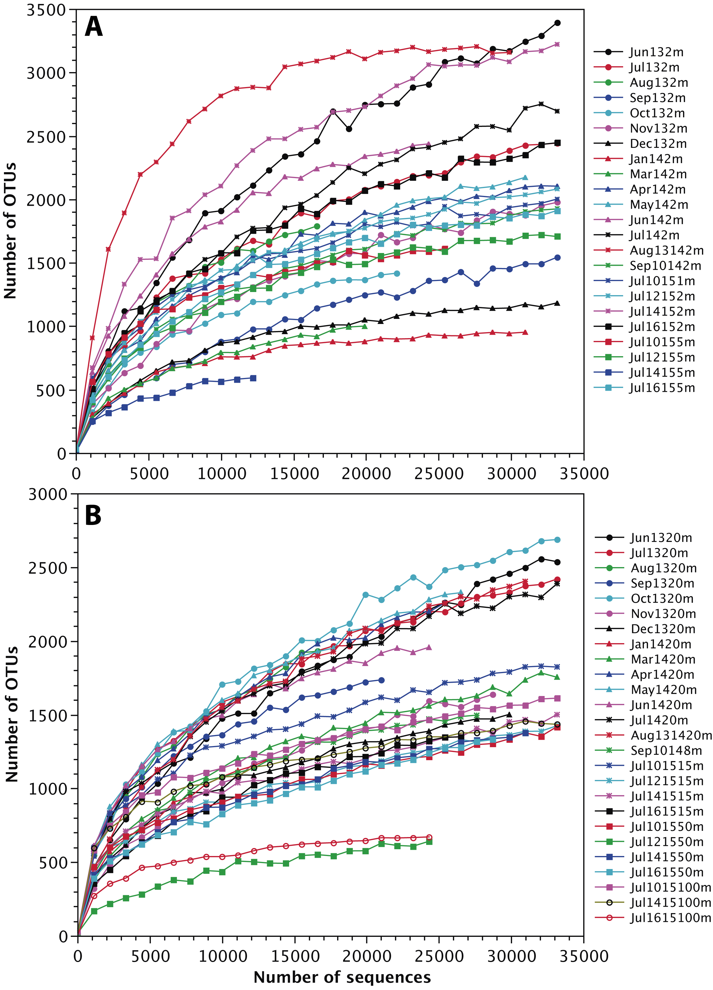

Supplementary Figure 1. Rarefaction curves for prokaryote assemblages from surface (A) and subsurface and deeper (B) waters for each sampling dates and depths in the Puyuhuapi fjord.

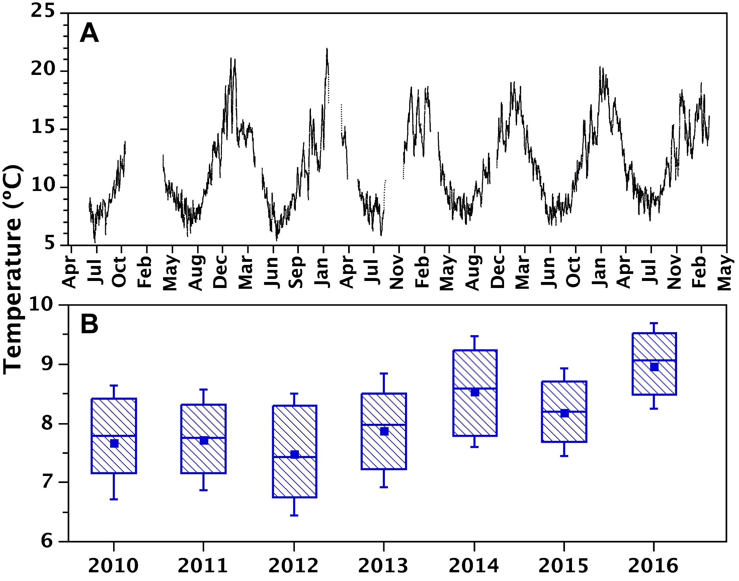
Supplementary Figure 2. Time series of surface water temperature (A) and boxplots of average winter temperature (June-September) in the time series of surface water temperature in Puyuhuapi Fjord (B). Winter temperatures of 2013, 2014, 2015 and 2016 were significantly different (Mann-Whitney U test, p < 0.05) of those of 2010, 2011 and 2012. Significant differences were also found between temperatures of successive winters from 2012 to 2016.

Supplementary Tables
Supplementary Table 1. Abundance of diatoms and dinoflagellates in waters sampled between June 2013 and September 2014, and during July 2015, at the fixed station located in Puyuhuapi fjord.

Date | Depth (m) | Diatoms (cell mL⁻¹) | Dinoflagellates (cell mL⁻¹)
1-Jun-13 | 2 | 234 | 2864
6-Jul-13 | 2 | 167 | 142
8-Aug-13 | 2 | 15631 | 241
28-Sep-13 | 2 | 7882 | 72
29-Oct-13 | 2 | 3283 | 97
24-Nov-13 | 2 | 2535 | 0
18-Dec-13 | 2 | 2052 | 60
22-Jan-14 | 2 | 2776 | 48
5-Mar-14 | 2 | 2281 | 121
28-Apr-14 | 2 | 3150 | 676
13-May-14 | 2 | 2197 | 72
17-Jun-14 | 2 | 92 | 483
9-Jul-14 | 2 | 94 | 157
13-Aug-14 | 2 | 52 | 144
10-Sep-14 | 2 | 3278 | 6
10-Jul-15 | 1 | 32 | 3167
12-Jul-15 | 2 | 646 | 7950
14-Jul-15 | 2 | 194 | 3975
16-Jul-15 | 2 | 549 | 3200
10-Jul-15 | 5 | 549 | 614
12-Jul-15 | 5 | 194 | 4719
14-Jul-15 | 5 | 323 | 4201
16-Jul-15 | 5 | 162 | 3135
1-Jun-13 | 20 | 256 | 19
6-Jul-13 | 20 | 82 | 51
8-Aug-13 | 20 | 7556 | 97
28-Sep-13 | 20 | 193 | 145
29-Oct-13 | 20 | 1931 | 24
24-Nov-13 | 20 | 1074 | 0
18-Dec-13 | 20 | 616 | 36
22-Jan-14 | 20 | 591 | 36
5-Mar-14 | 20 | 2511 | 133
28-Apr-14 | 20 | 1255 | 84
13-May-14 | 20 | 724 | 12
17-Jun-14 | 20 | 31 | 181
9-Jul-14 | 20 | 17 | 84
13-Aug-14 | 20 | 0 | 0
10-Sep-14 | 8 | 465 | 6
10-Jul-15 | 15 | 0 | 32
12-Jul-15 | 15 | 194 | 32
14-Jul-15 | 15 | 0 | 388
16-Jul-15 | 15 | 162 | 582
10-Jul-15 | 50 | 0 | 0
12-Jul-15 | 50 | 0 | 19
14-Jul-15 | 50 | 32 | 52
16-Jul-15 | 50 | 6 | 58
10-Jul-15 | 100 | 0 | 0
12-Jul-15 | 100 | 0 | 0
14-Jul-15 | 100 | 0 | 0
16-Jul-15 | 100 | 368 | 1306

