Supplementary Material

Synthesis, characterization, antioxidant and antibacterial properties of non‑peripherally and peripherally tetra-substituted phthalocyanines

ESMA HANDE ALICI, ARMAĞAN GÜNSEL, MUSTAFA AKIN, AHMET T. BILGIÇLI, GULNUR ARABACI* and M. NILÜFER YARASIR*

**Contents**

**Fig. S1.** FT-IR spectra of compound **7**.

**Fig. S2.** FT-IR spectra of compound **8**.

**Fig. S3.** Mass spectra of compound **7**.

**Fig. S4.** Mass spectra of compound **8**.

**Fig. S5.** Antibacterial activities of phthalocyanines **3**, **5** and **7** bearing 4-methoxy-phenoxy substituents on the non-peripheral positions and Ampicillin against *Bacillus subtilis* (ATCC 6633).

**Fig. S6.** Antibacterial activities of phthalocyanines **4**, **6** and **8** bearing 4-methoxy-phenoxy substituents on the peripheral positions against *Bacillus subtilis* (ATCC 6633).

**Fig. S7.** Antibacterial activities of phthalocyanines **3**, **5** and **7** bearing 4-methoxy-phenoxy substituents on the non-peripheral positions and Ampicillin against *Bacillus subtilis* (ATCC 6051).

**Fig. S8.** Antibacterial activities of phthalocyanines **4**, **6** and **8** bearing 4-methoxy-phenoxy substituents on the peripheral positions against *Bacillus subtilis* (ATCC 6051).

**Fig. S9.** Antibacterial activities of phthalocyanines **3**, **5** and **7** bearing 4-methoxy-phenoxy substituents on the non-peripheral positions and Ampicillin against *Escherichia coli* (ATCC 25922).

**Fig. S10.** Antibacterial activities of phthalocyanines **4**, **6** and **8** bearing 4-methoxy-phenoxy substituents on the peripheral positions against *Escherichia coli* (ATCC 25922).

**Fig. S11.** Antibacterial activities of phthalocyanines **3**, **5** and **7** bearing 4-methoxy-phenoxy substituents on the non-peripheral positions and Ampicillin against *Bacillus cereus* (SBT8).

**Fig. S12.** Antibacterial activities of phthalocyanines **4**, **6** and **8** bearing 4-methoxy-phenoxy substituents on the peripheral positions against *Bacillus cereus* (SBT8).

**Fig. S13.** Antibacterial activities of phthalocyanines **3**, **5** and **7** bearing 4-methoxy-phenoxy substituents on the non-peripheral positions and Ampicillin against *Staphylococcus aureus* (ATCC 25923).

**Fig. S14.** Antibacterial activities of phthalocyanines **4**, **6** and **8** bearing 4-methoxy-phenoxy substituents on the peripheral positions against *Staphylococcus aureus* (ATCC 25923).



**Fig. S1.** FT-IR spectra of compound **7**.



**Fig. S2.** FT-IR spectra of compound **8**.

C:\Users\Sau\Desktop\7 nolu madde masss.tif

**Fig. S3.** Mass spectra of compound **7**.

C:\Users\Sau\Desktop\8 nolu madde Mass spectrum.tif

**Fig. S4.** Mass spectra of compound **8**.

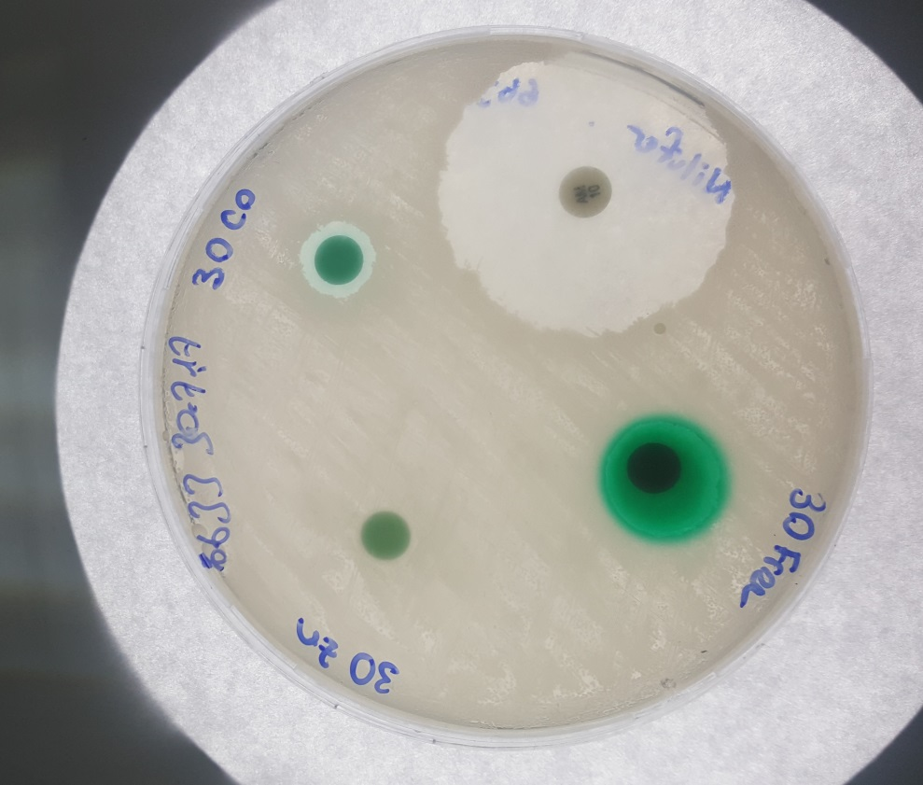

**Fig. S5.** Antibacterial activities of phthalocyanines **3**, **5** and **7** bearing 4-methoxy-phenoxy substituents on the non-peripheral positions and Ampicillin against *Bacillus subtilis* (ATCC 6633).

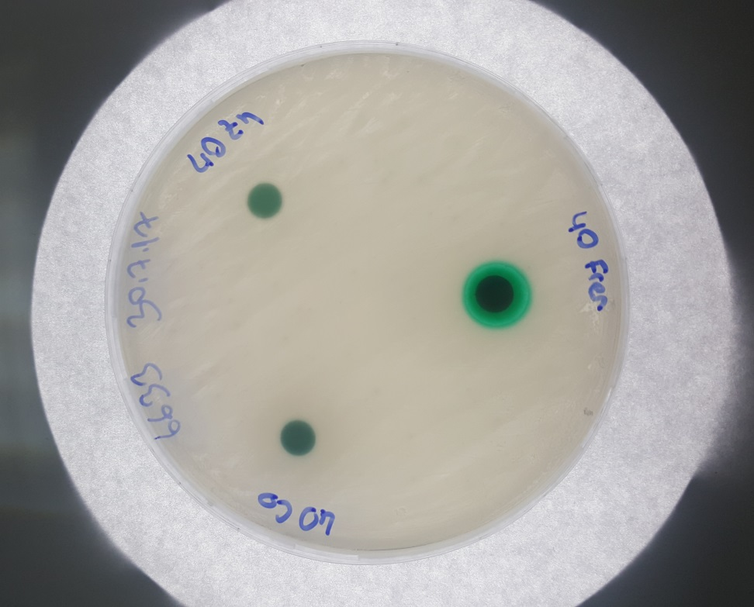

**Fig. S6.** Antibacterial activities of phthalocyanines **4**, **6** and **8** bearing 4-methoxy-phenoxy substituents on the peripheral positions against *Bacillus subtilis* (ATCC 6633).

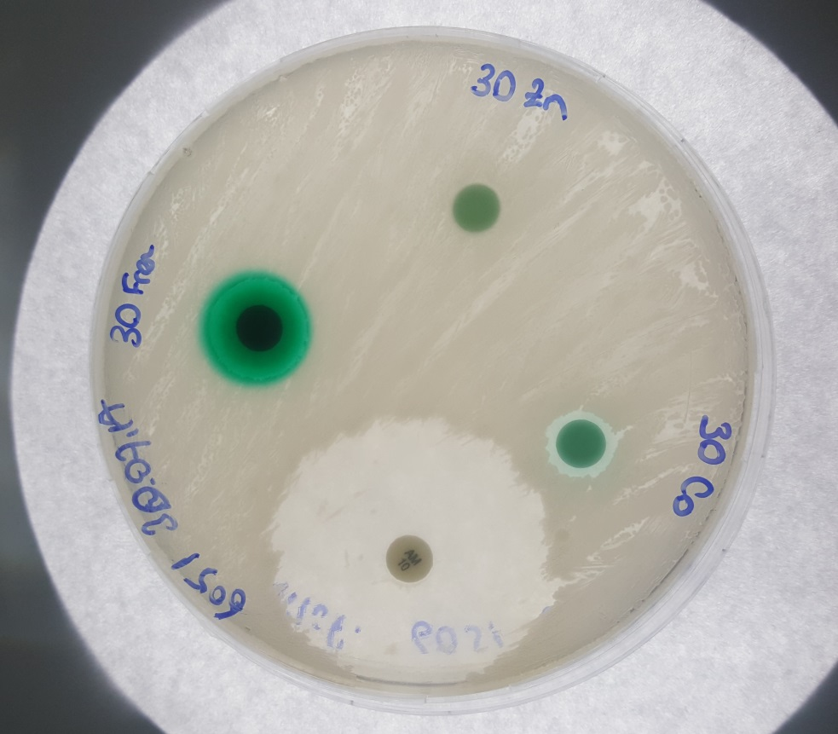

**Fig. S7** Antibacterial activities of phthalocyanines **3**, **5** and **7** bearing 4-methoxy-phenoxy substituents on the non-peripheral positions and Ampicillin against *Bacillus subtilis* (ATCC 6051).

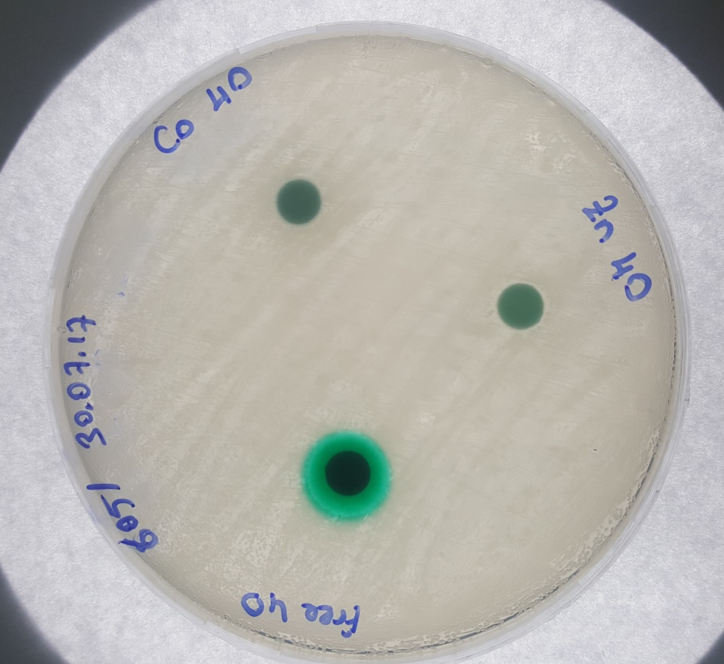

**Fig. S8.** Antibacterial activities of phthalocyanines **4**, **6** and **8** bearing 4-methoxy-phenoxy substituents on the peripheral positions against *Bacillus subtilis* (ATCC 6051).

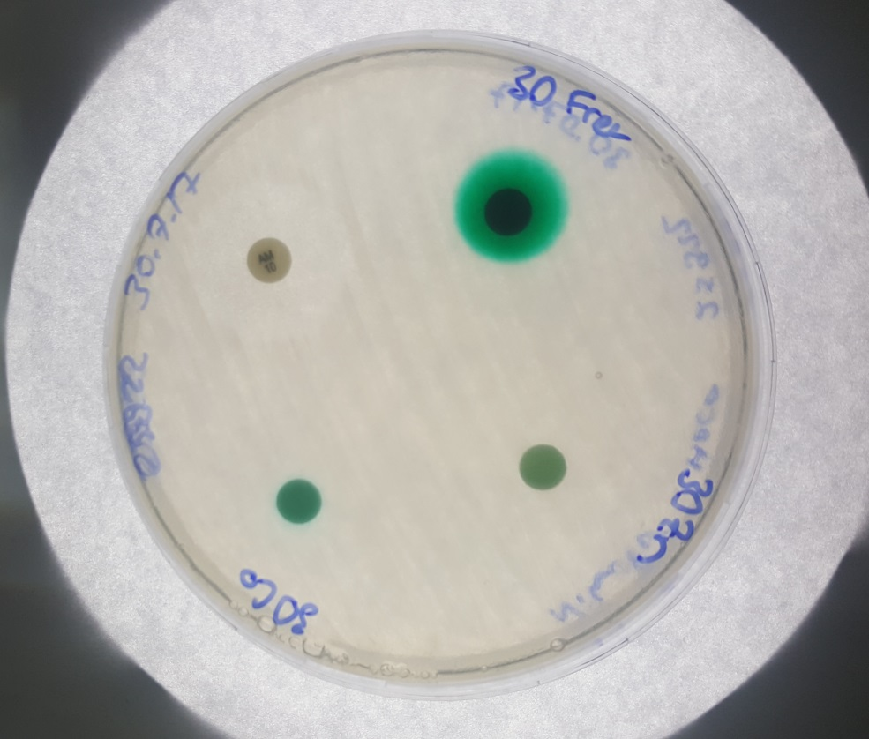

**Fig. S9.** Antibacterial activities of phthalocyanines **3**, **5** and **7** bearing 4-methoxy-phenoxy substituents on the non-peripheral positions and Ampicillin against *Escherichia coli* (ATCC 25922).

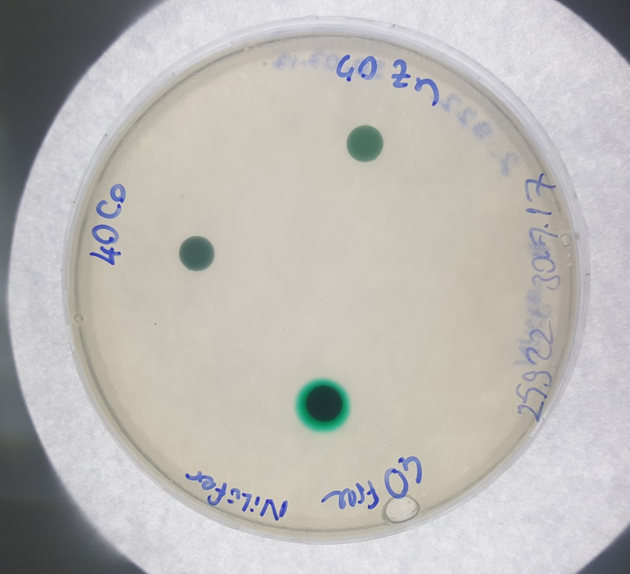

**Fig. S10.** Antibacterial activities of phthalocyanines **4**, **6** and **8** bearing 4-methoxy-phenoxy substituents on the peripheral positions against *Escherichia coli* (ATCC 25922).

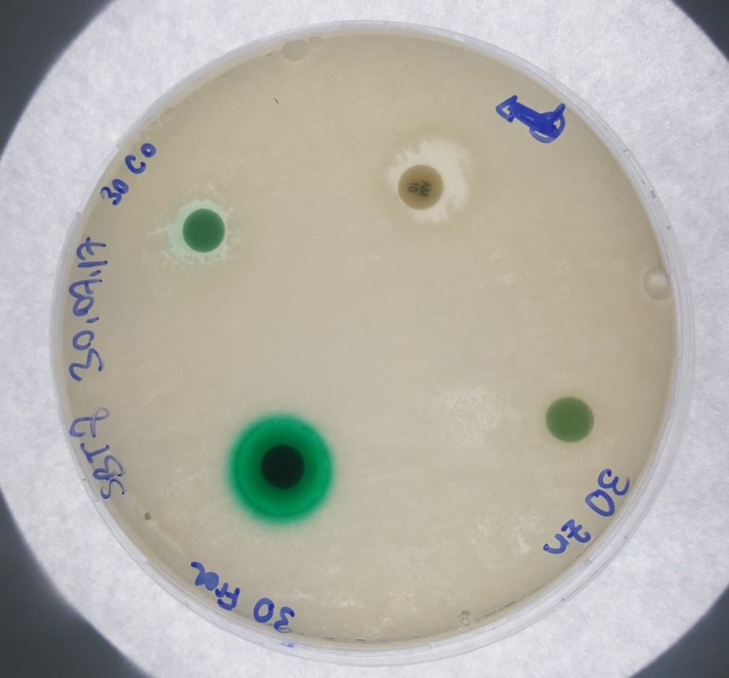

**Fig. S11.** Antibacterial activities of phthalocyanines **3**, **5** and **7** bearing 4-methoxy-phenoxy substituents on the non-peripheral positions and Ampicillin against *Bacillus cereus* (ATCC SBT8).

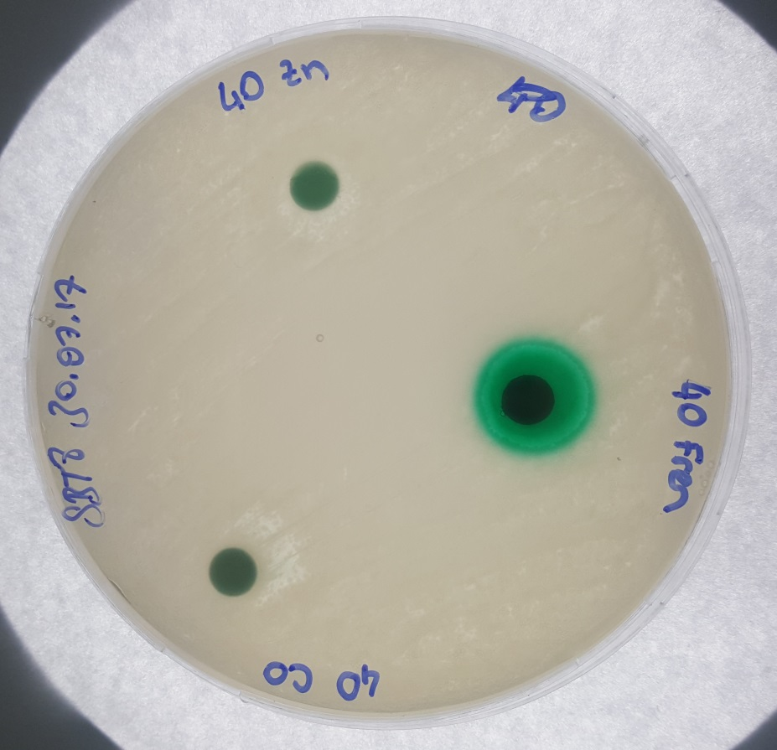

**Fig. S12.** Antibacterial activities of phthalocyanines **4**, **6** and **8** bearing 4-methoxy-phenoxy substituents on the peripheral positions against *Bacillus cereus* (ATCC SBT8).

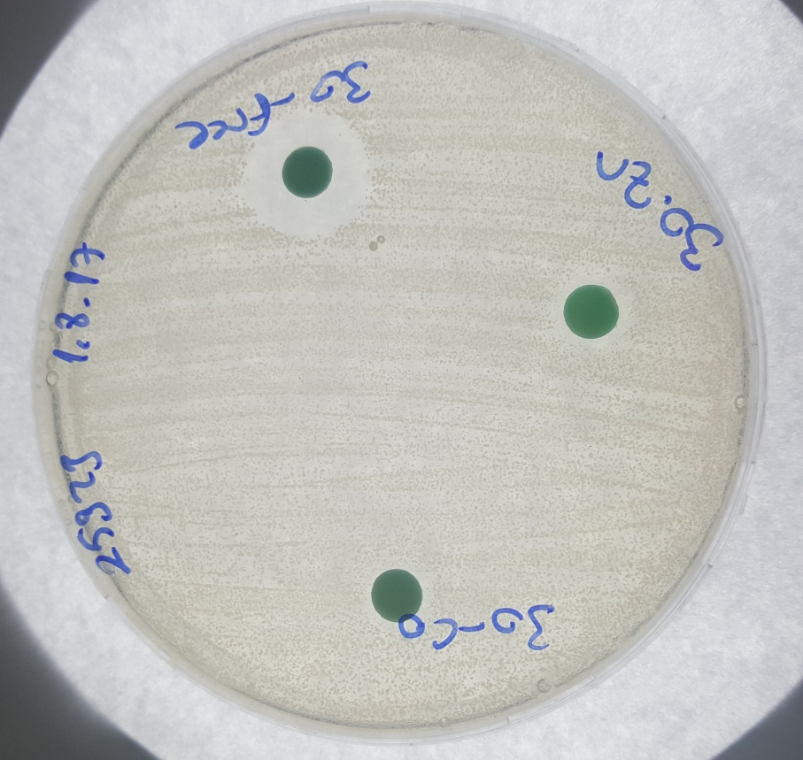

**Fig. S13.** Antibacterial activities of phthalocyanines **3**, **5** and **7** bearing 4-methoxy-phenoxy substituents on the non-peripheral positions and Ampicillin against *Staphylococcus aureus* (ATCC 25923).

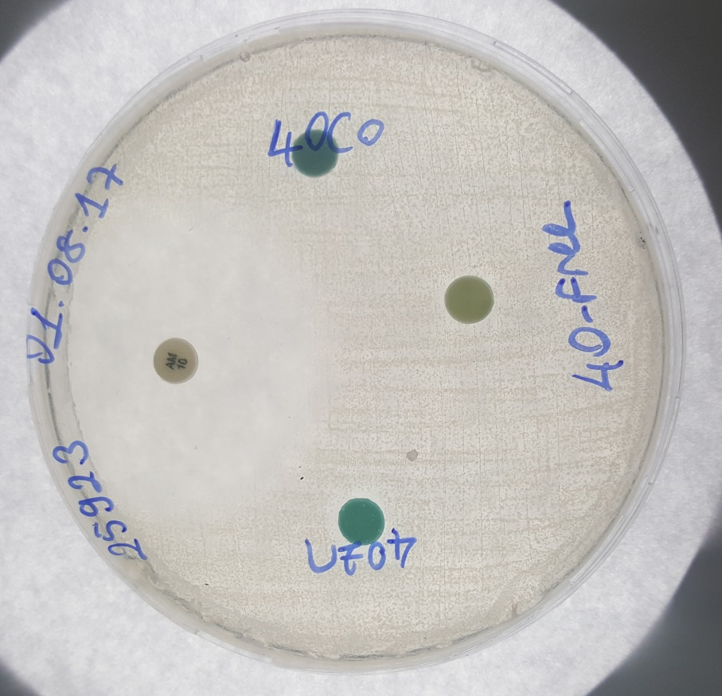

**Fig. S14.** Antibacterial activities of phthalocyanines **4**, **6** and **8** bearing 4-methoxy-phenoxy substituents on the peripheral positions against *Staphylococcus aureus* (ATCC 25923).