Supporting Information
An antibacterial silver(I) supramolecular network assembled from thiophene-2,5-dicarboxylate and benzimidazole

ABDUL RAUF, JUNWEI YE*, AIYU HAO, LIYUAN ZHAO, SIQI ZHANG, YE QI, LEI SHI and GUILING NING*

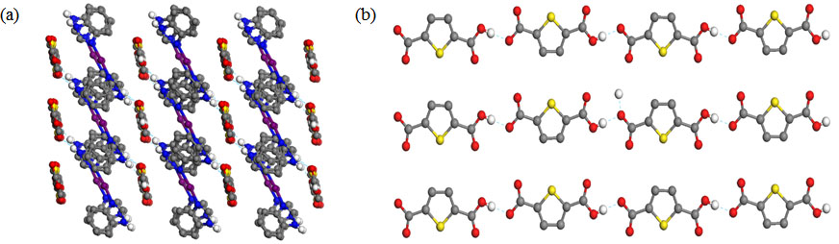
Figure S1. Packing network in complex 1.

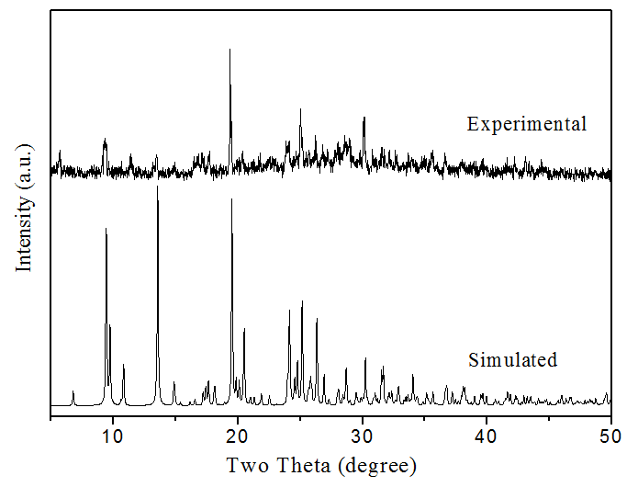
Figure S2. Experimental and simulated XRD patterns of complex 1.

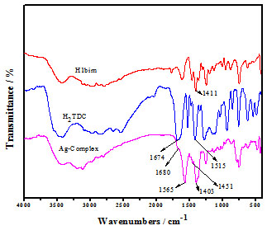
Figure S3. Infrared spectra of complex 1, H₂TDC and HBim.

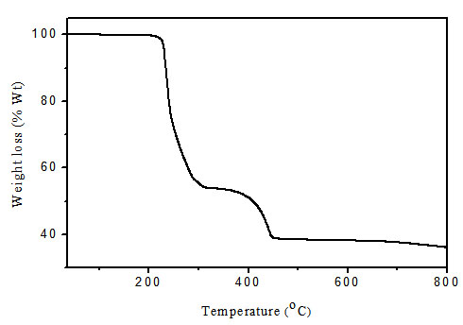
Figure S4. Thermogravimetric curves for complex 1.

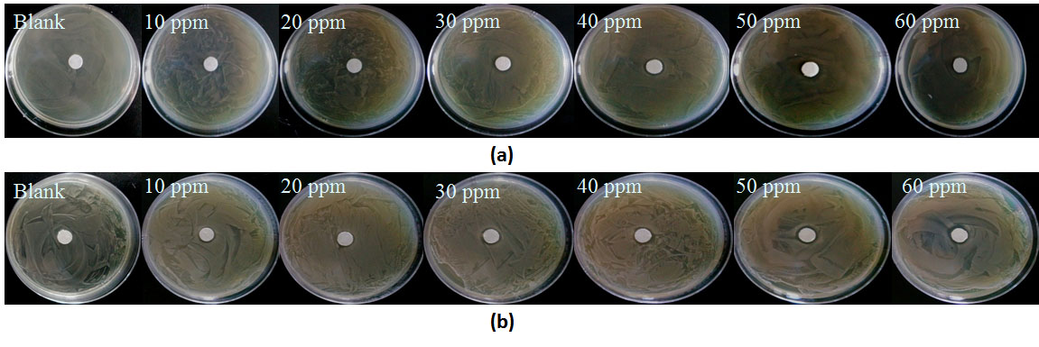
Figure S5. Images of inhibition zones for complex 1 against E. coli (a) and S. aurues (b) with concentration of blank, 10, 20, 30, 40, 50 and 60 ppm.

Table S1. Selected bond lengths [Å] and angles [°] for complex 1.
Ag(1)-N(1) | 2.091(3) | C(2)-N(1)-Ag(1) | 127.6(2)
Ag(1)-N(3) | 2.096(3) | C(8)-N(3)-Ag(1) | 130.8(3)
N(1)-Ag(1)-N(3) | 174.38(12) | C(14)-N(3)-Ag(1) | 122.9(2)
C(1)-N(1)-Ag(1) | 127.4(3)

