Supplementary Material

Synthesis, characterization, theoretical simulation and DNA nuclease activity of a newly synthesized Mn-oximato complex

PRIYANGANA DEB, MADHULIKA GHOSE, NAYIM SEPAY, SATYABRATA MAITI and KALYAN K. MUKHERJEA*

Figure S1. TGA of complex.

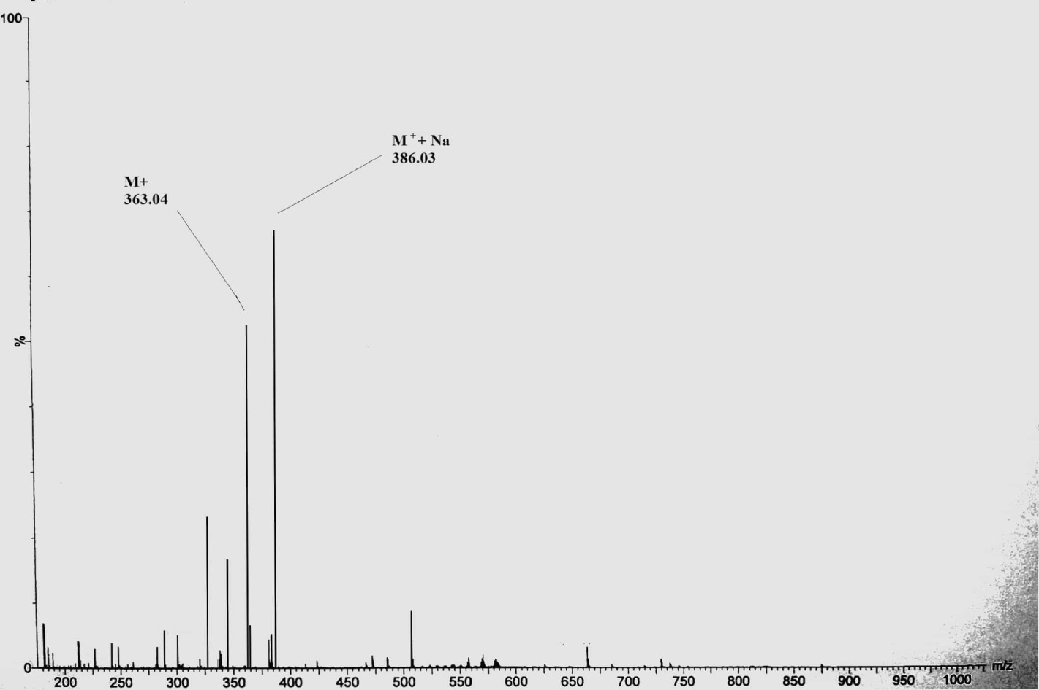
Figure S2. ESI-MS of complex.

Figure S3. EPR spectra of complex (Mn[sal-oxime]₂[H₂O]₂) at 298 K (g = 1.97; freq. = 9445.141 MHz, power = 0.9908 mW, sweep time = 4.00 min).

Figure S4. HOMO and LUMO of sal-oxime ligand.

