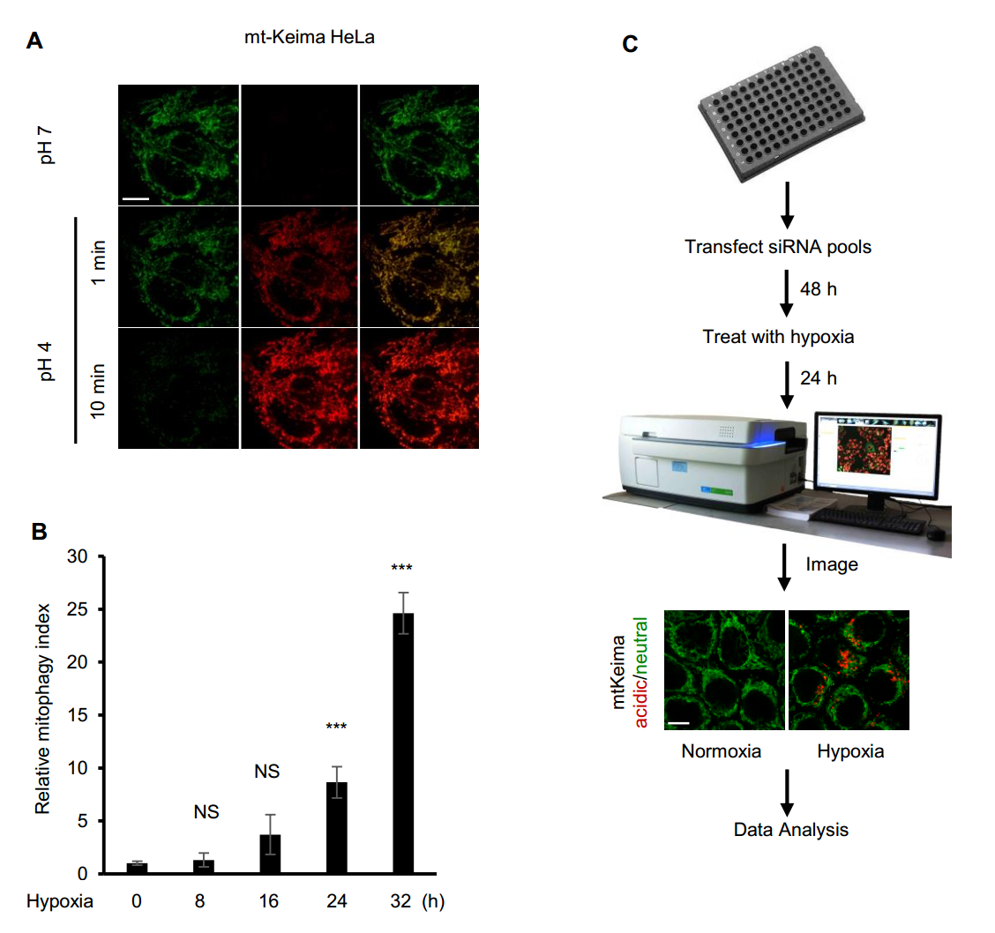

Figure S1. HeLa cells expressing mt-Keima can rapidly and sensitively response to pH changes. (A) Representative confocal images of HeLa cells expressing mt-Keima equilibrated in 1 or 10 minutes with different buffers at pH 4 and 7. (B) Quantification of relative mitophagy index in (Fig. 1A), n=3 independent experiments. Data are shown as the mean ± SD (One-way ANOVA, ***p < 0.001, NS, nonsignificant). (C) Layout of the RNAi screen conditions. HeLa cells stably expressing mt-Keima were simultaneously transfected with arrayed pools of siRNAs in 96-well plates. Following knockdown, cells were treated with hypoxia (1% O₂) for 24 h to induce mitophagy. Scale bars: 10 μm.

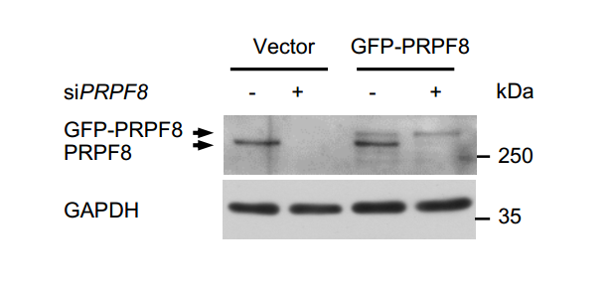

Figure S2. Western blot analysis of HeLa cells transfected with the indicated siRNAs and siRNA-resistant PRPF8-expressing plasmid.

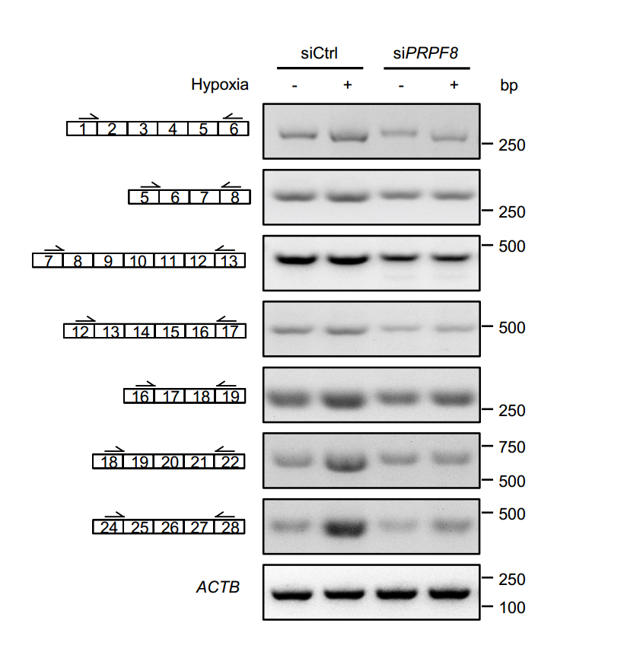

Figure S3. Knockdown of PRPF8 does not affect other PCR products of ULK1 mRNA. A representative gel picture shows bands corresponding to spliced products of ULK1 mRNA in HeLa cells transfected with the indicated siRNAs during normoxia or hypoxia (1% O₂, 24 h) in RT-PCR assays. Each product is confirmed by DNA sequencing. ACTB was used as a loading control.

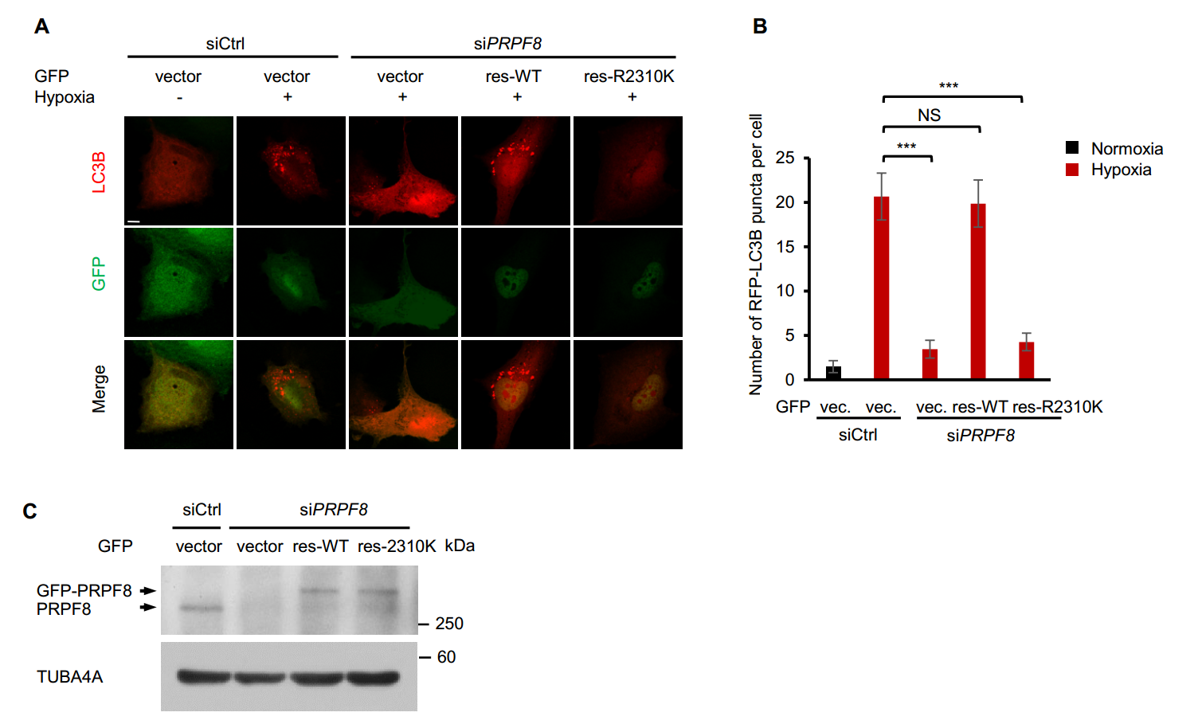

Figure S4. A PRPF8 retinitis pigmentosa disease-associated mutant has defects in mitophagy in RPE cells. (A) Representative confocal images of RFP-LC3 signals in RPE cells transfected with the siRNAs and plasmids indicated as shown under normoxia or hypoxia (1% O₂) for 12 h. (B) Quantification of the number of RFP-LC3 puncta per cell in (B). n=3 independent experiments. Data are shown as the mean ± SD (One-way ANOVA, ***p < 0.001, NS, nonsignificant). Scale bars: 10 μm. (C) Western blot analysis of RPE cells transfected with the indicated siRNAs and siRNA-resistant PRPF8-expressing plasmids.

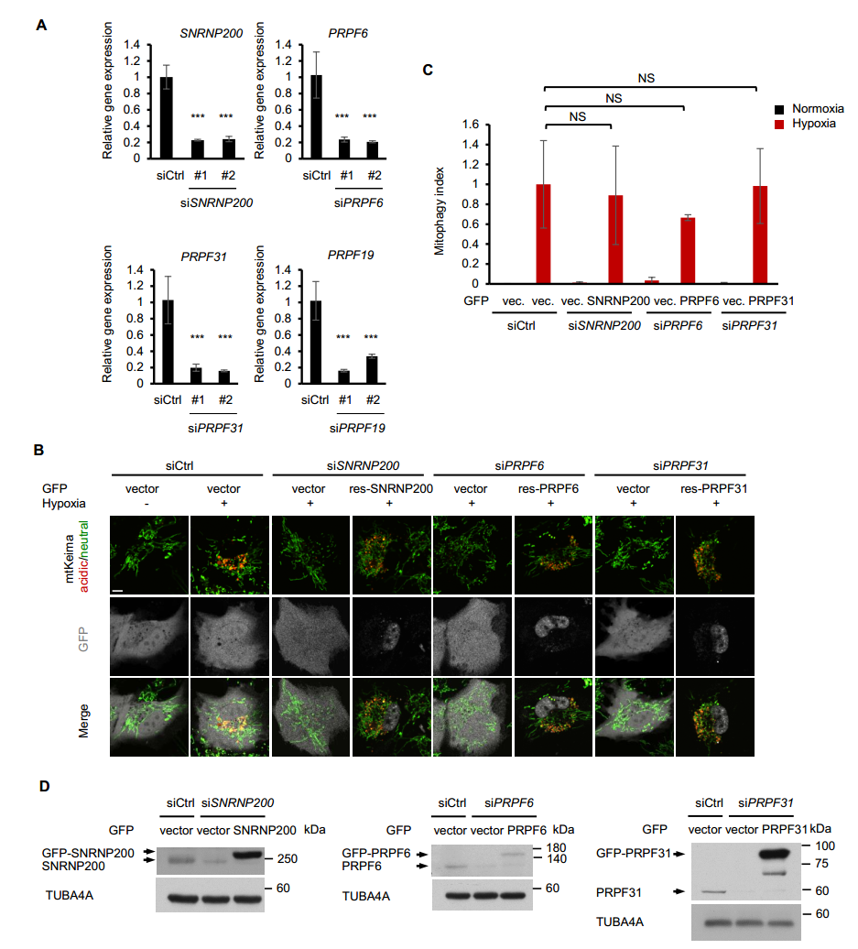

Figure S5. Retinitis pigmentosa-associated spliceosomal proteins regulate mitophagy under hypoxia in RPE cells. (A) Quantitative real-time PCR analysis of mRNA levels for the indicated genes in HeLa cells. Data are shown as the mean ± SD from a representative of 3 independent experiments. (B) mt-Keima imaging in RPE cells transfected with SNRNP200, PRPF6 or PRPF31 siRNAs and GFP-tagged siRNA-resistant plasmids after hypoxia treatment (1% O₂, 24 h). GFP fluorescence is depicted in gray. (C) Quantification of mitophagy index of GFP-positive cells in (B). Mitophagy index in hypoxia-treated control cells was normalized to 1. n=3 independent experiments. (D) Western blot analysis of RPE cells transfected with the indicated siRNAs and siRNA-resistant plasmids. Data are shown as the mean ± SD (One-way ANOVA, ***p < 0.001, NS, nonsignificant). Scale bars: 10μm.

Table S1. siRNA duplexes used in this study.

Gene symbol | siRNA no. | Target sequences (5'-3')
Negative Control |  | UUCUCCGAACGUGUCACGU
PRPF8 | #1 | CACGUAUCAAGAUUGGACU
 | #2 | GGAUUAUGAUGCGCCGAGA
 | #3 | CUCAUGAAACAUGAUGUUA
SNRNP200 | #1 | GACUAUUUGUGCAGAGUUU
 | #2 | GACAUAUGUGGGUAUCACA
PRPF6 | #1 | GAGAAGAUUGGGCAGCUUA
 | #2 | GACAGUUGUGUAGCCCACA
PRPF31 | #1 | CGUAUGAGCUUCGGAGAGA
 | #2 | CUGAGUUCCUCAAGGUCAA
Prpf8 (mouse) |  | CAGAUCAUUGUCACUCGGA

Table S2. Primers for ULK1 splicing analysis in RT-PCR assays.

 | Primer name | Target sequences (5'-3')
E1-E6 | Forward | TCTTCAAGGGCCGCCACC
 | Reverse | GTGTCCTCGCTCAGCGTGC
E5-E8 | Forward | GGGACCTGGCCGACTACC
 | Reverse | AGTGCTGGGACATGATGACC
E7-E13 | Forward | CTCTGCGGCTCCCCCATG
 | Reverse | CTGCAGCTGCTGCATCTCG
E12-E17 | Forward | CTCCACCTCCCACCTGGCC
 | Reverse | TGCCTGACCTGCGGATGG
E16-E19 | Forward | CCCACCCAGTTCCAAACACC
 | Reverse | GAGTGCTCGGGTGCAGAGG
E18-E22 | Forward | TGGCAGGTCCCCTCGTCC
 | Reverse | CCTCCAAAGCCAGCTGAGG
E21-E25 | Forward | GCACGGAGAGCCTGCAGGAGAAGCC
 | Reverse | GGTACAGCACCAGCTGTTCC
E24-E28 | Forward | CCTGCTGAGCCGAGAATGG
 | Reverse | TCTCCGCTCAATGCACAGC

Table S3. Primers for quantitative PCR used in this study.

Gene name | Primer name | Target sequence (5'-3') | Gene name | Primer name | Target sequence (5'-3')
PRPF8 | Forward | TGACAAAAGGGTTTACTTGGGTG | MTOR | Forward | ATGCTTGGAACCGGACCTG
 | Reverse | CTCATTGACGAAGGAAATGGCT |  | Reverse | TCTTGACTCATCTCTCGGAGTT
SNRNP200 | Forward | CCAAGCTGACCGTTCTCTCAT | ULK1 | Forward | CAGAACTACCAGCGCATTGA
 | Reverse | GCCTTGTCTCCCATACGGG |  | Reverse | TCCACCCAGAGACATCTTCC
PRPF6 | Forward | CCGTTGGGGACCAGATGAAG | BECN1 | Forward | TCCACAGAAAGTGCCAACAG
 | Reverse | GGCGTTCCATACGATATTTCTCT |  | Reverse | GACGTTGAGCTGAGTGTCCA
PRPF31 | Forward | GAGATCGAAAACGAGCTGAACA | ATG4A | Forward | TGCTGGTTGGGGATGTATGC
 | Reverse | GTGACGCTGACGACCATGAT |  | Reverse | GCGTTGGTATTCTTTGGGTTGT
PRPF19 | Forward | GGCACGGATGTCCAGATCTAC | ATG5 | Forward | AAAGATGTGCTTCGAGATGTGT
 | Reverse | CACGCCAAGTTCATCGCTTC |  | Reverse | CACTTTGTCAGTTACCAACGTCA
ATG9B | Forward | CCCCTCATACAAGAAGCTCCC | ATG7 | Forward | ATGATCCCTGTAACTTAGCCCA
 | Reverse | TGCAGGTTGAGCCTGTGTTG |  | Reverse | CACGGAAGCAAACAACTTCAAC
ATG13 | Forward | AGACAGTTCGTGTTGGGACAG | WIPI1 | Forward | AACAGGTCTATGTGCTCTCTCT
 | Reverse | CTCAAATTGCCTGGTAGACATGA |  | Reverse | CTCATGGGCAGCAATAGTGC
ACTB | Forward | AGAAAATCTGGCACCACACC | ATG16L1 | Forward | AACGCTGTGCAGTTCAGTCC
 | Reverse | AGAGGCGTACAGGGATAGCA |  | Reverse | AGCTGCTAAGAGGTAAGATCCA

