Supplemental file 1 analytical methods
Zircon grains were extracted using conventional heavy liquid and magnetic techniques, and were mounted in epoxy, then polished and coated with gold for cathodoluminescence (CL) imaging at Guangdong Provincial Key Laboratory of Mineral Resources and Geological Processes, Sun Yat-Sen University, Guangzhou, China.
Zircon U-Pb dating and trace element analyses were conducted using a Laser ICP-MS at the Guangzhou Institute of Geochemistry (GIG), Chinese Academy of Sciences (CAS). The zircon standards 91500 and GJ-1 were used to calibrate the U-Th-Pb ratios. The spot size for data collection was 30 µm. The errors for individual U-Pb analyses are presented with 1σ error and uncertainties in grouped ages are quoted at 95 % level (2σ). Off-line inspection and integration of background and analysis signals, and time-drift correction and quantitative calibration for trace element analyses and U–Pb dating were performed using ICPMSDataCal (Liu et al., 2008). Further detailed descriptions of the instrumentation and analytical procedure for the LA-ICP-MS zircon U-Pb and trace element technique are similar to those described by Yuan et al. (2004).
Whole rock samples for geochemistry were crushed to 200-mesh using an agate mill for elemental and Sr-Nd isotopic analyses. The major oxides were analyzed by a wavelength X-ray fluorescence spectrometry at GIG CAS. Trace element analyses were performed at the GIG CAS by a Perkin-Elmer Sciex ELAN 6000 ICP-MS. Detailed sample preparation and analytical procedure followed Li et al. (2002). Sr and Nd isotopic analyses were carried out at the GIG CAS on a Neptune Plus (Thermo Fisher Scientific, MA, USA) multi-collection mass spectrometry equipped with nine Faraday cup collectors and eight ion counters. Details analytical methods are presented by Yang et al. (2006). Normalizing factors used to correct the mass fractionation of Sr and Nd during the measurements were ⁸⁶Sr/⁸⁸Sr = 0.1194 and ¹⁴⁶Nd/¹⁴⁴Nd = 0.7219 (Yang et al., 2005; Yang et al., 2007b).
References
Liu, Y.S., Hu, Z.C., Gao, S., Gunther, D., Xu, J., Gao, C.G., Chen, H.H., 2008. In situ analysis of major and trace elements of anhydrous minerals by LA-ICP-MS without applying an internal standard. Chem Geol 257, 34-43.
Yuan, H.L., Gao, S., Liu, X.M., Li, H.M., Gunther, D., Wu, F.Y., 2004. Accurate U-Pb age and trace element determinations of zircon by laser ablation-inductively coupled plasma-mass spectrometry. Geostand Geoanal Res 28, 353-370.
Li, X.H., Li, Z.X., Zhou, H.W., Liu, Y., Kinny, P.D., 2002. U-Pb zircon geochronology, geochemistry and Nd isotopic study of Neoproterozoic bimodal volcanic rocks in the Kangdian Rift of South China: implications for the initial rifting of Rodinia. Precambrian Res 113, 135-154.
Yang, J.H., Wu, F.Y., Shao, J.A., Wilde, S.A., Xie, L.W., Liu, X.M., 2006. Constraints on the timing of uplift of the Yanshan Fold and Thrust Belt, North China. Earth Planet Sc Lett 246, 336-352.
Yang, Y.H., Zhang, H.F., Wu, F.Y., Xie, L.W., Zhang, Y.B., 2005. Accurate Measurement of Strontium Isotopic Composition by Neptune Multiple Collector Inductively Coupled Plasma Mass Spectrometry. Journal of Chinese Mass Spectrometry Society 26, 215-221 (in Chinese with English abstract).
Yang, Y.H., Zhang, H.F., Xie, L.W., Wu, F.Y., 2007b. Accurate Measurement of Neodymium Isotopic Composition Using Neptune Multiple Collector Inductively Coupled Plasma Mass Spectrometry. Chinese J Anal Chem 1, 71-74 ( in Chinese with English abstract).

Supplemental file 2 table 1
LA-ICPMS zircon U-Pb dating results of the Dazhonghe volcanics
Spots | Th/U | Isotopic ratios |  |  |  |  |  | Ages (Ma)
 |  | ²⁰⁷Pb/²⁰⁶Pb | ±σ | ²⁰⁷Pb/²³⁵U | ±σ | ²⁰⁶Pb/²³⁸U | ±σ | ²⁰⁷Pb/²³⁵U | ±σ | ²⁰⁶Pb/²³⁸U | ±σ
15YN-41B1
1 | 1 | 0.0581 | 0.0009 | 0.5368 | 0.0107 | 0.067 | 0.0013 | 436 | 7 | 418 | 8
2 | 0.3 | 0.0556 | 0.0009 | 0.5177 | 0.0093 | 0.0676 | 0.0011 | 424 | 6 | 421 | 7
3 | 0.4 | 0.0545 | 0.0009 | 0.5081 | 0.0101 | 0.0677 | 0.0013 | 417 | 7 | 422 | 8
4 | 0.4 | 0.0588 | 0.0009 | 0.5405 | 0.0096 | 0.0666 | 0.0011 | 439 | 6 | 416 | 7
5 | 0.5 | 0.0549 | 0.0009 | 0.508 | 0.0094 | 0.0672 | 0.0012 | 417 | 6 | 419 | 7
6 | 0.6 | 0.0548 | 0.0009 | 0.5088 | 0.0097 | 0.0674 | 0.0013 | 418 | 7 | 420 | 8
7 | 0.7 | 0.0552 | 0.0009 | 0.5086 | 0.009 | 0.0667 | 0.0011 | 418 | 6 | 416 | 7
8 | 0.8 | 0.0551 | 0.0008 | 0.5124 | 0.0092 | 0.0675 | 0.0012 | 420 | 6 | 421 | 7
9 | 0.4 | 0.0554 | 0.0009 | 0.5141 | 0.0099 | 0.0673 | 0.0012 | 421 | 7 | 420 | 8
10 | 0.7 | 0.0552 | 0.0009 | 0.5108 | 0.0102 | 0.067 | 0.0013 | 419 | 7 | 418 | 8
11 | 0.5 | 0.0543 | 0.0009 | 0.4998 | 0.009 | 0.0667 | 0.0012 | 412 | 6 | 417 | 7
12 | 0.6 | 0.0548 | 0.0008 | 0.5051 | 0.0087 | 0.0669 | 0.0011 | 415 | 6 | 418 | 7
13 | 0.5 | 0.0545 | 0.0009 | 0.5018 | 0.0093 | 0.0669 | 0.0012 | 413 | 6 | 417 | 7
14 | 0.5 | 0.0549 | 0.0009 | 0.505 | 0.0093 | 0.0668 | 0.0011 | 415 | 6 | 417 | 7
15 | 0.4 | 0.0551 | 0.0009 | 0.5069 | 0.009 | 0.0667 | 0.0011 | 416 | 6 | 416 | 7
16 | 0.7 | 0.0549 | 0.0009 | 0.5065 | 0.0086 | 0.067 | 0.0011 | 416 | 6 | 418 | 7
17 | 0.6 | 0.055 | 0.0009 | 0.5083 | 0.0101 | 0.0671 | 0.0013 | 417 | 7 | 418 | 8
18 | 1.2 | 0.2697 | 0.0041 | 23.5271 | 0.3979 | 0.6329 | 0.0107 | 3249 | 17 | 3161 | 42
15YN-41E1
1 | 0.6 | 0.0556 | 0.0009 | 0.5169 | 0.0104 | 0.0675 | 0.0014 | 423 | 7 | 421 | 8
2 | 0.8 | 0.0552 | 0.0009 | 0.5079 | 0.0087 | 0.0668 | 0.0011 | 417 | 6 | 417 | 7
3 | 0.6 | 0.055 | 0.0009 | 0.5117 | 0.0087 | 0.0675 | 0.0011 | 420 | 6 | 421 | 7
4 | 0.7 | 0.055 | 0.0009 | 0.5088 | 0.009 | 0.0671 | 0.0012 | 418 | 6 | 419 | 7
5 | 0.8 | 0.0565 | 0.0009 | 0.5214 | 0.01 | 0.0668 | 0.0011 | 426 | 7 | 417 | 7
6 | 0.5 | 0.0549 | 0.0008 | 0.5079 | 0.0088 | 0.0671 | 0.0011 | 417 | 6 | 419 | 7
7 | 0.7 | 0.0553 | 0.0009 | 0.512 | 0.0089 | 0.0672 | 0.0011 | 420 | 6 | 419 | 7
8 | 0.5 | 0.0558 | 0.0009 | 0.5111 | 0.0091 | 0.0664 | 0.0011 | 419 | 6 | 415 | 7
9 | 0.7 | 0.0551 | 0.0008 | 0.5149 | 0.0092 | 0.0678 | 0.0012 | 422 | 6 | 423 | 7
10 | 0.5 | 0.0548 | 0.0009 | 0.5087 | 0.009 | 0.0673 | 0.0012 | 418 | 6 | 420 | 7
11 | 0.6 | 0.0549 | 0.0009 | 0.5102 | 0.0095 | 0.0674 | 0.0012 | 419 | 6 | 421 | 7
12 | 0.6 | 0.0562 | 0.0009 | 0.522 | 0.0101 | 0.0672 | 0.0012 | 426 | 7 | 419 | 7
13 | 0.9 | 0.0548 | 0.0009 | 0.5089 | 0.0093 | 0.0673 | 0.0012 | 418 | 6 | 420 | 7
14 | 0.5 | 0.0549 | 0.0009 | 0.5089 | 0.0088 | 0.0672 | 0.0011 | 418 | 6 | 419 | 7
15 | 0.5 | 0.055 | 0.0009 | 0.5072 | 0.0092 | 0.0669 | 0.0012 | 417 | 6 | 417 | 7
16 | 0.5 | 0.0549 | 0.0009 | 0.5093 | 0.0086 | 0.0672 | 0.0011 | 418 | 6 | 419 | 7

Supplemental file 3 table 2
Major (wt. %) and trace elements (ppm) analytical results of the Dazhonghe volcanics
Sample | 15YN-41A1 | 15YN-41A2 | 15YN-41B1 | 15YN-41B2 | 15YN-41C1 | 15YN-41C2 | 15YN-41D1 | 15YN-41D2 | 15YN-41E1 | 15YN-41E2 | 15YN-41F1 | 15YN-41F2
Ref. | This study
SiO₂ | 67.33 | 55.72 | 71.53 | 69.58 | 64.35 | 70.89 | 79.95 | 76.13 | 70.71 | 66.64 | 60.23 | 58.48
TiO₂ | 0.37 | 1.85 | 0.28 | 0.29 | 0.34 | 0.30 | 0.21 | 0.23 | 0.45 | 0.65 | 0.81 | 0.71
Al₂O₃ | 12.95 | 14.12 | 13.51 | 11.70 | 15.96 | 11.46 | 10.36 | 12.22 | 13.91 | 15.71 | 16.80 | 15.99
FeOT | 5.56 | 12.36 | 2.48 | 4.60 | 5.20 | 4.72 | 1.47 | 1.86 | 4.20 | 4.85 | 6.48 | 6.37
MnO | 0.14 | 0.10 | 0.10 | 0.12 | 0.12 | 0.12 | 0.05 | 0.06 | 0.11 | 0.11 | 0.14 | 0.14
MgO | 2.58 | 1.48 | 0.78 | 3.23 | 4.22 | 3.36 | 0.36 | 0.43 | 1.26 | 1.25 | 2.12 | 1.97
CaO | 1.82 | 2.46 | 1.18 | 1.66 | 1.01 | 1.02 | 0.53 | 0.41 | 0.21 | 0.35 | 1.54 | 3.21
Na₂O | 5.07 | 8.31 | 6.16 | 3.95 | 4.35 | 3.99 | 3.78 | 4.22 | 5.75 | 6.50 | 4.54 | 4.52
K₂O | 0.18 | 0.09 | 0.75 | 0.32 | 0.29 | 0.28 | 1.40 | 1.96 | 1.15 | 0.94 | 3.13 | 2.65
P₂O₅ | 0.05 | 0.44 | 0.04 | 0.02 | 0.03 | 0.02 | 0.04 | 0.04 | 0.08 | 0.12 | 0.13 | 0.11
LOI | 3.03 | 1.76 | 2.62 | 3.99 | 3.17 | 2.90 | 1.50 | 1.87 | 1.62 | 2.43 | 3.14 | 4.79
Total | 99.71 | 100.07 | 99.72 | 99.98 | 99.61 | 99.59 | 99.80 | 99.64 | 99.93 | 100.10 | 99.77 | 99.66
V | 149 | 187 | 27.3 | 154 | 141 | 141 | 26.1 | 31.9 | 80.0 | 113 | 190 | 166.3
Cr | 10.0 | 9.90 | 10.3 | 19.6 | 20.1 | 20.0 | 11.4 | 12.0 | 10.3 | 9.8 | 19.9 | 19.8
Ga | 12.95 | 13.27 | 12.83 | 11.28 | 12.83 | 11.39 | 12.84 | 15.05 | 14.87 | 15.89 | 17.54 | 16.83
Rb | 1.49 | 4.85 | 12.83 | 4.22 | 3.91 | 3.60 | 34.61 | 42.35 | 9.74 | 10.30 | 60.19 | 50.00
Sr | 94 | 184 | 141 | 183 | 154 | 167 | 132 | 141 | 76 | 106 | 287 | 195
Y | 17.34 | 15.15 | 19.30 | 13.24 | 16.14 | 14.59 | 28.49 | 35.98 | 26.35 | 26.68 | 20.43 | 19.01
Zr | 43 | 37 | 102 | 37 | 48 | 42 | 109 | 120 | 99 | 85 | 62 | 57
Nb | 1.30 | 1.09 | 2.53 | 1.08 | 1.30 | 1.20 | 3.11 | 3.39 | 2.97 | 2.84 | 2.39 | 2.08
Cs | 0.15 | 0.50 | 0.69 | 0.99 | 0.98 | 0.91 | 1.03 | 1.40 | 0.38 | 0.51 | 3.82 | 4.53
Ba | 31 | 145 | 137 | 56 | 61 | 59 | 313 | 589 | 266 | 205 | 632 | 455
La | 4.5 | 4.3 | 9.2 | 5.2 | 5.2 | 4.6 | 10.9 | 12.1 | 7.3 | 10.0 | 8.6 | 8.2
Ce | 10.1 | 9.3 | 19.0 | 10.4 | 11.4 | 10.1 | 25.4 | 29.8 | 18.7 | 20.1 | 17.7 | 16.7
Pr | 1.29 | 1.18 | 2.28 | 1.29 | 1.36 | 1.31 | 2.96 | 3.60 | 2.45 | 2.69 | 2.38 | 2.17
Nd | 5.78 | 5.25 | 9.40 | 5.59 | 5.92 | 5.60 | 12.24 | 14.25 | 11.18 | 11.87 | 10.56 | 9.70
Sm | 1.72 | 1.57 | 2.30 | 1.54 | 1.62 | 1.54 | 3.06 | 3.44 | 3.06 | 3.15 | 2.82 | 2.50
Eu | 0.49 | 0.49 | 0.66 | 0.51 | 0.55 | 0.52 | 0.64 | 0.77 | 0.85 | 1.11 | 1.06 | 1.15
Gd | 2.16 | 2.04 | 2.61 | 1.84 | 2.06 | 1.99 | 3.24 | 4.12 | 3.63 | 3.73 | 3.19 | 2.97
Tb | 0.38 | 0.35 | 0.42 | 0.32 | 0.40 | 0.35 | 0.63 | 0.76 | 0.64 | 0.62 | 0.52 | 0.49
Dy | 2.71 | 2.37 | 2.77 | 2.14 | 2.62 | 2.30 | 4.26 | 5.42 | 4.21 | 4.12 | 3.38 | 3.12
Ho | 0.62 | 0.55 | 0.64 | 0.46 | 0.58 | 0.53 | 0.95 | 1.24 | 0.96 | 0.89 | 0.74 | 0.68
Er | 1.82 | 1.59 | 1.93 | 1.36 | 1.76 | 1.53 | 2.84 | 3.56 | 2.84 | 2.60 | 2.17 | 1.93
Tm | 0.29 | 0.26 | 0.31 | 0.21 | 0.28 | 0.25 | 0.45 | 0.53 | 0.45 | 0.40 | 0.34 | 0.30
Yb | 1.95 | 1.72 | 2.25 | 1.31 | 1.89 | 1.71 | 2.92 | 3.49 | 2.97 | 2.61 | 2.13 | 1.98
Lu | 0.33 | 0.28 | 0.38 | 0.21 | 0.30 | 0.27 | 0.48 | 0.56 | 0.47 | 0.42 | 0.36 | 0.31
Hf | 1.40 | 1.09 | 2.73 | 1.18 | 1.50 | 1.30 | 3.21 | 3.59 | 2.87 | 2.45 | 1.79 | 1.68
Ta | 0.10 | 0.10 | 0.20 | 0.12 | 0.10 | 0.10 | 0.20 | 0.20 | 0.21 | 0.20 | 0.10 | 0.10
Th | 1.04 | 0.87 | 2.07 | 0.94 | 1.17 | 1.06 | 2.92 | 3.27 | 2.45 | 2.17 | 1.65 | 1.52
U | 0.48 | 0.43 | 0.82 | 0.44 | 0.54 | 0.48 | 1.09 | 1.25 | 0.90 | 0.79 | 0.59 | 0.52
W | 2.38 | 1.09 | 12.30 | 8.26 | 2.45 | 1.41 | 0.87 | 1.06 | 1.07 | 1.08 | 2.30 | 2.86
Sn | 2.32 | 1.06 | 11.96 | 8.03 | 2.38 | 1.37 | 0.84 | 1.03 | 1.04 | 1.05 | 2.24 | 2.78

Table 2 continued
Sample | 15YN-41G1 | 15YN-41G2 | 15YN-41J1 | 15YN-41J2 | DZH01-1 | DZH01-2 | DZH01-3 | DZH01-4 | DZH01-5 | DZH01-6 | DZH01-7
Ref. | This study |  |  |  | Mao et al., 2012
SiO₂ | 75.88 | 49.88 | 79.55 | 72.10 | 58.39 | 56.60 | 64.48 | 58.99 | 61.16 | 62.80 | 57.07
TiO₂ | 0.30 | 0.83 | 0.29 | 0.38 | 0.92 | 0.81 | 0.94 | 0.85 | 1.07 | 1.04 | 1.03
Al₂O₃ | 11.61 | 14.34 | 9.55 | 14.44 | 15.45 | 14.58 | 12.73 | 14.58 | 13.58 | 13.05 | 16.63
FeOT | 2.25 | 9.42 | 2.64 | 2.62 | 7.62 | 9.69 | 7.23 | 8.22 | 7.87 | 7.04 | 7.76
MnO | 0.08 | 0.17 | 0.09 | 0.09 | 0.20 | 0.29 | 0.16 | 0.21 | 0.18 | 0.17 | 0.19
MgO | 0.34 | 8.55 | 0.97 | 0.20 | 3.64 | 4.32 | 3.07 | 3.82 | 3.26 | 2.86 | 3.64
CaO | 0.53 | 12.36 | 0.12 | 0.24 | 1.83 | 2.48 | 1.25 | 1.58 | 1.25 | 2.36 | 1.39
Na₂O | 5.84 | 1.91 | 4.13 | 6.82 | 3.53 | 3.61 | 3.20 | 3.66 | 3.64 | 3.95 | 4.32
K₂O | 0.69 | 0.09 | 0.71 | 0.96 | 3.52 | 2.02 | 3.16 | 2.84 | 2.87 | 2.46 | 3.59
P₂O₅ | 0.07 | 0.05 | 0.04 | 0.09 | 0.22 | 0.23 | 0.23 | 0.23 | 0.32 | 0.35 | 0.26
LOI | 1.81 | 1.28 | 1.44 | 1.20 | 4.23 | 4.69 | 3.12 | 4.51 | 3.45 | 3.58 | 3.62
Total | 99.65 | 99.92 | 99.82 | 99.44 | 100.40 | 100.40 | 100.37 | 100.41 | 99.53 | 100.44 | 100.36
V | 37.4 | 58.9 | 39.1 | 49.0 | 139 | 152 | 162 | 161 | 183 | 160 | 145
Cr | 8.4 | 9.1 | 11.0 | 10.0 | 6.63 | 9.62 | 6.4 | 6.32 | 7.56 | 6.97 | 6.16
Ga | 10.91 | 12.26 | 10.73 | 9.29 | 18.8 | 21.1 | 15.9 | 19.7 | 17.4 | 14.5 | 20.7
Rb | 13.84 | 16.48 | 15.94 | 33.88 | 77.3 | 44.3 | 74.5 | 63 | 64.4 | 48.3 | 81.5
Sr | 168 | 121 | 112 | 131 | 132 | 156 | 108 | 113 | 136 | 102 | 191
Y | 21.72 | 29.33 | 19.95 | 13.49 | 40.9 | 41.4 | 31.7 | 35.3 | 38.9 | 36.9 | 54.5
Zr | 96 | 116 | 113 | 65 | 176 | 139 | 133 | 148 | 141 | 124 | 228
Nb | 2.43 | 2.94 | 3.71 | 2.40 | 5.72 | 4.97 | 4.38 | 5.17 | 4.61 | 4.02 | 7.6
Cs | 0.67 | 0.98 | 0.48 | 2.28 | 6.37 | 2.93 | 3.95 | 4.02 | 3.9 | 2.14 | 6
Ba | 95 | 150 | 147 | 112 | 337 | 198 | 375 | 252 | 276 | 312 | 313
La | 8.0 | 6.5 | 6.9 | 6.8 | 21.4 | 34 | 13.7 | 21.7 | 17.1 | 18.2 | 20.9
Ce | 20.8 | 18.6 | 20.2 | 15.1 | 50.5 | 56.1 | 33.7 | 46.4 | 40.8 | 41.3 | 55.7
Pr | 2.90 | 2.33 | 1.98 | 1.28 | 6.55 | 6.75 | 4.35 | 5.57 | 5.24 | 5.31 | 7.64
Nd | 12.63 | 10.60 | 8.42 | 5.40 | 28.5 | 28.7 | 19 | 23.8 | 23 | 23.4 | 33.9
Sm | 3.22 | 3.11 | 2.04 | 1.34 | 6.76 | 6.18 | 4.51 | 5.43 | 5.75 | 5.67 | 8.08
Eu | 0.74 | 0.78 | 0.47 | 0.36 | 1.69 | 1.85 | 1.32 | 1.3 | 1.47 | 1.43 | 1.73
Gd | 3.51 | 3.92 | 2.24 | 1.39 | 6.72 | 6.39 | 4.74 | 5.36 | 5.9 | 5.7 | 7.96
Tb | 0.59 | 0.67 | 0.43 | 0.26 | 1.08 | 1 | 0.77 | 0.85 | 0.97 | 0.93 | 1.28
Dy | 3.55 | 4.65 | 2.95 | 1.76 | 6.66 | 6.19 | 4.76 | 5.25 | 5.97 | 5.78 | 8.1
Ho | 0.81 | 1.10 | 0.75 | 0.42 | 1.3 | 1.23 | 0.94 | 1.03 | 1.17 | 1.13 | 1.62
Er | 2.43 | 3.28 | 2.42 | 1.34 | 3.72 | 3.59 | 2.72 | 3.14 | 3.35 | 3.19 | 4.75
Tm | 0.40 | 0.54 | 0.41 | 0.22 | 0.58 | 0.53 | 0.41 | 0.47 | 0.52 | 0.47 | 0.73
Yb | 2.78 | 3.67 | 2.87 | 1.49 | 3.79 | 3.29 | 2.69 | 3.24 | 3.18 | 2.98 | 4.62
Lu | 0.44 | 0.62 | 0.49 | 0.24 | 0.59 | 0.51 | 0.41 | 0.49 | 0.47 | 0.45 | 0.69
Hf | 2.83 | 3.63 | 3.21 | 1.80 | 4.83 | 3.74 | 3.42 | 3.96 | 3.56 | 3.22 | 5.89
Ta | 0.10 | 0.20 | 0.20 | 0.10 | 0.37 | 0.35 | 0.27 | 0.33 | 0.28 | 0.24 | 0.46
Th | 1.99 | 2.29 | 2.49 | 1.83 | 5.73 | 5.75 | 4.64 | 5.31 | 4.7 | 4.05 | 7.63
U | 0.80 | 0.88 | 0.77 | 0.57 | 2.18 | 1.58 | 1.16 | 1.74 | 1.32 | 1.27 | 2.24
W | 2.19 | 4.36 | 1.11 | 1.46
Sn | 2.13 | 4.24 | 1.08 | 1.42
The analytical errors for major elements are generally <2%. The analytical precision for trace elements is generally better than 5% for elements with concentrations >200 ppm, and 5–10% when <200 ppm (Li et al., 2002).
References
Li, X.H., Li, Z.X., Zhou, H.W., Liu, Y., Kinny, P.D., 2002. U-Pb zircon geochronology, geochemistry and Nd isotopic study of Neoproterozoic bimodal volcanic rocks in the Kangdian Rift of South China: implications for the initial rifting of Rodinia. Precambrian Research 113 (1-2), 135-154.
Mao, X.C., Wang, L.Q., Li,B., Wang, B.D., Wang, D.B., Yin, F.G., Sun, Z.M., 2012. Discovery of the Late Silurian volcanic rocks in the Dazhonghe area, Yunxian-Jinggu volcanic arc belt, western Yunnan, China and its geological significance. Petrologica Sinica 28, 1517-1528. (In Chinese with English abstract)

Supplemental file 4 table 3
Major (wt. %) and trace elements (ppm) data of the Dawazi volcanics
Sample | 15YN-37A1 | 15YN-37A2 | 15YN-39A | 15YN-39B | 2701 | 3201 | 3203 | D-35 | D-36 | D-42 | D-46
Ref. | This study |  |  |  | Lehmann et al., 2013
SiO₂ | 74.63 | 76.20 | 71.06 | 72.26 | 67.08 | 72.93 | 74.24 | 75.18 | 45.57 | 67.40 | 88.16
TiO₂ | 0.45 | 0.45 | 0.31 | 0.32 | 0.81 | 0.21 | 0.32 | 0.19 | 0.83 | 0.34 | 0.04
Al₂O₃ | 9.45 | 9.09 | 12.83 | 12.47 | 14.59 | 12.62 | 12.52 | 12.59 | 16.06 | 12.74 | 6.88
FeOT | 4.18 | 5.20 | 3.11 | 3.66 | 4.77 | 2.13 | 2.21 | 2.16 | 11.47 | 1.78 | 0.22
MnO | 0.04 | 0.02 | 0.12 | 0.10 | 0.05 | 0.10 | 0.04 | 0.07 | 0.24 | 0.04 | 0.01
MgO | 1.95 | 2.21 | 3.80 | 3.84 | 1.06 | 0.84 | 0.55 | 0.36 | 5.58 | 9.35 | 0.07
CaO | 2.10 | 0.30 | 0.76 | 0.23 | 0.81 | 2.16 | 1.50 | 0.47 | 5.84 | 0.20 | 0.06
Na₂O | 1.91 | 1.08 | 3.62 | 2.02 | 5.38 | 3.58 | 4.90 | 5.51 | 4.47 | 1.93 | 3.37
K₂O | 0.84 | 0.70 | 0.80 | 1.51 | 1.24 | 1.73 | 0.97 | 1.06 | 0.13 | 0.17 | 0.12
P₂O₅ | 0.02 | 0.01 | 0.05 | 0.05 | 0.06 | 0.04 | 0.07 | 0.04 | 0.10 | 0.07 | 0.02
LOI | 3.91 | 3.70 | 2.93 | 2.96 | 3.42 | 3.21 | 2.18 | 1.85 | 8.26 | 5.63 | 1.01
Total | 99.94 | 99.55 | 99.73 | 99.84 | 99.72 | 99.75 | 99.76 | 99.70 | 99.60 | 99.76 | 99.85
V | 49.1 | 43.0 | 47.2 | 45.1 | 117 | 33 | 12 | 5 | 357 | 21 | 2
Cr | 10.0 | 10.0 | 11.3 | 8.5 | 10 | 3 | 3 | 3 | 11 | 3 | 3
Ga | 9.62 | 9.89 | 12.20 | 12.66 | 16.3 | 11.3 | 13.1 | 11 | 19.5 | 16 | 4.2
Rb | 22.06 | 20.49 | 11.89 | 21.39 | 13.8 | 13.1 | 6.3 | 16 | 0.7 | 2.3 | 2.8
Sr | 141 | 71 | 58 | 24 | 298 | 60 | 97.1 | 94 | 145 | 58.8 | 40.7
Y | 16.84 | 18.49 | 28.20 | 27.96 | 10.7 | 9.22 | 23.1 | 22 | 8.49 | 32.5 | 36.4
Zr | 62 | 67 | 78 | 77 | 115 | 67 | 52 | 117 | 24 | 53 | 49
Nb | 1.70 | 1.80 | 2.15 | 2.06 | 6.7 | 2.3 | 2.3 | 2 | 1.2 | 2.7 | 3
Cs | 0.61 | 1.04 | 0.56 | 1.44 | 4.39 | 2.59 | 1.08 | 1 | 0.29 | 0.94 | 0.29
Ba | 74 | 82 | 211 | 366 | 168 | 271 | 220 | 237 | 57 | 59 | 56
La | 9.9 | 9.1 | 9.9 | 6.6 | 12.2 | 9.5 | 13.3 | 10.5 | 2.9 | 11.1 | 10.5
Ce | 21.1 | 19.5 | 20.9 | 13.2 | 29.7 | 22.2 | 30.8 | 20 | 7.17 | 12.4 | 23.2
Pr | 2.76 | 2.61 | 2.46 | 1.63 | 3.13 | 2.35 | 3.91 |  | 1.01 | 3.45 | 3.12
Nd | 12.23 | 11.19 | 10.36 | 7.06 | 12.9 | 8.47 | 17.8 | 6 | 4.79 | 16.2 | 12.6
Sm | 3.22 | 2.70 | 2.69 | 1.99 | 3.22 | 2.03 | 4.72 | 2.7 | 1.47 | 4.84 | 3.43
Eu | 1.17 | 0.82 | 0.63 | 0.53 | 0.88 | 0.62 | 1.31 | 0.8 | 0.53 | 1.38 | 0.24
Gd | 3.31 | 2.83 | 3.17 | 2.57 | 3.06 | 2.17 | 4.92 |  | 1.69 | 5.74 | 4.12
Tb | 0.51 | 0.47 | 0.57 | 0.53 | 0.46 | 0.33 | 0.71 | 0.5 | 0.29 | 0.97 | 0.76
Dy | 3.09 | 3.16 | 4.03 | 3.86 | 2.73 | 1.92 | 4.07 |  | 1.83 | 6.32 | 5.68
Ho | 0.65 | 0.68 | 0.93 | 0.89 | 0.55 | 0.41 | 0.89 |  | 0.39 | 1.32 | 1.35
Er | 1.85 | 1.91 | 2.78 | 2.72 | 1.75 | 1.25 | 2.91 |  | 1.27 | 4.13 | 4.44
Tm | 0.28 | 0.29 | 0.44 | 0.43 | 0.25 | 0.19 | 0.47 |  | 0.17 | 0.63 | 0.69
Yb | 1.82 | 1.88 | 2.85 | 2.96 | 1.87 | 1.43 | 3.66 | 4.2 | 1.3 | 4.25 | 4.95
Lu | 0.29 | 0.31 | 0.44 | 0.48 | 0.3 | 0.2 | 0.57 | 0.63 | 0.19 | 0.64 | 0.77
Hf | 1.90 | 2.00 | 2.26 | 2.26 | 3.4 | 2.1 | 2.3 | 3 | 1.1 | 3.1 | 1.6
Ta | 0.10 | 0.10 | 0.10 | 0.10 | 0.5 | 0.1 | 0.1 | 0.5 | 0.1 | 0.2 | 0.1
Th | 1.82 | 1.83 | 2.56 | 2.56 | 2.4 | 3 | 2 | 3.7 | 0.7 | 2.4 | 3.9
U | 0.61 | 0.72 | 1.17 | 1.09 | 0.5 | 3.1 | 4.8 | 1.1 | 0.5 | 2.6 | 1.5
W | 1.05 | 1.38 | 1.11 | 1.12
Sn | 1.02 | 1.34 | 1.08 | 1.09

Table 3 continued
Sample | DP-9 | DP-70 | DP-71 | DP-30 | DO-35 | DP-21 | DP-81 | NO.1 | DP6-7 | DP5-3 | DP2-4 | DP2-3
Ref. | Li et al., 2012 |  |  |  |  |  |  |  | Zhong et al., 2000
SiO₂ | 80.83 | 83.31 | 85.06 | 86.01 | 87.37 | 73.33 | 88.86 | 78.38 | 72.37 | 72.07 | 73.90 | 76.39
TiO₂ | 0.20 | 0.23 | 0.20 | 0.19 | 0.19 | 0.28 | 0.14 | 0.10 | 0.17 | 0.16 | 0.28 | 0.14
Al₂O₃ | 7.59 | 8.56 | 6.94 | 6.05 | 4.86 | 11.22 | 5.59 | 9.12 | 12.77 | 13.05 | 13.01 | 10.85
FeOT | 4.54 | 2.15 | 2.08 | 2.52 | 3.12 | 5.30 | 1.10 | 4.33 | 3.40 | 3.14 | 3.89 | 3.29
MnO | 0.04 | 0.02 | 0.02 | 0.04 | 0.04 | 0.03 | 0.03 | 0.03 | 0.08 | 0.10 | 0.13 | 0.13
MgO | 0.60 | 0.36 | 0.27 | 0.35 | 0.39 | 1.26 | 0.30 | 0.64 | 1.40 | 1.20 | 2.30 | 1.60
CaO | 0.09 | 0.08 | 0.45 | 0.17 | 0.12 | 0.08 | 0.09 | 0.11 | 1.11 | 0.70 | 1.30 | 0.70
Na₂O | 0.07 | 0.07 | 0.06 | 0.05 | 0.05 | 0.08 | 0.08 | 2.56 | 3.30 | 3.31 | 3.48 | 3.71
K₂O | 1.92 | 2.42 | 1.87 | 1.65 | 1.23 | 2.90 | 1.54 | 0.77 | 1.03 | 2.29 | 0.37 | 0.51
P₂O₅ | 0.03 | 0.01 | 0.00 | 0.01 | 0.04 | 0.03 | 0.01 | 0.00 | 0.10 | 0.12 | 0.11 | 0.10
LOI | 3.69 | 2.40 | 2.11 | 2.19 | 2.43 | 5.02 | 1.39 | 3.49 | 0.09 | 0.20 | 0.05 | 0.09
Total | 99.60 | 99.61 | 99.06 | 99.23 | 99.84 | 99.53 | 99.13 | 99.53 | 95.82 | 96.34 | 98.82 | 97.51
V | 16.30 | 22.9 | 18.1 | 16.2 | 16.9 | 21.4 | 17.4 | 16.3 | 20.9 | 22.6 | 26.9 | 10.7
Cr | 11.30 | 7.7 | 1.9 | 3.8 | 16.3 | 0.2 | 10.4 | 22.8 | 12.7 | 13 | 13.3 | 20.2
Ga
Rb | 23.50 | 22 | 21.2 | 22 | 16.8 | 32.6 | 22 | 11 | 15 | 31.6 | 4.76 | 7.31
Sr | 9.10 | 10.1 | 11.9 | 10.1 | 8.7 | 14.9 | 12.2 | 40.7 | 85.9 | 52.2 | 104 | 64.2
Y | 7.30 | 4.4 | 8.6 | 4.4 | 6.6 | 12.3 | 7.3 | 16.6 | 23.7 | 21.5 | 14 | 18
Zr | 52.10 | 40.4 | 47.3 | 40.4 | 40.8 | 90.6 | 50.9 | 77.9 | 80.6 | 90.9 | 54.4 | 60.1
Nb | 6.30 | 5.6 | 5.6 | 5.6 | 5.5 | 8.9 | 5.9 | 7.3 | 2.06 | 2.28 | 1.97 | 1.98
Cs | 1.92 | 0.75 | 0.5 | 0.75 | 0.66 | 1.06 | 0.55 | 0.2
Ba | 427.00 | 315 | 609 | 315 | 233 | 911 | 514 | 176 | 252 | 476 | 108 | 611
La | 3.1 | 3.2 | 2.5 | 1.8 | 2.8 | 4.3 | 2.8 | 2.2 | 12.4 | 6.18 | 4.1 | 2.06
Ce | 6.4 | 6.7 | 2.6 | 3.4 | 5.7 | 8.4 | 3.8 | 4.7 | 18.6 | 18.6 | 8.7 | 4.84
Pr | 0.98 | 1 | 0.51 | 0.5 | 0.92 | 1.24 | 0.76 | 0.65 | 2.95 | 1.84 | 1.19 | 0.67
Nd | 4.7 | 4.7 | 2.9 | 2.4 | 4.1 | 6.5 | 3.6 | 2.8 | 13.5 | 8.71 | 5.9 | 3.72
Sm | 1.14 | 1.22 | 0.76 | 0.56 | 0.99 | 1.68 | 0.88 | 0.76 | 3.79 | 2.54 | 1.61 | 1.25
Eu | 0.7 | 0.7 | 1.7 | 0.5 | 0.4 | 1.4 | 1 | 0.4 | 0.95 | 0.64 | 0.43 | 0.35
Gd | 0.6 | 0.6 | 0.3 | 0.3 | 0.6 | 0.8 | 0.5 | 0.4 | 3.34 | 2.54 | 1.53 | 1.46
Tb | 0.13 | 0.14 | 0.07 | 0.06 | 0.12 | 0.17 | 0.1 | 0.1 | 0.68 | 0.59 | 0.34 | 0.37
Dy | 1.2 | 1.6 | 1.3 |  |  | 1.9 | 1.1 | 2.2 | 4.2 | 3.57 | 2.27 | 3.26
Ho | 0.26 | 0.35 | 0.28 | 0.14 | 0.21 | 0.44 | 0.24 | 0.53 | 1.16 | 1.07 | 0.68 | 0.85
Er | 0.5 | 0.6 | 0.4 | 0.3 | 0.5 | 0.8 | 0.4 | 0.7 | 2.81 | 2.64 | 1.87 | 2.46
Tm | 0.18 | 0.22 | 0.15 | 0.09 | 0.12 | 0.24 | 0.15 | 0.38 | 0.5 | 0.5 | 0.32 | 0.45
Yb | 1.07 | 1.33 | 1.03 | 0.58 | 0.81 | 1.57 | 1.03 | 1.98 | 3.35 | 3.21 | 2.29 | 2.96
Lu | 1.2 | 0.2 | 0.1 | 0.1 | 0.1 | 0.2 | 0.1 | 0.3 | 0.46 | 0.45 | 0.27 | 0.4
Hf | 0.59 | 1.15 | 2.22 | 1.15 | 2.03 | 3.2 | 1.81 | 3.77 | 2.15 | 2.71 | 1.76 | 1.82
Ta | 0.16 | 0.27 | 0.46 | 0.27 | 0.45 | 0.58 | 0.42 | 0.59
Th | 0.80 | 5 | 6.9 | 5 | 5.4 | 3.8 | 6.8 | 9.3 | 2.59 | 2.7 | 1.54 | 1.72
U | 0.50 | 2.1 | 2.8 | 2.1 | 2.2 | 1.6 | 2.7 | 3.7
W
Sn

Table 3 continued
Sample | DP-1 | DP-10 | DP-51 | DP-73 | DP-29 | NO.2 | DP5-7' | DP6-3 | DP6-6 | DP6-5' | DP6-5 | DP4-4
Ref. | Zhong et al., 2000
SiO₂ | 69.06 | 67.36 | 70.12 | 71.04 | 72.92 | 74.03 | 67.25 | 61.95 | 49.33 | 44.28 | 51.92 | 51.65
TiO₂ | 0.36 | 0.53 | 0.41 | 0.41 | 0.35 | 0.21 | 0.13 | 0.25 | 0.70 | 0.72 | 0.42 | 0.67
Al₂O₃ | 12.71 | 15.92 | 13.02 | 13.59 | 12.80 | 12.22 | 10.36 | 15.42 | 19.76 | 20.00 | 16.87 | 17.35
FeOT | 4.17 | 4.62 | 3.89 | 3.97 | 3.94 | 2.69 | 9.12 | 5.69 | 10.45 | 15.41 | 5.73 | 10.59
MnO | 0.15 | 0.11 | 0.16 | 0.20 | 0.14 | 0.05 | 0.23 | 0.09 | 0.12 | 0.21 | 0.15 | 0.13
MgO | 4.37 | 2.44 | 2.81 | 3.28 | 1.97 | 3.95 | 5.20 | 7.70 | 7.00 | 7.20 | 5.00 | 5.50
CaO | 1.27 | 0.34 | 1.09 | 0.39 | 0.32 | 0.21 | 0.50 | 1.00 | 1.70 | 2.80 | 9.10 | 2.00
Na₂O | 3.81 | 3.14 | 4.70 | 2.08 | 3.83 | 2.24 | 0.08 | 1.79 | 4.52 | 3.15 | 1.94 | 0.71
K₂O | 0.49 | 2.29 | 0.39 | 2.19 | 1.13 | 1.15 | 0.33 | 0.87 | 0.09 | 0.16 | 0.84 | 2.42
P₂O₅ | 0.08 | 0.14 | 0.09 | 0.10 | 0.07 | 0.03 | 0.13 | 0.18 | 0.03 | 0.12 | 0.12 | 0.15
LOI | 3.62 | 2.96 | 2.53 | 2.87 | 2.38 | 3.09 |  | 0.10 | 0.17 |  |  | 0.21
Total | 100.09 | 99.85 | 99.21 | 100.12 | 99.85 | 99.87 | 93.33 | 95.04 | 93.87 | 94.05 | 92.09 | 91.38
V | 26.50 | 40.4 | 28.5 | 36.2 | 29.2 | 19.2 | 46.2 | 26.8 | 119 | 325 | 173 | 174
Cr | 4.00 | 16.4 | 8.1 | 8.4 | 7.4 | 8.2 | 7.53 | 12.7 | 46.3 | 45.1 | 17.3 | 40.4
Ga
Rb | 8.30 | 34.2 | 6 | 29.8 | 16.4 | 16.2 | 4.71 | 14.8 | 1.43 | 2.65 | 16.5 | 50.4
Sr | 48.80 | 85 | 117 | 51.5 | 76.3 | 32.1 | 4.58 | 46.5 | 151 | 106 | 122 | 30.1
Y | 29.70 | 26 | 13.6 | 19.4 | 14.8 | 22.7 | 11.1 | 26.6 | 13.8 | 13.8 | 24.6 | 11.4
Zr | 79.30 | 80.8 | 79.4 | 84.4 | 77.7 | 87.6 | 42.8 | 72.8 | 30.2 | 36.7 | 40.8 | 31.9
Nb | 7.20 | 8 | 6.6 | 6.8 | 6.5 | 8.3 | 1.34 | 2.52 | 1.8 | 1.93 | 1.49 | 0.93
Cs | 1.00 | 7.32 | 0.4 | 3.76 | 1.19 | 3.91
Ba | 139.00 | 516 | 332 | 694 | 328 | 170 | 189 | 205 | 90 | 122 | 188 | 645
La | 13 | 9.1 | 3.5 | 4 | 9.4 | 11 | 5.79 | 12.9 | 6.46 | 6.07 | 27.3 | 6.93
Ce | 26.9 | 21.6 | 9.7 | 8 | 21.9 | 22.3 | 8.47 | 26.3 | 14.2 | 12 | 60.2 | 13.6
Pr | 3.25 | 2.32 | 0.91 | 0.9 | 2.09 | 3.03 | 1.48 | 3.41 | 1.82 | 1.57 | 7.57 | 1.85
Nd | 13.7 | 11.4 | 4 | 4.3 | 9 | 13.1 | 6.77 | 15.8 | 8.59 | 7.74 | 29.8 | 9.6
Sm | 3.26 | 2.83 | 1.04 | 1.13 | 1.99 | 3.18 | 1.57 | 4.13 | 2.18 | 2.17 | 8.01 | 2.39
Eu | 0.5 | 1.2 | 0.8 | 1.7 | 0.8 | 0.5 | 0.38 | 0.89 | 0.79 | 1.09 | 2.88 | 0.69
Gd | 2 | 1.6 | 0.5 | 0.6 | 1.4 | 2 | 1.55 | 4 | 2.18 | 2.24 | 6.33 | 2.09
Tb | 0.4 | 0.34 | 0.12 | 0.13 | 0.26 | 0.39 | 0.3 | 0.75 | 0.44 | 0.42 | 1.13 | 0.42
Dy | 4.3 | 4 | 1.8 | 2.4 | 2.4 | 3.6 | 1.93 | 4.33 | 2.65 | 2.29 | 5.55 | 2.29
Ho | 0.98 | 0.91 | 0.42 | 0.62 | 0.5 | 0.83 | 0.55 | 1.23 | 0.76 | 0.66 | 1.29 | 0.66
Er | 1.7 | 1.5 | 0.6 | 0.8 | 1 | 1.6 | 1.28 | 2.98 | 1.58 | 1.54 | 2.63 | 1.54
Tm | 0.58 | 0.52 | 0.26 | 0.41 | 0.3 | 0.47 | 0.22 | 0.51 | 0.22 | 0.27 | 0.41 | 0.27
Yb | 3.24 | 3.01 | 1.51 | 2.16 | 1.74 | 2.81 | 1.5 | 3.35 | 1.56 | 1.71 | 2.53 | 1.71
Lu | 0.5 | 0.4 | 0.2 | 0.3 | 0.3 | 0.4 | 0.23 | 0.41 | 0.16 | 0.19 | 0.34 | 0.19
Hf | 4.00 | 4.79 | 3.07 | 4.16 | 4.06 | 5.7 | 1.39 | 2.1 | 1.05 | 1.04 | 1.23 | 0.79
Ta | 0.37 |  |  |  |  |  |  |  |  | 0.25 | 0.46 | 0.68
Th | 3.20 | 3.3 | 8.1 | 8.5 | 4.7 | 12.5 | 1.2 | 2.58 | 1.08 | 1.04 | 1.2 | 0.92
U | 1.10 | 13 | 3 | 3.4 | 1.9 | 4.7
W
Sn
The analytical errors for major elements are generally <2%. The analytical precision for trace elements is generally better than 5% for elements with concentrations >200 ppm, and 5–10% when <200 ppm (Li et al., 2002).
References
Lehmann, B., Zhao, X.F., Zhou, M.F., Du, A.D., Mao, J.W., Zeng, P.S., Henjes-Kunst, F., Heppe, K., 2013. Mid-Silurian back-arc spreading at the northeastern margin of Gondwana: The Dapingzhang dacite-hosted massive sulfide deposit, Lancangjiang zone, southwestern Yunnan, China. Gondwana Res 24, 648-663.
Li, J. B., 2012. Geochemical characteristics of the volcanic rocks in Dapingzhang copper deposit (SW China). Master's Thesis of Kunming university of Science and Technology, 1-80. (In Chinese with English abstract)
Li, X.H., Li, Z.X., Zhou, H.W., Liu, Y., Kinny, P.D., 2002. U-Pb zircon geochronology, geochemistry and Nd isotopic study of Neoproterozoic bimodal volcanic rocks in the Kangdian Rift of South China: implications for the initial rifting of Rodinia. Precambrian Research 113 (1-2), 135-154.
Zhong, H., Hu, R.Z., Ye, Z.J., Tu, G.Z., 2000. Isotope geochronology of Dapingzhang spilite-keratophyre formation in Yunnan Province and its geological significance. Sci China Earth Sci 43, 200-206.

Supplemental file 5 table 4
Sr-Nd isotopic compositions for the Dazhonghe and Dawazi volcanics (t=420 Ma)

Sample | Ref. | Rb | Sr | Rb/Sr | ⁸⁷Rb/⁸⁶Sr | ⁸⁷Sr/⁸⁶Sr | 2s | (⁸⁷Sr/⁸⁶Sr)i | Sm | Nd | ¹⁴⁷Sm/¹⁴⁴Nd | ¹⁴³Nd/¹⁴⁴Nd | 2s | T_{DM}(Ga) | (¹⁴³Nd/¹⁴⁴Nd)i | ε_{Nd}(t)
15YN-37B1 | This study | 1.49 | 94.5 | 0.02 | 0.04578 | 0.70701 | 13 | 0.70674
15YN-41B1 |  | 12.8 | 141 | 0.09 | 0.26246 | 0.7075 | 11 | 0.70593 | 2.3 | 9.40 | 0.15 | 0.51279 | 10 | 0.85 | 0.51238 | 5.5
15YN-41E1 |  | 9.74 | 75.6 | 0.13 | 0.37297 | 0.70806 | 10 | 0.70583 | 3.06 | 11.2 | 0.17 | 0.5128 | 9 | 1.1 | 0.51235 | 4.9
15YN-41G1 |  | 16.5 | 121 | 0.14 | 0.39361 | 0.70813 | 11 | 0.70578 | 3.11 | 10.6 | 0.18 | 0.51279 | 6 | 1.52 | 0.5123 | 4
DP5-7 | Zhong et al., 2000 | 0.41 | 6.75 | 0.06 | 0.17995 | 0.7091 | 19 | 0.70803 | 1.65 | 5.89 | 0.17 | 0.51268 | 15 | 1.63 | 0.51221 | 2.3
DP5-7' |  | 4.84 | 4.61 | 1.05 | 3.0237 | 0.72981 | 25 | 0.71172 | 1.42 | 6.85 | 0.12 | 0.51252 | 14 | 1.04 | 0.51218 | 1.7
DP6-3 |  | 15.1 | 48.5 | 0.31 | 0.91301 | 0.7145 | 18 | 0.70904 | 4.29 | 16.2 | 0.16 | 0.51265 | 19 | 1.38 | 0.51221 | 2.2
DP6-5' |  | 2.74 | 111 | 0.02 | 0.07375 | 0.70841 | 16 | 0.70796 | 2.87 | 8.66 | 0.2 | 0.51279 | 17 | 4.14 | 0.51224 | 2.7
DP6-6 |  | 1.51 | 166 | 0.01 | 0.02675 | 0.70801 | 27 | 0.70785 | 2.26 | 8.69 | 0.15 | 0.51263 | 12 | 1.29 | 0.51221 | 2.2
D36 |  |  |  |  |  |  |  |  | 1.34 | 4.64 | 0.17 | 0.51285 |  | 1.16 | 0.51237 | 5.4
D8 |  |  |  |  |  |  |  |  | 1.17 | 3.82 | 0.19 | 0.51255 |  | 3.26 | 0.51204 | -1.1
3203 | Lehmann et al., 2013 |  |  |  |  |  |  |  | 4.72 | 18.3 | 0.16 | 0.51273 |  | 1.11 | 0.5123 | 4
D46 |  |  |  |  |  |  |  |  | 3.29 | 12.1 | 0.16 | 0.51278 |  | 1.14 | 0.51233 | 4.5
D42 |  |  |  |  |  |  |  |  | 4.11 | 14.3 | 0.17 | 0.51278 |  | 1.46 | 0.5123 | 3.9
2701 |  |  |  |  |  |  |  |  | 4.12 | 19.4 | 0.13 | 0.51257 |  | 1.03 | 0.51222 | 2.4
3201 |  |  |  |  |  |  |  |  | 2.07 | 9.57 | 0.13 | 0.51271 |  | 0.8 | 0.51235 | 5

References
Lehmann, B., Zhao, X.F., Zhou, M.F., Du, A.D., Mao, J.W., Zeng, P.S., Henjes-Kunst, F., Heppe, K., 2013. Mid-Silurian back-arc spreading at the northeastern margin of Gondwana: The Dapingzhang dacite-hosted massive sulfide deposit, Lancangjiang zone, southwestern Yunnan, China. Gondwana Res 24, 648-663.
Zhong, H., Hu, R.Z., Ye, Z.J., Tu, G.Z., 2000. Isotope geochronology of Dapingzhang spilite-keratophyre formation in Yunnan Province and its geological significance. Sci China Earth Sci 43, 200-206.

Supplemental file 6
Selected trace elements (ppm) versus Zr (ppm) diagrams for checking element mobility during post-eruption alteration. Symbols are the same as in figure 5a.

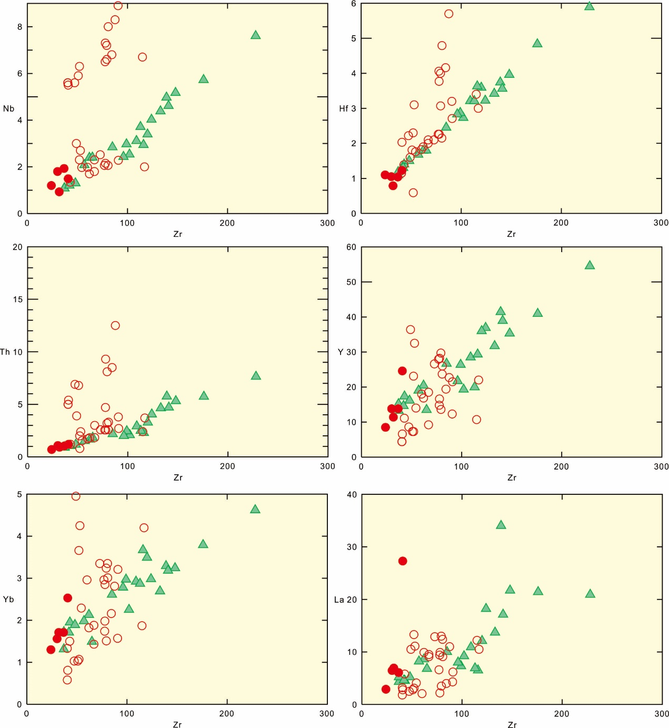

Supplemental file 7
Nb/La versus MgO (wt. %) and SiO₂ (wt. %) diagrams. Symbols are the same as in figure 5a.

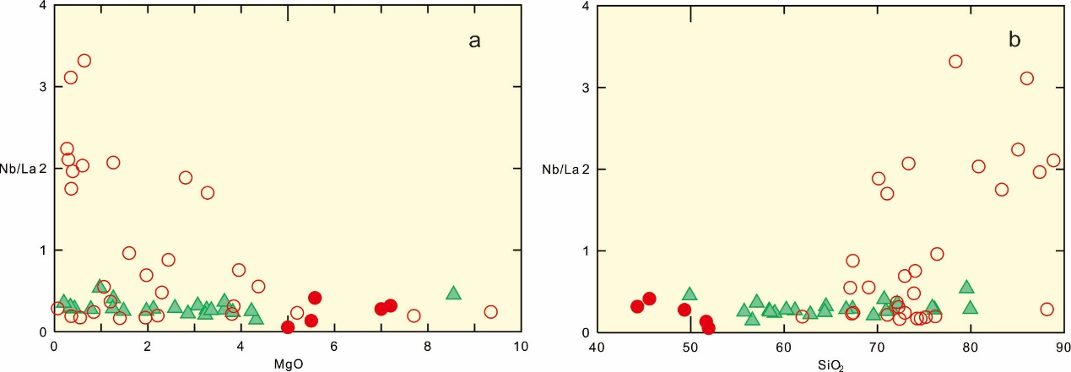

Supplemental file 8
Harker diagrams for the Dawazi and Dazhonghe volcanics. Symbols are the same as in figure 5.

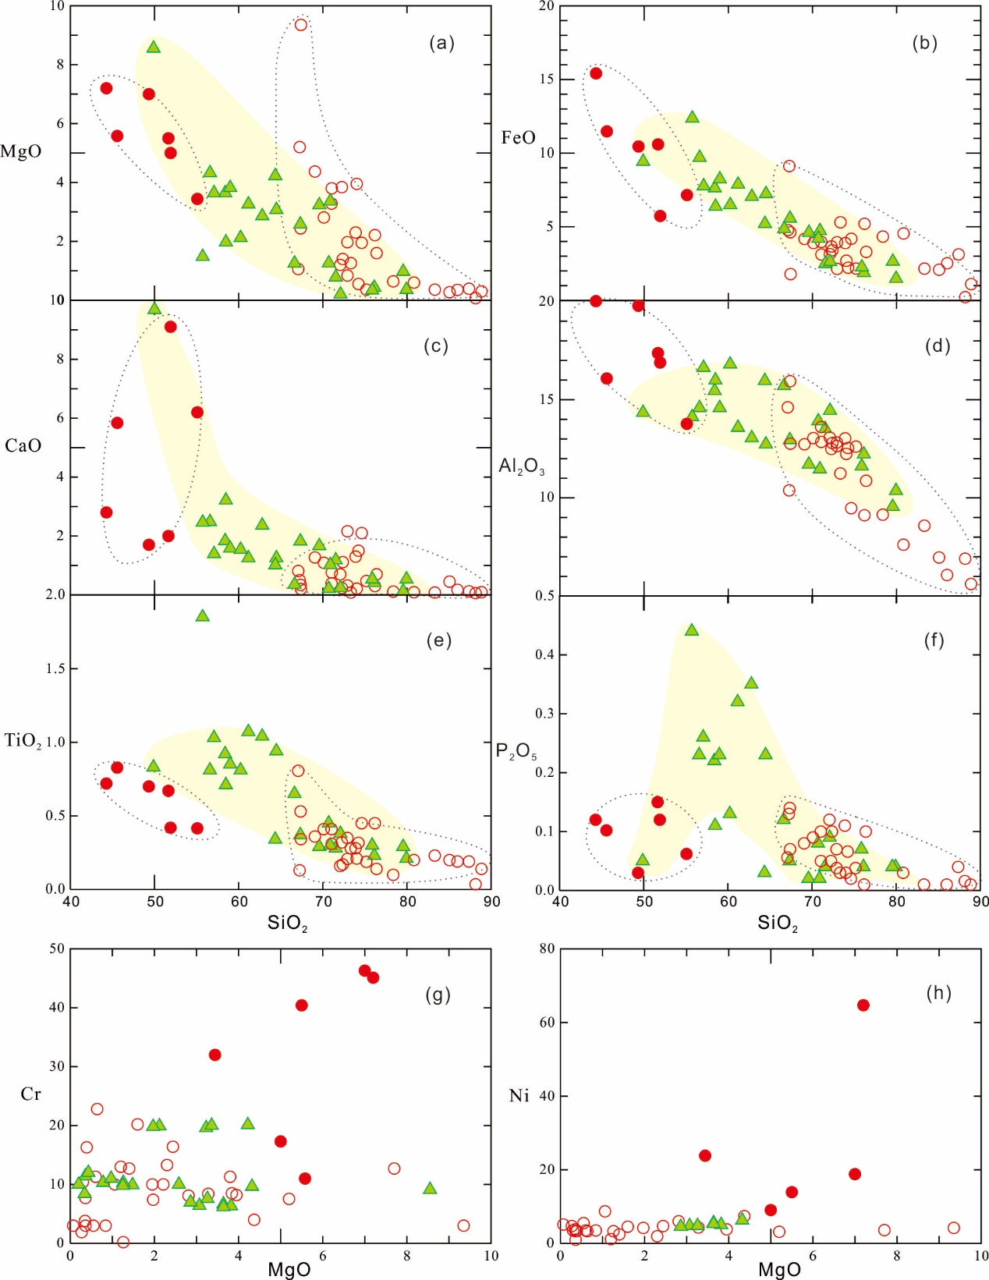

Supplemental file 9
Selected major (wt. %) and trace elements (ppm) versus Mg# diagrams. Symbols are the same as in figure 5a.

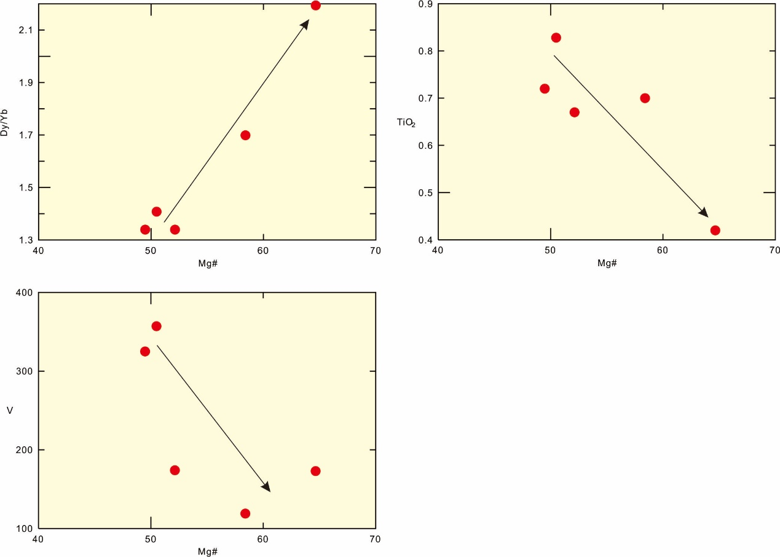

Supplemental file 10
(a) Cr versus Ni plot. (b) K₂O versus Na₂O plot. (c) (K₂O+Na₂O)/CaO versus (Zr + Nb + Ce + Y) diagram (after Whalen et al., 1987). (d) Nb/U versus Nb plot. FG represents fractionated felsic granite; OGT represents unfractionated M-, I-, and S-type granite. Data for MORB and OIB are taken from Sun and McDonough (1989). Data for Upper Continental Crust (UCC) and Bulk Continental Crust (BCC) are from Taylor and McLennan (1985) and Rudnick (1995), respectively. Symbols are the same as in Fig. 5.
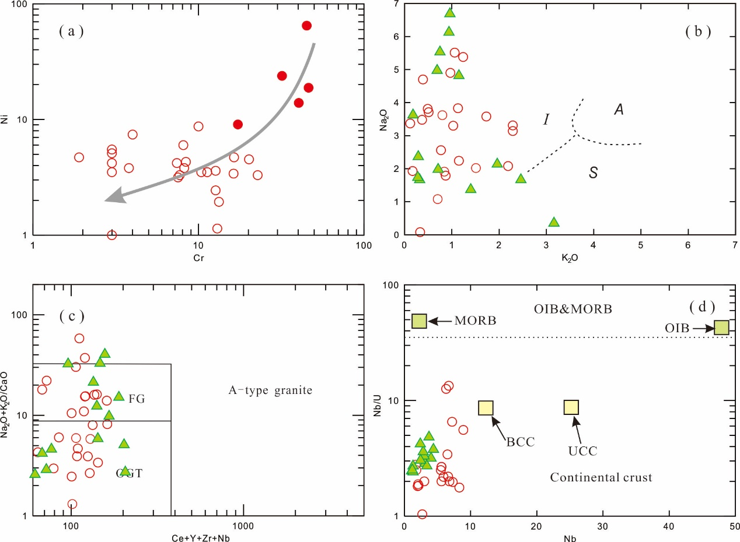
References
Whalen, J.B., Currie, K.L., Chappell, B.W., 1987. A-type granites: geochemical characteristics, discrimination and petrogenesis. Contrib Mineral Petr 95, 407–419.
Sun, S.S., McDonough, W.F., 1989. Chemical and isotopic systematics of oceanic basalts: implication for mantle composition and process. Geological Society, London, Special Publications 42, 313-345.
Taylor, S.R., McLennan, S.M., 1985. The Continental Crust: its Composition and Evolution. Blackwel, Oxford.
Rudnick, R.L., 1995. Making Continental-Crust. Nature 378, 571-578.

Supplemental file 11
(a) Rb/Ba versus Rb/Sr plot. (b) Al₂O₃/(FeOT+MgO+TiO₂) versus Al₂O₃+ FeOT+ MgO + TiO₂ plot. (c) Rb/Sr versus Ba plot. (d) TiO₂+MgO+FeOT versus SiO₂ plot. Fields in (a–b) are from Patiňo-Douce and Harris (1998), Sylvester (1998) and Patiňo-Douce (1999). Symbols are the same as in figure 5.
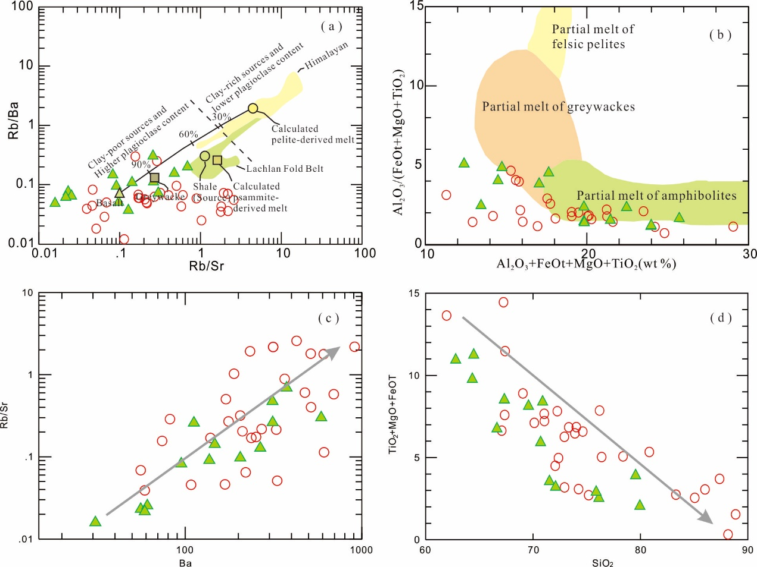
References
Patiňo-Douce, A.E., 1999. What do experiments tell us about the relative contributions of crust and mantle to the origin of granitic magmas. Geological Society London Special Publications 168, 55-75.
Patiňo-Douce, A.E., Harris, N., 1998. Experimental constraints on Himalayan anatexis. J Petrol 39, 689-710.
Sylvester, P.J., 1998. Post-collisional strongly peraluminous granites. Lithos 45, 29-44.

Supplemental file 12
(a) La/Yb versus Yb plot. (b) Th/Yb versus Yb plot. (c) Nb/La versus SiO₂ plot. (d) Rb-Ba-Sr plot (EL Bouseily and El Sokkary, 1975). Symbols are the same as in figure 5.
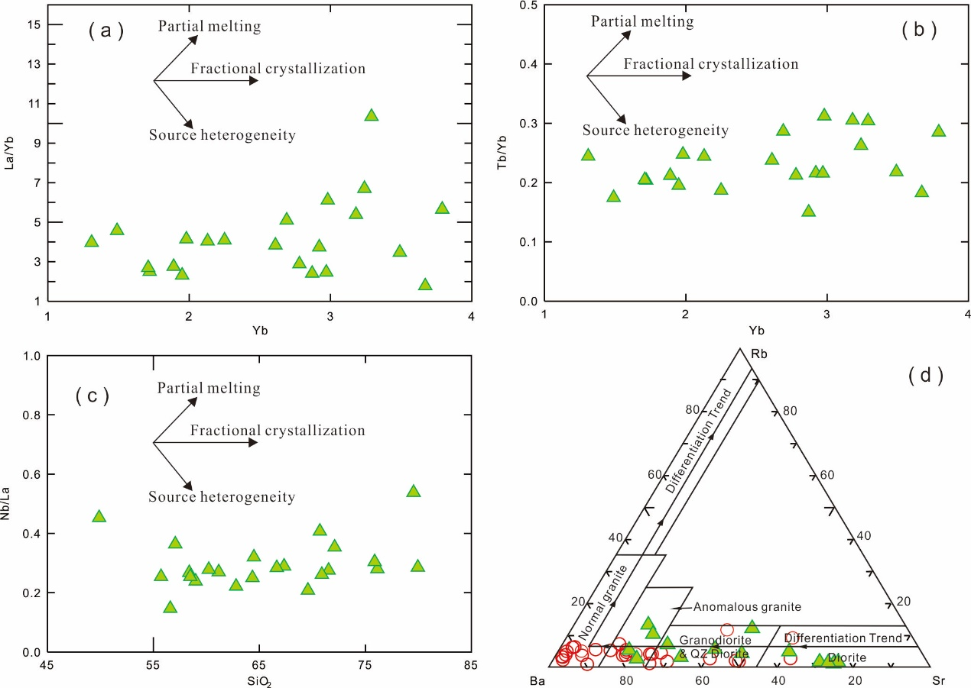
References
EL Bouseily, A.M., El Sokkary, A.A., 1975. The relation between Rb, Ba and Sr in granitic rocks. Chem Geol 16, 207-219.

Supplemental file 13
(a) Th/Yb versus Sr/Nd plot. (b) Th/Nd versus Ba/Nd plot. (c) Ba/Th versus (La/Sm)_{N} plot. Data for MORB are taken from Sun and McDonough (1989). Data for Upper Continental Crust (UCC) are from Taylor and McLennan (1985). Symbols are the same as in figure 5.
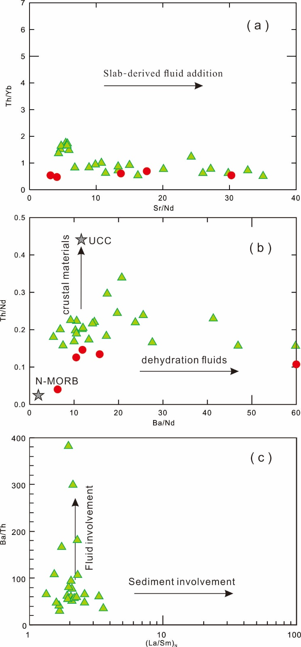
References
Sun, S.S., McDonough, W.F., 1989. Chemical and isotopic systematics of oceanic basalts: implication for mantle composition and process. Geological Society, London, Special Publications 42, 313-345.
Taylor, S.R., McLennan, S.M., 1985. The Continental Crust: its Composition and Evolution. Blackwel, Oxford.

Supplemental file 14
Tectonic discrimination diagrams for the Dawazi and Dazhonghe basaltic rocks involving (a) Ti/1000 versus V plot (after Shervais, 1982), (b) Ta/Yb versus Th/Yb diagram (Pearce and Cann, 1973) and (c-e) Th–Zr/117–Nb/16, Th–Hf/3–Ta and Th–Hf/3–Nb/16 diagrams (Wood, 1980). Symbols are the same as in figure 5.
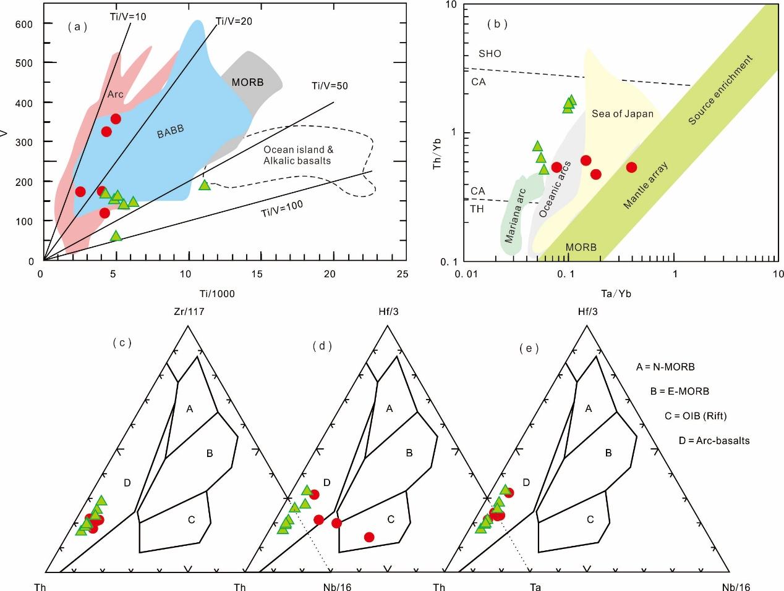
References
Wood, D.A., 1980. The application of a Th Hf Ta diagram to problems of tectonomagmatic classification and to establishing the nature of crustal contamination of basaltic lavas if the British Tertiary volcanic province. Earrh and Planetary Science Letters 50.
Shervais, J.W., 1982. Ti-V plots and the origin of modern and ophiolitic lavas. Earrh and Planetary Science Letters 59, 101-118.
Pearce, J.A., Cann, J.R., 1973. Tectonic setting of basic volcanic rocks determined using trace element analyses. Earth Planet Sc Lett 19, 290–300.

Supplemental file 15
Tectonic discrimination diagrams for the Dawazi and Dazhonghe silicic rocks involving (a) Rb-(Y+Nb) , Rb-(Yb+Ta), Nb-Y and Hf–Rb/30–Ta×3 diagrams (after Pearce, 1996; Pearce et al., 1984). Symbols are the same as in figure 5.
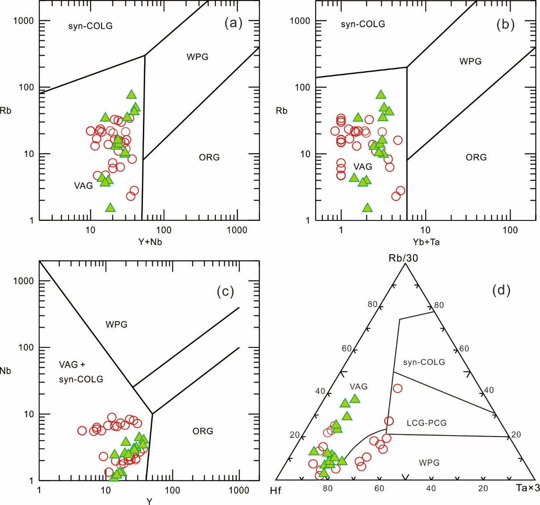
References
Pearce, J., 1996. Sources and settings of granitic rocks. Episodes 19, 120-125.
Pearce, J.A., Harris, N.B.W., Tindle, A.G., 1984. Trace-Element Discrimination Diagrams for the Tectonic Interpretation of Granitic-Rocks. J Petrol 25, 956-983.

