APPENDIX 1

Sampling procedures (4)
Before collecting the samples

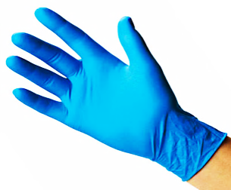
Before collecting the samples, the sampling bottle and the graduated cylinder should be rinsed
3 times with the river water.

- Person #1 puts on short gloves
- Person #2 puts on long gloves
- Person #3 opens the cooler containing sampling bottles
- Person #1 takes the sampling bottle (1L) associated with the station number, opens it and gives it to Person #2
- Person #2 fills the bottle with river water, shakes it and empties it (Repeat 3 times)
- Person #1 takes the graduated cylinder associated with the station number and gives it to Person #2
- With the help of Person #1, Person #2 rinses 3 times the graduated cylinder with the river water collected with the sampling bottle.

Sampling procedures (5)
Collecting unfiltered samples

6 bottles/tubes can be filled with river water without filtration:
- 1 square glass bottles for phosphorus (125mL)
- 1 round glass bottles for nitrogen (100mL)
- 3 plastic square bottles for major ions (125mL)
- 1 plastic tube for metals (40mL)

Volumes of liquid can be measured with the graduated cylinder.

On each bottle/tube filled with water, we should write sampling information with a permanent marker:
- Station #
- Sample #
- Volume collected
- Date (e.g. 2016-JL-XX)
- Time (e.g. 10:30 AM)

When this task is completed, throw away the water that remained in the sampling bottle.

Sampling procedures (6)
Filtration

Pieces of equipment required:
- Plastic or glass filtration units
- Appropriate filter
- Tweezers
- Hamp pump
- Graduated cylinder
- Appropriate conservation bottle

Filtration has 7 general steps:
- Insert the appropriate filter on the filter holder of the filtration unit with tweezers
- Close tightly the filtration unit
- Plug the pump on the side of the collector
- Measure the volume of water required for a sample and add it gradually to the funnel
- Pump smoothly until the water is completely filtrated
- Empty the collector (in the conservation bottle) when the filtration is finished or when the collector is full
Remove the filter with tweezers.

APPENDIX 2
Caribou Sample Collection
STEP 1: IDENTIFICATION
Hunter’s name:
Date of animal kill:
Hunting location:
GPS coordinates:
Sex of animal: | Female Male | Pregnant? Yes No
Age: | Calf Juvenile Adult | Nursing? Yes No
Body Size: | Small Average Large
Animal condition: | Skinny Not bad Fat Very fat

STEP 2: TISSUE COLLECTION
Sample number (written on bag): ___________________________________________
Place samples in labelled plastic bags. Keep samples cold. Freeze as soon as possible!
Liver + Meat Sample Size
Sample | Description | Collected  (please tick)
Liver | 2 x 2 inches, 1 inch thick
Meat (from hind) | 2 x 2 inches, 1 inch thick
Kidney (left one) | Whole + surrounding fat
Ankle bone | Whole (or with 6” marrow)

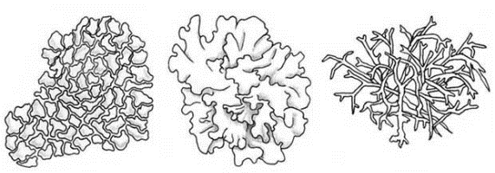
STEP 3: LICHENS
At the hunting location, completely fill the labelled bag with lichens from the ground. Collect lichens from 3 ground sites nearby the hunting location and place them in the same bag.

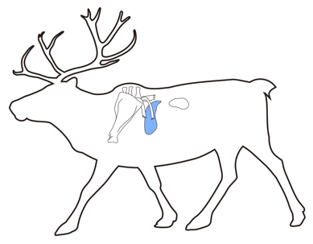
STEP 4: CHECKLIST OF COLLECTED DATA
Tissue Sample | Amount | Collected (please tick)
Step 1: Identification | $10.00
Step 2: Tissue Collection | $50.00
Step 3: Lichens | $15.00
Total | $____ | (Max. $75.00 per caribou)

Ringed Seal Sample Collection
STEP 1: IDENTIFICATION
Hunter’s name:
Date of animal kill:
Hunting location:
GPS coordinates:
Sex of animal: | Female Male | Pregnant? Yes No
Animal condition: | Skinny Not bad Fat Very fat

STEP 2: MEASURMENTS (BEFORE BUTCHERING)
- Length: Place the animal on its back and measure from tip of nose to tip of tail.
- Axial girth: Measure the girth of the animal from behind the front flippers.
- Maximum girth: Measure the girth of the animal from the largest part of the body.
- Blubber thickness: Cut the skin at breastbone. Measure the fat thickness from the skin to meat.
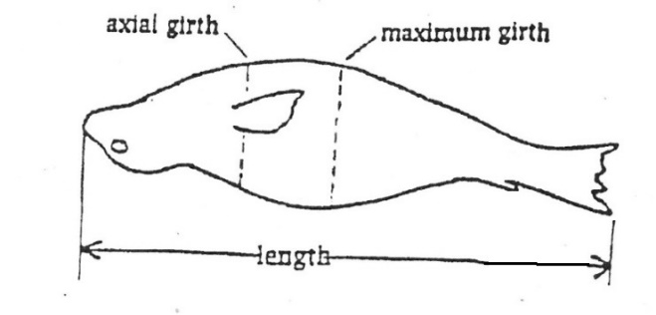
Length: _____________(cm) or __________ (inches)
Axial girth: _____________(cm) or __________ (inches)
Maximum girth: _____________(cm) or __________ (inches)
Blubber thickness: _____________(cm) or __________ (inches)

STEP 3: TISSUE COLLECTION (AFTER BUTCHERING)
Sample number (written on bag): ___________________________________________
Place samples in labelled plastic bags. Keep samples cold. Freeze as soon as possible!
Sample Size
Sample | Description | Collected  (please tick)
Liver | 2 x 2 inches, 1 inch thick
Meat (from back) | 2 x 2 inches, 1 inch thick
Blubber | 2 x 2 inches, 1 inch thick
Lower Jaw | Whole jaw

STEP 4: CHECKLIST OF COLLECTED DATA
Tissue Sample | Amount | Collected (please tick)
Step 1: Identification | $10.00
Step 2: Measurements | $15.00
Step 3: Tissue Collection | $50.00
Total | $____ | (Max. $75.00 per seal)
WHITEFISH SAMPLE COLLECTION
STEP 1: IDENTIFICATION Hunter’s name: ________________________________

STEP 2: MEASUREMENTS AND SAMPLE COLLECTION
Collect a total of 20 whitefish from a few different locations near the community. Place each fish (whole body) into a Ziploc bag. Please match the sample number on the bag with the location information provided below. Record the GPS coordinates and the water depth at the fishing locations. Record the method used to collect the fish (e.g., net, fishing rod). If possible, take photos of the fish collection.
Keep the fish cold and freeze as soon as possible (ideally the same day).
Date | Time | Bag ID | Collection method | Water depth (m) | Latitude °N | Longitude °W
 |  | Fish 1
 |  | Fish 2
 |  | Fish 3
 |  | Fish 4
 |  | Fish 5

STEP 3: CHECKLIST OF SAMPLES COLLECTED
Sample | Amount | Collected (please tick)
Sample (per fish) | 40$
Total # of fish collected | ___ x 40$
Total amount | _____ $

