Supplemental Material
Density functional and ab initio study of samarium dihalides, SmX₂ (X = I, Br, and Cl)

Jiwon Moon, Heehyun Baek, and Joonghan Kim*
Department of Chemistry, The Catholic University of Korea, Bucheon 14662,

Republic of Korea

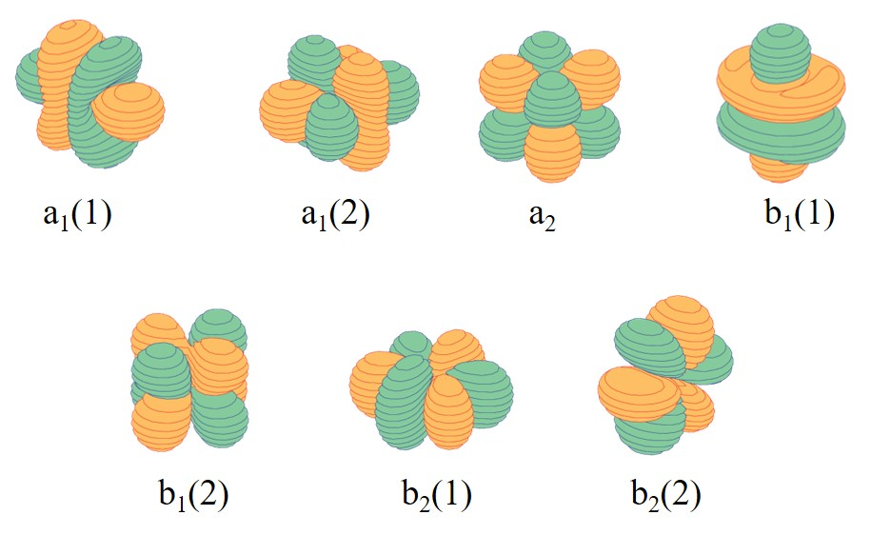

Figure S1. The active orbitals of the CAS(6,7) reference wave function of SmI₂.
Table S1. The relative energies (in kcal/mol) of SmI₂ on the optimized molecular structure of the ⁷B₁(2) state by CCSD(T).
SmI₂ | CAS(6,7) | Large frozen core MRCI+Qª | Small frozen core MRCI+Q^{b}
⁷A₁ | 1.76 | 2.12 | 2.11
⁷A₂(1) | 3.64 | 3.98 | 3.97
⁷A₂(2) | 0.52 | 0.63 | 0.63
⁷B₁(1) | 1.76 | 2.00 | 2.00
⁷B₁(2) | 0.00 | 0.00 | 0.00
⁷B₂(1) | 3.64 | 3.98 | 3.97
⁷B₂(2) | 0.64 | 0.74 | 0.74
a: the 5s and 5p electrons of Sm and 5s and 5p electrons of I were correlated in the MRCI+Q calculation.
b: the 5s and 5p electrons of Sm and 4d, 5s, and 5p electrons of I were correlated in the MRCI+Q calculation.

Table S2. Vibrational frequencies (in cm^{–1}) and NPA charges of low-lying electronic states of SmI_{2.}
SmI₂ |  |  | PBE0 | B1B95 | B3LYP | MP2
⁷A₁ | ω | a₁ (1)ª | 21 | 20 | 22 | 19
 |  | a₁ (2)^{b} | 134 | 132 | 132 | 139
 |  | b₂^{c} | 172 | 171 | 167 | 180
 | NPA^{d} |  | 1.337,  -0.669 | 1.349,  -0.674 | 1.342,  -0.671 | 1.317,  -0.658
⁷A₂(1) | ω | a₁ (1)ª | 23 | 22 | 24 | 22
 |  | a₁ (2)^{b} | 137 | 135 | 134 | 143
 |  | b₂^{c} | 170 | 170 | 166 | 178
 | NPA^{d} |  | 1.324,  -0.662 | 1.337,  -0.669 | 1.327,  -0.664 | 1.301,  -0.651
⁷A₂(2) | ω | a₁ (1)ª | 21 | 20 | 22 | 20
 |  | a₁ (2)^{b} | 134 | 132 | 131 | 140
 |  | b₂^{c} | 173 | 172 | 168 | 179
 | NPA^{d} |  | 1.342,  -0.671 | 1.353,  -0.676 | 1.347,  -0.674 | 1.313,  -0.656
⁷B₁(1) | ω | a₁ (1)ª | 21 | 20 | 22 | 19
 |  | a₁ (2)^{b} | 134 | 132 | 132 | 139
 |  | b₂^{c} | 172 | 171 | 167 | 180
 | NPA^{d} |  | 1.337,  -0.668 | 1.348,  -0.674 | 1.341,  -0.671 | 1.317,  -0.658
⁷B₁(2) | ω | a₁ (1)ª | 17 | 15 | 18 | 16
 |  | a₁ (2)^{b} | 130 | 127 | 128 | 136
 |  | b₂^{c} | 175 | 174 | 170 | 182
 | NPA^{d} |  | 1.353,  -0.677 | 1.367,  -0.684 | 1.356,  -0.678 | 1.330,  -0.665
⁷B₂(1) | ω | a₁ (1)ª | 23 | 22 | 24 | 22
 |  | a₁ (2)^{b} | 137 | 135 | 134 | 143
 |  | b₂^{c} | 170 | 170 | 166 | 178
 | NPA^{d} |  | 1.324,  -0.662 | 1.337,  -0.669 | 1.327,  -0.663 | 1.301,  -0.650
⁷B₂(2) | ω | a₁ (1)ª | 20 | 19 | 21 | 21
 |  | a₁ (2)^{b} | 133 | 131 | 131 | 142
 |  | b₂^{c} | 173 | 172 | 168 | 179
 | NPA^{d} |  | 1.340,  -0.670 | 1.352,  -0.676 | 1.342,  -0.671 | 1.306,  -0.653
ªExperimentally observed vibrational frequency is 26 cm⁻¹ (bending mode) from Ref. [22] in the main text.
^{b}Experimentally observed vibrational frequency is 118 cm⁻¹ (symmetric stretching mode) from Ref. [22] in the main text.
^{c}Experimentally observed vibrational frequency is 168 cm⁻¹ (asymmetric stretching mode) from Ref. [22] in the main text.
^{d}Positive and negative charges are Sm and I atoms of SmI₂, respectively.
Table S3. Vibrational frequencies (in cm^{–1}) and NPA charges of low-lying electronic states of SmBr_{2.}
SmBr₂ |  |  | PBE0 | B1B95 | B3LYP | MP2
⁷A₁ | ω | a₁ (1)ª | 32 | 31 | 32 | 29
 |  | a₁ (2)^{b} | 183 | 180 | 178 | 191
 |  | b₂^{c} | 209 | 208 | 203 | 220
 | NPA^{d} |  | 1.427,  -0.713 | 1.439,  -0.720 | 1.431,  -0.715 | 1.422,  -0.711
⁷A₂(1) | ω | a₁ (1)ª | 34 | 33 | 35 | 33
 |  | a₁ (2)^{b} | 184 | 182 | 180 | 193
 |  | b₂^{c} | 207 | 206 | 202 | 218
 | NPA^{d} |  | 1.415,  -0.707 | 1.429,  -0.714 | 1.416,  -0.708 | 1.409,  -0.705
⁷A₂(2) | ω | a₁ (1)ª | 31 | 30 | 31 | 31
 |  | a₁ (2)^{b} | 182 | 180 | 178 | 192
 |  | b₂^{c} | 209 | 208 | 204 | 218
 | NPA^{d} |  | 1.431,  -0.716 | 1.443,  -0.721 | 1.437,  -0.718 | 1.418,  -0.709
⁷B₁(1) | ω | a₁ (1)ª | 31 | 31 | 31 | 29
 |  | a₁ (2)^{b} | 183 | 181 | 179 | 191
 |  | b₂^{c} | 209 | 207 | 203 | 220
 | NPA^{d} |  | 1.426,  -0.713 | 1.439,  -0.719 | 1.430,  -0.715 | 1.423,  -0.711
⁷B₁(2) | ω | a₁ (1)ª | 26 | 24 | 27 | 25
 |  | a₁ (2)^{b} | 179 | 176 | 175 | 188
 |  | b₂^{c} | 211 | 210 | 206 | 222
 | NPA^{d} |  | 1.442,  -0.721 | 1.456,  -0.728 | 1.445,  -0.722 | 1.436,  -0.718
⁷B₂(1) | ω | a₁ (1)ª | 34 | 33 | 34 | 33
 |  | a₁ (2)^{b} | 184 | 182 | 180 | 193
 |  | b₂^{c} | 207 | 206 | 202 | 218
 | NPA^{d} |  | 1.415,  -0.707 | 1.428,  -0.714 | 1.416,  -0.708 | 1.409,  -0.704
⁷B₂(2) | ω | a₁ (1)ª | 31 | 29 | 31 | 32
 |  | a₁ (2)^{b} | 182 | 179 | 178 | 193
 |  | b₂^{c} | 209 | 208 | 204 | 219
 | NPA^{d} |  | 1.430,  -0.715 | 1.443,  -0.722 | 1.432,  -0.716 | 1.413,  -0.707
ªExperimentally observed vibrational frequency is 40 ± 8 cm⁻¹ (bending mode) from Ref. [23] in the main text.
^{b}Experimentally observed vibrational frequency is 200 ± 10 cm⁻¹ (symmetric stretching mode) from Ref. [23] in the main text.
^{c}Experimentally observed vibrational frequency is 225 ± 10 cm⁻¹ (asymmetric stretching mode) from Ref. [23] in the main text.
^{d}Positive and negative charges are Sm and Br atoms of SmBr₂, respectively.
Table S4. Vibrational frequencies (in cm^{–1}) and NPA charges of low-lying electronic states of SmCl_{2.}
SmCl₂ |  |  | PBE0 | B1B95 | B3LYP | MP2
⁷A₁ | ω | a₁ (1)ª | 51 | 50 | 51 | 48
 |  | a₁ (2)^{b} | 282 | 279 | 275 | 291
 |  | b₂^{c} | 289 | 287 | 282 | 30054
 | NPA^{d} |  | 1.496,  -0.748 | 1.509,  -0.754 | 1.499,  -0.750 | 1.496,  -0.748
⁷A₂(1) | ω | a₁ (1)ª | 54 | 52 | 54 | 53
 |  | a₁ (2)^{b} | 282 | 280 | 275 | 292
 |  | b₂^{c} | 288 | 285 | 281 | 299
 | NPA^{d} |  | 1.484,  -0.742 | 1.498,  -0.749 | 1.484,  -0.742 | 1.484,  -0.742
⁷A₂(2) | ω | a₁ (1)ª | 49 | 48 | 48 | 51
 |  | a₁ (2)^{b} | 283 | 280 | 276 | 291
 |  | b₂^{c} | 290 | 287 | 282 | 298
 | NPA^{d} |  | 1.499,  -0.750 | 1.511,  -0.756 | 1.504,  -0.752 | 1.491,  -0.746
⁷B₁(1) | ω | a₁ (1)ª | 50 | 48 | 49 | 48
 |  | a₁ (2)^{b} | 282 | 280 | 275 | 291
 |  | b₂^{c} | 290 | 287 | 283 | 305
 | NPA^{d} |  | 1.494,  -0.747 | 1.507,  -0.754 | 1.498,  -0.749 | 1.496,  -0.748
⁷B₁(2) | ω | a₁ (1)ª | 41 | 37 | 42 | 40
 |  | a₁ (2)^{b} | 280 | 277 | 274 | 289
 |  | b₂^{c} | 291 | 288 | 284 | 301
 | NPA^{d} |  | 1.509,  -0.755 | 1.524,  -0.762 | 1.512,  -0.756 | 1.508,  -0.754
⁷B₂(1) | ω | a₁ (1)ª | 54 | 52 | 55 | 53
 |  | a₁ (2)^{b} | 282 | 280 | 275 | 292
 |  | b₂^{c} | 288 | 285 | 282 | 299
 | NPA^{d} |  | 1.484,  -0.742 | 1.498,  -0.749 | 1.484,  -0.742 | 1.484,  -0.742
⁷B₂(2) | ω | a₁ (1)ª | 47 | 46 | 47 | 52
 |  | a₁ (2)^{b} | 281 | 278 | 274 | 292
 |  | b₂^{c} | 289 | 286 | 283 | 299
 | NPA^{d} |  | 1.499,  -0.749 | 1.513,  -0.756 | 1.501,  -0.750 | 1.488,  -0.744
ªBending mode.
^{b}Symmetric stretching mode.
^{c}Asymmetric stretching mode.
^{d}Positive and negative charges are the Sm and Cl atoms of SmCl₂, respectively.

