***Supplemental Data***

**Identifying the inserted locus of randomly integrated expression plasmid by whole-genome sequencing of *Aspergillus* strains**

Aya K. Takeda1¶*, Hiroaki Udagawa2, Yasuo Uemura1§, Shinobu Takagi2*, ** (*equally contributed to this work, **corresponding)

1Genaris Inc., Kanagawa, Japan, 2Novozymes Japan Ltd., Chiba, Japan

**Corresponding author:**

Shinobu Takagi

Novozymes Japan Ltd.

CB-5 MTG, 1-3 Nakase, Mihama-ku,

Chiba, 261-8501, Japan

Tel: +81 90 6008 1039 / Fax: +81 43 296 6760

E-mail: st@novozymes.com

**Current address**

¶ Cykinso, Inc., 1-36-1 Yoyogi, Shibuya-ku, Tokyo, Japan

§ GeneBay, Inc., 3-8-8 Shin-Yokohama, Kohoku, Yokohama, Kanagawa, Japan

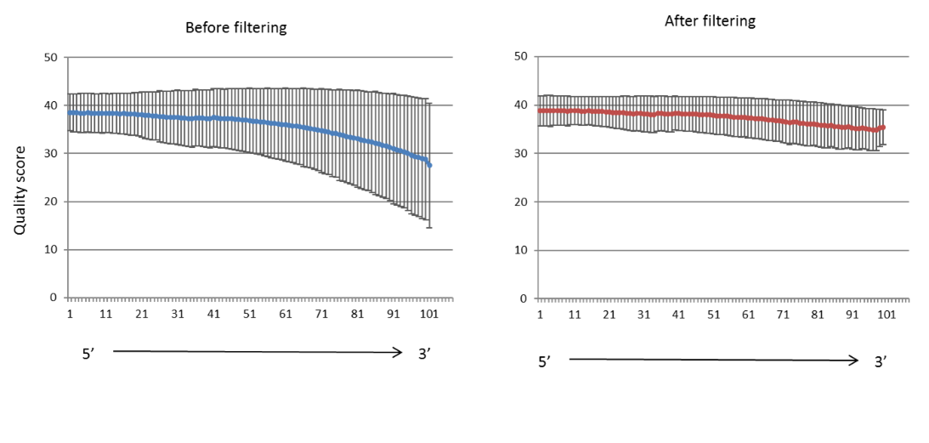

**Figure S1. Per-base average quality and standard deviation of the reads before and after trimming.** Filtering and Trimming was done by qtrim program developed by Genaris, Inc.



**Figure S2. View on GiNeS of commonly mapped linking reads on chromosome 3.** The reference is the *A. oryzae* RIB40 from DOGAN. The position numbers at reference are shown in “Zoom scale”, and location on chromosome is shown in “Wide Scale” of Reference. “Genes” are annotated CDS in DOGAN and arrow in parenthesis shows the direction of CDS. Mapping results of four different pools, “NZ-A linking reads”, “NZ-A w/o linking reads”, “NZ-S linking reads” and “NZ-S w/o linking reads”, are shown. In GiNeS, bars colored in pink represent depth of coverage, i.e., number of reads aligned at each base position. AO090023000944 (2488464~2490507) is the CDS encoding alpha-amylase. The commonly mapped region with linking reads from both NZ-A and NZ-S (around 2490600~2491130) is in the 5’-UTR of AO090023000944.

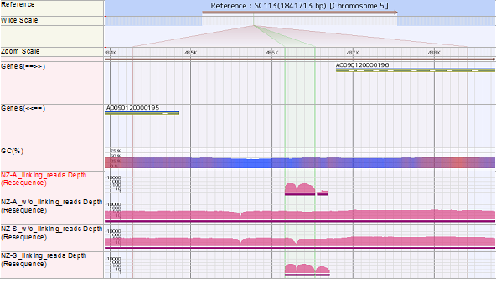

**Figure S3. View on GiNeS of commonly mapped linking-reads on chromosome 5.**

AO090120000196 (486782~488825) is the CDS encoding alpha-amylase gene. The commonly mapped region around 486160~486700 is in the 5’-UTR of AO090120000196.

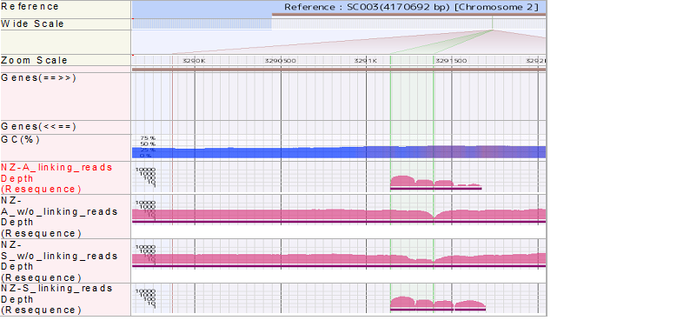

**Figure S4. View on GiNeS of commonly mapped linking reads on chromosome 2.** The commonly mapped region around 3291150~ 3291700 is about 1.9kb downstream of AO09003001209 (outside the view) encoding a presumed maltase/glucoamylase gene. It was discovered that the mapped region was highly homologous to the 5’-UTR of alpha-amylase genes shown in Fig. S2 and S3. A presumed alpha-amylase gene was identified at 3291763~3293806 (outside the view).

1 80

A196 (1) ATGATGGTCGCGTGGTGGTCTCTATTTCTGTACGGCCTTCAGGTCGCGGCACCTGCTTTGGCTGCAACGCCTGCGGACTG

A944 (1) ATGATGGTCGCGTGGTGGTCTCTATTTCTGTACGGCCTTCAGGTCGCGGCACCTGCTTTGGCTGCAACGCCTGCGGACTG

SC003 (1) ATGATGGTCGCGTGGTGGTCTCTATTTCTGTACGGCCTTCAGGTCGCGGCACCTGCTTTGGCTGCAACGCCTGCGGACTG

Consensus (1) ATGATGGTCGCGTGGTGGTCTCTATTTCTGTACGGCCTTCAGGTCGCGGCACCTGCTTTGGCTGCAACGCCTGCGGACTG

81 160

A196 (81) GCGATCGCAATCCATTTATTTCCTTCTCACGGATCGATTTGCAAGGACGGATGGGTCGACGACTGCGACTTGTAATACTG

A944 (81) GCGATCGCAATCCATTTATTTCCTTCTCACGGATCGATTTGCAAGGACGGATGGGTCGACGACTGCGACTTGTAATACTG

SC003 (81) GCGATCGCAATCCATTTATTTCCTTCTCACGGATCGATTTGCAAGGACGGATGGGTCGACGACTGCGACTTGTAATACTG

Consensus (81) GCGATCGCAATCCATTTATTTCCTTCTCACGGATCGATTTGCAAGGACGGATGGGTCGACGACTGCGACTTGTAATACTG

161 240

A196 (161) CGGATCAGGTGTGTTGTTACCTACTAGCTTTCAGAAAGAGGAATGTAAACTGACTTGATATAGAAATACTGTGGTGGAAC

A944 (161) CGGATCAGGTGTGTTGTTACCTACTAGCTTTCAGAAAGAGGAATGTAAACTGACTTGATATAGAAATACTGTGGTGGAAC

SC003 (161) CGGATCGGGTGTGTTGTTACCTACTAGCTTTCAGAAAGAGGAATGTAAACTGACTTGATATAGAAATACTGTGGTGGAAC

Consensus (161) CGGATCAGGTGTGTTGTTACCTACTAGCTTTCAGAAAGAGGAATGTAAACTGACTTGATATAGAAATACTGTGGTGGAAC

241 320

A196 (241) ATGGCAGGGCATCATCGACAAGGTAAATTGCCCCTTTATCAAAAAAAAAGAAGGAAAAGCAGAAGAAAAATAAAATAAAA

A944 (241) ATGGCAGGGCATCATCGACAAGGTAAATTGCCCCTTTATCAAAAAAAAAGAAGGAAAAGCAGAAGAAAAATAAAATAAAA

SC003 (241) ATGGCAGGGCATCATCGACAAGGTAAATTGCCCCTTTATCAAAAAAAAAGAAGGAAAAGCAGAAGAAAAATAAAATAAAA

Consensus (241) ATGGCAGGGCATCATCGACAAGGTAAATTGCCCCTTTATCAAAAAAAAAGAAGGAAAAGCAGAAGAAAAATAAAATAAAA

321 400

A196 (321) AGAACTCTAGTCCTAACCATCACATAGTTGGACTATATCCAGGGAATGGGCTTCACAGCCATCTGGATCACCCCCGTTAC

A944 (321) AGAACTCTAGTCCTAACCATCACATAGTTGGACTATATCCAGGGAATGGGCTTCACAGCCATCTGGATCACCCCCGTTAC

SC003 (321) AGAACTCTAGTCCTAACCATCACATAGTTGGACTATATCCAGGGAATGGGCTTCACAGCCATCTGGATCACCCCCGTTAC

Consensus (321) AGAACTCTAGTCCTAACCATCACATAGTTGGACTATATCCAGGGAATGGGCTTCACAGCCATCTGGATCACCCCCGTTAC

401 480

A196 (401) AGCCCAGCTGCCCCAGACCACCGCATATGGAGATGCCTACCATGGCTACTGGCAGCAGGATATGTAAGTCGATTTCTTTA

A944 (401) AGCCCAGCTGCCCCAGACCACCGCATATGGAGATGCCTACCATGGCTACTGGCAGCAGGATATGTAAGTCGATTTCTTTA

SC003 (401) AGCCCAGCTGCCCCAGACCACCGCATATGGAGATGCCTACCATGGCTACTGGCAGCAGGATATGTAAGTCGATTTCTTTA

Consensus (401) AGCCCAGCTGCCCCAGACCACCGCATATGGAGATGCCTACCATGGCTACTGGCAGCAGGATATGTAAGTCGATTTCTTTA

481 560

A196 (481) AATATCTACCTGTCATCTTTTACATCAATATGAACTAACTTGATGGTTTTAGATACTCTCTGAACGAAAACTACGGCACT

A944 (481) AATATCTACCTGTCATCTTTTACATCAATATGAACTAACTTGATGGTTTTAGATACTCTCTGAACGAAAACTACGGCACT

SC003 (481) AATATCTACCTGTCATCTTTTACATCAATATGAACTAACTTGATGGTTTTAGATACTCTCTGAACGAAAACTACGGCACT

Consensus (481) AATATCTACCTGTCATCTTTTACATCAATATGAACTAACTTGATGGTTTTAGATACTCTCTGAACGAAAACTACGGCACT

561 640

A196 (561) GCAGATGACTTGAAGGCGCTCTCTTCGGCCCTTCATGAGAGGGGGATGTATCTTATGGTCGATGTGGTTGCTAACCATAT

A944 (561) GCAGATGACTTGAAGGCGCTCTCTTCGGCCCTTCATGAGAGGGGGATGTATCTTATGGTCGATGTGGTTGCTAACCATAT

SC003 (561) GCAGATGACTTGAAGGCGCTCTCTTCGGCCCTTCATGAGAGGGGGATGTATCTTATGGTCGATGTGGTTGCTAACCATAT

Consensus (561) GCAGATGACTTGAAGGCGCTCTCTTCGGCCCTTCATGAGAGGGGGATGTATCTTATGGTCGATGTGGTTGCTAACCATAT

641 720

A196 (641) GGTTCGTGGTCCTTTGCAACTGACTTCGCGGATATGGTTCATTTCAGTACTGACAATGAGTAATATCAGGGCTATGATGG

A944 (641) GGTTCGTGGTCCTTTGCAACTGACTTCGCGGATATGGTTCATTTCAGTACTGACAATGAGTAATATCAGGGCTATGATGG

SC003 (641) GGTTCGTGGTCCTTTGCAACTGACTTCGCGGATATGGTTCATTTCAGTACTGACAATGAGTAATATCAGGGCTATGATGG

Consensus (641) GGTTCGTGGTCCTTTGCAACTGACTTCGCGGATATGGTTCATTTCAGTACTGACAATGAGTAATATCAGGGCTATGATGG

721 800

A196 (721) AGCGGGTAGCTCAGTCGATTACAGTGTGTTTAAACCGTTCAGTTCCCAAGACTACTTCCACCCGTTCTGTTTCATTCAAA

A944 (721) AGCGGGTAGCTCAGTCGATTACAGTGTGTTTAAACCGTTCAGTTCCCAAGACTACTTCCACCCGTTCTGTTTCATTCAAA

SC003 (721) AGCGGGTAGCTCAGTCGATTACAGTGTGTTTAAACCGTTCAGTTCCCAAGACTACTTCCACCCGTTCTGTCTCATTCAAA

Consensus (721) AGCGGGTAGCTCAGTCGATTACAGTGTGTTTAAACCGTTCAGTTCCCAAGACTACTTCCACCCGTTCTGTTTCATTCAAA

801 880

A196 (801) ACTATGAAGATCAGACTCAGGTTGAGGATTGCTGGCTAGGAGATAACACTGTCTCCTTGCCTGATCTCGATACCACCAAG

A944 (801) ACTATGAAGATCAGACTCAGGTTGAGGATTGCTGGCTAGGAGATAACACTGTCTCCTTGCCTGATCTCGATACCACCAAG

SC003 (801) ACTATGAAGATCAGACTCAGGTTGAGGATTGCTGGCTAGGAGATAACACTGTCTCCTTGCCTGATCTCGATACCACCAAG

Consensus (801) ACTATGAAGATCAGACTCAGGTTGAGGATTGCTGGCTAGGAGATAACACTGTCTCCTTGCCTGATCTCGATACCACCAAG

881 960

A196 (881) GATGTGGTCAAGAATGAATGGTACGACTGGGTGGGATCATTGGTATCGAACTACTCCAGTAAGATATTTCTCCCTCATTC

A944 (881) GATGTGGTCAAGAATGAATGGTACGACTGGGTGGGATCATTGGTATCGAACTACTCCAGTAAGATATTTCTCCCTCATTC

SC003 (881) GATGTGGTCAAGAATGAATGGTACGACTGGGTGGGATCATTGGTATCGAACTACTCCAGTAAGATATTTCTCCCTCATTC

Consensus (881) GATGTGGTCAAGAATGAATGGTACGACTGGGTGGGATCATTGGTATCGAACTACTCCAGTAAGATATTTCTCCCTCATTC

961 1040

A196 (961) TACAACTTGGCTGATCGATGATACTTACGAAATCAGTTGACGGCCTCCGTATCGACACAGTAAAACACGTCCAGAAGGAC

A944 (961) TACAACTTGGCTGATCGATGATACTTACGAAATCAGTTGACGGCCTCCGTATCGACACAGTAAAACACGTCCAGAAGGAC

SC003 (961) TACAACTTGGCTGATCGATGATACTTACGAAATCAGTTGACGGCCTCCGTATCGACACAGTAAAACACGTCCAGAAGGAC

Consensus (961) TACAACTTGGCTGATCGATGATACTTACGAAATCAGTTGACGGCCTCCGTATCGACACAGTAAAACACGTCCAGAAGGAC

1041 1120

A196 (1041) TTCTGGCCCGGGTACAACAAAGCCGCAGGCGTGTACTGTATCGGCGAGGTGCTCGACGGTGATCCGGCCTACACTTGTCC

A944 (1041) TTCTGGCCCGGGTACAACAAAGCCGCAGGCGTGTACTGTATCGGCGAGGTGCTCGACGGTGATCCGGCCTACACTTGTCC

SC003 (1041) TTCTGGCCCGGGTACAACAAAGCCGCAGGCGTGTACTGTATCGGCGAGGTGCTCGACGGTGATCCGGCCTACACTTGTCC

Consensus (1041) TTCTGGCCCGGGTACAACAAAGCCGCAGGCGTGTACTGTATCGGCGAGGTGCTCGACGGTGATCCGGCCTACACTTGTCC

1121 1200

A196 (1121) CTACCAGAACGTCATGGACGGCGTACTGAACTATCCCATGTATGGTTCCTCCAACCATGAGCCTTCTTGCAAGTCTCATC

A944 (1121) CTACCAGAACGTCATGGACGGCGTACTGAACTATCCCATGTATGGTTCCTCCAACCATGAGCCTTCTTGCAAGTCTCATC

SC003 (1121) CTACCAGAACGTCATGGACGGCGTACTGAACTATCCCATGTATGGTTCCTCCAACCATGAGCCTTCTTGCAAGTCTCATC

Consensus (1121) CTACCAGAACGTCATGGACGGCGTACTGAACTATCCCATGTATGGTTCCTCCAACCATGAGCCTTCTTGCAAGTCTCATC

1201 1280

A196 (1201) TCCTAACGAAACGGCTAAAACCAGTTACTATCCACTCCTCAACGCCTTCAAGTCAACCTCCGGCAGCATGGACGACCTCT

A944 (1201) TCCTAACGAAACGGCTAAAACCAGTTACTATCCACTCCTCAACGCCTTCAAGTCAACCTCCGGCAGCATGGACGACCTCT

SC003 (1201) TCCTAACGAAACGGCTAAAACCAGTTACTATCCACTCCTCAACGCCTTCAAGTCAACCTCCGGCAGCATGGACGACCTCT

Consensus (1201) TCCTAACGAAACGGCTAAAACCAGTTACTATCCACTCCTCAACGCCTTCAAGTCAACCTCCGGCAGCATGGACGACCTCT

1281 1360

A196 (1281) ACAACATGATCAACACCGTCAAATCCGACTGTCCAGACTCAACACTCCTGGGCACATTCGTCGAGAACCACGACAACCCA

A944 (1281) ACAACATGATCAACACCGTCAAATCCGACTGTCCAGACTCAACACTCCTGGGCACATTCGTCGAGAACCACGACAACCCA

SC003 (1281) ACAACATGATCAACACCGTCAAATCCGACTGTCCAGACTCAACACTCCTGGGCACATTCGTCGAGAACCACGACAACCCA

Consensus (1281) ACAACATGATCAACACCGTCAAATCCGACTGTCCAGACTCAACACTCCTGGGCACATTCGTCGAGAACCACGACAACCCA

1361 1440

A196 (1361) CGGTTCGCTTCGTAAGTCTTCCCTTTTATTTTCCGTTCCCAATTTCCACACAGAACCCCACCTAACAAGAGCAAAGTTAC

A944 (1361) CGGTTCGCTTCGTAAGTCTTCCCTTTTATTTTCCGTTCCCAATTTCCACACAGAACCCCACCTAACAAGAGCAAAGTTAC

SC003 (1361) CGGTTCGCTTCGTAAGTCTTCCCTTTTATTTTCCGTTCCCAATTTCCACACAGAACCCCACCTAACAAGAGCAAAGTTAC

Consensus (1361) CGGTTCGCTTCGTAAGTCTTCCCTTTTATTTTCCGTTCCCAATTTCCACACAGAACCCCACCTAACAAGAGCAAAGTTAC

1441 1520

A196 (1441) ACCAACGACATAGCCCTCGCCAAGAACGTCGCAGCATTCATCATCCTCAACGACGGAATCCCCATCATCTACGCCGGCCA

A944 (1441) ACCAACGACATAGCCCTCGCCAAGAACGTCGCAGCATTCATCATCCTCAACGACGGAATCCCCATCATCTACGCCGGCCA

SC003 (1441) ACCAACGACATAGCCCTCGCCAAGAACGTCGCAGCATTCATCATCCTCAACGACGGAATCCCCATCATCTACGCCGGCCA

Consensus (1441) ACCAACGACATAGCCCTCGCCAAGAACGTCGCAGCATTCATCATCCTCAACGACGGAATCCCCATCATCTACGCCGGCCA

1521 1600

A196 (1521) AGAACAGCACTACGCCGGCGGAAACGACCCCGCGAACCGCGAAGCAACCTGGCTCTCGGGCTACCCGACCGACAGCGAGC

A944 (1521) AGAACAGCACTACGCCGGCGGAAACGACCCCGCGAACCGCGAAGCAACCTGGCTCTCGGGCTACCCGACCGACAGCGAGC

SC003 (1521) AGAACAGCACTACGCCGGCGGAAACGACCCCGCGAACCGCGAAGCAACCTGGCTCTCGGGCTACCCGACCGACAGCGAGC

Consensus (1521) AGAACAGCACTACGCCGGCGGAAACGACCCCGCGAACCGCGAAGCAACCTGGCTCTCGGGCTACCCGACCGACAGCGAGC

1601 1680

A196 (1601) TGTACAAGTTAATTGCCTCCGCGAACGCAATCCGGAACTATGCCATTAGCAAAGATACAGGATTCGTGACCTACAAGGTA

A944 (1601) TGTACAAGTTAATTGCCTCCGCGAACGCAATCCGGAACTATGCCATTAGCAAAGATACAGGATTCGTGACCTACAAGGTA

SC003 (1601) TGTACAAGTTAATTGCCTCCGCGAACGCAATCCGGAACTATGCCATTAGCAAAGATACAGGATTCGTGACCTACAAGGTA

Consensus (1601) TGTACAAGTTAATTGCCTCCGCGAACGCAATCCGGAACTATGCCATTAGCAAAGATACAGGATTCGTGACCTACAAGGTA

1681 1760

A196 (1681) AGCACAACCTCTAAGCATACCCTAATGGCCTATCTTCAGAGTATCTGACACAAGAGACTAATCACTGGCAATACAGAACT

A944 (1681) AGCACAACCTCTAAGCATACCCTAATGGCCTATCTTCAGAGTATCTGACACAAGAGACTAATCACTGGCAATACAGAACT

SC003 (1681) AGCACAACCTCTAAGCATACCCTAATGGCCTATCTTCAGAGTATCTGACACAAGAGACTAATCACTGGCAATACAGAACT

Consensus (1681) AGCACAACCTCTAAGCATACCCTAATGGCCTATCTTCAGAGTATCTGACACAAGAGACTAATCACTGGCAATACAGAACT

1761 1840

A196 (1761) GGCCCATCTACAAAGACGACACAACGATCGCCATGCGCAAGGGCACAGATGGGTCGCAGATCGTGACTATCTTGTCCAAC

A944 (1761) GGCCCATCTACAAAGACGACACAACGATCGCCATGCGCAAGGGCACAGATGGGTCGCAGATCGTGACTATCTTGTCCAAC

SC003 (1761) GGCCCATCTACAAAGACGACACAACGATCGCCATGCGCAAGGGCACAGATGGGTCGCAGATCGTGACTATCTTGTCCAAC

Consensus (1761) GGCCCATCTACAAAGACGACACAACGATCGCCATGCGCAAGGGCACAGATGGGTCGCAGATCGTGACTATCTTGTCCAAC

1841 1920

A196 (1841) AAGGGTGCTTCGGGTGATTCGTATACCCTCTCCTTGAGTGGTGCGGGTTACACAGCCGGCCAGCAATTGACGGAGGTCAT

A944 (1841) AAGGGTGCTTCGGGTGATTCGTATACCCTCTCCTTGAGTGGTGCGGGTTACACAGCCGGCCAGCAATTGACGGAGGTCAT

SC003 (1841) AAGGGTGCTTCGGGTGATTCGTATACCCTCTCCTTGAGTGGTGCGGGTTACACAGCCGGCCAGCAATTGACGGAGGTCAT

Consensus (1841) AAGGGTGCTTCGGGTGATTCGTATACCCTCTCCTTGAGTGGTGCGGGTTACACAGCCGGCCAGCAATTGACGGAGGTCAT

1921 2000

A196 (1921) TGGCTGCACGACCGTGACGGTTGGTTCGGATGGAAATGTGCCTGTTCCTATGGCAGGTGGGCTACCTAGGGTATTGTATC

A944 (1921) TGGCTGCACGACCGTGACGGTTGGTTCGGATGGAAATGTGCCTGTTCCTATGGCAGGTGGGCTACCTAGGGTATTGTATC

SC003 (1921) TGGCTGCACGACCGTGACGGTTGGTTCGGATGGAAATGTGCCTGTTCCTATGGCAGGTGGGCTACCTAGGGTATTGTATC

Consensus (1921) TGGCTGCACGACCGTGACGGTTGGTTCGGATGGAAATGTGCCTGTTCCTATGGCAGGTGGGCTACCTAGGGTATTGTATC

2001 2044

A196 (2001) CGACTGAGAAGTTGGCAGGTAGCAAGATCTGTAGTAGCTC----

A944 (2001) CGACTGAGAAGTTGGCAGGTAGCAAGATCTGTAGTAGCTCGTGA

SC003 (2001) CGACTGAGAAGTTGGCAGGTAGCAAGATCTGTAGTAGCTCGTGA

Consensus (2001) CGACTGAGAAGTTGGCAGGTAGCAAGATCTGTAGTAGCTCGTGA

**Figure S5. Alignment of alpha-amylase genes of *A. oryzae* RIB40.** Sequence alignment of the discovered alpha-amylase with other alpha-amylase genes. A196: AO090120000196 on SC113/chromosome 5, A944: AO090023000944 on SC023/chromosome 3, and SC003: a presumed CDS at (3291763..3293806) on SC003/chromosome 2 which was identified in this work. The sequence of AO090120000196 and AO090023000944 are identical. The presumed CDS at (3291763..3293806) on SC003 has 2 bases difference from the other two genes (A167G, T791C).

|  |
| --- |
|  |

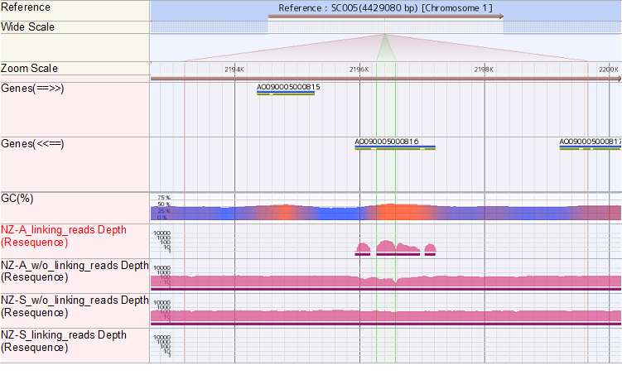

**Figure S6. Linking-reads from NZ-A mapped to chromosome 1.** Only the linking reads from NZ-A were mapped onto AO090005000816, encoding an asparaginase. Reads were mapped only to exons but not to introns, as the used asparaginase gene in the expression plasmid was cDNA clone.

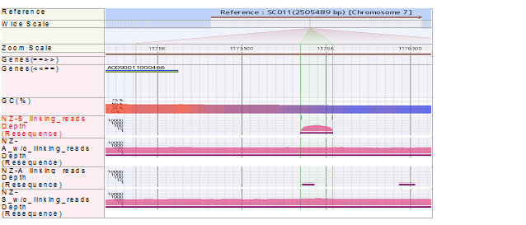

**Figure S7. Linking-reads from NZ-S mapped to chromosome 7.** 200 bases from linking reads of NZ-S were mapped around 0.9 kb up-stream of AO090011000466 encoding unknown protein.

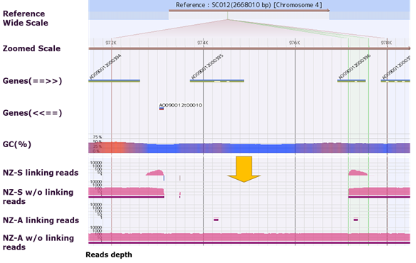

**Figure S8. View on GiNeS around the inserted locus of the expression plasmid pMT2155.** Identified inserted locus of pMT2155 is shown with arrow. There was a 4-kb long deletion on genome of *A. oryzae* pMT2155/BECh2-Fb3 at the inserted locus, as there were no reads from NZ-S aligned to this region, while the reads from NZ-A w/o linking reads were aligned. The deleted region contained the whole gene of AO090012000395 and 5’-end of AO090012000396.

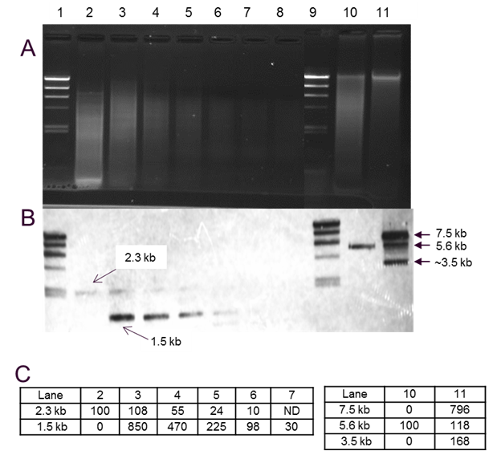

**Figure S9. Southern blotting analysis on *A. oryzae* pCaHj621/BECh2#10**

A) Agarose gel after electrophoresis on digested genomic DNA. Lane 1 & 9: DNA marker. Lane 2 &10: genomic DNA of *A. oryzae* BECh2, Lane 3-8, 11: DNA of *A. oryzae* pCaHj621/BECh2 #10. Lane 2~8: DNA digested with *Bam*Hl/*Nsi*I. Lane 10 &11: DNA digested with *Bam*HI. Lane 4, 5, 6, 7, 8 were diluted samples of the one applied to lane 3 by 2x, 4x, 8x, 16x and 32x, respectively. B) The hybridization results with the probe generated from asparaginase gene. The bands of 2.3 kb and 5.6 kb were originated from the endogenous asparaginase gene. The bands at 1.5 kb, 7.5 kb and 3.5 kb were derived from the asparaginase gene on the expression plasmid pCaHj621. 7.5kb is the size of pCaHj621. C) Relative intensities of the bands from asparaginase gene calculated by Gel DocTM EZ Imager. Intensity of the bands from BECh2 (Lane 2 and 10), carrying one copy of asparaginase gene, was set as 100. The intensity of 1.5 kb band of Lane 6, the sample diluted by 8x, was about the same as the reference on Lane 2. The intensity of the band of 7.5 kb on Lane 11 was about 8 times stronger than the band of 5.6 kb in the same lane which has similar intensity of the reference on Lane 10. Results suggest that *A. oryzae* pCaHj621/BECh2#10 carries about 8 copies of asparaginase gene derived from pCaHj621.

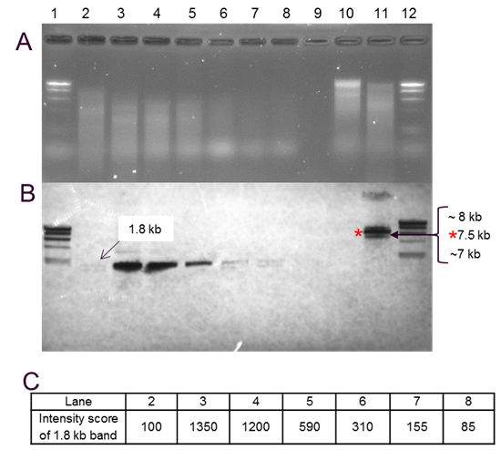

**Figure S10. Southern blotting analysis on *A. oryzae* pMT2155/BECh2-Fb-3**

A) Picture of the agarose gel after electrophoresis. Lane 1 & 12: DNA size marker. Lane 2: genomic DNA of *A. aculeatus* NV-132, Lane 3-8, 11: *A. oryzae* pMT2155/BECh2-Fb-3, Lane 10: *A. oryzae* BECh 2. Lane 2-8: DNA digested with *Eco*RI/*Hind*IIl/*Xho*I. Lane 9 &10: digested with *Eco*RI. Lane 4-8 were the diluted sample of the one applied to lane 3 by 2x, 4x, 8x, 16x, and 32x. B) The hybridization results. The bands of 1.8kb were derived from the xylanase gene used for expression plasmid pMT2155. 7.5kb is the size of pMT2155. C) Relative intensities of the bands calculated by Gel DocTM EZ Imager. The intensity of the band from NV-132 (Lane 2), the donor of the xylanase gene, was set as 100. The band intensity of Lane 7 (diluted by 16x) and Lane 8 (diluted by 32x) was close to the reference. Estimated copy number of xylanase gene in *A. oryzae* pMT2155/BECh2-Fb-3 was about 30.

**Magnified Fig. 3 (A)**



**Magnified Fig. 3 (C)**

