Supplementary Materials

Enantioselective Benzylation of Methyl 4-Oxo-3-Piperidinecarboxylate
with Cinchona Alkaloids Phase-Transfer Catalysts
Yaomin Wang, Shuai Zhao, Qiaoyun Xue, Xin Chen*
School of Pharmaceutical & Life Sciences, Changzhou University, Changzhou, Jiangsu 213164, P. R. China
Fax: +86(519) 86334598
E-mail: xinchen@cczu.edu.cn

Materials and General Methods
Melting Points were measured on SGW X-4B Melting Point Apparatus. ¹H NMR spectra were recorded on a Bruker Avance 300 (300 MHz) spectrometer and 400 (400 MHz). Chemical shifts were reported in ppm from tetramethylsilane with the solvent resonance resulting from incomplete deuterium incorporation as the internal standard (CDCl₃: δ 7.26 ppm). ¹³C NMR spectra were recorded on a Bruker Avance 300 (75 MHz) and 400 (100 MHz) spectrometer with complete proton decoupling. Chemical shifts were reported in ppm from tetramethylsilane with the solvent resonance as the internal standard (CDCl₃: δ 77.16 ppm). High-resolution mass spectrometry was performed on Thermo Orbitrap Elite. Optical rotations were measured on an Autopol IV (d = 589 nm, Hg lamp, 50 mm cell). The enantiomeric excess was determined by Agilent 1260 infinity series HPLC (Chiral Technologies Chiralpak AD-H column (4.6 mm x 250 mm) and Chiral Technologies Chiralpak OD-H column (4.6 mm x 250 mm)). Chemicals and solvents were purchase Linfeng and Annaiji from commercial suppliers. Silica gel plates (Qingdao Haiyang) were used for thin-layer chromatography (TLC). Purification spectrums of the product was carried out by flash column chromatography using silica gel (Yantai Jiangyou, particle size 0.100-0.075 mm).

The phase transfer catalysts 1a-1q were prepared according to the literature procedures, and the structures were confirmed by their spectral properties.

Methyl (R)-1,3-Dibenzyl-4-oxopiperidine-3-carboxylate (3c)
To a 10 mL reaction tube was added methyl 1-benzyl-4-oxopiperidine- 3-carboxylate 2c (49.5 mg, 0.2 mmol), 50% aq. KOH (112 mg, 1 mmol, 5 eq) and phase transfer catalyst 1k (12.1 mg, 0.02 mmol, 10 mol%) followed by p-xylene (1 mL). After the mixture was stirred at rt for 30 min, BnBr (71.3 uL, 0.6 mmol, 3 eq) was added, and the stirring was continued at rt for additional 12 h (monitored by TLC analysis). The crude product was purified by column flash chromatography (eluting with 20:1 hexane/EtOAc) to afford 3c (256 mg, 76% yield) as colorless transparent liquid. -17.2º (c = 0.5, CH₂Cl₂); 73% ee; ¹H NMR (300 MHz, CDCl₃): δ 7.33-7.27 (m, 5H), 7.25-7.13 (m, 5H), 3.61 (s, 3H), 3.57 (s, 2H), 3.39 (dd, J = 11.4, 2.4 Hz, 1H), 3.21 (d, J = 13.5 Hz ,1H), 2.97-2.90 (m, 2H), 2.85-2.74 (m, 1H), 2.49-2.37 (m, 2H), 2.31 (d, J = 11.4 Hz, 1H); ¹³C NMR (75 MHz, CDCl₃): δ 205.6, 171.2, 137.8, 136.2, 130.5, 128.9, 128.3, 128.1, 127.4, 126.8, 62.8, 61.8, 60.7, 53.1, 52.1, 40.5, 37.5; HRMS (ESI, positive): calcd for C₂₁H₂₃NO₃ [M+H]⁺ 338.1751, found: 338.1749.
The enantiomeric excess of 3c was determined by chiral HPLC analysis (column, Chiralpak OD-H, 4.6×250 mm, n-hexane/i-PrOH = 99:1; flow rate: 1 mL/min, λ = 230 nm).

Table S1. Optimization of the reaction conditions for 3cª
Entry | cat | BnBr | 50% aq. KOH | Temp/℃ | Yield (%)^{b} | ee (%)^{c}
1 | 10 mol% | 0.6 mmol (3eq) | 0.2 mmol (1 eq) | rt. | 69 | 70
2 | 10 mol% | 1.0 mmol (5 eq) | 0.2 mmol (1 eq) | rt. | 70 | 65
3 | 10 mol% | 0.6 mmol (3 eq) | 0.6 mmol (3 eq) | rt. | 72 | 70
4 | 10 mol% | 0.6 mmol (3 eq) | 1.0 mmol (5 eq) | rt. | 76 | 73
5 | 10 mol% | 0.6 mmol (3 eq) | 1.2 mmol (6 eq) | rt. | 75 | 70
6 | 20 mol% | 0.6 mmol (3 eq) | 1.0 mmol (5 eq) | rt. | 78 | 68
7 | 5 mol% | 0.6 mmol (3 eq) | 1.0 mmol (5 eq) | rt. | 70 | 69
8 | 10 mol% | 0.6 mmol (3 eq) | 1.0 mmol (5 eq) | 0 | 64 | 70
9 | 10 mol% | 0.6 mmol (3 eq) | 1.0 mmol (5 eq) | -10 | 61 | 71
10 | 10 mol% | 0.6 mmol (3 eq) | 1.0 mmol (5 eq) | -30 | 58 | 70
11^{d} | 10 mol% | 0.6 mmol (3 eq) | 1.0 mmol (5 eq) | rt. | 74 | 71
12e | 10 mol% | 0.6 mmol (3 eq) | 1.0 mmol (5 eq) | rt. | 70 | 69
Reaction conditions: ª 2c (0.2 mmol) in p-xylene (1 mL) ^{b} Yield of isolated product; ^{c} Determined by chiral HPLC; ^{d} the reaction was added p-xylene (2 mL); ^{e} the reaction was added p-xylene (0.5 mL).

Methyl (R)-1-benzyl-3-(3-fluorobenzyl)-4-oxopiperidine-3-carboxylate (3d):
Colorless liquid; Yield 65%; [α]22 D -24.8º (c = 0.5, CH₂Cl₂); 60% ee; ¹H NMR (300 MHz, CDCl₃): δ 7.36-7.25 (m, 5H), 7.20-7.13 (m, 1H), 6.94-6.85 (m, 3H), 3.61 (s, 3H), 3.58 (s, 2H), 3.40 (dd, J = 11.7, 2.7 Hz, 1H), 3.20 (d, J = 13.5 Hz, 1H), 2.98-2.77 (m, 3H), 2.48-2.37 (m, 2H), 2.28 (d, J = 11.7 Hz, 1H); ¹³C NMR (75 MHz, CDCl₃): δ 205.5, 171.2, 164.4, 160.9, 138.9, 138.7, 137.7, 129.0, 128.4, 117.6, 117.3, 113.9, 113.6, 62.9, 61.8, 60.9, 53.3, 52.3, 40.6, 37.2; HRMS (ESI, positive): Calcd for C₂₁H₂₃FNO₃ [M+H]⁺ 416.0856, found: 416.0859.

Methyl (R)-1-benzyl-3-(3-chlorobenzyl)-4-oxopiperidine-3-carboxylate (3e):
Colorless liquid; Yield 68%; [α]22 D -19.2º (c = 0.5, CH₂Cl₂); 67% ee; ¹H NMR (300 MHz, CDCl₃): δ 7.36-7.25 (m, 5H), 7.19-7.11 (m, 3H), 7.06-7.03 (m, 1H), 3.61 (s, 3H), 3.58 (s, 2H), 3.39 (dd, J = 11.4, 2.4 Hz, 1H), 3.18 (d, J = 13.5 Hz, 1H), 2.99-2.77 (m, 3H), 2.48-2.37 (m, 2H), 2.27 (d, J = 11.7 Hz, 1H); ¹³C NMR (75 MHz, CDCl₃): δ 205.5, 171.1, 138.4, 137.7, 133.8, 130.6, 129.3, 129.0, 128.8, 128.4, 127.5, 127.0, 62.8, 61.8, 60.9, 53.2, 52.3, 40.5, 37.1; HRMS (ESI, positive): Calcd for C₂₁H₂₃ClNO₃ [M+H]⁺ 372.1361, found: 372.1358.

Methyl (R)-1-benzyl-3-(3-bromobenzyl)-4-oxopiperidine-3-carboxylate (3f):
Colorless liquid; Yield 70%; [α]22 D -23.6º (c = 0.5, CH₂Cl₂); 66% ee; ¹H NMR (300 MHz, CDCl₃): δ 7.36-7.25 (m, 5H), 7.12-7.05 (m, 2H), 3.61 (s, 3H), 3.57 (d, J = 2.7 Hz, 2H), 3.39 (dd, J = 11.4, 9.0 Hz, 1H), 3.18 (d, J = 13.8 Hz, 1H), 2.99-2.92 (m, 1H), 2.87-2.76 (m, 2H), 2.48-2.37 (m, 2H), 2.27 (d, J = 11.7 Hz, 1H); ¹³C NMR (75 MHz, CDCl₃): δ 205.5, 171.1, 138.7, 137.7, 133.5, 129.9, 129.6, 129.2, 129.0, 128.4, 127.5, 122.1, 62.8, 61.8, 60.9, 53.2, 52.2, 40.5, 37.1; HRMS (ESI, positive): Calcd for C₂₁H₂₃BrNO₃ [M+H]⁺ 356.1656, found: 356.1653.

Methyl (R)-1-benzyl-3-(3-methylbenzyl)-4-oxopiperidine-3-carboxylate (3g):
Colorless liquid; Yield 70%; [α]22 D -31.2º (c = 0.5, CH₂Cl₂); 67% ee; ¹H NMR (300 MHz, CDCl₃): δ 7.34-7.24 (m, 5H), 7.13-7.08 (m, 1H), 7.00-6.92 (m, 3H), 3.61 (s, 3H), 3.57 (s, 2H), 3.39 (dd, J = 11.7, 9.0 Hz, 1H), 3.17 (d, J = 13.5 Hz, 1H), 2.93-2.88 (m, 2H), 2.83-2.75 (m, 1H), 2.47-2.37 (m, 2H), 2.32 (s, 1H), 2.28 (s, 3H); ¹³C NMR (75 MHz, CDCl₃): δ 205.6, 171.3, 137.8, 137.5, 136.1, 131.3, 129.0, 128.3, 128.0, 127.5, 127.4, 62.8, 61.8, 60.8, 53.1, 52.1, 40.5, 37.4, 21.5; HRMS (ESI, positive): Calcd for C₂₂H₂₆NO₃ [M+H]⁺ 352.1910, found: 352.1907.
The enantiomeric excess of 3d-3g was determined by chiral HPLC analysis (column, Chiralpak IB, 4.6×250 mm, n-hexane/i-PrOH = 98:2; flow rate: 1 mL/min, λ = 254 nm).

Ethyl (R)-1,3-Dibenzyl-4-oxopiperidine-3-carboxylate (3h)
To an oven-dried 100 mL round-bottom flask was sequentially added 1-benzyl-3-ethoxycarbonyl-4-piperidone hydrochloride (1.2 g, 4 mmol), 50% aq. KOH (2.7 g, 24 mmol, 6 eq), O-allyl-N-9-anthracenemethylcindexnine bromide (1k) (242 mg, 0.4 mmol, 10 mol%) and p-xylene (20 mL). After the mixture was stirred at rt for 30 min, BnBr (1.4 mL, 12 mmol, 3 eq) was introduced, and the stirring was continued at rt for additional 12 h. The solvent was evaporated under reduced pressure and the crude product was purified by flash column chromatography (eluting with 20:1 hexane/EtOAc) to give 3h (983 mg, 70% yield) as colorless liquid. -43.6º (c = 0.5, CH₂Cl₂); 76% ee; ¹H NMR (400 MHz, CDCl₃) δ 7.34-7.27 (m, 5H), 7.22-7.16 (m, 5H), 4.14-4.00 (m, 2H), 3.60 (d, J = 13.2 Hz, 1H), 3.54 (d, J = 13.2 Hz, 1H), 3.42 (dd, J = 11.6, 2.4 Hz, 1H), 3.22 (d, J = 13.6 Hz, 1H), 2.98-2.91 (m, 2H), 2.86-2.78 (m, 1H), 2.47-2.35 (m, 2H), 2.30 (d, J = 11.6 Hz, 1H), 1.11 (t, J = 7.2 Hz, 3H); ¹³C NMR (100 MHz, CDCl₃): δ 205.9, 170.9, 138.0, 136.4, 130.7, 129.0, 128.4, 128.1, 127.4, 126.6, 62.8, 61.9, 61.3, 61.2, 53.2, 40.7, 37.6, 14.0; HRMS (ESI, positive): calcd. for C₂₃H₂₅NO₅ [M+H]⁺ 352.1907, found: 352.1906.
The enantiomeric excess of 3h was determined by chiral HPLC analysis (column, Chiralpak AD-H, 4.6×250 mm, n-hexane/i-PrOH=99:1; flow rate: 1 mL/min, λ = 230 nm).

Ethyl (R)-3-benzyl-4-oxopiperidine-3-carboxylate (4)
To a 50 mL round-bottom flask were sequentially added 3h (351mg, 1 mmol), 10% Pd/C (70 mg) and EtOH (10 mL), and the mixture was stirred at rt and under hydrogen atmosphere for 12 h. The reaction mixture was filtered through a celite pad, the filtrate was concentrated under reduced pressure, and the crude product was purified by flash column chromatography (eluting with DCM/MeOH, 50:1 to 20:1) to afford 4 (225mg, 86% yield) as light yellow oil. -150.8º (c = 0.5, CH₂Cl₂). ¹H NMR (400 MHz, CDCl₃): δ 7.27-7.20 (m, 3H), 7.10-7.06 (m, 2H), 4.18-4.08 (m, 2H), 3.70-3.67 (m, 1H), 3.41-3.36 (m, 2H), 2.93-2.86 (m, 1H), 2.82 (d, J = 14.0 Hz, 1H), 2.63 (d, J = 13.6 Hz, 1H), 2.48-2.42 (m, 2H), 1.87 (s, 1H), 1.20 (t, J = 7.2 Hz, 3H); ¹³C NMR (75 MHz, CDCl₃): δ 204.6, 170.6, 136.0, 130.1, 128.2, 126.8, 64.4, 61.6, 55.3, 48.0, 43.5, 37.5, 14.0; HRMS (ESI, positive): calcd for C₁₅H₁₉NO₃ [M+H]⁺ 262.1438, found: 262.1438.

Ethyl (R)-3-benzyl-1-(tert-butyl)-4-oxopiperidine-1,3-dicarboxylate (5)
4 (120 mg, 0.46 mmol) was dissolved in anhydrous CH₂Cl₂ (5 mL), triethylamine (0.13 mL, 0.92 mmol, 2 eq), 4-dimethylaminopyridine (6 mg, 0.046 mmol, 0.1 eq) and di-(tert-butyl) pyrocarbonate (0.11 mL, 0.46 mmol, 1 eq) were added successively at 0 ℃，and the reaction mixture was stirred at rt for 15 min. After completion of the reaction monitored by TLC, the reaction was quenched by the addition of saturated aqueous NaHCO₃ (3 mL), and the resulting mixture was extracted with DCM (25 mL×3). The combined organic phases were washed with brine (30 mL), dried over anhydrous Na₂SO₄, filtered, and concentrated in vacuo. The residue was purified by flash column chromatography (eluting with 20:1 hexane/EtOAc) to afford 5 (122 mg, 87% yield) as white solid. mp 89-91℃; -53.5º (c = 3, CH₂Cl₂) [Lit.^{[6]} -45.8º (c = 3, CH₂Cl₂)]; 66% ee; ¹H NMR (300 MHz, CDCl₃): δ 7.28-7.15 (m, 5H), 4.62 (s, 1H), 4.17 (bs, 1H), 4.11-4.06 (m, 2H), 3.26 (d, J = 13.8 Hz, 1H), 3.19-3.11 (m, 1H), 3.01 (d, J = 13.5 Hz, 2H), 2.75-2.65 (m, 1H), 2.44 (d, J = 14.4 Hz, 1H), 1.45 (s, 9H), 1.15 (t, J = 7.2 Hz, 3H); ¹³C NMR (75 MHz, CDCl₃): δ 204.6, 169.8, 154.3, 135.7, 130.5, 128.3, 127.0, 80.5, 62.3, 61.8, 50.4, 43.2, 40.1, 37.4, 28.3, 14.0; HRMS (ESI, positive): calcd. for C₂₀H₂₇NNaO₅ [M+Na]⁺ 384.1781, found: 384.1781.
The enantiomeric excess of 5 was determined by chiral HPLC analysis (column, Chiralpak OD-H, 4.6×250 mm, n-hexane/i-PrOH = 99:1; flow rate: 1 mL/min, λ = 230 nm).

3αR-Benzyl-1-(tert-butyl)oxycarbonyl-2-methyl-4,5,6,7-tetrahydro-2H-pyrazolo- [4,3-c]pyridine-3(3αH)-one (6)
A solution of 5 (940 mg, 2.6 mmol), methylhydrazinium sulphate (750 mg, 5.2 mmol, 2 eq) and sodium acetate (854 mg, 10.4 mmol, 4 eq) in EtOH (35 mL) was heated at 80 ℃ under nitrogen atmosphere for 12 h. After the reaction is complete, the reaction mixture was cooled to rt, and concentrated in vacuo. The crude residue was diluted with DCM (100 mL), and was washed with saturated aqueous NaHCO₃ (30 mL) and brine (30 mL), and dried (anhydrous Na₂SO₄). The crude product was purified by flash column chromatography (eluting with hexane/EtOAc, 5:1 to 3:1) to give 6 (620mg, 70% yield) as white solid. mp 123-125℃; 44.8º (c = 1, CH₂Cl₂); 69 % ee; ¹H NMR (300 MHz, CDCl₃): δ 7.18-7.09 (m, 3H), 7.02-6.97 (m, 2H), 4.60 (bs, 1H), 4.39 (d, J = 12.6 Hz, 1H), 3.17 (d, J = 13.2 Hz, 1H), 3.00 (s, 3H), 2.95 (d, J = 13.5 Hz, 1H), 2.64 (bs, 3H), 2.49 (d, J = 9.6 Hz, 1H), 1.47 (s, 9H); ¹³C NMR (75 MHz, CDCl₃): δ 174.5, 162.0, 154.6, 134.7, 128.6, 128.3, 127.2, 81.0, 60.3, 56.7, 50.8, 45.5, 37.9, 30.7, 28.3; HRMS (ESI, positive): calcd. for C₁₉H₂₅N₃NaO₃ [M+Na]⁺ 366.1788, found: 366.1791.
The enantiomeric excess of 6 was determined by chiral HPLC analysis (column, Chiralpak AD-H, 4.6 × 250 mm, n-hexane/i-PrOH = 99:1; flow rate: 1 mL/min, λ = 254 nm).

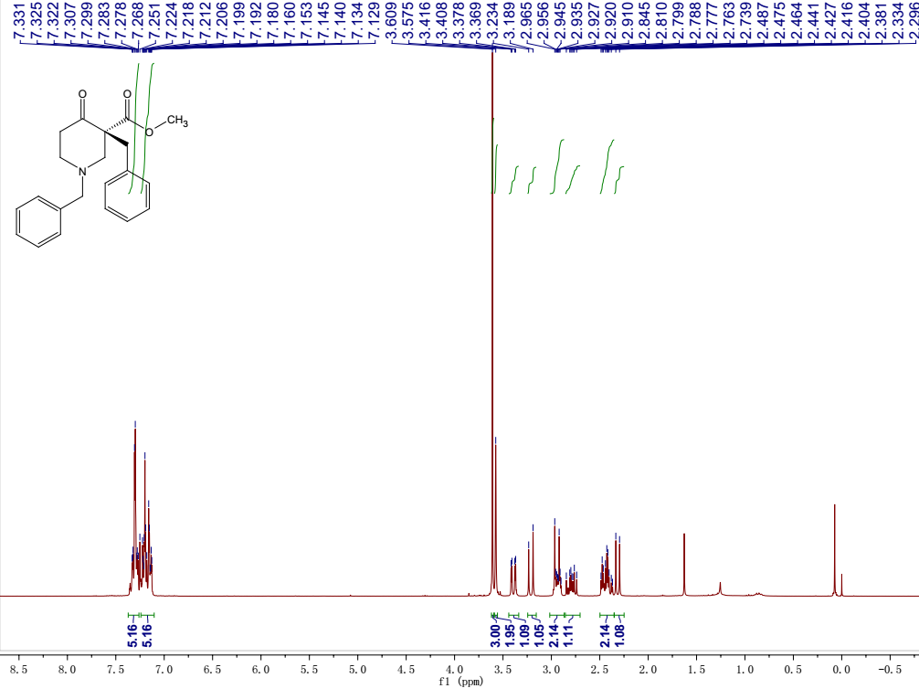

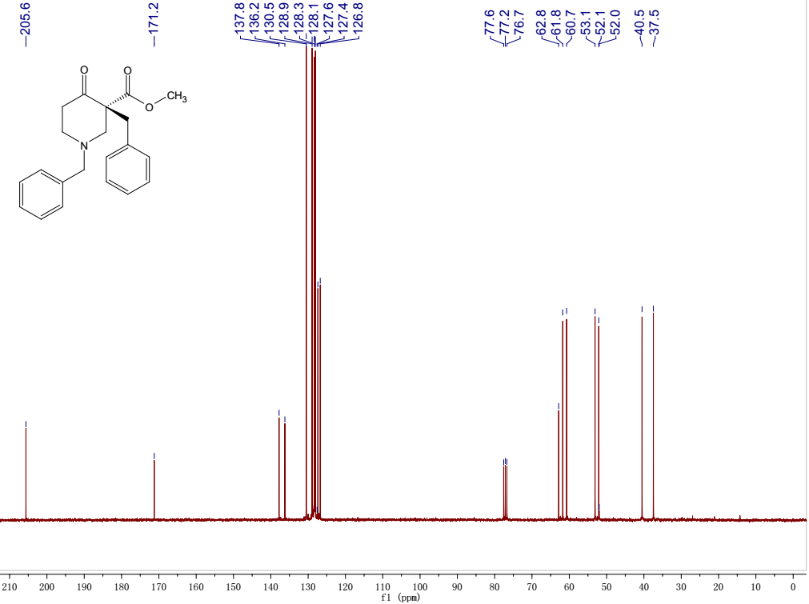
Fig 1: ¹H NMR and ¹³C NMR spectra of 3c

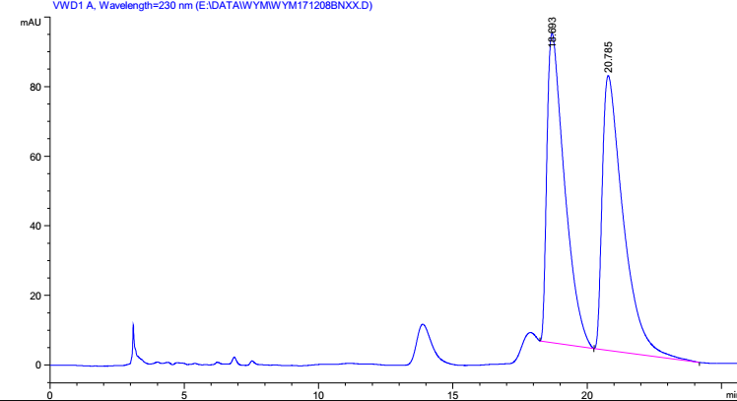

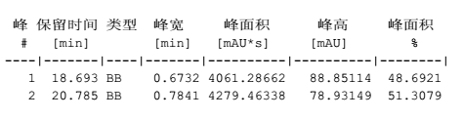

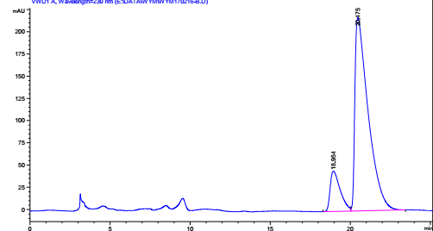

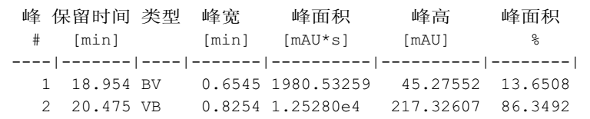

Fig 2: HPLC chromatogram of 3c comparing to the racemic mixture
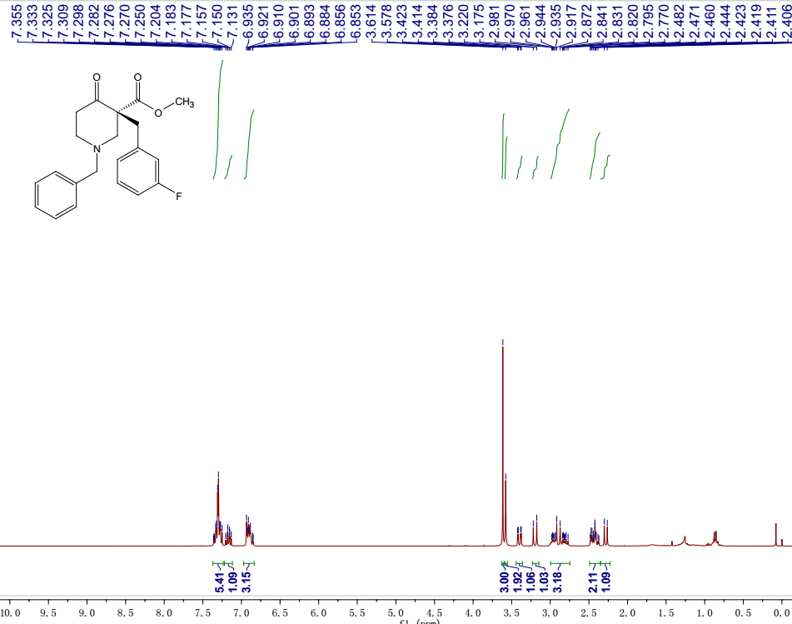

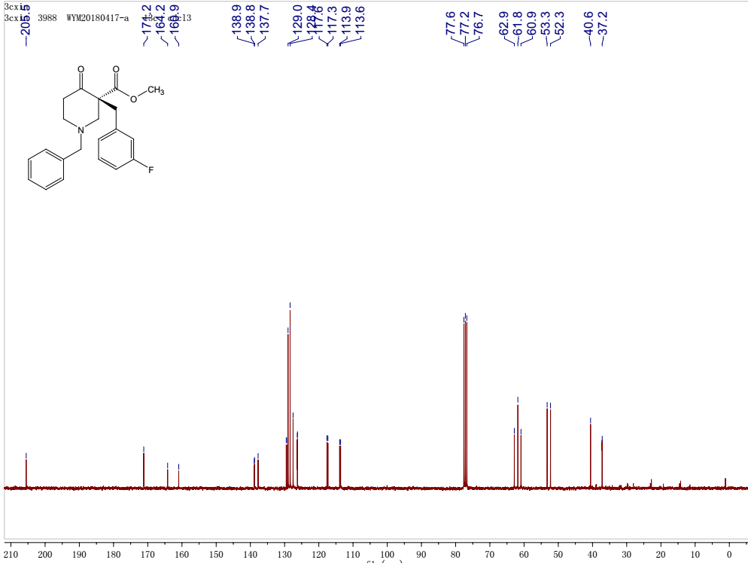

Fig 3: ¹H NMR and ¹³C NMR spectra of 3d

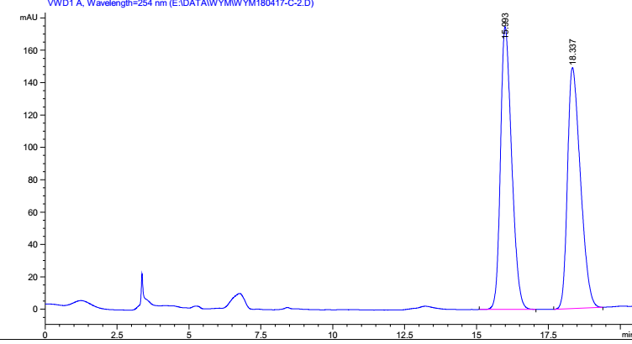
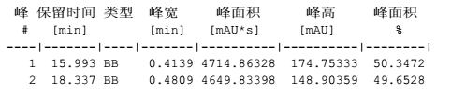
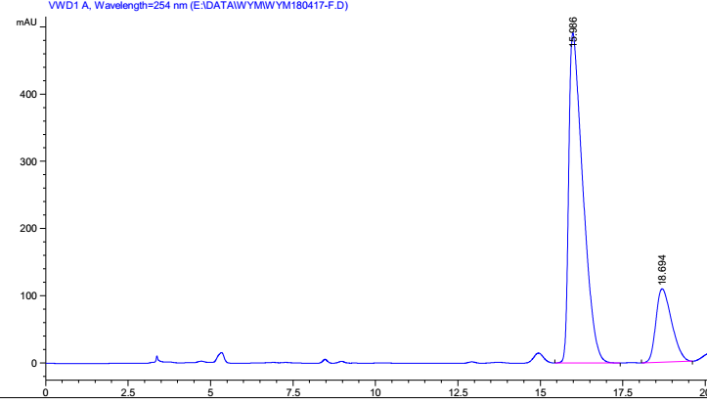
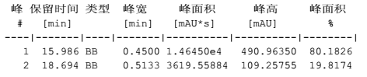
Fig 4: HPLC chromatogram of 3d comparing to the racemic mixture

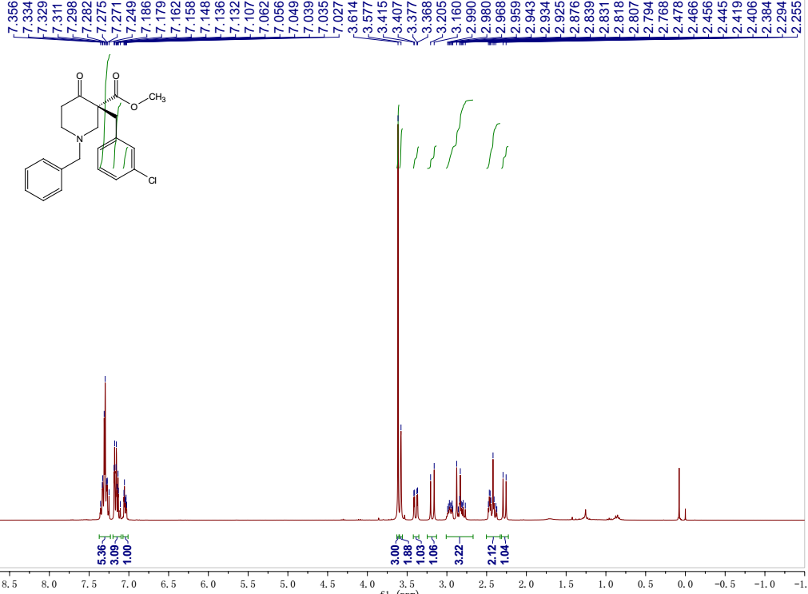

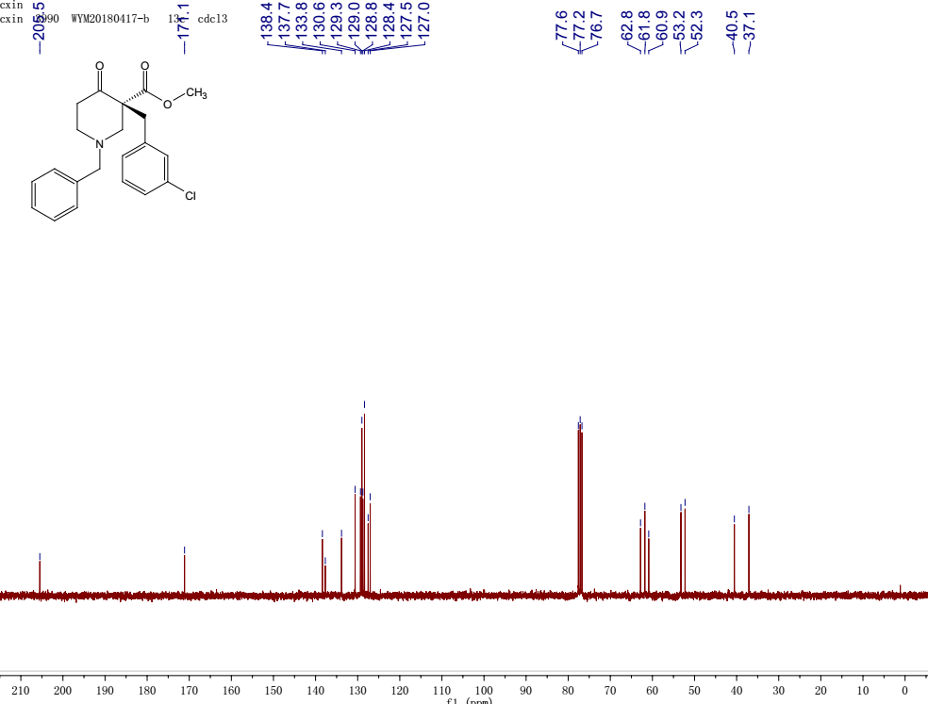

Fig 5: ¹H NMR and ¹³C NMR spectra of 3e

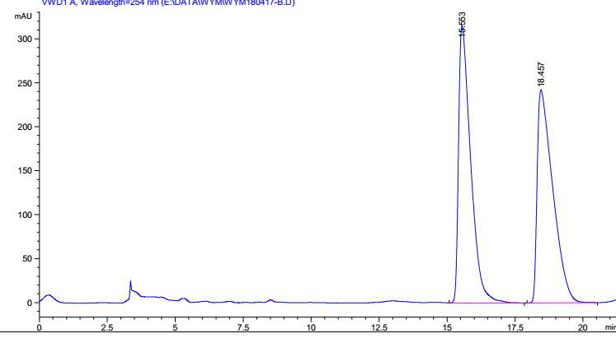
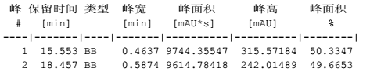

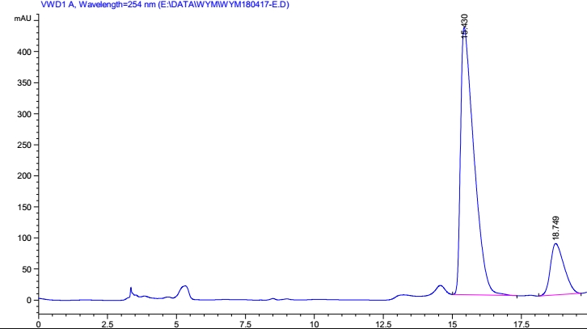
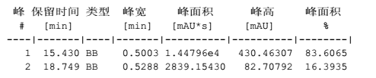
Fig 6: HPLC chromatogram of 3e comparing to the racemic mixture

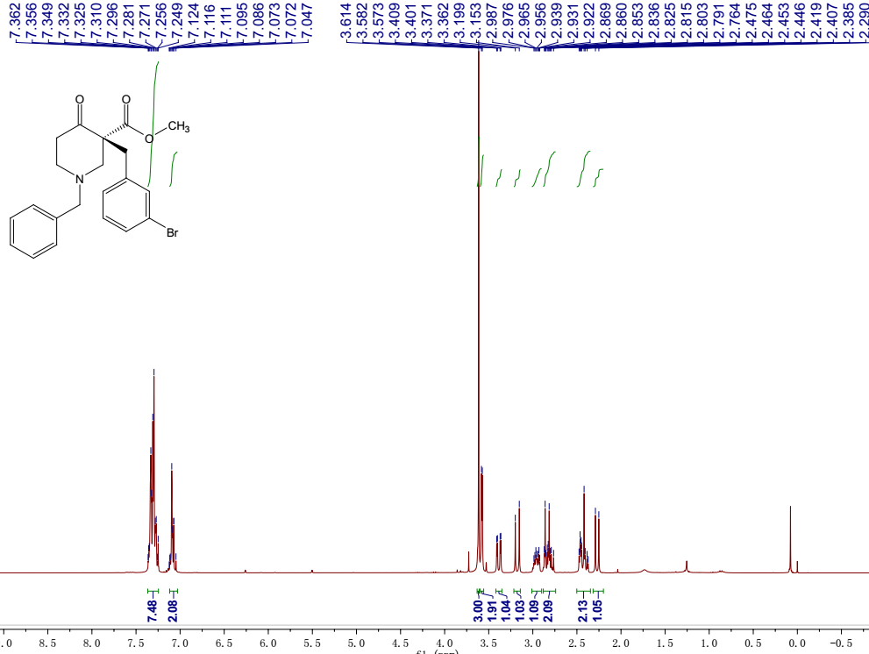

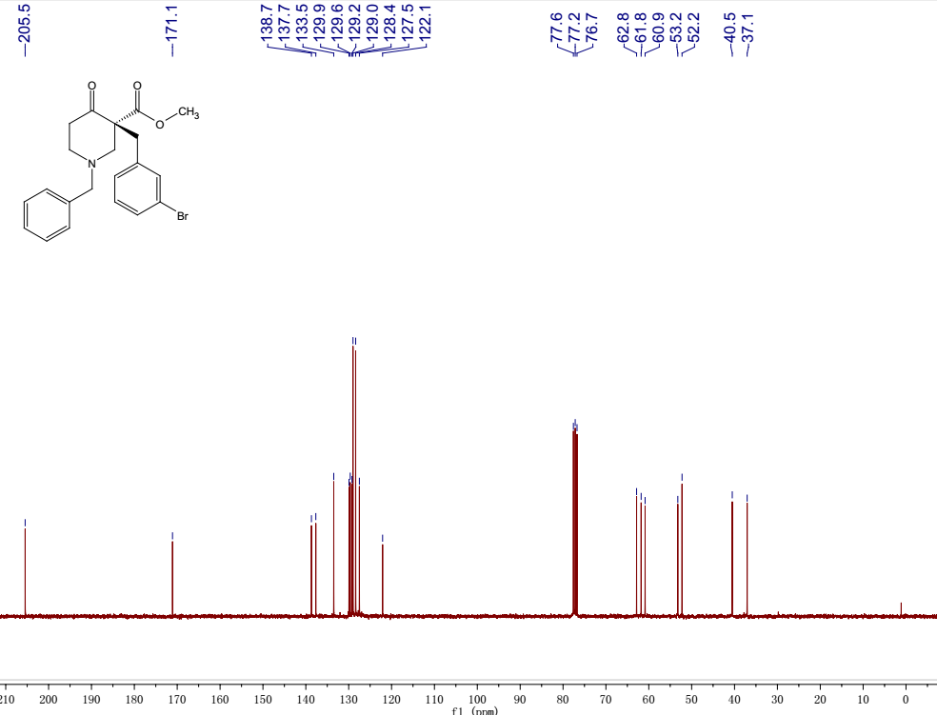

Fig 7: ¹H NMR and ¹³C NMR spectra of 3f
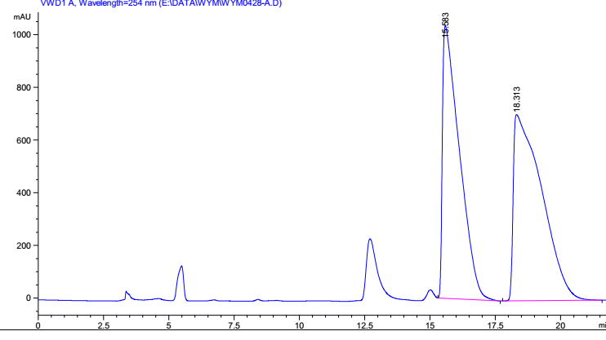

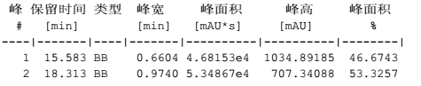

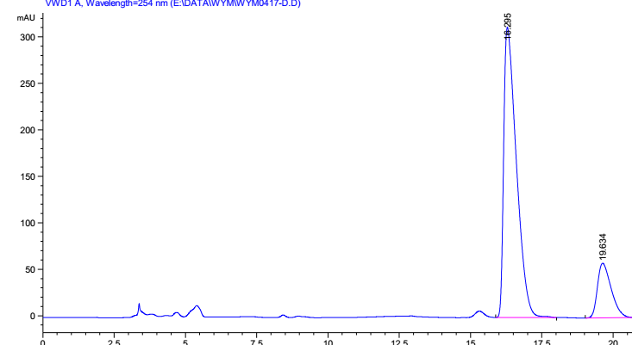

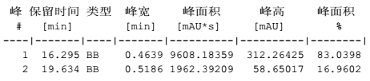
Fig 8: HPLC chromatogram of 3f comparing to the racemic mixture

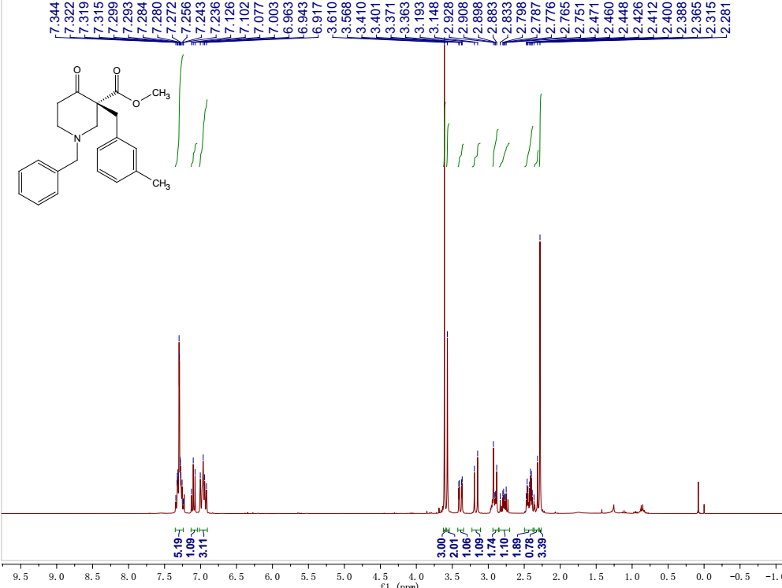

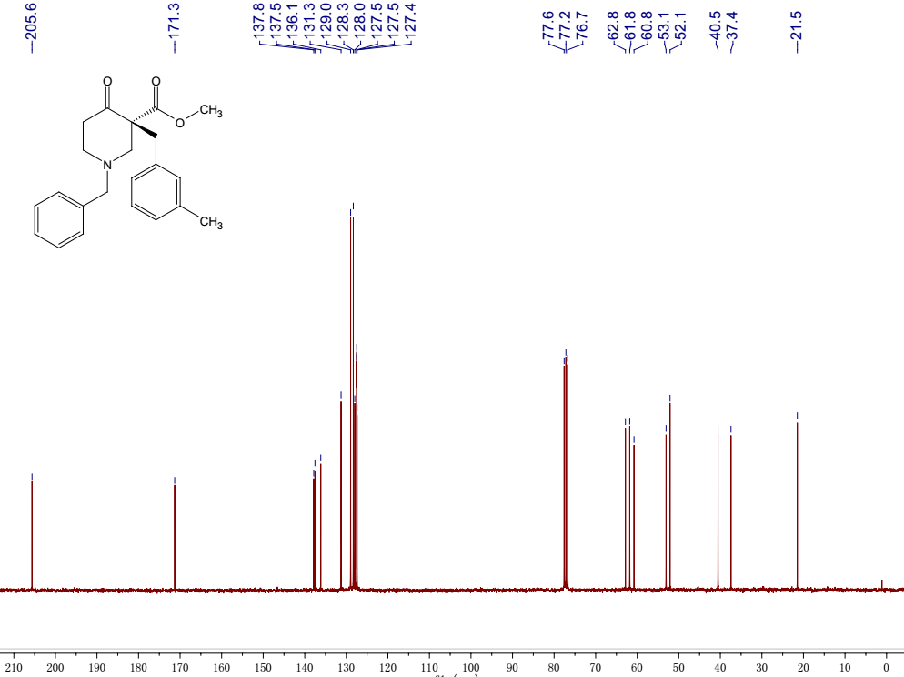

Fig 9: ¹H NMR and ¹³C NMR spectra of 3g

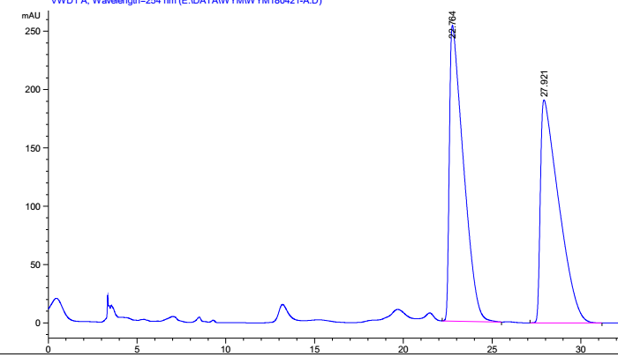

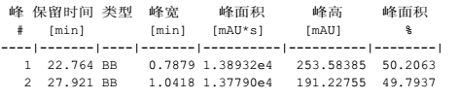

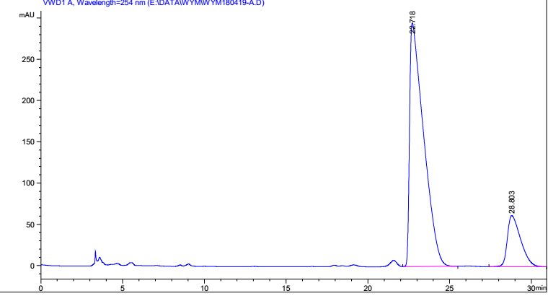

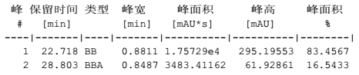
Fig 10: HPLC chromatogram of 3g comparing to the racemic mixture

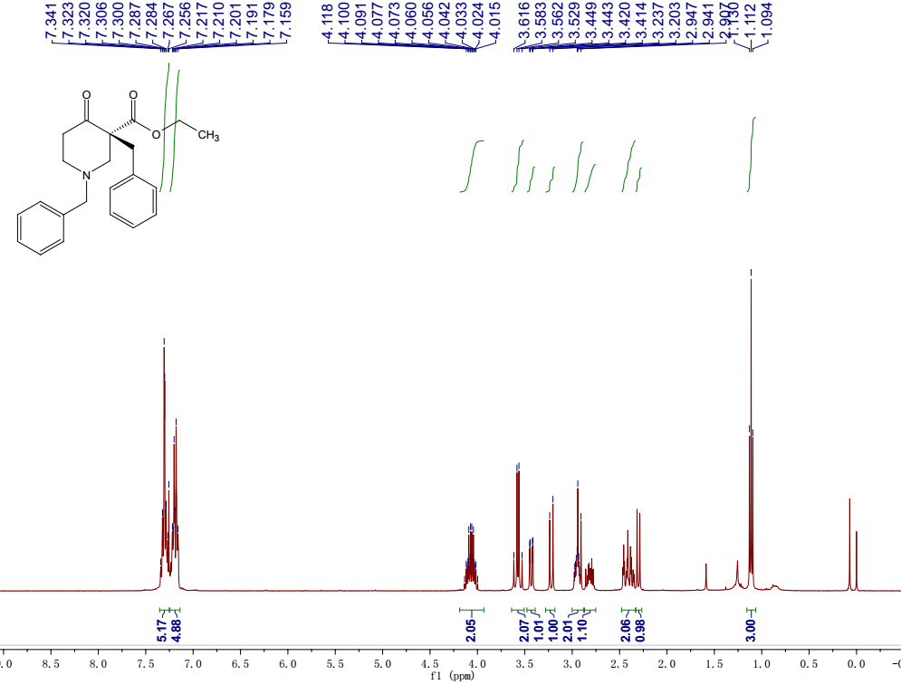

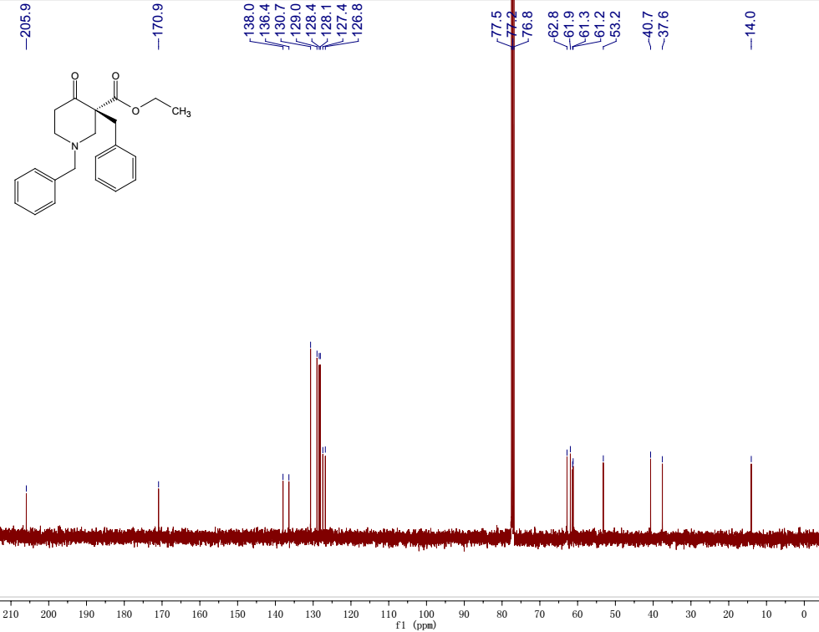

Fig 11: ¹H NMR and ¹³C NMR spectra of 3h

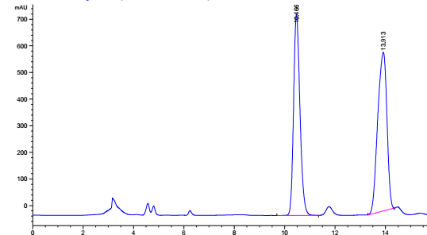

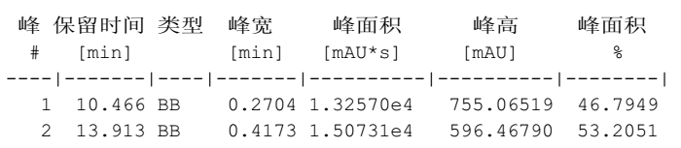

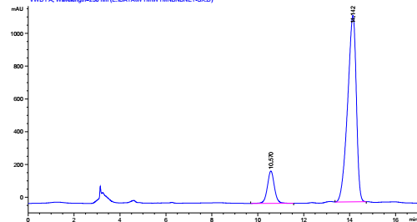

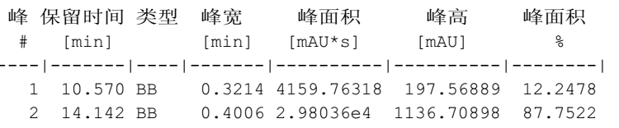

Fig 12: HPLC chromatogram of 3h comparing to the racemic mixture

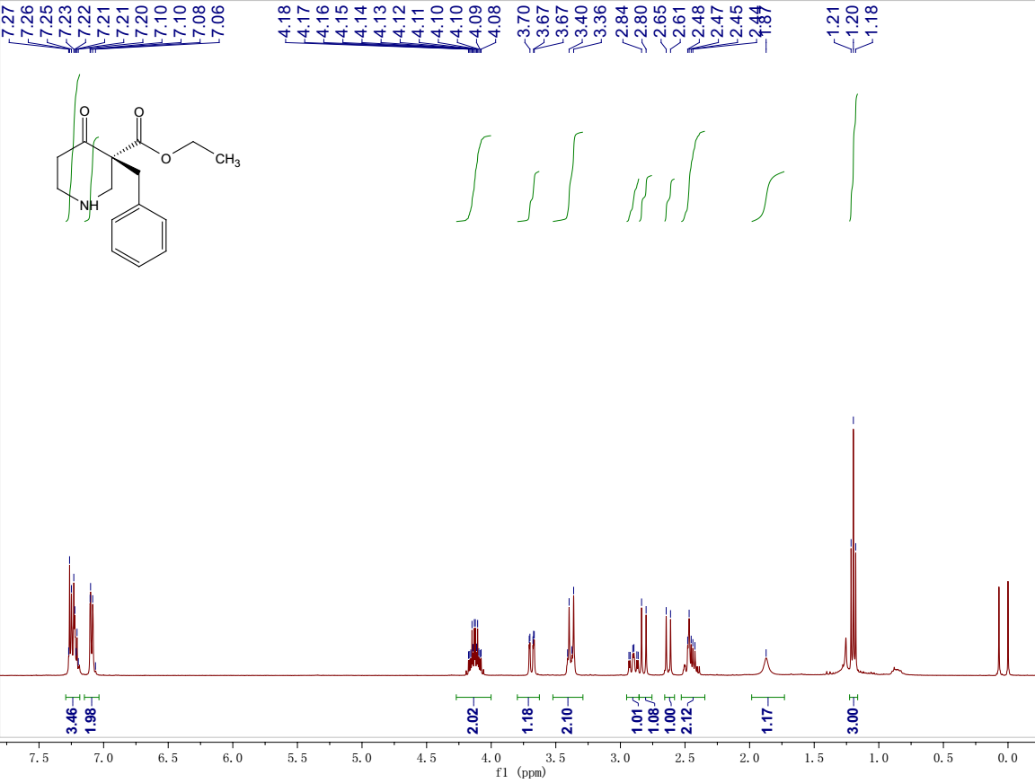

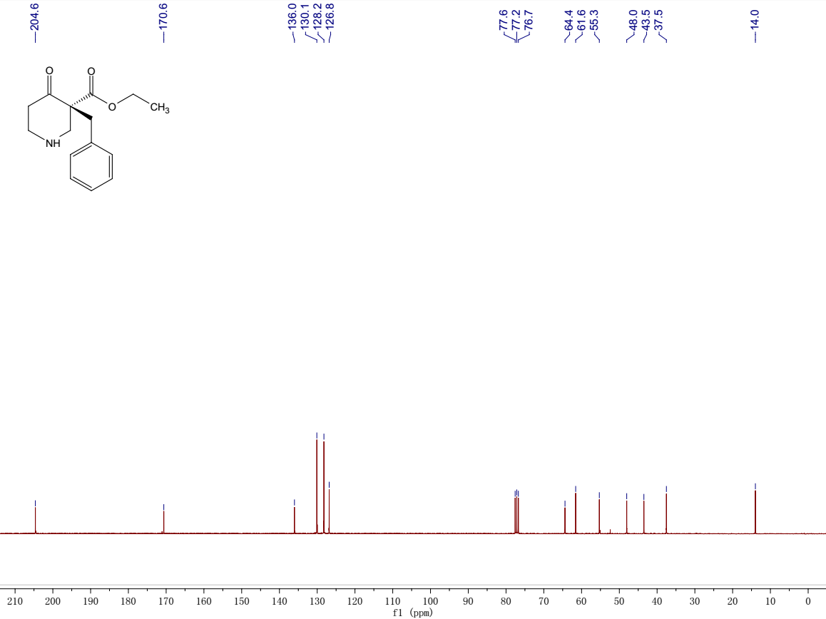
Fig 13: ¹H NMR and ¹³C NMR spectra of 4
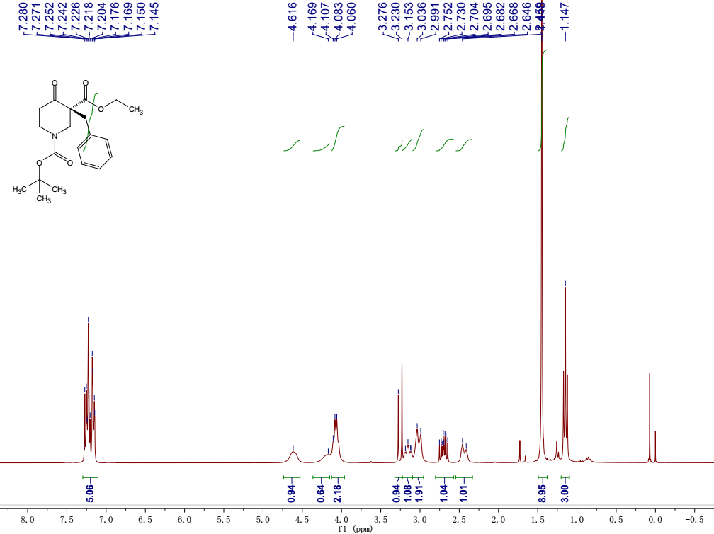

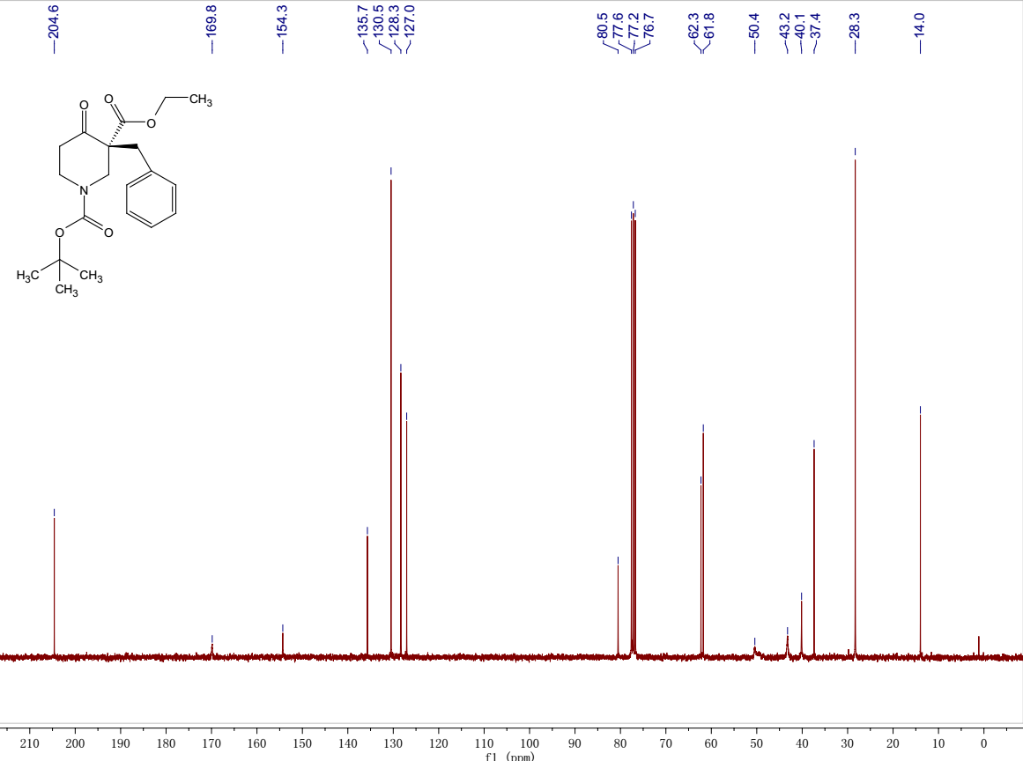

Fig 14: ¹H NMR and ¹³C NMR spectra of 5

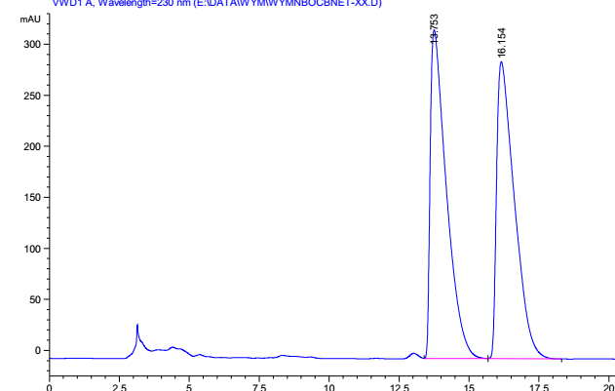

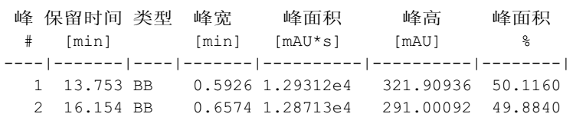

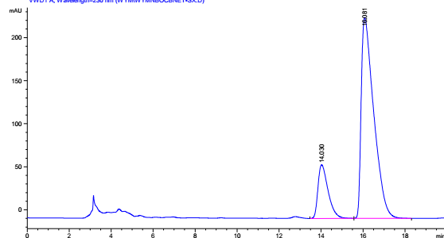

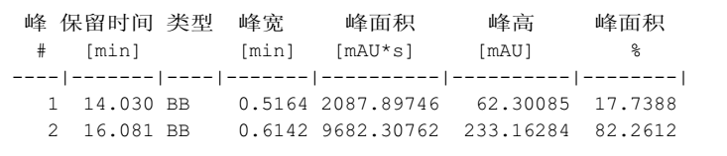

Fig 15: HPLC chromatogram of 5 comparing to the racemic mixture.

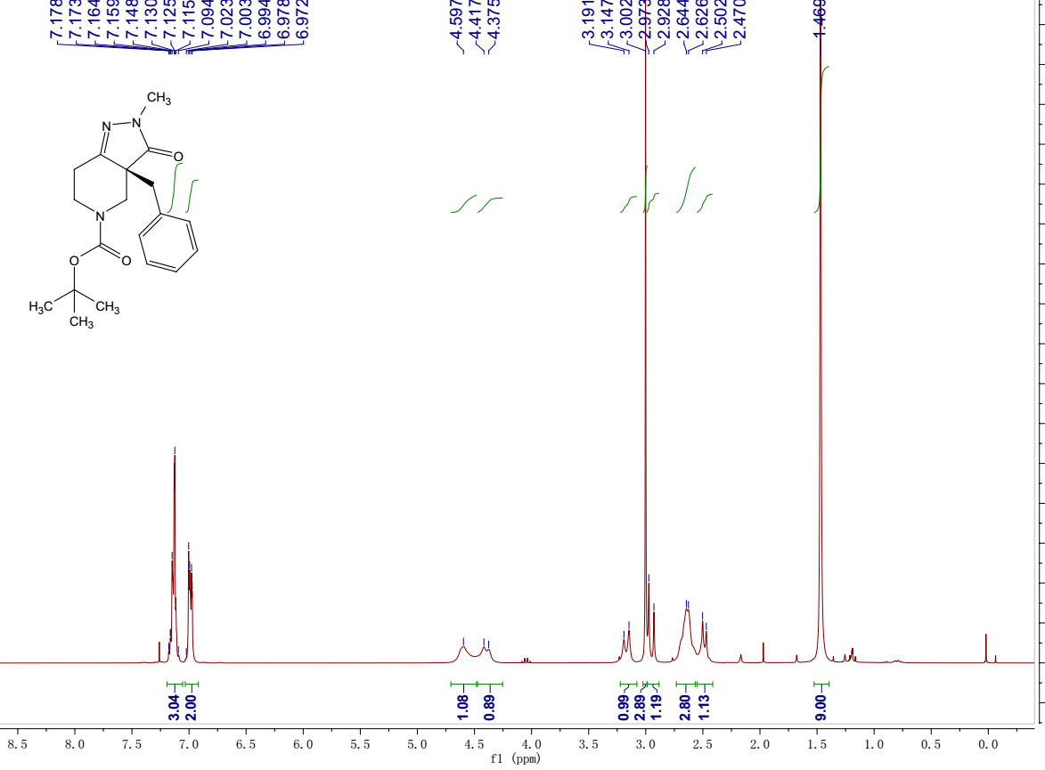

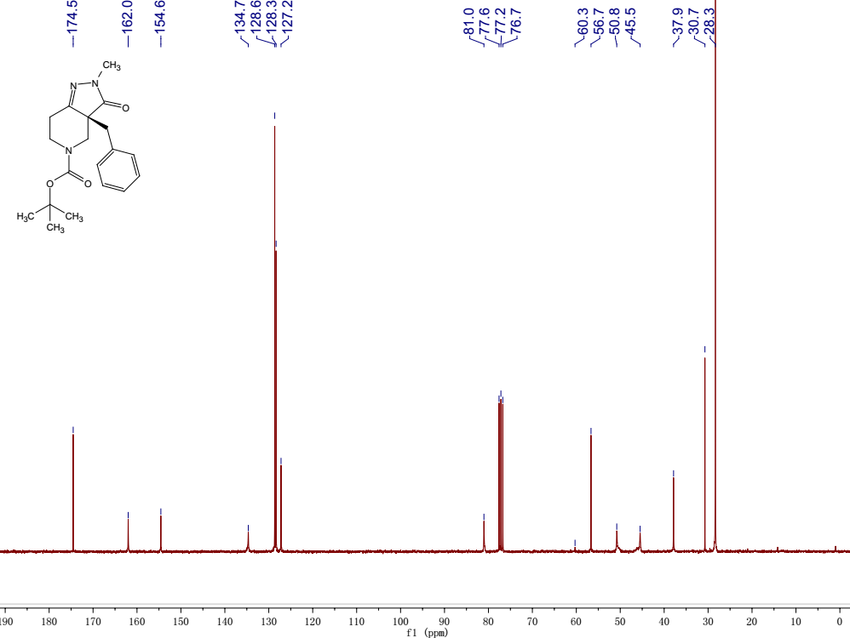

Fig.16. ¹H NMR and ¹³C NMR spectra of 6

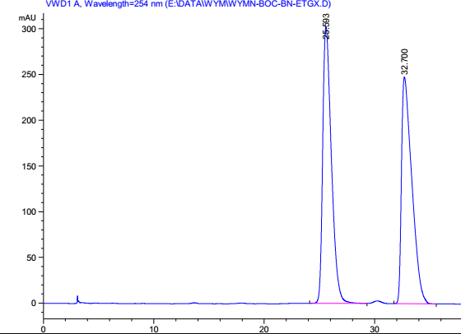

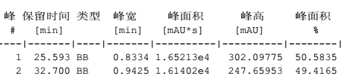

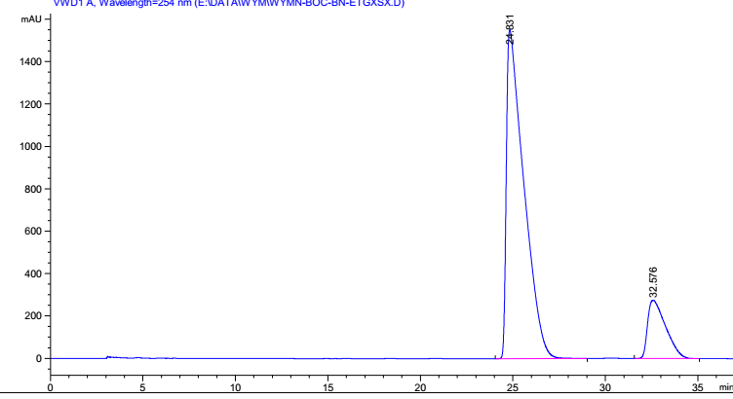

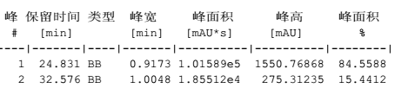

Fig 17: HPLC chromatogram of 6 comparing to the racemic mixture.

