Supplemental Material

Synergic Highly Effective Photothermal-chemotherapy with Platinum Prodrug Linked Melanin-like Nanoparticles

Chengwei Zhang, Xiaozhi Zhao, and Hongqian Guo

Department of Urology, Drum Tower Hospital, Medical School of Nanjing University, Institute of Urology, Nanjing University. Nanjing 210008, P. R. China.

Table S1 IC₅₀ values of Pt(IV)-MeNP, Pt(IV)-COOH or cisplatin in different
prostate cancer cell lines after 48h treatment
IC₅₀ (95% CI) µM | PC 3 | DU 145 | LnCap
Pt(IV)-MeNP | 7.161 (5.785-9.063) | 3.606 (2.530-5.105) | 7.164 (1.960-31.751)
Pt(IV)-COOH | >32 | >32 | 20.437 (15.484-29.474)
Cisplatin | 2.067 (1.693-2.485) | 0.980 (0.338-1.744) | 1.116 (0.581-1.746)
IC₅₀, half inhibitory concentration; 95% CI, 95% confidence interval.

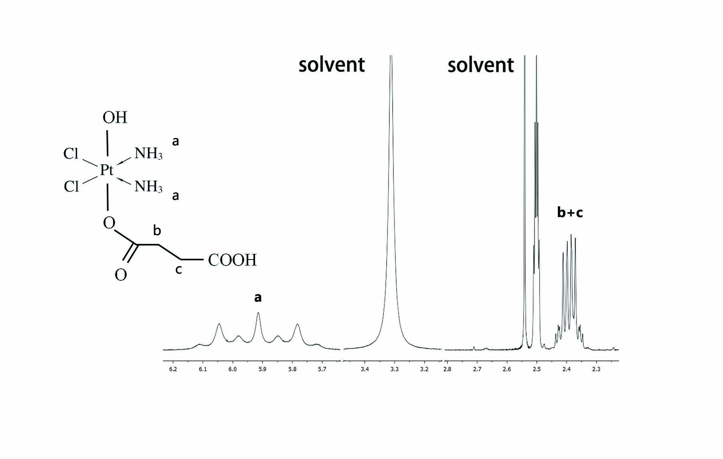
Fig.S1 ¹H NMR spectra of Pt(IV)-COOH in DMSO-d₆.

Fig.S2 Changes in the mitochondrial membrane potential in PC3 cells as revealed by the JC-1 assay. JC-1 assay of PC3 cells treated with various drugs [Pt(IV)-MeNP, Pt(IV)-COOH, cisplatin, NH₂-MeNP and PBS]. Platinum concentration was 10 μM. (a) The JC-1 stained cells images were viewed by confocal laser scanning microscopy after 4 h incubation. Scale bar 50 μm. (b) the fluorescence intensity ratio (green to red) was measured with plate reader at different time points. *P<0.05 were calculated by student's t-test.

Fig.S3 Micrographs of H&E stained tumor or major organ slices from mice with different treatments collected when the monitoring finished. Scale bar 100 μm.

Fig.S4 Serum biochemical examination of treated mice. AST, aspartate transaminase; ALT, alanine aminotransferase; ALP, alkaline phosphatase; TBIL, total bilirubin; BUN, blood urea nitrogen; Cr, creatinine.

