A comprehensive benchmark of the XMS-CASPT2 Method for the Photochemistry of a Retinal Chromophore Model

Saumik Sen, Igor Schapiro*

Fritz Haber Center for Molecular Dynamics, Institute of Chemistry, The Hebrew University of Jerusalem, Jerusalem, 91904, Israel

Figure S1. Energy profiles (in kcal mol⁻¹) along the BLA pathway at various methods relative to cis-PSB3 ground state energy using (A) SS-SR and (B) MS-MR contraction schemes for MRPT2 calculations. The solid line represents the diabatic Ψ_{DIR} state while the dashed line the Ψ_{CT} state. The positions of the transition states (TS_{CT} and TS_{DIR}) and the conical intersection along the BLA coordinate (CI_{BLA}) are indicated by the vertical dashed lines in gray. The approximate position of the surface crossings at each method is indicated by a filled circle.

Figure S2. Energy profiles (in kcal mol⁻¹) along the MEP_{CT} pathway at various methods relative to cis-PSB3 ground state energy using (A) SS-SR and (B) MS-MR contraction schemes for MRPT2 calculations.

Figure S3. Energy profiles (in kcal mol⁻¹) along the MEP_{DIR} pathway at various methods relative to cis-PSB3 ground state energy using (A) SS-SR and (B) MS-MR contraction schemes for MRPT2 calculations.

Figure S4. Energy profiles (in kcal mol⁻¹) along the composite CASSCF paths comprising MEP_{CIS}, CI seam and MEP_{TRANS} pathways relative to trans-PSB3 ground state energy using (A) SS-SR and (B) MS-MR contraction schemes for MRPT2 calculations. The insets show the 12 points nearest to each of the cis- and trans-PSB3, and the CI seam.

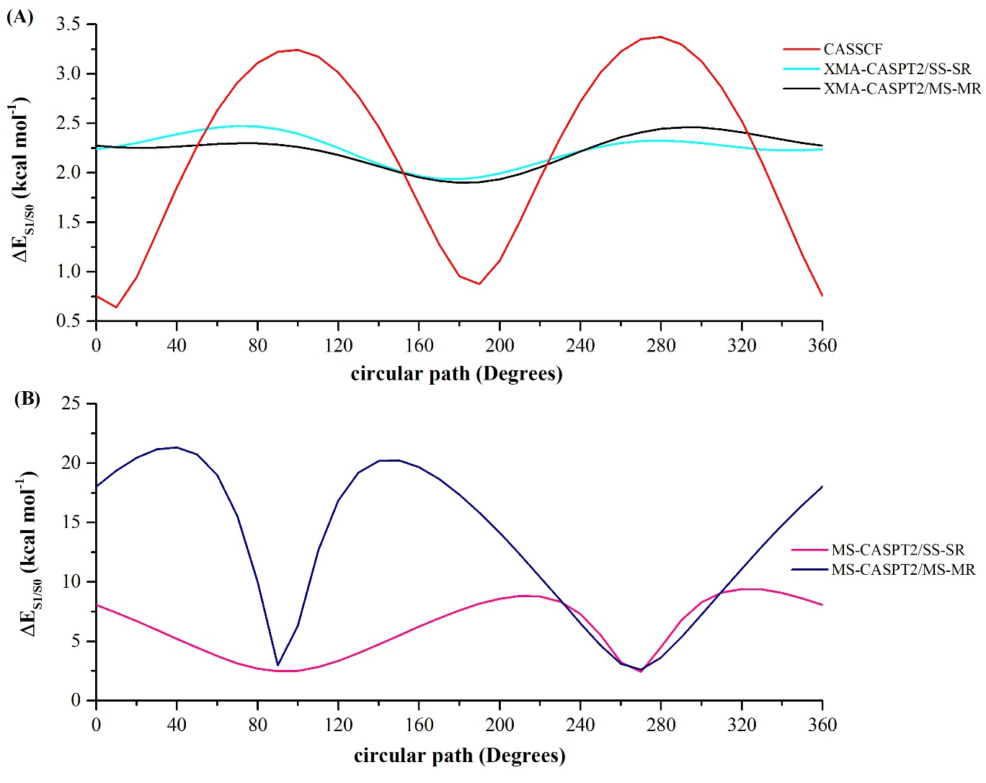
Figure S5. S₁–S₀ energy profiles (in kcal mol⁻¹) of PSB3 along the circular loop centered around the crossing point along BLA scan at (A) CASSCF (red), XMS-CASPT2/SSSR (cyan), XMS-CASPT2/MSMR (black), and (B) MS-CASPT2/SSSR (pink) and MS-CASPT2/MSMR (navy) methods.

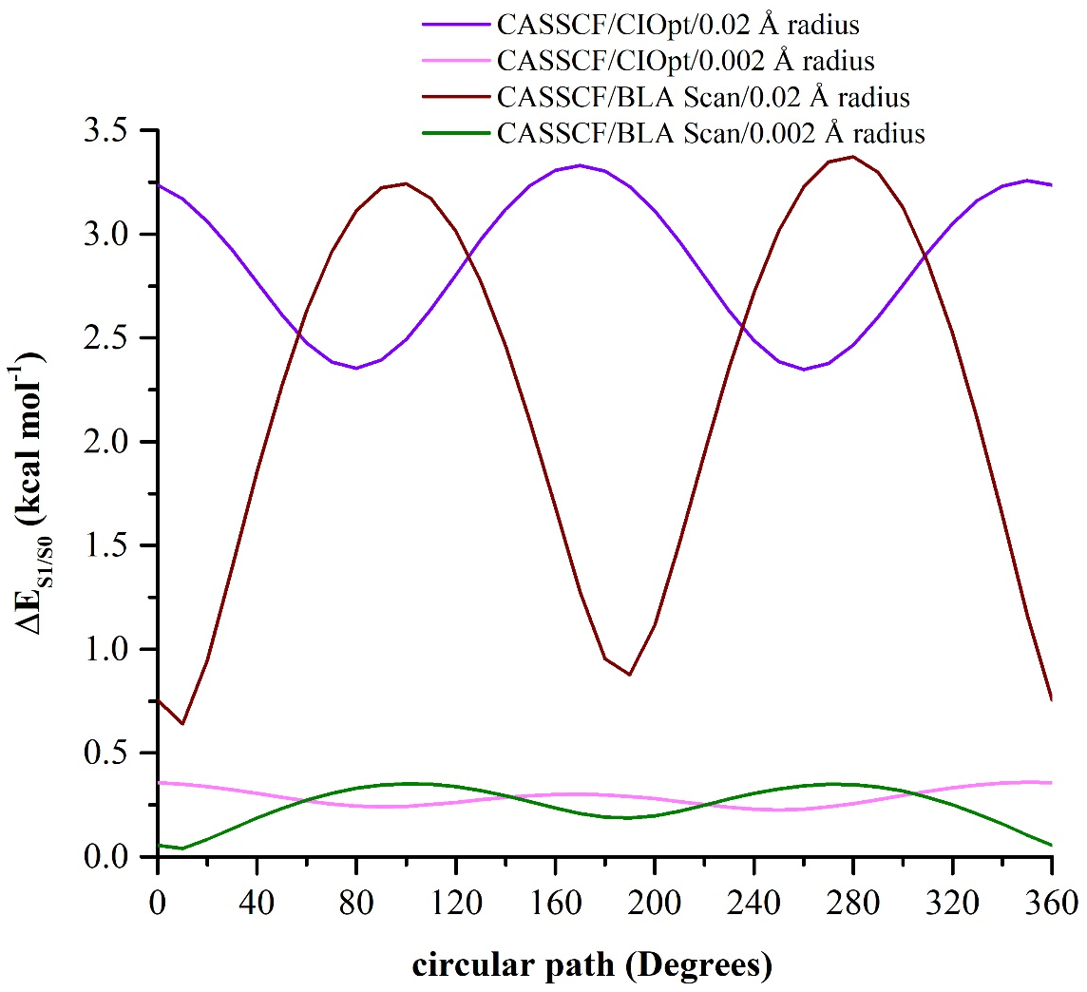
Figure S6. S₁–S₀ energy profiles (in kcal mol⁻¹) of PSB3 along the circular loop centered around the optimized conical intersection and crossing point along BLA scan at CASSCF method for two different circle radius.

