Supplementary material
Greenland Ice Sheet surface topography and drainage structure controlled by the transfer of basal variability
Ádám Ignéczi^{1*,} Andrew J. Sole¹, Stephen J. Livingstone^{1*}, Felix S. L. Ng¹, Kang Yang^{2, 3}
1. Department of Geography, University of Sheffield, UK
2. School of Geographical and Oceanographic Sciences, Nanjing University, Nanjing, China
3. Joint Center for Global Change Studies, Beijing, China

* Correspondence:
Ádám Ignéczi
aigneczi1@sheffield.ac.uk
Stephen J. Livingstone
s.j.livingstone@sheffield.ac.uk

Supplementary material 1: Basal slip ratio optimisation

Overall, the predicted surface relief underestimates the observed surface relief (Fig. 6, main text). As higher basal slip ratios promote a more efficient bed-to-surface variability transfer (Gudmundsson, 2003), the general underestimation of the basal slip ratios (MacGregor et al., 2016; Ng et al., 2018) could partially explain this. The underestimation of basal slip ratios in the calculations of MacGregor et al. (2016) was caused by the overestimation of deformational velocities (u_{d}) and the underestimation of representative surface velocities (u_{s}) as basal slip ratios were approximated by u_{s}/u_{d}. Deformational velocities were generally overestimated due to the assumption of a constant creep parameter, associated with temperate ice (A = 2.4 $×$ 10⁻²⁴ Pa⁻³ s⁻¹), across the whole GrIS (MacGregor et al., 2016).

Here we follow the approach of Ng et al. (2018) of correcting for this overestimation, by considering the actual/likely thermal structure of the GrIS. The creep parameter decreases strongly with decreasing ice temperature; its value is around 10 times smaller at -15°C than at 0°C (Cuffey and Paterson, 2010). MacGregor et al. (2016) used a creep parameter assuming temperate ice (i.e. 0°C), yet around the ice sheet divide we expect much of the ice column to have temperatures of -15 to -20°C (Ng et al., 2018). Therefore, the deformational velocity and thus the basal slip ratio could be underestimated by an order of magnitude in the ice sheet interior. Close to the ice sheet margin the entire ice column could be temperate (Harrington et al., 2015; MacGregor et al., 2016), thus as we go towards the margins along the flowlines the factor of basal slip ratio underestimation is expected to decrease. In order to quantify the factor of basal slip ratio underestimation, a profile containing a basal slip ratio correction factor (Eq. S1) was constructed along each flowline (Ng et al., 2018):

$b\left(x\right)= b_{1}+\left(b_{2}-b_{1}\right)\frac{x}{x_{max}}$ (Eq. S1)

where b₁ and b₂ are the basal slip correction factors at x = 0 (the ice sheet divide) and x_{max} (the ice sheet margin) respectively. Then, the original basal slip ratio profile was multiplied with this profile. The modified basal slip ratio profile was used in the standard procedure outlined in the main text (section Predicting Surface Topographical Variability) to predict surface undulations. Following Ng et al. (2018), we allow b₁ and b₂ to vary independently between 1 and 100, with an increment of 1, and seek their optimal combination yielding the best fit (minimal root-mean-squared error) between the observed and predicted surface undulation profiles. This process was repeated for all of our flowlines. Figure S6A plots the resulting optimal basal slip correction factor (b) across the GrIS, after it has been interpolated to the gridded coordinates.

The optimal basal slip ratio correction factor shows a marked tendency to increase towards the ice sheet divide (Fig. S1A). This agrees well with the assumed increasing trend of basal slip ratio underestimation towards the ice sheet divide, caused by colder ice there. Around the central ice divide, b is rarely larger than 25 (Fig. S1A), and falls in the range of what we expect due to the decreasing ice temperature and creep parameter, which could be more than 10 times smaller near the ice sheet divides than around the margin of the ice sheet (Cuffey and Paterson, 2010). The major exception occurs in the northern section of the GrIS (Fig. S1A), where b is especially high as the ice is colder compared to lower latitudes (Rignot and Mouginot, 2012). Strikingly, the basal slip ratio correction factor is found to be 1 in numerous areas (Fig. S1A). In these areas, a larger basal slip ratio always increases the mismatch between the observed and predicted surface undulations along flowlines. This was the case for flowlines which contained sections that significantly overestimated the observed surface undulations (negative relief anomaly) even before artificially increasing the basal slip ratios. Increasing the basal slip ratios along these flowlines raises the overestimation, as high basal slip ratios enable more effective transfer of basal variability, which was not compensated by the better fit elsewhere. This suggestion is confirmed by the fact that areas where the basal slip correction factor is 1 correspond to flowlines which intersect major negative relief anomalies (Fig. 6, main text).

Figure S1 ǀ (A) Basal slip ratio correction factor (b) map. (B) The difference between the predicted mean surface reliefs calculated using the original and the optimised basal slip ratios was only calculated where the correction factor was larger than 1.
The underestimation of basal slip ratios due to the assumption of a temperate ice column across the whole GrIS caused a significant underestimation of the predicted surface relief, especially in the interior of the ice sheet (Fig. S1B). However, the large-scale pattern of the predicted mean surface relief has not been modified due to this effect (Fig. 4, main text). Instead, the basal slip optimisation affected the rate of relief decrease towards the interior of the ice sheet (Fig. S1B). Regions where large surface relief has been predicted (and observed) far from the ice sheet margin, e.g. NW, W, NE, using the original basal slip ratio dataset (Fig. 4, main text) have even higher relief with the optimised basal slip ratio dataset (Fig. S1B). However, the coverage and position of these regions have not changed significantly and new regions with similar characteristics have not been detected (Fig. S1B).

Supplementary material 2: Estimating the relative response of surface topography to basal slipperiness perturbations

Although the actual basal slipperiness perturbations – c(x) – are unknown, we can estimate the response of the surface topography to c(x) relative to basal topographic perturbations, b(x). As a first approach, we use the equations of Gudmundsson (2003) to calculate the non-dimensional amplitude transfer ratios (the ratio of basal and surface undulation amplitudes) of c(x) and b(x) with a wide range of non-dimensional wavelengths (basal undulation wavelengths scaled to a constant ice thickness, λ/H) for a variety of background basal slip ratios and surface slopes. Using the non-dimensional amplitude transfer ratios, we also investigate the importance of c(x) relative to b(x) in determining surface topography.

Non-dimensional amplitude transfer ratios of c(x) and b(x) differ significantly, especially at short wavelengths and high background basal slip ratios (Fig. S2A-B). Although Gudmundsson (2003) discussed this in detail, the relative surface topographical response to c(x) and b(x) has received less attention. Our calculations demonstrate that the relative surface topographical response to c(x) – compared to the response to b(x) – is well below 0.2 when the non-dimensional wavelengths (λ/H) of basal perturbations are lower than 5-10. Basal slipperiness perturbations with longer wavelengths and/or under thinner ice (around λ/H > 10) have a larger relative effect on the surface topography (between ~0.2 and ~0.5) though even in the case of very large λ/Hs the ratio does not approach unity (Fig. S2). The relative surface topographical response to c(x) increases with background slip ratios when basal perturbations have λ/Hs above ~10, whereas background slip ratios have the opposite effect when basal perturbations have lower λ/Hs (Fig. S2). It is also interesting that surface slope does not affect the relative surface topographical response to c(x) (Fig. S2). In conclusion, the theory of Gudmundsson (2003) suggests that the relative surface topographical response to c(x) is the highest when basal perturbations are relatively long – above 20 times the local ice thickness – and background slip ratios are high. However, this ratio remains below 0.5, even for the most favourable conditions (Fig. S2).
Figure S2 ǀ (A-B) Non-dimensional amplitude transfer ratios of b(x) (blue lines) and c(x) (red lines) for a wide range of non-dimensional wavelengths and background slip ratios (C = 1, 10 and 100; solid dashed and dotted lines respectively) and surface slopes (3° and 0.3° for (A) and (B) respectively). (C-D) Surface topographical response to c(x) relative to the response to b(x) (black lines), using the same parameters as on panels (A) and (B).
However, these calculations only provide additional clarifications within the theoretical framework of Gudmundsson (2003) and thus have limited relevance to our results. In order to evaluate the surface topographical response to c(x) relative to the response to b(x) in the context of the non-stationary convolution approach of Ng et al. (2018), where the surface relief is calculated from the CWT of surface undulations, we need further sensitivity tests. As c(x) is dimensionless and scaled to the background ice thickness in Eq. 1 (main text), it is possible to replace the unknown c(x) in the second integral of Eq. 1 with the observed b(x) and skip the scaling. Hence, it is possible to calculate the surface topographical response using the two transfer functions – T_{sb} and T_{sc} within the two integrals of Eq. 1 – separately but with the same input forcings. Positive b(x) (i.e. bed bumps) acts as resistance to the ice flow while positive c(x) (i.e. slippery spots) enhances ice flow (Gudmundsson, 2003), thus we replaced c(x) with –b(x) in Eq. 1 to ensure that forcings are not just of the same magnitude but the same effective phase as well. After these steps, the mean surface relief due to the bed-to-surface transfer of both b(x) and synthetic c(x) – i.e. -b(x) – was calculated using the approach outlined in the main text (section Predicting Surface Topographical Variability). Using these outputs the ratio of predicted mean surface relief due to b(x) and synthetic/potential c(x) could be calculated and analysed under typical ice sheet conditions.

These results confirm theoretical expectations. The relative response of surface relief to synthetic c(x), which has the same magnitude and effective phase as the b(x), is low in the interior of the ice sheet (< 0.15), where ice is thicker and basal wavelengths have lower λ/H (Fig. S3). Closer to the margins, where ice is thinner and λ/H higher, the relative effect of c(x) on surface relief is higher, though still predominantly below 0.3 (Fig. S3). The effects of background slip ratios on the relative surface relief response to synthetic c(x) are less obvious. However, the general increase in basal slip ratios towards the margins of the ice sheet (Fig 4D), where λ/Hs are higher, could contribute to the increase in the relative surface relief response. It is also interesting that the relative surface relief response to synthetic c(x) is especially low on the Northeast Greenland Ice Stream, Jakobshavn Isbrae, Helheim Glacier in SE Greenland and other major outlet glaciers (Fig. S3). This supports the theoretical expectation that bed topography exerts a dominant control on the surface topographical undulations on ice streams (Gudmundsson et al., 1998; Gudmundsson, 2003; De Rydt et al., 2013). However, we also suggest that a key precondition is the presence of relatively thick ice (Fig. S2 and Fig. S3). In conclusion, the relative surface relief response to c(x) is expected to be highest close to the margins, where the ice is thin and the basal slip ratio high. However, even here this ratio – relative to b(x) – is below 0.3-0.4, and more typically 0.1-0.3. Hence, we propose that the response to c(x) from the total surface relief response to b(x) and c(x) remains well below < 25% in most cases.

Figure S3 ǀ (A-B) Predicted mean surface relief response to b(x) and synthetic c(x), respectively. (C-D) A map and a histogram, respectively, showing the relative predicted mean surface relief response to synthetic c(x) compared to the response to b(x).

Supplementary material 3: Smoothing distance

The smoothing distance (L), determining the corner frequency of the 6th-order Butterworth low pass filter, used to separate the background variables (determining the strength of the transfer) and the perturbations (which are transferred to the surface) is not unique. Our choice of L is based on two opposing considerations described in the main text (section Predicting Surface Topographical Variability). Sensitivity tests were carried out to inform this choice. The observed and predicted mean surface relief profiles, derived from the continuous wavelet transforms (CWTs) of the observed and predicted surface topographical undulation profiles, were calculated using L from 5 to 30 km at 5 km intervals. The performance of each L-value was evaluated by linear regression analysis of the relationship between the observed and predicted mean surface relief (Fig. S4 and Fig. S5). In addition, we calculated the mean wavelet coherence for each L, indicating the match between the observed and predicted surface topographical undulation profiles at different wavelengths, by taking the mean of the wavelet coherence matrices calculated along our flowlines (Fig. S5).

The linear regression models for all choices of L were statistically significant (p-value < 0.01), but their coefficients showed considerable variations (Fig. S4 and Fig. S5). The slope increases with the smoothing distance until 20 km, above which it starts to decrease. The coefficient of determination (R²) generally increases with increasing smoothing distance, though it is anomalously high at 5 km and the rate of increase slows down above 20 km. The mean wavelet coherence exhibits a steady increase with L, and (like the R²) the rate of increase drops down above 20 km.

These R² and mean wavelet coherence results show that low smoothing distances yielded a relatively weak match between the observed and predicted relief (Fig. S5). This matches with our expectations, as short smoothing distances retain fast changes in the background variable profiles, making the approximations used in the non-stationary transfer functions less applicable (Ng et al., 2018). Accordingly, the match between the observations and the predictions improves as L increases, although more slowly above 20 km (Fig. S5). This effect is also consistent with the theory, as long smoothing distances yield large amplitude perturbations for which Gudmundsson’s (2003) linearised transfer theory is less applicable (Ng et al., 2018). The slope of the best fit linear equation at 20 km is slightly higher than 1, corresponding to the expected 1:1 linear relationship. However, the local maxima of the slopes, the drop in the rate of change of the R² and the mean wavelet coherence (Fig. S5) suggest that 20 km is roughly where the two opposing considerations about the choice of the smoothing distance cancel each other out.
Figure S4 ǀ Observed and predicted mean surface relief, derived from the continous wavelet transforms of the surface undulation profiles, are plotted against each other on dot density plots. The colorbars indicate the count of points per pixel. The different smoothing distances used to obtain the results are indicated on the subpanels. Linear trend lines were fitted on the data to test the expected 1:1 linear relationship between the observed and predicted values, the equations and the coefficients of determination (R²) are also provided.
Figure S5 ǀ (A) The slope, (B) and the coefficient of determination (R²) which correspond to the linear relationships between observed and predicted mean surface relief obtained using different smoothing diatances. (C) The mean wavelet coherence between the observed and predicted surface topographical undulations, calculated along the flowlines obtained using different sommothing distances.

Supplementary material 4: Determining the minimum catchment area used for the extraction of surface rivers from the GIMP-DEM

In order to estimate the potential maximum spatial coverage of rivers on the GrIS, a flow accumulation raster was derived from the GIMP-DEM, after filling the sinks not included in our surface depression dataset, using ArcGIS 10.1 Hydrology toolset. Next, a minimal river catchment area was applied to extract river vectors from the flow accumulation raster. The resultant river network is highly sensitive to the choice of this minimal catchment area, thus the extraction of rivers was carried out using a variety of catchment areas and compared with the Landsat-8 derived river dataset (Fig. S6). For brevity we used the same binning approach (based on the observed surface relief) as used in the main text, and compared the density of the Landsat-8 derived rivers with the density of the GIMP-DEM derived rivers, which were calculated using different minimal river catchment areas (Fig. S6).

Since the GIMP-DEM derived rivers should approximate the maximal potential density of the Landsat-8 derived rivers, we propose that a minimal catchment area of 0.3 km² provides the best estimation (Fig. S6). We also note that the river density trends associated with the different GIMP-DEM derived river datasets are quite similar (Fig. S6), though higher catchment areas tend to exhibit less significant/strong quadratic trends (Table S1). Therefore, we expect that our final outputs (in the main text) are not influenced significantly by the choice of a minimal river catchment area.
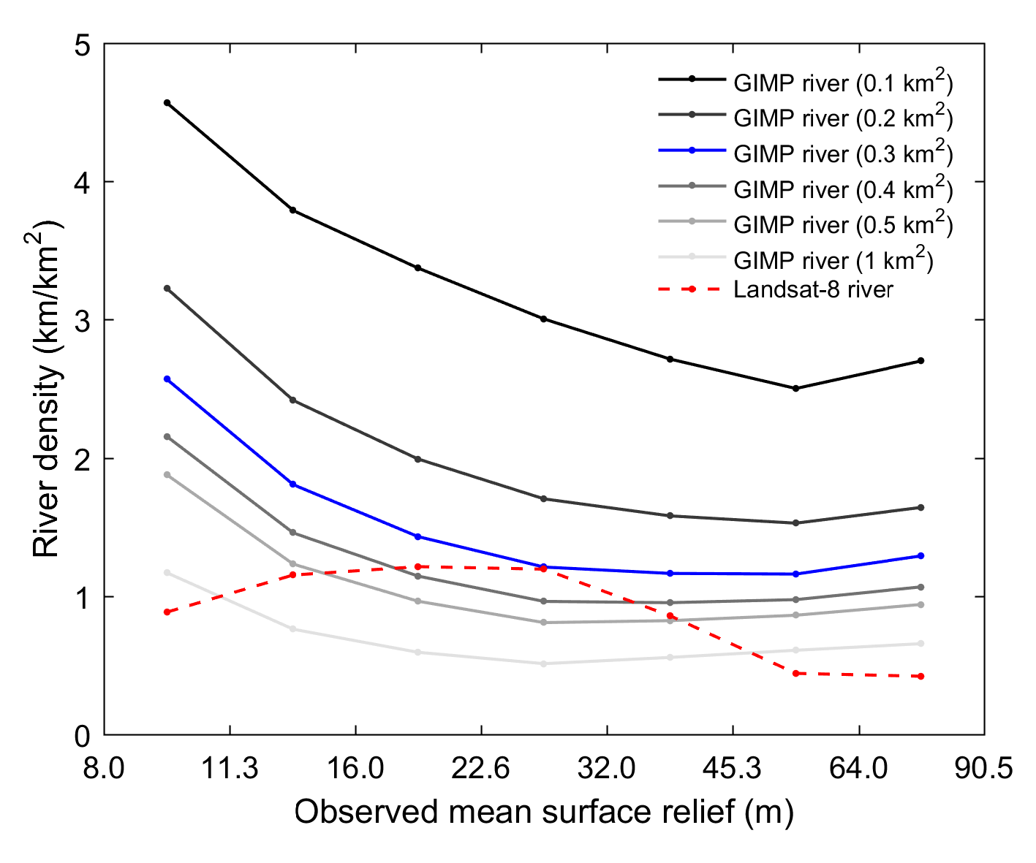
Figure S6 ǀ River densities corresponding to observed mean surface relief categories. Rivers have been obtained from the Landsat-8 survey (dashed red line) and from the GIMP-DEM using different minimal catchment areas (indicated on the legend).
Table S1 ǀ Coefficients of determination (R²) and p-values of the quadratic models fitted on river density, obtained from different datasets, and observed mean surface relief. P-values of the maximum and minimum standard scores, describing the probability of getting such values assuming a normal distribution, are also provided.

References
Cuffey, K., Paterson, W. (2010) The Physics of Glaciers, 3rd Ed. Pergamon.
Harrington, J.A., Humphrey, N.F. and Harper, J.T. (2015) Temperature distribution and thermal anomalies along a flowline of the Greenland ice sheet. Annals of Glaciology 56(70), 98-104. doi: 10.3189/2015AoG70A945
Rignot, E., Mouginot, J. (2012) Ice flow in Greenland for the International Polar Year 2008-2009. Geophysical Research Letters, 39, L11501. doi: 10.1029/2012GL051634

