EMAP Resources for Euterpe 1 | emaproject.eu/events/euterpe/resources
Euripides Orestes Chorus

Performing materials
by Barnaby Brown & Armand D’Angour

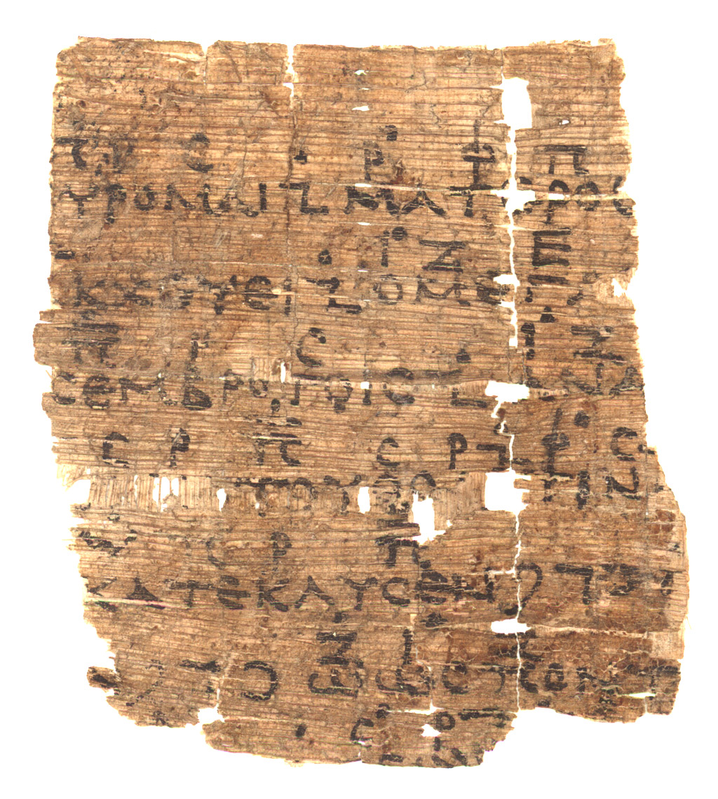
Papyrus fragment, 9.2 × 8.5 cm, written around 200 BCE in Hermopolis, Egypt.
Austrian National Library, G 2315. Image: www.wdl.org/en/item/4309/

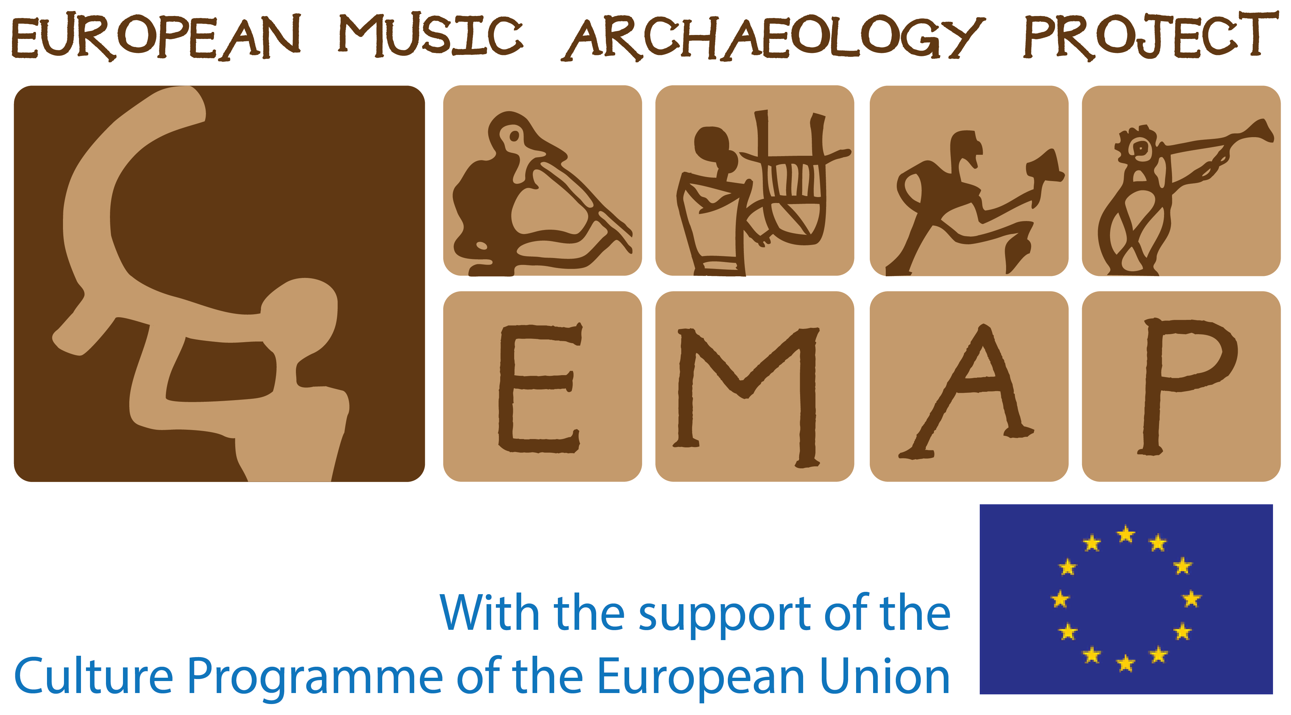

Published for the European Music Archaeology Project
by Barnaby Brown
2018
Duration: 1½–2 minutes

CONTENTS
Introduction to the EMAP Resources for Euterpe
by Barnaby Brown 3
Volume 1. Euripides Orestes Chorus
- Text and translation 9
- Reconstruction with Pydna aulos accompaniment 10
- Reconstruction with blank staff (Dorian) 12
- Reconstruction with blank staff (Phrygian) 14
- Text with interlinear transliteration and translation 16
- Commentary 18
Bibliography 19

This PDF binding contains:
Words Version 1.3 (1 August 2018)
Music AD3-BB3 (30 May 2018)
Music AD3-Dorian (31 July 2018)
Music AD3-Phrygian (31 July 2018)
Open file formats: DOI 10.6084/m9.figshare.6885089
Updates, audio, video & discussion: doublepipes.info/euripides-orestes-chorus

Licence
These materials are released under the Creative Commons license CC BY 4.0 to help establish an open culture of data-sharing, collaboration, and distributed testing and development in the field of Very Early music. Suggestions for best practice include:
- in the case of performances, releasing audio or video documentation online and linking reciprocally between this and the development hub for these materials at doublepipes.info/euripides-orestes-chorus; and
- in the case of revisions and transformations of these performing materials, providing a summary of the changes you make with explanations in a form that engages performers, giving bar references and citing any ancient evidence or scholarship that informs your decisions (see page 6).
All aulos players today are, by necessity, composers. Any public performance or recording with aulos should therefore be treated as contemporary music, which means completing forms for the national society that collects royalties (an important part of how musicians make a living). For performances of the aulos accompaniment on pages 10–11, please provide details as follows:
Title of work: ‘Euripides Orestes Chorus’
Composer/Author/Arranger: ‘Barnaby Brown’
Publisher: ‘—’ (i.e. copyright remains with the composer).

Introduction to the EMAP Resources for Euterpe

by Barnaby Brown
1. Euripides Orestes Chorus for voice and Pydna/Poseidonia aulos
2. Descending Equi-heptatonic Circuits for Pydna/Poseidonia/Elgin aulos
3. Vocables for Learning the Aristides Scales for voice
4. Pindar’s 12th Pythian Ode for voice and Pydna/Poseidonia aulos
5. Delphic Paean by Athenaios Athenaiou for voice and Louvre aulos

T
HESE FIVE VOLUMES are produced for aulos learners and for the singers, composers and scholars with whom they collaborate. The number of people who possess the instruments, reeds and embouchure skills necessary to play all the aulos parts can currently be counted on one hand, but that is set to change. The first Euterpe Doublepipe School, held in Tarquinia in May 2018, had twenty participants from Argentina, Italy, Norway, Poland, Spain, Sweden, Switzerland, UK and USA. Conditions are favourable for the ranks of competent players to grow thanks to specialists’ high-quality, pioneering efforts over the last two decades. These founders of the revival measured archaeological finds, manufactured critical reproductions, developed reeds that are rewarding to play and shared their knowledge generously. Reed-making expertise is, from my vantage point, perhaps the most significant breakthrough. As double reed players know, good reeds are transformative: they bring the instrument to life and make you want to practise. This series is therefore dedicated to Robin Howell, Stefan Hagel, and Callum Armstrong whose hard-won success, discovering what makes a better aulos reed, enabled me to compose.
Now that we have instruments that work well, and have moved beyond the immature stage in which basic evidence is overlooked or undervalued (the ‘we know better’ phase), the time is ripe for publication of attractive performing materials. This need was recognised by the European Music Archaeology Project (EMAP), which commissioned this series and organised the Euterpe Doublepipe School to support learners. I had the privilege of directing that inaugural event, which provided ideal conditions for knocking these materials into better shape. I am grateful to everyone who has given feedback on earlier versions, particularly Stefan Hagel and Stef Conner; any inadequacies that remain are my responsibility.
In the preface to his 2009 book, Ancient Greek Music: A New Technical History, Hagel asks:
How can one hope to add something worthwhile to a discussion that has been based on the ever-same pieces of evidence for such a long time?
These resources are my response to that question. They enrich the mode of communication, supplementing black-and-white writing with full-colour diagrams, audio and video. This achieves a broader engagement (reaching other disciplines and cultures) and a more successful transmission of ideas within the disciplines of philology and musicology. It also initiates serious conversations in areas that, before the digital age, lay beyond the bounds of scholarship. For millennia, aspects of music that were not encoded on clay tablet, papyrus, stone or vellum were evanescent, ineffable; there was no permanent record. Now, that only applies to aspects of music that the YouTube video fails to capture. The tools of secondary or digital orality have profound implications. The richest opportunities for breaking new ground in ancient Greek music, however, are surely provided by practical experiment: by engaging more deeply with the archaeological finds of doublepipes. Instruments in superlative condition have been unearthed as recently as 1996 (Pydna) and 2005 (Megara). Only through a dedication consistent with the high status of auletic culture in antiquity will we begin to approach the levels of competence that made doublepipes the most popular musical instruments of Greek and Roman cultures. I began practising the aulos at the age of 40 and have not yet approached the number of hours of training that a professional skill demands. The more advanced skills of a community of auletes with diverse cultural backgrounds and younger starts will add significantly more to this discussion in years ahead.

The nature of this series
This series presents the five compositions that have stretched me most fruitfully in my short journey as an aulos learner, 2014–18. I trust they will be equally rewarding for others, providing a path through one corner of the field of possibilities. The written elements in each PDF are supported by audio and video materials online. This revival is so young that my own ideas and approaches are wide open to change. Every time I come back to a score, I make revisions because my skills have developed, or I have discovered a new technique. I regard these compositions as having a dual nature: obstacle courses for an athletic musical training, and experiments to be tested and fine-tuned. Through discussion, sharing experiences and addressing each other’s weaknesses constructively, we can grow wiser about how to train and smarter about how to compose.
Each volume takes a different point of departure. Volume 1 is a response to ancient notation on the papyrus fragment reproduced on the front cover. Volume 2 offers a solution to the puzzling hole boring of Classical-era auloi, interpreting them as ‘panharmonic’ instruments capable of modulating mid-phrase. Volume 3 gives schoolchildren, students and composers a means of getting to know the six ancient scales described by Aristides Quintilianus; to do this, it reconstructs a system of vocabelising that makes ancient Greek music theory universally accessible. Volume 4 is an experiment constructing new music for an ode by Pindar, attending to the rhythms and pitch contours of ancient Greek while exploring how the Aristides scales might be used in practice. Volume 5 presents two solutions for the Athenaios Paean, the most substantial and complete item of ancient musical notation; one solution is by Stefan Hagel, the other by Armand D’Angour. Nothing reveals the issues involved more sharply than getting two scholars to explain why they have each made different decisions, note for note. It becomes clear that a single solution is not only impossible but undesirable. I am deeply grateful to these specialists for taking the time and trouble to explain, in words that a novice can understand, the insights that they and previous generations of scholars have developed, examining evidence that is highly problemmatic.

Acknowledgements
These compositions and scores were tested and developed through numerous rehearsals and performances funded by EMAP and the University of Oxford. Stefan Hagel, who blazed the trail reviving the aulos, has been unstintingly generous sharing his practical and scholarly expertise. Through EMAP, joining forces with the players Olga Sutkowska, Cristina Majnero and Roberto Stanco, and the makers Thomas Rezanka, Chrestos Terzēs, Marco Sciascia and Peter Holmes, we benefitted from interdisciplinary meetings, rehearsals and performances as ‘The Workshop of Dionysus’. These encounters and the wider knowledge exchange arising from our multi-author blog, www.doublepipes.info, have had an enormous impact since 2013, mobilising the aulos revival. Momentum increased significantly in 2015 when Robin Howell, Callum Armstrong and Raúl Lacilla brought their energy to the Workshop. I am grateful to all EMAP’s stakeholders and personnel for their vision and foresight, bringing this Workshop into being and placing interdisciplinary collaboration at its heart. This overcomes the serious limitations of working in isolation.
Two individuals deserve special thanks for the colossal fundraising efforts and organisation of events that bear fruit in these resources: Emiliano Li Castro and Armand D’Angour. I am also grateful to the Actors Touring Company for braving the unknown in 2016, commissioning reproductions of Classical-era auloi for a production of The Suppliant Women by Aeschylus. Neither Callum Armstrong nor I could figure out how to play the Pydna or Poseidonia in time for the show, but our formative experiences playing the Louvre for rehearsals and performances at Edinburgh’s Royal Lyceum Theatre and London’s Young Vic were invaluable, raising our skill levels and shaping these scores. As a result they bridge a gap between academia and the needs and expectations of professional musicians.
There are too many individuals to thank by name – I am grateful to them all for the input and support that have made these resources better in one way or another. One individual stands out: Robin Howell. His profound understanding of double reed instruments of the globe, genius making reeds and auloi, and wise mentorship regarding embouchure development have led me into a new musical universe.

Multiple realisations
These resources are the first scores for aulos in modern times – at least, the first to capture in notation something consistent with the superstar status of this instrument in Classical antiquity. There is much more to discover in the years ahead: this release does not mark an endpoint, rather a milestone in a continuing process of evolution. Flaws in the early versions may prove to be their most valuable aspects, provoking deeper learning. Open-source release encourages multiple realisations and adaptations, and builds a culture of distributed testing and development. Sharing open file formats makes it easier to collaborate, both in artistic and scholarly environments. It also fosters a research culture in which public engagement is fully embedded.
This mode of publication is in itself an experiment, exploring how the scholarly editor harnesses digital technologies when presenting musical notation from a remote culture. It responds to the vision of a leading digital edition maker, Peter Robinson, expressed in a lecture he delivered in 2014:
Instead of our own, single, monolithic edition, there would be a flourishing ecoculture of overlapping sites, using our material in multiple ways, each finding their own readership. I have to say that persuading scholars to relinquish control of what they have made is not easy. We have been trained, since our first undergraduate days, to regard our research as dragons value their gold: of more value if we hoard it than if we spend it. But in the digital world, giving and taking is all that matters... We all know the topos that we are standing on the shoulders of the scholars who have preceded us. The digital age offers a variant on this. As well as stand on the shoulders of others, we should help others to stand on our shoulders. This will change who we are. Now, that would be revolutionary.
(Robinson, pp. 200–1)
The goal of these materials is not to be ‘right’ or to increase the impact of research by translating existing knowledge into forms more accessible the general public; rather, it is to stimulate new scientific discovery and deeper understanding, changing how scholars think through stronger collaborations with practitioners. The route will be one of trial and error, gradually gleaning from a vast number of possibilities. Since the publication in 2009 of Hagel’s formidable book, research in this field is inextricably bound up with the exacting matter of learning how to play the aulos. Accepting that we lack teachers with generations of accumulated expertise, let us turn towards the fact that we must be embarrassingly incompetent compared to aulos players in Euripides’ time. Addressing that incompetence, training ourselves to become better players, is fundamentally what these scores are about.
If we embrace the good-practice guidelines developed in experimental archaeology, then interdisciplinary and intercultural collaboration will lead to new insights and potentially produce some brilliant solutions. The problems are numerous: we are handling evidence that is fragmentary, widely scattered and often anachronistic or potentially unreliable, distorted by ancient writers’ contexts, agendas, mistakes and fantasies. The EMAP Resources for Euterpe are seeds for future performing materials, ready to be adapted and transformed to suit different circumstances in ways that we have no wish to control. Our goal is to help others generate new hypotheses that will provoke historians, philologists and (ethno)music-ologists to notice new things in the same pieces of evidence that, in turn, inform the next generation of performances. Discovering what the Orestes chorus or Athenaios paean sounded like in antiquity is out of reach; at the same time, we can come to know and understand the evidence more deeply. This involves developing a stronger connection with things that are outside our zone of expertise and remote from our time and culture.

An emerging discipline
When making new constructions for the present, rather than reconstructions of the past, it is helpful to distinguish scientific research from imaginative entertainment. Equally valuable is sharpening our awareness of the effects of cultural conditioning – the neural highways of embodied knowledge, both our muscle memory and our preconceptions. A new discipline is currently emerging from the intersection of archaeology and musical performance, one described at the 2014 Galway Early Music Festival as ‘Very Early music’. Combining the observations of Rosenfeld (2003) and Outram (2008) with my own experiences developing performances for EMAP since 2013, the following recommendations may help to build the fitness and respectability of this discipline:
- Avoid knowingly contradicting ancient evidence; at the same time, recognise the scope for interpreting that evidence in a truly creative manner.
- Take previous experiments into account, both of professional academics and professional performers.
- Address human bias and blind spots through interdisciplinary and intercultural collaboration, turning towards difficulties and conflicts with preconceived ideas.
- As far as possible, use materials, technologies and techniques of the time, place and activity under investigation.
- Rather than striving for the final word on the subject, accept that alternative solutions are both inevitable and desirable, and that mistakes can be more constructive than successes.
- Share your results, performing materials, decision-making process and reflections as fully, transparently and promptly as possible, crediting everyone involved, citing the work you build on and making your experiment reproducible.
- Be savvy using technology (version control, open file formats, fonts, Unicode blocks, licensing, etc.).
- Maintain a clear distinction between experiments (research) and experiences (education and culture), recognising that skilled experimenters acquire competence through experiences that are engaging and fun.
These points will be developed in a forthcoming article co-written with Stef Conner. They are a big ask for performers who do not see themselves as researchers. For recommendation 6, I imagine that YouTube interviews could be a better solution than written commentaries of the kind produced for this series, because they engage a wider audience and may draw out more depth and detail from freelance musicians whose core activity is not writing but performing.
As well as stimulating better collaborations between academics, instrument makers and musicians, we hope the EMAP Resources for Euterpe will encourage scholars of ancient languages to take the publication of practical performing materials more seriously. After all, most early literature was sung. Although the revivals of the instruments that accompanied ancient literature are still in their infancy, EMAP has made exciting progress pushing back the frontiers of Historically Informed Performance, not just to Classical antiquity but to the Stone Age. We have much to learn from the Early Music enterprise, particularly the ever-present dangers of wishful thinking, sometimes dubbed ‘the historicist fallacy’. Like searching for the holy grail, there is no final destination, no single answer. The value to society of Very Early music lies more in enriching the present than in illuminating the past.

Notating aulos music
In 2014, Stefan Hagel made the following suggestion in his post ‘Notating aulos music?’ on the Workshop of Dionysus blog:
I propose using our natural scale for the ancient natural ‘Lydian’, which maps the ‘white keys’ of the piano onto the finger holes of the pipes, regardless of their actual pitch.
In this way, the lowest note of the Louvre as well as the Berlin aulos would become ‘A’, and the highest, ‘d’. For optimal fit with the ideas of ancient music, I suggest distributing uppercase and lowercase letters across the instruments’ eleventh as follows:
A B C D e f g a b c d
With the Louvre, this results in a discrepancy of a third between written and sounding pitch – the lowest note sounds a little flatter than F sharp. Treating the aulos as a transposing instrument would be sensible if we were only working with the Louvre and Berlin auloi, but not when we have instruments from the Classical period in our case. They behave completely differently.
Another proposal of Hagel’s is to treat the Lydian tonos as the natural key, rather than the Hypolydian tonos, which has been used in scholarly transcriptions since 1847 (2009, p. 453). This would make transcriptions of ancient notation symbols appear a ¾-tone flat on the page, instead of between a minor and major third sharp. To produce the ancient pitch, performers could simply recalibrate their ‘A’ to 490 Hz. This approach makes sense for transcriptions of ancient notation, but not for contemporary music.
With a view to preparing auletes for professional employment in mainstream environments (theatre, film, gaming, etc.), this series adopts the policy of writing at sounding pitch to within a quartertone of A 440 Hz. This policy has three advantages. First, it makes it easier to collaborate with other musicians, particularly singers. It makes no sense to produce scores for voice and aulos in which the vocal part is in a different key to the aulos part. This would prevent singers from reading the harmony, which is helpful both for pitching and for tuning. Secondly, writing (and thinking) at sounding pitch simplifies life for beginners who don’t know what pitch each fingering is supposed to produce. It also makes it easier to collaborate with composers and academics who ask you what notes you can play. As French horn players know, composers regularly get transposing instruments wrong even when good guidance is easily found. My experience developing and touring in The Suppliant Women leaves me in no doubt that treating the aulos as a transposing instrument would introduce a tripwire, causing unnecessary complications and stress to everyone: composer, director, singers and aulos player. Thirdly, writing at sounding pitch takes the headache out of score production. When engraving software transposes a part, manual formatting is inevitably lost. This can represent hours of work, getting spacing to look good. Even if the transpose button didn’t throw things awry, having to produce two scores (one in concert pitch for the chorus and one transposed for the aulos player) would be a waste of time and money.
The only case for treating the aulos as a transposing instrument would be if all doublepipes behaved like the Louvre, but sounded in different keys. They don’t. Greek and Roman finds span a 700-year period during which doublepipes underwent a paradigm shift. Generally, Classical-era pipes are a tone apart, Roman-era pipes a fourth apart, but there are also finds of what appear to be unison pipes from both ends of this period. Without a standard design, transposition offers no practical advantage to the modern aulete, as it does to the clarinetist or would have done in the case of the ancient aulete who played a single type of instrument. In some situations, when a score can be played on more than one type of aulos, I make this clear on the page after testing to verify that it works. This may depend on the configuration: the opening or closing of lower holes out of reach of the fingers. For example, Descending Equi-heptatonic Circuits (volume 2) can also be played on the Elgin, sounding about a tone lower than the Pydna, but volumes 1 and 4 cannot.
For the notation of quartertones, I have consistently placed the oxypykna and mesopykna (‘high’ and ‘middle compressions’) at the same vertical position on the staff. The barypykna (‘low compressions’) are placed one step lower. This conveys the fingering I use to produce quartertones, a shared vertical position signifying a shared fingering. I execute the quartertones by making a slight embouchure adjustment, rather than leaking air from a fingerhole, because I find this method more conducive to virtuosity. Other solutions are possible.

Making a difference
Embracing the digital revolution means that multiple versions of each text can be released online on an ad hoc basis, encouraging the development of an ecoculture in which different solutions can be compared and cited. We must learn here from software developers: without version control and summaries of what has changed and why, we will leave a trail of confusion behind us that makes it harder for others to stand on our shoulders. It is too early to know what kind of digital brain or version logging practice would be most helpful long-term – all we can be sure of is that better solutions will emerge. At the moment, figshare appears to be the most elegant, economic and future-proof solution for our needs, sharing filesets that will evolve under a single Digital Object Identifier (DOI).
Please help us to strengthen future versions of these resources by sending feedback to barnaby@pibroch.net or by leaving a comment on the relevant Updates & discussion page – each volume has its own one (links are in the page footers). Better still, release your own transformations, with written commentary or online video explaining your decisions. Figshare is free and easy to use. We look forward to linking to ‘children’ and ‘branches’ of the EMAP Resources for Euterpe, including recordings of any performances, at the relevant Updates & discussion page, making it easier for every performance to learn from previous experiments.
Whether as contemporary artists or as scholars of ancient materials, it is vital to keep pushing boundaries, reaching beyond what is familiar at the same time as drawing on previous experience. At this exciting point in the revival, the following advice based on the teachings of the Buddha seems particularly appropriate:
Traditions are not to be followed simply because they are traditions. Reports (such as historical accounts or news) are not to be followed simply because the source seems reliable. One’s own preferences are not to be followed simply because they seem logical or resonate with one’s feelings. Instead, any view or belief must be tested by the results it yields when put into practice; and – to guard against the possibility of any bias or limitations in one’s understanding of those results – they must further be checked against the experience of people who are wise. The ability to question and test one’s beliefs in an appropriate way is called appropriate attention. The ability to recognize and choose wise people as mentors is called having admirable friends.
Thanissaro Bhikkhu
on the Kalama Sutta (AN 3.65)

Euripides Orestes Chorus
1. Text & translation

στροφή

δρομάδες ὦ πτεροφόροι
ποτνιάδες θεαί,
ἀβάκχευτον αἳ θίασον ἐλάχετ᾽ ἐν
δάκρυσι καὶ γόοις,
μελάγχρωτες εὐμενίδες, αἵτε τὸν
ταναὸν αἰθέρ᾽ ἀμπάλλεσθ᾽, αἵματος
τινύμεναι δίκαν, τινύμεναι φόνου,
καθικετεύομαι καθικετεύομαι,
τὸν Ἀγαμέμνονος
γόνον ἐάσατ᾽ ἐκλαθέσθαι λύσσας
μανιάδος φοιταλέου. φεῦ μόχθων
οἵων, ὦ τάλας, ὀρεχθεὶς ἔρρεις.

ἀντιστροφή

τίς ἔλεος, τίς ὅδ᾽ ἀγὼν
φόνιος ἔρχεται;
θοάζων σε τὸν μέλεον, ᾧ δάκρυα
δάκρυσι συμβάλλει.
πορεύων τις ἐς δόμον ἀλαστόρων
ματέρος αἷμα σᾶς, ὅ σ᾽ ἀναβακχεύει·
κατολοφύρομαι κατολοφύρομαι.
ὁ μέγας ὄλβος οὐ μόνιμος ἐν βροτοῖς·
ἀνὰ δὲ λαῖφος ὥς
τις ἀκάτου θοᾶς τινάξας δαίμων
κατέκλυσεν δεινῶν πόνων ὡς πόντου
λάβροις ὀλεθρίοισιν ἐν κύμασιν.

Euripides, Orestes 317–44
Strophe

O demon runners with beating wings,
Goddesses of the night,
with baneful music you dance sinister revels
with wailing and láments;
ye black-coated Kindly Goddesses who tread
the thinning air aloft, for bloody kin-murder
demanding due redress, demanding due justice,

I beg you from my heart, I beg you from my soul,
that Agamemnon’s son
is given leave to overcome his frenzies,
these mad attacks driving him wild. Woe, the toils
that you, O poor man, have faced and endured.

Antistrophe

What kind of pity, what kind of struggle
of blood awaits you now?
It rushes upon you, wretch, bringing sorrow,
tears upon tears it brings.
Some nameless avenging spirit dances in
to quench your mother’s blood, by driving you insane!
For you my tears are shed, for you my tears are shed.
Good fortune does not last for mortals on this earth;
like sails on a swift ship
that cuts the ocean waves God buffets us about
and sinks us in a sea of troubles like the o-
cean’s death-dealing billows that sweep o’er the main.

Isorhythmic translation: Armand D’Angour

4. Text with interlinear transliteration & translation

Strophe
δρομάδες ὦ πτεροφόροι
dromades ō pterophoroi
O demon runners with beating wings,
ποτνιάδες θεαί,
potniades theai,
Goddesses of the night
ἀβάκχευτον αἳ θίασον ἐλάχετ᾽ ἐν
abakcheuton hai thiason elakhet’ en
with baneful music you dance sinister revels
δάκρυσι καὶ γόοις,
dakrusi kai goois;
with wailing and láments;
μελάγχρωτες εὐ- μενίδες, αἵτε τὸν
melankhrōtes Eu- menides, haite ton
ye black-coated Kind- ly Goddesses who tread
ταναὸν αἰθέρ᾽ἀμ- πάλλεσθ᾽, αἵματος
tanaon aither’am- pallesth’, haimatos
the thinning air aloft, for bloody kin-murder
τινύμεναι δίκαν, τινύμεναι φόνον,
tinumenai dikān, tinumenai phonon,
demanding due redress, demanding due justice,
καθικετεύομαι καθικετεύομαι,
kathiketeuomai kathiketeuomai,
I beg you from my heart, I beg you from my soul,

τὸν Ἀγαμέμνονος
ton Agamemnonos
that Agamemnon’s son
γόνον ἐάσατ᾽ ἐκ- λαθέσθαι λύσσας
gonon eāsat’ ek- lathesthai lussās
is given leave to o- vercome his frenzies,
μανιάδος φοιτα- λέου. φεῦ μόχθων
maniados phoitā- leou. pheu mochthōn [Bold = spoken]
these mad attacks driving him wild. Woe, the toils
οἵων, ὦ τάλας, ὀρεχθεὶς ἔρρεις.
hoiōn, ō talās, orechtheis erreis.
that you, O poor man, have faced and endured.

Antistrophe
τίς ἔλεος, τίς ὅδ᾽ ἀγὼν
tis eleos, tis hod’ agōn
What kind of pity, what kind of struggle
φόνιος ἔρχεται;
phonios erchetai?
of blood awaits you now?
θοάζων σε τὸν μέλεον, ᾧ δάκρυα
thoazdōn se ton meleon, hōi dakrua
It rushes upon you, wretch, bringing sorrow,
δάκρυσι συμβάλλει.
dakrusi sumballei.
tears upon tears it brings.
πορεύων τις ἐς δόμον ἀλαστόρων
poreuōn tis es domon alastorōn
Some nameless aveng- ing spirit dances in
ματέρος αἷμα σᾶς, ὅ σ᾽ ἀναβακχεύει·
māteros haima sās, ho s’anabakcheuei;
to quench your mother’s blood, by driving you insane!
κατολοφύρομαι κατολοφύρομαι.
katolophūromai katolophūromai.
For you my tears are shed, for you my tears are shed.
ὁ μέγας ὄλβος οὐ μόνιμος ἐν βροτοῖς·
ho megas olbos ou monimos em brotois:
Good fortune does not last for mortals on this earth;
ἀνὰ δὲ λαῖφος ὥς
ana de laiphos hōs
like sails on a swift ship
τις ἀκάτου θοᾶς τινάξας δαίμων
tis akatou thoās tinaxās daimōn
that cuts the ocean waves God buffets us about
κατέκλυσεν δεινῶν πόνων ὡς πόντου
kateklusen deinōn ponōn hōs pontou
and sinks us in a sea of troubles like the o-
λάβροις ὀλεθρίοι- σιν ἐν κύμασιν.
labrois olethrioi- sin en kūmasin.
cean’s death-dealing billows that sweep o’er the main.

5. Commentary

T
HIS BINDING of the Euripides Orestes Chorus contains five elements. Three scores are framed by two different layouts of the words. These are performer-ready in the sense that we have tried to eliminate the contradictions and omissions that eat into valuable preparation and rehearsal time. The first layout of the words can be cut and pasted for programs; the second is interlinear, which may be useful for singers wanting to memorise the text. The first score includes an accompaniment for Pydna/
Poseidonia aulos developed and tested between December 2016 and May 2018 through performances in Oxford, Cambridge, London, Tarquinia (Italy) and Lefkosia (Cyprus). The other two have a blank staff to facilitate experiments developing alternative accompaniments, perhaps on other types of aulos.
We hope these starting points will provoke others to publish alternative solutions that lead us deeper into the subject, explaining the creative decisions in ways that performers can understand without needing to take a degree in Classics, or devoting a year to reading and digesting scholarly literature (see ‘An emerging discipine’, page 6). Before releasing Version 2, we would like to do at least two things: process feedback on Version 1 from professional academics and professional performers; and reconstruct an ancient score that supplements the missing portions of the papyrus fragment. This would aim to look something like what a coryphaeus (‘chorus leader’) may have used in the third century BCE – i.e. Pöhlmann and West 2001, page 18, but filling in the gaps in the antistrophe and adding the strophe.

Performing forces
The chorus that Euripides used in tragedies consisted of 15 men, one of whom was the coryphaeus, placed in the middle of the chorus. They were accompanied by a single aulete playing a hyperteleios, literally a ‘hyper-grown-up’ or bass aulos (West 1992, pp. 41, 47 and 90).

Pitch & choice of aulos
Stefan Hagel produces compelling arguments that the original pitch would be about a quartertone lower than is written in the first two scores (2009, pp. 68–95). This holds true if the ancient notation is an example of fixed-pitch usage, which is by no means certain. The Pydna aulos, buried 400–350 BCE, provides this pitch but lacks the lowest note in the papyrus (an instrumental 𝈫 at the start of the last line of the fragment). A hyperteleios aulos would probably have had this note – perhaps operated by a bronze slider, as on the auloi of Megara. The Pydna was chosen for this experiment because it is the most complete find of an aulos from the time of Euripides. Unlike the Louvre, which has an identical bombyx pitch (the lowest available note), the Pydna is loud enough to accompany a chorus owing to its wider bore. The out-of-range note (the D in bars 21–2 and 49) is transposed an octave higher in this experiment, but left at the original pitch in the scores with a blank staff.
The problem with this interpretation of the notation is that it places the chorus in what was probably, in Euripides’ lifetime, the Dorian harmonia. According to Euripides’ younger contemporary, Plato, Dorian was associated with moderation and free choice, in contrast to the Phrygian harmonia, which was associated with emotion and compulsion. Phrygian seems a more likely choice of harmonia given the subject matter of the text and the influence of the ‘New Music’ in Euripides’ later works. A movable-pitch interpretation is supported by the use of the same notation symbols for both Phrygian and Dorian in a table of ancient scales transmitted by Aristides Quintilianus (see Volume 2, Diagram 2). The only visible difference between these scales is their highest scale step: a tone in Phrygian, a ditone in Dorian. An accompaniment pitched one aulos finger-hole higher would certainly increase the sense of agitation and distress, so this is an option worth testing.

Pronunciation
The transliteration does not attempt to encode sounds precisely or systematically; it is a culture-specific solution using English orthography, intended as an aide-mémoire for singers who learn pronunciation by ear from recordings online. For version 2, we are considering providing a rendering in the International Phonetic Alphabet. This would eliminate ambiguity and cultivate more successful communications between historical phonologists and professional singers. For Classical-era pronunciation, we are of course in the realm of scholarly conjecture. The evidence is still essentially that given in W.S. Allen’s Vox Graeca (3rd edn 1987; and preceding him, E.H. Sturtevant 1920). There is a reasonable realisation by W.B. Stanford (1967) now on YouTube: https://youtu.be/zyeJXzGZMbs.

Bibliography

ALLEN, W. S. (1987) Vox Graeca. 3rd edn. Cambridge: Cambridge University Press.
D’ANGOUR, A. J. (2015) ‘Sense and Sensation in Music’. In P. Murray and P. Destrée (eds.), Blackwell Companion to Ancient Aesthetics. Chichester/Malden, MA: Wiley-Blackwell, 188–203.
HAGEL, S. (2009) Ancient Greek Music. A New Technical History. Cambridge: Cambridge University Press.
HORROCKS, G. (2010) Greek: A History of the Language and its Speakers. 2nd edn. Chichester/Malden, MA: Wiley-Blackwell.
JAN, C. von (1962 [1895]) Musici Scriptores Graeci. Hildesheim.
OUTRAM, A. K. (2008) ‘Introduction to experimental archaeology’. In Experimental Archaeology. World Archaeology 40(1): 1–6.
PÖHLMANN, E. and WEST, M. L. (2001) Documents of Ancient Greek Music. Oxford: Oxford University Press.
ROBINSON, P. (2016) ‘The Digital Revolution in Scholarly Editing’. In B. Crostini, G. Iversen, and B. M. Jensen (eds.), Ars Edendi Lecture Series 4. Stockholm: Stockholm University Press, 181–207.
ROSENFELD, R. A. (2003) ‘Performance practice, experimental archaeology, and the problem of the respectability of results’. In T. J. McGee (ed.), Improvisation in the Arts of the Middle Ages and Renaissance. Kalamazoo: Medieval Institute Publications, Western Michigan Unversity, 71–97.
WEST, M. L. (1992) Ancient Greek Music. Oxford: Oxford University Press.
⎯⎯ (2011) Collected Papers Vol. 2. Oxford: Oxford University Press.

