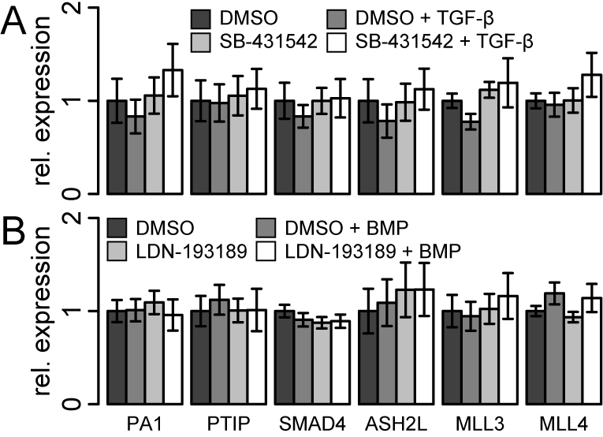
Figure S1. MLL3/4 complex member expression analysis. (A-B) Gene expression analysis of SET/MLL complex member genes. (A) U-2 OS cells were treated with 10 µM SB-431542 inhibitor for 24 h and subsequently stimulated with 10 ng/ml TGF-β for 6 h as indicated. (B) U-2 OS cells were treated with 100 nM LDN-193189 inhibitor for 24 h and subsequently stimulated with 10 ng/ml BMP for 6 h as indicated. (A-B) Samples were analyzed using qRT-PCR. Bars represent average expression corrected for ACTIN and normalized to the siNT control. Error bars represent standard deviation. Technical replication n = 3 for all samples.
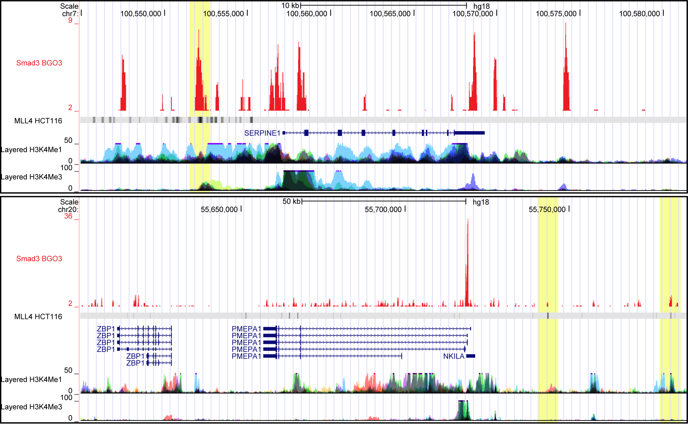
Figure S2. UCSC genome browser tracks for TGF-β target genes SERPINE1 and PMEPA1. ChIP-seq tracks for SMAD3 in hESC BGO3 cells ¹ and MLL4 in HCT116 cells ². H3K4me1 and H3K4me3 abundance is shown for 8 and 9 different cell lines respectively. Co-occurrence of SMAD3 and MLL4 binding is highlighted in yellow.
Supplemental references
1. Mullen AC, Orlando DA, Newman JJ, Loven J, Kumar RM, Bilodeau S, et al. Master transcription factors determine cell-type-specific responses to TGF-beta signaling. Cell 2011; 147:565-76.
2. Hu D, Gao X, Morgan MA, Herz HM, Smith ER, Shilatifard A. The MLL3/MLL4 branches of the COMPASS family function as major histone H3K4 monomethylases at enhancers. Mol Cell Biol 2013; 33:4745-54.

