Q1) Which department/service are you a part of?
- Fire
- Law Enforcement
- Emergency Medical Technicians
- Search and Rescue
- Explosive Ordinance Disposal
- Hazmat
- Military
- Other (please specify)
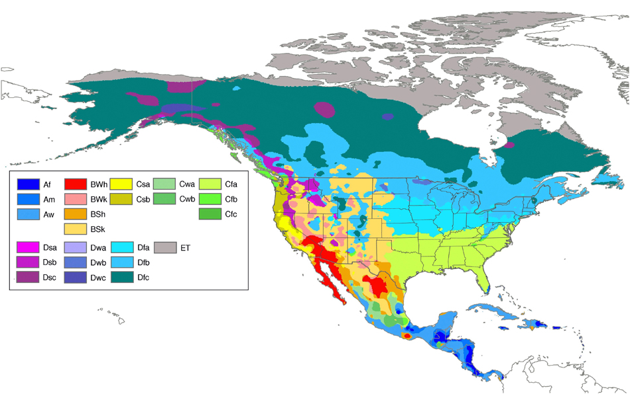
Peel MC, Finlayson BL & McMahon TA (2007), Updated world map of the Köppen-Geiger climate classification, Hydrol. Earth Syst. Sci., 11, 1633-1644.

Q2) Please indicate from the climate map ALL geographical location(s) where work from your department takes place?

Q3) Please indicate from the climate map in which geographical location does the MAJORITY of your departments work take place?

Q4) Would you classify HEAT STRAIN and/or HEAT ILLNESS as an identified risk to employee safety during occupational duties?
- Yes
- No

Q5) Does your department currently employ PRECOOLING strategies before occupational duties or training to combat heat strain?
- Yes
- No

Q6) Please identify ANY of the following PRECOOLING technique(s) currently used by your department:
- Water Immersion
- Cold Air Exposure
- Ice Exposure or Application (including garments)
- Cold Air Inhalation
- Ice Slurry Ingestion
- Other (please specify)
Q7) How EFFECTIVE do you believe those PRECOOLING technique(s) you currently use to be?
 | Not at all | A little | Somewhat | Quit a lot
- Water Immersion
- Cold Air Exposure
- Ice Exposure or Application (including garments)
- Cold Air Inhalation
- Cold Liquid Beverages
- Ice Slurry Ingestion
- Other (please specify)

Q8) Please provide ANY model(s) and/or brand name(s) relating to each of the PRECOOLING technique(s) you currently use:
- Water Immersion: ___________
- Cold Air Exposure: ___________
- Ice Exposure or Application (including garments): ___________
- Cold Air Inhalation: ___________
- Cold Liquid Beverages: ___________
- Ice Slurry Ingestion: ___________
- Other (please specify): ___________

Q9) Please indicate ANY barriers that prevent your department from using PRECOOLING strategies:
- Employee Comfort/Durability
- Effectiveness
- Financial Cost
- Logistics/Time
- Availability
- Lack of Evidence/Knowledge
- Other (please specify): ___________

Q10) Does your department currently employ INTERMITTENT/RECOVERY COOLING strategies to combat heat strain between or following work periods?
- Yes
- No

Q11) Please identify ANY of the following INTERMITTENT/RECOVERY COOLING technique(s) currently used by your department:
- Doffing/Opening Equipment or Clothing
- Rest Periods in the Ambient Environment
- Rest Periods in Air Conditioning
- Fan Exposure (including misting fans)
- Cold Water/Ice Bath Immersion (e.g. arm, feet)
- Ice Exposure or Application (including garments)
- Cold Liquid Beverages
- Ice Slurry Ingestion
- Other (please specify): ___________

Q12) How EFFECTIVE do you believe those INTERMITTENT/RECOVERY COOLING technique(s) you currently use to be?
 | Not at all | A little | Somewhat | Quit a lot
- Doffing/Opening Equipment or Clothing
- Rest Periods in the Ambient Environment
- Rest Periods in Air Conditioning
- Fan Exposure (including misting fans)
- Cold Water/Ice Bath Immersion (e.g. arm, feet)
- Ice Exposure or Application (including garments)
- Cold Liquid Beverages
- Ice Slurry Ingestion
- Other (please specify)

Q13) Please provide any model(s) and/or brand name(s) relating to each of the INTERMITTENT/RECOVERY COOLING technique(s) you currently use:
- Fan Exposure (including misting fans)
- Cold Water/Ice Bath Immersion (e.g. arm, feet)
- Ice Exposure or Application (including garments)
- Cold Liquid Beverages
- Ice Slurry Ingestion
- Other (please specify): ___________

Q14) Indicate ANY barriers that prevent your department from using INTERMITTENT/RECOVERY COOLING strategies:
- Employee Comfort/Durability
- Effectiveness
- Financial Cost
- Logistics/Time
- Availability
- Lack of Evidence/Knowledge
- Other (please specify): ___________

Q15) Does your department currently employ CONCURRENT COOLING strategies to combat heat strain during operational training or duties whilst wearing PPE/PPC?
- Yes
- No

Q16) Please identify ANY of the following CONCURRENT COOLING technique(s) currently used by your department:
- Evaporative Cooling Systems
- Ice-based Phase Change Systems
- Non-ice Phase Change Systems
- Vapour Compression Air Cooled Systems
- Venturi/Vortex Tube Systems
- Ice-based Liquid Cooled Systems
- Vapour Compression Liquid Cooled Systems
- Thermoelectric Liquid Cooled Systems
- Other (please specify): ___________

Q17) How EFFECTIVE do you believe those CONCURRENT COOLING technique(s) you currently use to be?
 | Not at all | A little | Somewhat | Quit a lot
- Evaporative Cooling Systems
- Ice-based Phase Change Systems
- Non-ice Phase Change Systems
- Vapour Compression Air Cooled Systems
- Venturi/Vortex Tube Systems
- Ice-based Liquid Cooled Systems
- Vapour Compression Liquid Cooled Systems
- Thermoelectric Liquid Cooled Systems
- Other (please specify)

Q18) Please provide any model(s) and/or brand name(s) relating to each of the CONCURRENT COOLING technique(s) you currently use:
- Evaporative Cooling Systems
- Ice-based Phase Change Systems
- Non-ice Phase Change Systems
- Vapour Compression Air Cooled Systems
- Venturi/Vortex Tube Systems
- Ice-based Liquid Cooled Systems
- Vapour Compression Liquid Cooled Systems
- Thermoelectric Liquid Cooled Systems
- Other (please specify): ___________

Q19) Please indicate ANY barriers that prevent your department from employing CONCURRENT COOLING strategies:
- Employee Comfort/Durability
- Effectiveness
- Financial Cost
- Logistics/Time
- Availability
- Lack of Evidence/Knowledge
- Other (please specify): ___________

Q20) Please provide any other relevant comment on heat strain related issues or cooling systems in your workplace:

