Supporting Information for

Density Functional Theory Molecular Modelling, DNA interactions, Antioxidant, Antimicrobial, Anticancer and Biothermodynamic Studies of Bioactive Water Soluble Mixed Ligand Complexes

Karunganathan Sakthikumarª, Jeyaraj Dhaveethu Rajaª*, Rajadurai Vijay Solomon^{b} & Murugesan Sankarganeshª

ªChemistry Research Centre, Mohamed Sathak Engineering College, Kilakarai, Ramanathapuram 623 806, Tamilnadu, India

^{b}Department of Chemistry, Madras Christian College (Autonomous),
Tambaram East, Chennai 600 059, Tamil Nadu, India

*Correspondence should be addressed to Jeyaraj Dhaveethu Raja; jdrajapriya@gmail.com

*Corresponding author:

Dr. J. Dhaveethu Raja,
Associate Professor & Head, Chemistry Research centre,
Mohamed Sathak Engineering College,
Kilakarai-623 806, Ramanathapuram-District,
Tamil Nadu, India. Email: jdrajapriya@gmail.com
Phone: +91 94876 82202; +91 90925 61924

Synthesis of mixed ligand complexes (1-5)
A solution of 2-(2-Morpholinoethylimino)methyl) phenol Schiff base ligand (LH) (Primary ligand) (0.001 M) in methanol (40 mL) was added slowly to a solution of Metal(II) acetate (0.001 M) [Cu^{II}(OAc)₂.H₂O, Co^{II}(OAc)₂.4H₂O, Mn^{II}(OAc)₂.4H₂O, Ni^{II}(OAc)₂.4H₂O and Zn^{II}(OAc)₂.2H₂O] in 30 mL of absolute methanol and the resulting mixture was stirred for 30 minutes and the hot mixture of solution was slowly added into methanolic solution of 1,10-phenanthroline as secondary ligand (0.001 M). The obtaining mixture was refluxed for 3 hours. The solid product so formed was separated by filtration and purified by recrystallization using methanol and petroleum ether. Trace of water and solvents were recovered by keeping in vacuum desiccators over anhydrous CaCl₂. The preparation of mixed ligand complexes (1-5) was followed by the similar methods and the yield was found to be 71.06 – 83.23 %. The observed molar conductivity values of complexes (1-5) were in the range from 32.71 to 38.74 ohm⁻¹ cm² mol⁻¹ which shows that they are non electrolytic nature due to lack of dissociation and various analytical and physical data of schiff base ligand (LH) and its complexes (1-5) were listed below in the following order.

2-(2-Morpholinoethylimino)methyl)phenol Ligand (LH)
Yield 87.48 %, yellow liquid. FT-IR spectrum, KBr, ν, cm⁻¹: 1635 (H-C=N-), 1278 (C-O_{Ar}), 1197, 1114 (C-O), 1342 (C-N-C), 3056 (C-H_{Ar}), 2949 (C-H), 2854 (H-C=N-), 3676 (-OH_{Ar}). ¹H NMR spectrum (300 MHz, CDCl₃, δ / ppm): 13.52 (1H, s, (-OH_{Ar}), 6.84 - 7.32 (4H, m, C-H_{Ar}), 8.35 (1H, s, -HC=N-), 3.72 (4H, t, -O-CH₂), 2.44 (4H, t, -N-CH₂), 2.22 (-CH₂-CH₂, p, 2H). UV-vis spectrum, Me-OH, λ_{max}, nm (cm⁻¹): 258 (38,760), 319 (31,348). Molar Conductance (10³µM), Me-OH, ∧m, ohm⁻¹cm2 mol⁻¹: 22.66. ESI-MS Mass (m/z), Found: 235.10 (M+1). Anal.Cacld (%) for C₁₃H₁₈N₂O₂: C, 66.64; H, 07.74; N, 11.95. Found (%): C, 66.90; H, 07.60; N, 11.39.

[Cu^{II}(L)(phen)AcO].2H₂O Complex (1)
Yield: 83.23 %, green solid, m.p.110 °C. FT-IR spectrum, KBr, ν, cm⁻¹: 1607 (H-C=N-), 1532 (H-C=N-phen), 1654, 1430 (Acetate C=O), 1452 (C=C), 1312 (C-O_{Ar}), 1195, 1112 (C-O), 1336 (C-N-C), 3095 (C-H_{Ar}), 2962 (C-H), 2858 (H-C=N-), 3446, 848 (H-O-H), 503 (M-O), 467 (M-N). UV-vis spectrum, Me-OH, λ_{max}, nm (cm⁻¹): 650 (15,384). Molar Conductance (10³ µM), Me-OH, ∧m, ohm⁻¹cm2 mol⁻¹: 38.74. µ_{eff}, BM: 1.75. ESI-MS Mass (m/z), Found: 536.62 (M+1). Anal.Cacld (%) for CuC₂₇H₃₂N₄O₆: C, 56.68; H, 05.59; N, 09.79; Cu, 11.11. Found (%): C, 56.73; H, 05.63; N, 09.86; Cu, 11.16.

[Co^{II}(L)(phen)AcO].4H₂O Complex (2)
Yield: 71.78 %, dark brown solid, m.p.115 °C. FT-IR spectrum, KBr, ν, cm⁻¹:1585 (H-C=N-), 1522 (H-C=N-phen), 1641, 1404 (Acetate C=O), 1452 (C=C), 1311 (C-O_{Ar}), 1195, 1114 (C-O), 1324 (C-N-C), 3095 (C-H_{Ar}), 2975 (C-H), 2885 (H-C=N-), 3433, 844 (H-O-H), 497 (M-O), 464 (M-N). UV-vis spectrum, Me-OH, λ_{max}, nm (cm⁻¹): 646 (15,479), 496 (20,161). Molar Conductance (10³ µM), Me-OH, ∧m, ohm⁻¹cm2 mol⁻¹: 34.64. µ_{eff}, BM: 4.73. ESI-MS Mass (m/z), Found: 531.98 (M+1). Anal.Cacld (%) for CoC₂₇H₃₆N₄O₈: C, 53.73; H, 05.97; N, 09.28; Co, 09.77. Found (%): C, 53.78; H, 05.83; N, 09.32; Co, 09.78.

[Mn^{II}(L)(phen)AcO].4H₂O Complex (3)
Yield: 75.86 %, black solid, m.p.190 °C. FT-IR spectrum, KBr, ν, cm⁻¹: 1593 (H-C=N-), 1518 (H-C=N-phen), 1652, 1410 (Acetate C=O), 1445 (C=C), 1306 (C-O_{Ar}), 1197, 1114 (C-O), 1336 (C-N-C), 3095 (C-H_{Ar}), 2966 (C-H), 2858 (H-C=N-), 3426, 854 (H-O-H), 512 (M-O), 465 (M-N). Molar Conductance (10³µM), Me-OH, ∧m, ohm⁻¹cm2 mol⁻¹: 33.65. ESI-MS Mass (m/z), Found: 527.98 (M+1). Anal.Cacld (%) for MnC₂₇H₃₆N₄O₈: C, 54.09; H, 06.01; N, 09.44; Mn, 09.17. Found (%): C, 54.64; H, 05.94; N, 09.37; Mn, 09.22.

[Ni^{II}(L)(phen)AcO].4H₂O Complex (4)
Yield: 71.06 %, dark green solid, m.p. 95 °C. FTIR spectrum, KBr, ν, cm⁻¹:1588 (H-C=N-), 1518 (H-C=N-phen), 1644, 1414 (Acetate C=O), 1450 (C=C), 1305 (C-O_{Ar}), 1193, 1112 (C-O), 1334 (C-N-C), 3099 (C-H_{Ar}), 2966 (C-H), 2871 (H-C=N-), 3433, 848 (H-O-H), 518 (M-O), 459 (M-N). UV-Vis spectrum, Me-OH, λ_{max}, nm (cm⁻¹): 910 (10,989), 560 (17,857), 417 (23,980). Molar Conductance (10³µM), Me-OH, ∧m, ohm⁻¹cm2 mol⁻¹: 37.89. µ_{eff}, BM: 3.18. ESI-MS Mass (m/z), Found: 531.73 (M+1). Anal.Cacld (%) for NiC₂₇H₃₆N₄O₈: C, 53.75; H, 05.97; N, 09.29; Ni, 09.73. Found (%): C, 54.03; H, 05.81; N, 09.25; Ni, 10.67.

[Zn^{II}(L)(phen)AcO].2H₂O Complex (5)
Yield: 77.86 %, pale brown solid, m.p.70 °C. FT-IR spectrum, KBr, ν, cm⁻¹: 1582 (H-C=N-), 1515 (H-C=N-phen), 1644,1416 (Acetate C=O), 1446 (C=C), 1310 (C-O_{Ar}), 1193, 1114 (C-O), 1330 (C-N-C), 3107 (C-H_{Ar}), 2960 (C-H), 2856 (H-C=N-), 3426, 848 (H-O-H), 514 (M-O), 470 (M-N). ¹H NMR spectrum (300 MHz, CDCl₃, δ / ppm): 8.50 (1H, s, -HC=N-), 9.27 (1H, s, H-C=N-phen), 6.88-7.88 (12H, m, C-H_{Ar}), 3.73 (4H, t, -O-CH₂), 2.94 (4H, t, -N-CH₂), 2.24(-CH₂-CH₂, p, 2H), 2.04 (3H, s, CH₃COO). Molar Conductance (10³ µM), Me-OH, ∧m, ohm⁻¹cm2 mol⁻¹: 32.71. ESI-MS Mass (m/z), Found: 538.42 (M+1). Anal.Cacld (%) for ZnC₂₇H₃₂N₄O₆: C, 56.50; H, 05.58; N, 09.76; Zn, 11.40. Found (%): C, 56.66; H, 05.48; N, 09.84; Zn, 11.35.

Electro spray ionization mass spectra
ESI-MS spectrum of ligand (LH) shows the molecular ion peak at m/z 235.10 (M+1) corresponding to C₁₃H₁₈N₂O₂ and complex (1) molecular ion peak at m/z 536.62 (M+1) corresponding to molecular formula CuC₂₇H₂₈N₄O₄ which is confirmed the formation of MLL′ type stoichiometry (Fig. S1) and other fragmented molecular ion (M+1) peaks in the complex (1) are found at 131.1, 298.1, 338.6 and 476.1 which are responsible for C₆H₁₄N₂O⁺, C₁₃H₁₈N₂O₂Cu²⁺, C₁₈H₁₃N₂OCu²⁺ and C₂₅H₂₅N₄O₂Cu²⁺ molecular ions respectively. The molecular ion peaks of complexes (2-5) were observed at m/z (M+1) with relative abundance 531.98 (2), 527.98 (3), 531.73 (4) and 538.42 (5).

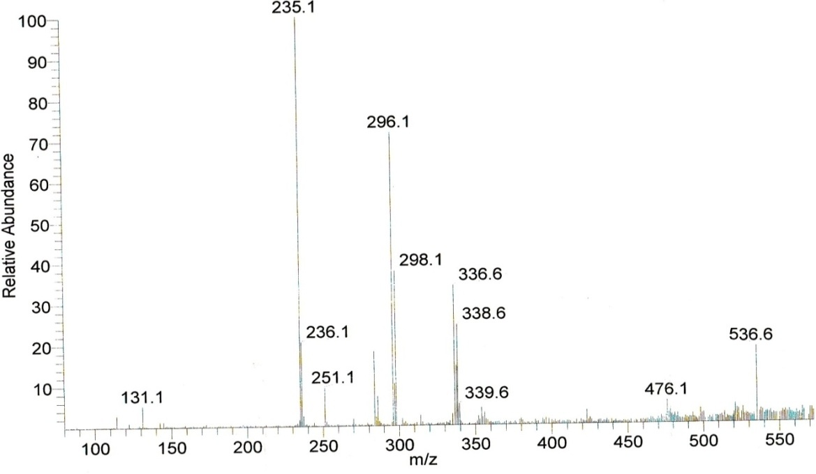
Fig. S1 ESI-MS Mass spectrum of complex (1)

Proton nuclear magnetic resonance spectra
The ¹H NMR spectra of the Schiff base ligand (LH) and its complex (5) show the following signals: δ values of ligand (LH): aromatic protons (m, 4H) at 6.84–7.32 ppm; azomethine proton (-HC=N-) (s, 1H) at 8.35 ppm; morpholinic-OCH₂ protons (t, 4H) at 3.72 ppm; morpholinic-N-CH₂ (t, 4H) at 2.44 ppm; -CH₂-CH₂ protons (p, 2H) at 2.22 ppm; phenolic-OH proton (s, 1H) at 13.52 ppm. Complex (5): aromatic protons (m, 12H) at 6.88 – 7.88 ppm; azomethine proton (-HC=N-) (s, 1H) at 8.50 ppm; phen-CH=N proton (s, 2H) at 9.27 ppm; morpholinic-O-CH₂ protons (t, 4H) at 3.73 ppm; morpholinic-N-CH₂ protons (t, 4H) at 2.94 ppm; acetate protons (s, 3H) at 2.04 ppm. The observed ¹H NMR spectra data of the complex (5) assigned that the azomethine proton (-HC=N-) and morpholinic-N-CH₂ proton signals are shifted to down field (deshielding) as compared to free ligand signals because of azomethine and morpholinic nitrogen atoms are taking part in complexation (Singh, Pandey, & Sengupta, 2012). The absence of singlet peak at 13.52 ppm in the complex (5) indicates the deprotonation of –OH proton due to complexation and there is no appreciable change in other signals in the complex (5) (Fig. S2).
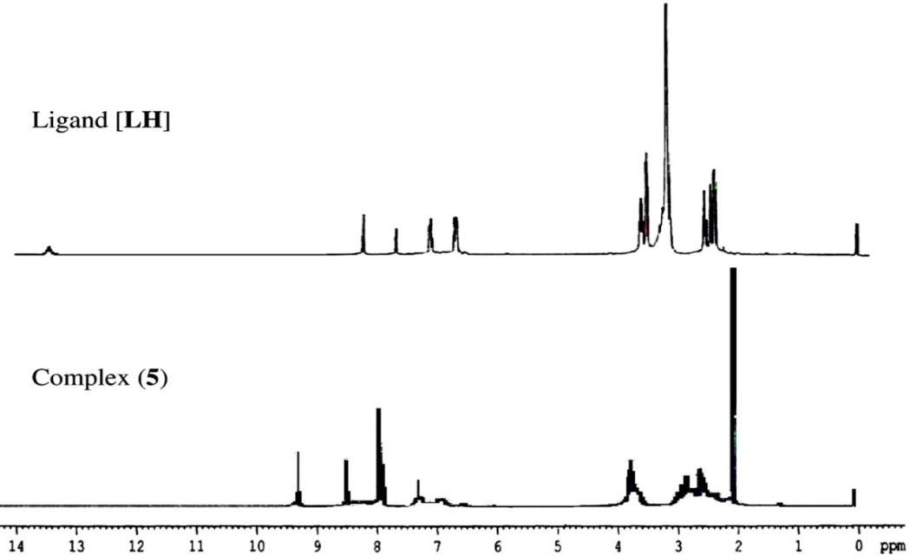
Fig. S2 ¹H-NMR-Spectra of ligand (LH) and its complex (5)

Fourier Transform infrared spectra
In the FT-IR Spectrum of ligand (LH) a strong sharp band was observed at 1635 cm⁻¹ which is assigned to the azomethine group (-HC=N-) and shifted to lower frequencies in the spectra of the complexes (1-5) indicating the involvement of imino nitrogen in coordination to the central metal ion (Aazam, EL Husseiny, & Al-Amri, 2012) and morpholinic-C-N-C band found at 1342 cm⁻¹ in the ligand (LH) which is shifted to lower frequency in the spectra of the complexes (1-5) indicating the involvement of morpholinic nitrogen in complexation. The observed peak at 3676 cm⁻¹ in the ligand (HL) is responsible for -OH group and it is disappeared in spectra of the complexes (1-5) which indicates the deprotonation of -OH group due to complexation and the peak at 1278 cm⁻¹ for the phenolic C-O group in the ligand (LH) is shifted to higher frequencies in the spectra of the complexes (1-5) confirming deprotonation of the phenolic–OH on chelation. In the spectra of complexes (1-5) a broad diffuse band was identified in the range of 3426–3446 cm⁻¹, followed by another weak band in-plane bending (rocking) at 844–854 cm⁻¹ that suggests the presence of water molecules in the complexes (1-5). In the complexes (1-5) two bands appeared in the region 1641–1654 cm⁻¹ (γ_{asymmetry}) and 1402–1430 cm⁻¹ (γ_{symmetry}) which attribute the carboxylate part in the acetate group and also suggest that they are responsible for the consisting of unidentate co-ordination site with the metal ion due to the value of differences (Δγ_{a-s}) between asymmetry and symmetry was greater than 200 cm⁻¹ (Gupta, Bansal, & Chandra, 2007). The far IR spectra of the complexes (1-5) show medium bands in the region 459–470 cm⁻¹ and 497–518 cm⁻¹ corresponding to M-N and M-O vibrations respectively (Dede, Karipcin, Arabalı, & Cengiz, 2010). In the FT-IR spectra of complexes (1-5), the peaks corresponding to the ring stretching frequencies γ(C=N), γ(C=C) at 1503, 1422 cm⁻¹ of free phenanthroline were shifted to higher frequencies in the region 1515–1532 cm⁻¹ and 1422–1452 cm⁻¹ respectively which indicate the complexation due to coordination of the heterocyclic nitrogen atoms to the metal ion (Dimitrov & Atanassova, 2003; Singh,1969) and other absorption bands are no significant change in the metal complexes (1-5) (Fig. S3).
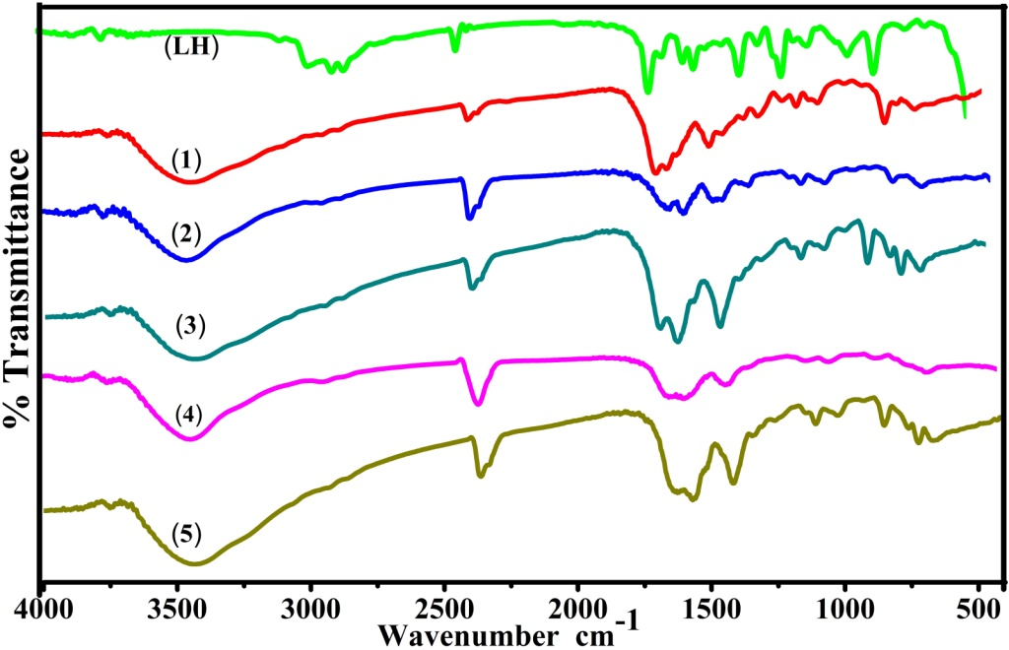
Fig. S3 FT-IR spectra of ligand (LH) and its complexes (1-5)

Electronic absorption spectra and magnetic susceptibility
Two intense absorption bands were observed in the electronic absorption spectrum of the ligand (LH). One less intense ILCT band appeared at 319 nm (31348 cm⁻¹) which assigned to n –π* transition and another one more intense LMCT band at 258 nm (38760 cm⁻¹) which attributes π –π* transition and they are responsible for azomethine (–CH=N–) and phenyl ring chromophore respectively (Shakir, Abbasi, Azam, & Khan, 2011) (Fig. S4). The bands for the complexes (1-2) and (4) are shifted to a longer wavelength which are attributed the donation of lone pair electron from the sp²-hybridized orbital of imino nitrogen in the ligand to the metal ion. Complex (1) exhibited only one low intensity broad band d-d transition at 650 nm (15,384 cm⁻¹) corresponding to ²E_{g}→²T_{2g} transition due to dynamic Jahn–Teller distortion and its observed μ_{eff} value was 1.75 B.M and slightly higher than the spin-only value 1.73 BM, which suggest possibility of distorted octahedral geometry. Complex (2) showed bands at 646 nm (15,479 cm⁻¹) and 496 nm (20,161 cm⁻¹) corresponding to ⁴T_{1g} (F) → ⁴A_{2g} (F) (υ₂) and ⁴T_{1g} (F) → ⁴T_{1g} (P) (υ₃) transitions. However, the lowest energy band corresponding to ⁴T_{1g} (F) → ⁴T_{2g} (F) (υ₁₎ transition was not observed possibly because it is band outside the range of the spectrometer (IR region >1000 nm) and the observed μ_{eff} value of the complex (2) was 4.73 B.M which is higher than the spin-only value due to orbital angular momentum contribution in d⁷ system and close to the value required for an octahedral structure (Raman, Kulandaisami, Shunmugasundaram, & Jeyasubramanian, 2001). Complex (4) showed three bands at 910 nm (10,989 cm⁻¹), 560 nm (17,857 cm⁻¹) and 417 nm (23,980 cm⁻¹) corresponding to ³A_{2g} (F) → ³T_{2g} (F), ³A_{2g} (F) → ³T_{1g} (F) and ³A_{2g} (F) → ³T_{1g} (P) transitions and μ_{eff} value of the complex (4) was observed at 3.18 B.M (Lever, 1968). Complexes (3) and (5) have no absorption in the visible region and crystal field theory does not predict the d-d transitions of the complexes (3) and (5) due to d⁵ and d¹⁰ electronic configurations respectively and the observed magnetic susceptibility value of the complex (5) is zero which indicates the diamagnetic nature (Panchal, Parekh, Pansuriya, & Patel, 2006). Manganese(II) ion has a high spin d⁵ electronic configuration with a ⁶S ground term, which gives no crystal field stabilisation energies for any coordination geometries and they are very weakly coloured due to spin forbidden d-d transition and laporte forbidden. It is very difficult to identify the d-d bands of a manganese(II) complex as these bands are not very well defined and submerged in the tail of the strong intra ligand transitions or charge transfer bands. However, the broad bands of low intensity may be appeared around 25,000 cm⁻¹ (400 nm) corresponding to the ⁶A_{1g} (F) → ⁴T_{2g} (G) transitions (Chandra & Kumar, 2005). On the basis of analytical, the observed spectral and magnetic susceptibility results suggest an octahedral environment around the central metal(II) ion.

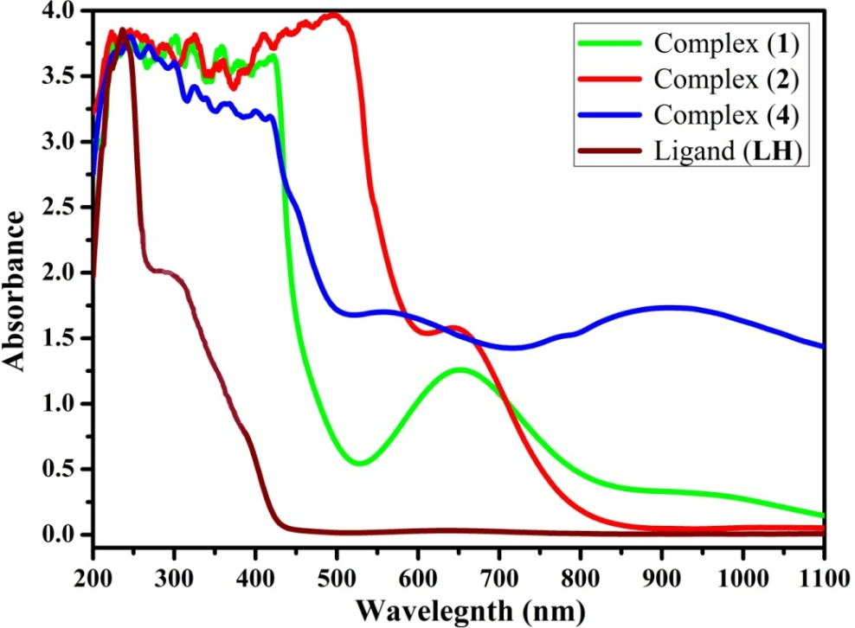
Fig. S4 Electronic spectra of ligand (LH) and its complexes (1-2 & 4)

Electron paramagnetic resonance spectra
Complex (1) exhibited one intense absorption band at 300 K in the high field region was isotropic due to the tumbling motion of the molecules and another one exhibited at 77 K was anisotropic pattern with well-resolved hyperfine lines (Fig. S5). The spin Hamiltonian parameters have been calculated by Kivelson’s method. The observed g_{tensor} values were in the following order g|| (2.1628) > g⊥ (2.0267) > g_{e} (2.00277) indicating that the unpaired electron lies predominantly in the$d_{x^{2}-y^{2}}$ orbital of Cu(II) (Halli, Sumathi, & Kinni, 2012) and the observed g|| values for complex (1) was less than 2.3 in agreement with the covalent environment character of the M-L bond (Kivelson & Neeman,1961). The covalent nature of the M–L bond in the complex (1) was further supported by the g_{eff} value. The observed g_{eff} value was 1.40 which was less than 2.00277 (Syamal, 1985). The observed hyperfine constant parameters of the complex (1) were in the following order A|| (124 G) > A_{av} (98.66 G) > A⊥ (86 G) (1G = 10⁻⁴ cm⁻¹). The values were obtained from the following equations (S1– S6).
${ g}_{⊥ }=\frac{{ (3g}_{av}- g_{||})}{2}$ (S1)
${ K}_{⊥ }=\frac{({ 3A}_{av}- { A}_{|| })}{2}$ (S2)
${ g}_{av }=\frac{{ g}_{|| +} 2 g_{⊥}}{3}$ (S3)
${ g}_{eff }=\frac{({ g}_{||}- { g}_{⊥ })}{3}$ (S4)
${ A}_{av }=$ $\frac{({ A}_{|| }+ 2A_{⊥})}{3}$ (S5)
$G=\frac{{( g}_{|| }- 2.00277)}{( g_{⊥}- 2.00277)}$ (S6)
The observed interaction coupling constant (G) value (6.69) of complex (1) was greater than 4 which suggests that there is no interaction between Cu–Cu centers in the solid state complex and the absence of half field signal at 1600 G corresponding to the ΔMs = ± 2 transition rules out a Cu–Cu interaction (Sharma et al., 2001). The values of molecular orbital coefficient parameters (α², β², γ²) were obtained by Kivelson and Neimann formulae (S7– S9).
$α^{2}=\frac{{ A}_{|| }}{P}+{( g}_{|| }- 2.00277)+\frac{3}{7}{(g}_{⊥}-2.00277)+0.04$ (S7)
${ β^{2}=(g}_{||}- 2.00277)(\frac{E_{d-d}}{-8λ_{0}a^{2}})$ (S8) ${{ γ}^{2}=(g}_{⊥}-2.00277)(\frac{E_{d-d}}{-2λ_{0}a^{2}})$ (S9)
The observed values of in-plane σ-bonding (α² = 0.55), in-plane π-bonding (β² = 0.68) and out-plane π-bonding (γ² = 0.40) were less than 1.0 which point out that the complex (1) has completely covalent character and also orbital reduction factors (K||, K⊥, K) are helpful to measure the covalent character. The observed $K_{||}^{2}$ (0.37) value was larger than $K_{⊥}^{2}$ (0.22) which indicates the presence of out-plane π-bonding in metal-ligand π-bonding and also, K ≥1 denotes ionic environment and K < 1 assigns covalent environment, the observed value of K (0.27) was less than 1.0 which designates the greater covalent character. The values are calculated from the equation (S10 – S14).
$K_{||}^{2}={(g}_{|| }-2.00277)(\frac{E_{d-d}}{-8λ_{0}})$ (S10)
$K_{⊥}^{2}={(g}_{⊥}-2.00277)(\frac{E_{d-d}}{-2λ_{0}})$ (S11)
$K=\frac{{(K}_{||}^{2 } + 2K_{⊥}^{2})}{3}$ (S12)
$µ_{eff}=g_{av} {[S(S+1)]}^{1/2}$ (S13)
$f_{|| }= \frac{g_{|| }}{A_{|| }}$ (S14)
Where, E_{d-d} = 15,503.87 cm⁻¹ which is responsible for d-d transition of complex (1) at 645 nm, the calculated magnetic susceptibility (µ_{eff} = 1.55 B.M) value from the equation (S13) which was less than the observed value (µ_{exp} = 1.75 B.M) from the Guoy’s balance experiment, one-electron spin orbit coupling constant of free Cu(II) ion (λ₀) = - 828 cm⁻¹ and free ion dipolar term (P) = 0.036 cm⁻¹. The observed Co-factor (f||) value of degree of geometrical distortion for complex (1) was 174.42 cm⁻¹ which is calculated from the equation (S14). The obtained spectral and magnetic susceptibility results of the complex (1) have been proposed an octahedral geometry (Nickless, Power, & Urbach, 1983).

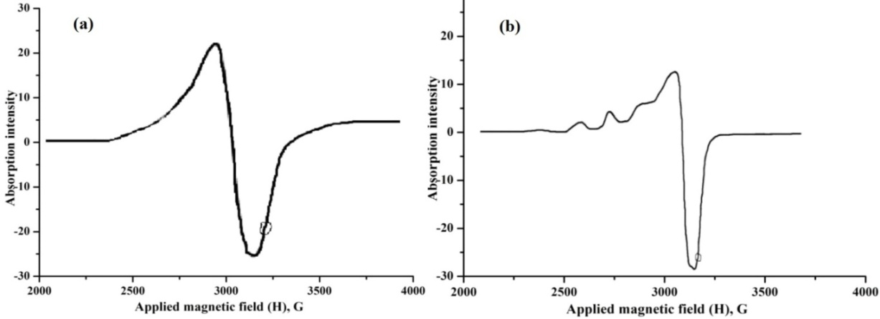Fig. S5 The EPR spectra of complex (1) at (a) room temperature (300 K) and (b) liquid nitrogen temperature (77 K)

Thermal analysis
Thermogravimetric analysis is an effective and useful technique to assess quantitative of weight changes with respect to temperature and to investigate the thermal stability and composition of complexes. It is an essential dynamic tool for exploring the probability of attachment of solvent molecules (H₂O) towards the central atom as a crystal or in a coordinate form / lattice form. Thermogram of the complexes (1-5) has been recorded in the temperature range from 40 °C to 730 °C (Fig. S6). The stages of decomposition, temperature range, decomposition products, the observed mass loss and calculated mass loss percentages of all complexes are summarized in Table S1. The data reveal the following findings: [M^{II}(L)(phen)AcO].nH₂O complexes (1-5) were thermally decomposed in three steps. In the endothermic process, the observed weight loss in the first step of decomposition of [Cu^{II}(L)(phen)AcO].2H₂O complex (1) was 06.32 % (06.29 %) at 120 °C corresponds to the loss of two hydrated lattice water molecules (Kalbende, Tarase, & Zade, 2013). The observed weight loss in the second degradation stage is consistent with the elimination of the acetate at 225 °C and 1,10-phenanthroline moiety at 440 °C was 41.79 % (41.85 %). The obtained weight loss in the third degradation stage is indicated that the elimination of the morpholine substituted ligand at 722 °C was 38.18 % (38.14 %). The obtained final product was 13.85 % (13.91 %) in this complex (1) which may be due to the formation of CuO residue (Farag, Altalbawy, Gehad, El-Ela Sayed, & Mohamed, 2011). Similarly, the observed weight loss in the first step of decomposition of [Co^{II}(L)(phen)AcO].4H₂O complex (2) was 12.00 % (11.94 %) at 105 °C corresponds to the loss of four hydrated water molecules. The observed weight loss in the second degradation step corresponding to the elimination of the acetate at 250 °C and 1,10-phenanthroline moiety at 438 °C was 39.71 % (39.67 %). The obtained weight loss in the third degradation step indicating to the elimination of the morpholine based ligand moiety at 718 °C was 36.12 % (36.15 %). The remaining mass loss of was 12.39 % (12.42 %) due to the formation of ZnO residue. The observed weight loss in the first step of decomposition of the complex (3) [Mn^{II}(L)(phen)AcO].4H₂O was 12.08 % (12.02 %) at 105 °C corresponding to the loss of four lattice water molecules. In the second degradation step, the loss of the acetate at 260 °C and 1,10-phenanthroline moiety at 400 °C was 39.80 % (39.93 %). In the third degradation step, the observed weight loss of the organic part of morpholine based ligand moiety at 728 °C was 36.40 % (36.39 %). The formation of MnO residue weight loss was 11.77 % (11.84 %). In the case of [Ni^{II}(L)(phen)AcO].4H₂O complex (4), the first step at 95 °C by estimated mass loss of 12.00 % (11.94 %) which may be attributed to the loss of four lattice water molecules. The second decomposition step at 248 °C and 400 °C respectively with an estimated mass loss of 39.72 % (39.68 %), accounting for the expulsion of the acetate and 1,10-phenanthroline moieties. The third decomposition step at 715 °C with an estimated mass loss of 36.14 % (36.17 %), accounting for the expulsion of the total organic part of morpholine based ligand moiety. The remaining mass loss is 12.35 % (12.39 %), regarded as NiO residue. [Zn^{II}(L)(phen)AcO].2H₂O complex (5) decomposed in three successive steps. The first step corresponds to the mass loss of two hydrated water molecules with an estimated mass loss of 06.31 % (06.27 %) at 105 °C. The second decomposition step occur with an estimated mass loss of 41.76 % (41.72 %) which may attribute to loss of the acetate at 220 °C and 1,10-phenanthroline moiety at 410 °C. The third decomposition step at 722 °C with an estimated mass loss of 38.07 % (38.02 %), corresponding to the expulsion of the total organic part of morpholine based ligand. The final product obtained was 14.16 % (14.19 %) in this complex which also may be due to the formation of ZnO and the overall thermal degradation steps of complexes (1-5) are possible as in the following flow chart. Based on the above results, the proposed structures of complexes (1-5) have been shown in Scheme 1.

Table S1 Thermal analysis of complexes (1-5) by TGA method
Complexes | M.W | Step | Temperature range (°C) | % Weight loss  [found (calcd)] | Assignment
(1) [Cu^{II}(L)(phen) AcO].2H₂O | 571.54 | I | 40–120 | 06.32 (06.29) | 2H₂O
 |  | II | 120–440 | 41.79 (41.85) | C₂H₃O₂  C₁₂H₈N₂
 |  | III | 440–722 | 38.18 (38.14) | C₁₃H₁₈N₂O
 |  | Residue | >722 | 13.85 (13.91) | CuO
(2) [Co^{II}(L)(phen) AcO].4H₂O | 602.93 | I | 40–105 | 12.00 (11.94) | 4H₂O
 |  | II | 110–410 | 39.71 (39.67) | C₂H₃O₂  C₁₂H₈N₂
 |  | III | 410–718 | 36.12 (36.15) | C₁₃H₁₈N₂O
 |  | Residue | >718 | 12.39 (12.42) | CoO
(3)[Mn^{II}(L)(phen) AcO].4H₂O | 598.94 | I | 40–105 | 12.08 (12.02) | 4H₂O
 |  | II | 110–385 | 39.80 (39.93) | C₂H₃O₂  C₁₂H₈N₂
 |  | III | 385–728 | 36.40 (36.39) | C₁₃H₁₈N₂O
 |  | Residue | >728 | 11.77 (11.84) | MnO
(4) [Ni^{II}(L)(phen) AcO].4H₂O | 602.70 | I | 40–95 | 12.00 (11.94) | 4H₂O
 |  | II | 110–400 | 39.72 (39.68) | C₂H₃O₂  C₁₂H₈N₂
 |  | III | 400–715 | 36.14 (36.17) | C₁₃H₁₈N₂O
 |  | Residue | >715 | 12.35 (12.39) | NiO
(5) [Zn^{II}(L)(phen) AcO].2H₂O | 573.37 | I | 40–105 | 06.31 (06.27) | 2H₂O
 |  | II | 110–400 | 41.76 (41.72) | C₂H₃O₂  C₁₂H₈N₂
 |  | III | 400–722 | 38.07 (38.02) | C₁₃H₁₈N₂O
 |  | Residue | >722 | 14.16 (14.19) | ZnO

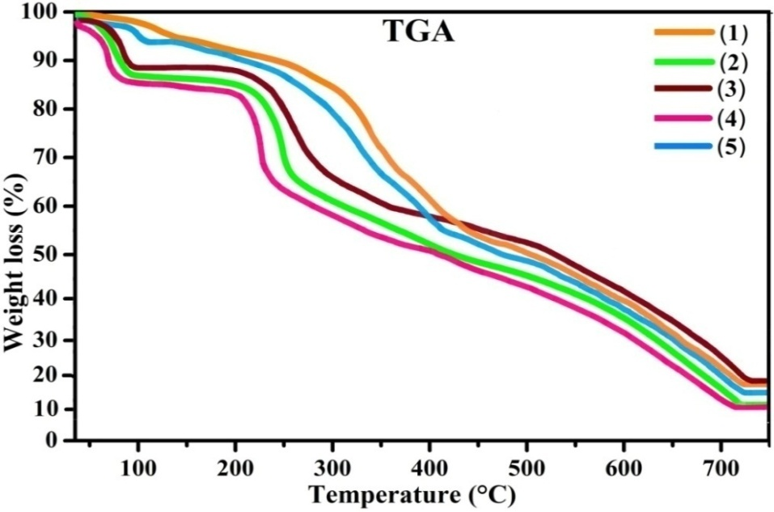
Fig. S6 TG plots of complexes (1-5) recorded under nitrogen atmosphere between the temperature range 40 and 750 °C at a heating rate of 20 °C /min

Cyclic voltammetry
Cyclic voltammetry is an essential tool to investigate the electron transfer reactions of the complexes. Complexes (1-5) (10⁻³ M) were recorded in the potential range -1.7 to 1.0 V in methanol at 298 K containing 0.1M n-Bu₄NClO₄ as supporting electrolyte at scan rate of 100 Mv s⁻¹. The cyclic voltammogram for mononuclear complexes (1-5) revealed that a quasi reversible one step reduction peak (E_{pc}) in the range from -0.73 V to -1.11 V corresponding to M(II) / M(I) and one oxidation peak (E_{pa}) in the range from -0.39 V to -0.66 V corresponding to M(I) / M(II). The values of peak-to-peak separation (ΔE_{P}) for complexes (1-5) were observed in the range of 340 – 530 mV which was greater than the Nernstian value [(E_{Pa}–E_{Pc}) (or) ΔE_{P} = 2.303RT/nF = 59/n mV] for the M(II) / M(I) redox couple revealing that this process is the best quasi-reversible (Fig. S7). If the peak current ratio is greater or less than unity (i_{pa} / i_{pc} > or < 1) which depicts quasi-reversible one electron transfer process (Shyamala & Chakravarty,1993). The observed current ratio of cathodic to anodic peak height was in the range from 0.11 µA to 0.50 µA and less than unity. The observed values of formal electrode potential (E° or E_{1/2}) were in the range from -0.56 to -0.88 V which indicate that each couple corresponds to one electron transfer process. The observed results are summarized in Table S2.

Table S2 Electrochemical data of complexes (1-5) in methanol medium
Complexes | Couple | E_{pa}  (V) | E_{pc}  (V) | ΔE_{P} (mV) | E°  (V) | i_{pa} /i_{pc} µA
(1) | Cu(II) / Cu(I) | -0.43 | -0.79 | 360 | -0.61 | 0.11
(2) | Co(II) / Co(I) | -0.39 | -0.73 | 340 | -0.56 | 0.41
(3) | Mn(II) / Mn(I) | -0.42 | -0.86 | 440 | -0.64 | 0.50
(4) | Ni(II) / Ni(I) | -0.66 | -1.11 | 450 | -0.88 | 0.16
(5) | Zn(II) / Zn(I) | -0.55 | -1.08 | 530 | -0.81 | 0.11
Formal electrode potential E° (or) E_{1/2} = ½ (E_{Pa} + E_{Pc}), ΔE_{P} = (E_{Pa}–E_{Pc}) Scan rate 100 mV s⁻¹.

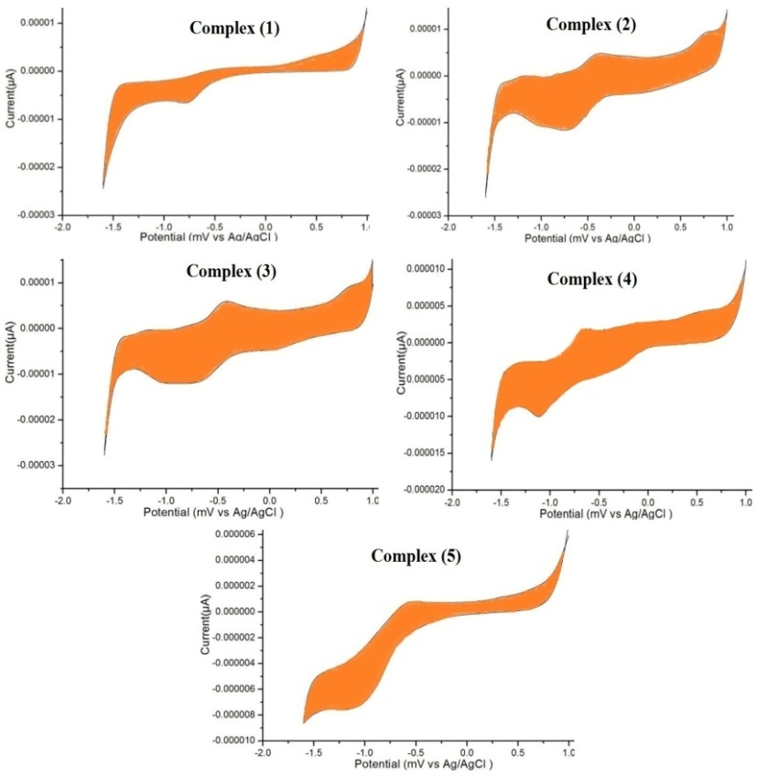
Fig. S7 Cyclic voltammograms of the complexes (1-5)
(10⁻³M) at scan rate 100 mvs⁻¹

References

Aazam, E. S., EL Husseiny, A. F., & Al-Amri, H. M. (2012). Synthesis and
photoluminescent properties of a Schiff-base ligand and its mononuclear Zn(II), Cd(II), Cu(II), Ni(II) and Pd(II) metal complexes. Arabian Journal of Chemistry, 5(1), 45–53. doi:10.1016/j.arabjc.2010.07.022
Chandra, S., & Kumar, U. (2005). Spectral and magnetic studies on manganese(II),
cobalt(II) and nickel(II) complexes with Schiff bases. Spectrochimica Acta Part A: Molecular and Biomolecular Spectroscopy, 61(1–2), 219–224. doi:10.1016/j.saa.2004.03.036
Dede, B., Karipcin, F., Arabalı, F., & Cengiz, M. (2010). Synthesis, structure and
solvent-extraction properties of tridentate oxime ligands and their cobalt(II), nickel(II), copper(II), zinc(II) complexes. Chemical Papers, 64(1), 25–33. doi: 10.2478/s11696-009-0095-6
Dimitrov, G. D., & Atanassova, M. S. (2003). Synthesis and spectroscopic
characterization of a complex of 1, 10-Phenanthroline with magnesium. Zeitschrift Für Anorganische Und Allgemeine Chemie, 629(1), 12–14. doi:10.1002/zaac.200390005
Farag, M. A., Altalbawy., Gehad, G., El-Ela Sayed, M. A., & Mohamed, M. I. A. (2011).
Synthesis, characterization and biological activity of some transition metal complexes with Schiff base ligands derived from 4-amino-5-phenyl-4H-1,2,4-triazole-3-thiol and salicaldehyde. Monatshefte für Chemie – Chemical Monthly, 143(1), 79–89. doi:10.1007/s00706-011-0626-z
Gupta, L. K., Bansal, U., & Chandra, S, (2007). Spectroscopic and physicochemical
studies on nickel(II) complexes of isatin-3,2′-quinolyl-hydrazones and their adducts. Spectrochimica Acta Part A: Molecular and Biomolecular Spectroscopy, 66(4–5), 972–975. doi:10.1016/j.saa.2006.04.035
Halli, M. B., Sumathi, R. B., & Kinni, M. (2012). Synthesis, Spectroscopic
characterization and biological evaluation studies of Schiff’s base derived from naphthofuran-2-carbohydrazide with 8-formyl-7-hydroxy-4-methyl coumarin and its metal complexes. Spectrochimica Acta Part A: Molecular and Biomolecular Spectroscopy, 99, 46–56. doi:10.1016/j.saa.2012.08.089
Kalbende, P. P., Tarase, M. V., & Zade, A. B. (2013). Preparation, characterization and
thermal degradation studies of p-nitrophenol-based copolymer. Journal of Chemistry, 2013, 1–9. Article ID 846327. doi:10.1155/2013/846327
Kivelson, D., & Neeman, R. (1961). ESR Studies on the bonding in copper complexes.
The Journal of Chemical Physics, 35(1), 149–155. doi:10.1063/1.1731880
Lever, A. B. P. (1968). Electronic spectra of some transition metal complexes: Derivation
of Dq and B. Journal of Chemical Education, 45(11), 711–712. doi:10.1021/ed045p711
Nickless, D. E., Power, M. J., & Urbach, F. L. (1983). Copper(II) complexes with
tetradentate bis(pyridyl)-dithioether and bis(pyridyl)-diamine ligands. Effect of thio ether donors on the electronic absorption spectra, redox behaviour and EPR parameters of copper(II) complexes. Inorganic Chemistry, 22(22), 3210–3217. doi:10.1021/ic00164a009
Panchal, P. K., Parekh, H. M., Pansuriya, P.B., & Patel, M. N. (2006). Bactericidal
activity of different oxovanadium(IV) complexes with Schiff bases and application of chelation theory. Journal of Enzyme Inhibition and Medicinal Chemistry, 21(2), 203–209. doi:10.1080/14756360500535229
Raman, N., Kulandaisami, A., Shunmugasundaram, A., & Jeyasubramanian, K.
(2001). Synthesis, spectral, redox and antimicrobial activities of Schiff base complexes derived from 1-phenyl-2,3-dimethyl-4-aminopyrazol-5-one and acetoacetanilide. Transition Metal Chemistry, 26(1/2), 131–135. doi:10.1023/A:1007100815918
Shakir, M., Abbasi, A., Azam, M., & Khan, A. U. (2011). Synthesis, spectroscopic
studies and crystal structure of the Schiff base ligand L derived from condensation of 2- thiophenecarboxaldehyde and 3,3′-diaminobenzidine and its complexes with Co(II), Ni(II), Cu(II), Cd(II) and Hg(II): Comparative DNA binding studies of L and its Co(II), Ni(II) and Cu(II) complexes. Spectrochimica Acta Part A: Molecular and Biomolecular Spectroscopy, 79(5), 1866–1875, doi:10.1016/j.saa.2011.05.077
Sharma, A. L., Singh, I. O., Singh, H. R., Kadam, R. M., Bhide, M. K., & Sastry, M. D.
(2001). EPR studies on dichloromono(1-phenylamidino-o-alkylurea)copper(II) complexes. Evidence for field induced partial ordering in the solid state and some unusual features in solution. Transition Metal Chemistry, 26(4/5), 532–537. doi:10.1023/A:1011063631998
Singh, A. K., Pandey, O. P., & Sengupta, S. K. (2012). Synthesis, spectral
characterization and biological activity of zinc(II) complexes with 3-substituted phenyl-4-amino-5-hydrazino-1, 2,4-triazole Schiff bases. Spectrochimica Acta Part A: Molecular and Biomolecular Spectroscopy, 85, 1–6. doi:10.1016/j.saa.2011.08.019
Singh, S. S. (1969). Infrared Spectra of 1:10 Phenanthroline and its addition compounds
with antimony trichloride and antimony pentachloride. zeitschrift für naturforschung A, 24(12). 2015–2016. doi:10.1515/zna-1969-1227
Shyamala, A., & Chakravarty, A. R. (1993). Synthesis, structure and electrochemical
properties of complexes with a (μ-oxo)bis-(μ-carboxylato)diruthenium(III) core. Polyhedron, 12 (12), 1545–1552. doi:10.1016/S0277-5387(00)84597-0
Syamal, A. (1985). Some improper terms in coordination chemistry. Journal of Chemical
Education, 62(2), 143. doi:10.1021/ed062p143

S.No | Supplementary Data –Table Captions
1 | Table S3 Relative specific viscosity vs [Complex] / [DNA]
2 | Table S4a IC₅₀ value for DPPH radical scavenging assay
3 | Table S4b IC₅₀ value for hydroxyl radical scavenging assay
4 | Table S4c IC₅₀ value for super oxide scavenging assay
5 | Table S4d IC₅₀ value for nitric oxide scavenging assay
6 | Table S4e IC₅₀ value for ferric reducing antioxidant power assay (FRAP)
7 | Table S5 Frontier molecular orbital energy gap and dipole moment values of ligand (LH) and its complexes (1-5)

Table S3 Relative specific viscosity Vs [Complex] / [DNA]
Compounds | Binding ratio (R) = [Complex] / [DNA]
 | 0.2 | 0.4 | 0.6 | 0.8 | 1.0 | Relative specific  viscosity (η/η₀)^{1/3}
EB (Control) | 0.68 | 1.35 | 1.63 | 1.82 | 1.99
Complex (1) | 0.69 | 1.12 | 1.50 | 1.67 | 1.64
Complex (2) | 0.68 | 1.08 | 1.20 | 1.35 | 1.53
Complex (3) | 0.67 | 0.85 | 0.97 | 1.10 | 1.45
Complex (4) | 0.54 | 0.77 | 0.90 | 1.02 | 1.39
Complex (5) | 0.52 | 0.69 | 0.78 | 0.87 | 1.18
η Specific viscosity of DNA in the presence complex,
η₀ Specific viscosity of DNA alone

Table S4a IC₅₀ values of DPPH radical scavenging assay
[Complex]  × 10⁻⁵ M | % Inhibition (IC₅₀)
 | (1) | (2) | (3) | (4) | (5) | (LH) | Ascorbic acid
4 | 34.5362 | 31.5683 | 28.5672 | 24.5620 | 21.6752 | 18.6421 | 41.6352
8 | 43.8549 | 40.6294 | 33.6293 | 37.6823 | 32.6454 | 26.5456 | 53.7453
12 | 47.6890 | 44.7239 | 38.8634 | 41.6321 | 36.3542 | 32.5432 | 58.9533
16 | 56.8862 | 54.7031 | 44.5127 | 49.6283 | 46.7182 | 43.5912 | 70.8642
20 | 65.7532 | 61.4532 | 51.2243 | 58.4263 | 55.4352 | 50.0131 | 82.7542
24 | 73.6548 | 66.3422 | 55.4521 | 63.5634 | 60.4357 | 55.4352 | 82.7542

Table S4b IC₅₀ values of hydroxyl radical scavenging assay
[Complex]  × 10⁻⁵ M | % Inhibition (IC₅₀)
 | (1) | (2) | (3) | (4) | (5) | (LH) | Ascorbic acid
4 | 17.7062 | 15.8812 | 11.0428 | 17.7512 | 14.3217 | 12.9532 | 30.7324
8 | 33.6582 | 29.3532 | 20.5721 | 25.8453 | 23.1031 | 20.8532 | 46.4536
12 | 37.7085 | 31.9042 | 30.6923 | 35.5201 | 28.4291 | 28.4835 | 51.8723
16 | 45.5829 | 41.7823 | 37.7613 | 40.4283 | 37.6537 | 36.3512 | 59.6582
20 | 55.8061 | 51.6031 | 44.6723 | 47.4272 | 44.4301 | 43.6215 | 65.6432
24 | 68.6341 | 60.4182 | 51.1243 | 58.5022 | 53.7652 | 50.6732 | 78.8351

Table S4c IC₅₀ values of super oxide scavenging assay
[Complex]  × 10⁻⁵ M | % Inhibition (IC₅₀)
 | (1) | (2) | (3) | (4) | (5) | (LH) | Ascorbic acid
4 | 19.8532 | 15.7812 | 13.2453 | 14.5432 | 15.4362 | 12.4562 | 29.6422
8 | 25.6524 | 19.7437 | 18.6423 | 19.6531 | 18.7432 | 18.7483 | 41.7293
12 | 43.5432 | 35.9743 | 27.6313 | 33.7223 | 31.3436 | 26.5752 | 55.6349
16 | 51.7623 | 43.5732 | 37.8543 | 41.8268 | 39.3842 | 34.7753 | 66.7532
20 | 60.6543 | 50.782 | 46.7543 | 47.7112 | 46.9026 | 41.2143 | 72.5543
24 | 68.8873 | 56.7954 | 51.6542 | 56.7131 | 52.8856 | 50.2371 | 84.8532

Table S4d IC₅₀ values of nitric oxide scavenging assay
[Complex]  × 10⁻⁵ M | % Inhibition (IC₅₀)
 | (1) | (2) | (3) | (4) | (5) | (LH) | Ascorbic acid
4 | 17.5437 | 11.7823 | 12.6557 | 15.3563 | 12.6342 | 10.7236 | 28.5523
8 | 25.6732 | 21.9354 | 16.6386 | 19.7743 | 16.2456 | 15.5673 | 35.7543
12 | 33.5123 | 27.6528 | 21.3902 | 25.8148 | 21.8732 | 18.5531 | 43.6573
16 | 42.6723 | 37.4214 | 26.3293 | 33.8251 | 37.8842 | 29.7303 | 52.6853
20 | 53.7283 | 48.6643 | 41.3652 | 47.8843 | 42.7622 | 40.9532 | 63.7217
24 | 62.6632 | 57.8521 | 50.9871 | 56.5321 | 52.3526 | 50.0953 | 72.7342

Table S4e IC₅₀ values of ferric reducing antioxidant power assay (FRAP)
[Complex]  × 10⁻⁵ M | % Inhibition (IC₅₀)
 | (1) | (2) | (3) | (4) | (5) | (LH) | Ascorbic acid
4 | 17.7241 | 15.6453 | 11.7432 | 14.3563 | 12.7583 | 13.8352 | 28.6843
8 | 23.2341 | 22.6271 | 14.2381 | 20.7743 | 16.6543 | 18.6342 | 37.6453
12 | 30.6327 | 28.5332 | 20.7435 | 25.8148 | 24.7762 | 24.6329 | 51.6453
16 | 40.5428 | 35.7632 | 30.5632 | 38.8251 | 37.7322 | 33.3520 | 68.7563
20 | 54.7283 | 51.3462 | 41.5621 | 50.9013 | 48.8435 | 50.8821 | 79.4561
24 | 63.7242 | 58.7623 | 56.3583 | 56.5321 | 57.6634 | 55.2944 | 88.6743

Table S5 Frontier molecular orbital energy gap and dipole moment values of ligand (LH) and its complexes (1-5)
Compounds | HOMO (eV) | LUMO  (eV) | HOMO-LUMO gap  (eV) | Dipole moment (Debye)
(LH) | -5.71 | -0.91 | 4.80 | 2.00
(1) | -4.40 | -1.71 | 2.69 | 1.10
(2) | -3.73 | -1.69 | 2.03 | 1.03
(3) | -3.19 | -1.70 | 1.50 | 1.22
(4) | -4.87 | -1.74 | 3.13 | 0.97
(5) | -4.36 | -1.53 | 2.83 | 1.38

