Precipitation is the main factor affecting the variation of foliar nitrogen isotope composition in two leguminous shrub species of northwestern China

Fei Ma^{1,2,*}, Ting-Ting Xu³, Ming Li^{1,2,}, Ji-Li Liu^{1,2,}, Zhao-Jun Sun^{1,2,}

¹Institute of Environmental Engineering, Ningxia University, Yinchuan 750021, PR China
²Ningxia (China-Arab) Key Laboratory of Resource Assessment and Environmental Regulation in the Arid Region, Ningxia University, Yinchuan 750021, PR China
³School of Life Science, Ningxia University, Yinchuan 750021, PR China

* Author for correspondence (mafei05@163.com)

Table S1. Coordinates and climatic factors of each sampling location
Species | Code | SY | Lat  (º) | Long  (º) | Alt (m) | MAP  (mm) | MAT  (°C) | DTR  (°C) | RH  (%) | SH  (%) | WR  (km/h) | MAI | PM  (mm/d) | MTCM  (°C) | MTWM(°C) | N  (mg / g) | C  (mg / g) | C:N | δ¹⁵N ± SD  (‰)
C. korshinskii | CK1 | 2015 | 40.95 | 110.03 | 1440 | 270.1 | 4.7 | 12.8 | 53.9 | 69.1 | 2.7 | 0.1 | 2.8 | -13.1 | 20.5 | 37.34 | 448.62 | 12.0 | 1.57 ± 0.25
C. korshinskii | CK2 | 2015 | 39.77 | 112.20 | 1325 | 434.4 | 4.4 | 12.3 | 54.8 | 64.8 | 2.5 | 0.2 | 2.6 | -12.4 | 19.0 | 35.87 | 426.15 | 11.9 | 0.89 ± 0.17
C. korshinskii | CK3 | 2015 | 38.02 | 107.38 | 1323 | 234.3 | 8.3 | 13.5 | 56.7 | 62.8 | 2.0 | 0.1 | 2.9 | -7.9 | 22.6 | 33.48 | 439.02 | 13.1 | 1.68 ± 0.18
C. korshinskii | CK4 | 2015 | 37.82 | 107.45 | 1431 | 258.6 | 8.2 | 13.3 | 56.9 | 62.0 | 2.0 | 0.1 | 2.8 | -7.7 | 22.4 | 34.76 | 433.87 | 12.5 | 1.22 ± 0.07
C. korshinskii | CK5 | 2015 | 36.86 | 105.98 | 1568 | 278.1 | 8.2 | 11.9 | 58.4 | 57.9 | 1.6 | 0.1 | 2.6 | -6.3 | 21.1 | 42.01 | 457.36 | 10.9 | 0.69 ± 0.22
C. korshinskii | CK6 | 2015 | 38.88 | 111.87 | 1520 | 555.1 | 1.7 | 11.0 | 54.6 | 63.2 | 2.8 | 0.3 | 2.4 | -13.9 | 15.6 | 33.64 | 438.04 | 13.0 | 0.46 ± 0.16
C. korshinskii | CK7 | 2015 | 39.87 | 111.48 | 1211 | 407.1 | 5.8 | 12.6 | 54.9 | 65.3 | 2.4 | 0.2 | 2.7 | -11.6 | 20.7 | 37.83 | 436.39 | 11.6 | 0.95 ± 0.35
C. korshinskii | CK8 | 2015 | 39.83 | 108.68 | 1412 | 249.9 | 6.3 | 13.0 | 54.3 | 67.7 | 2.5 | 0.1 | 2.9 | -10.9 | 21.5 | 30.40 | 435.59 | 14.3 | 2.21 ± 0.59
C. korshinskii | CK9 | 2015 | 39.12 | 108.03 | 1400 | 223.2 | 6.9 | 13.6 | 54.7 | 66.6 | 2.3 | 0.1 | 2.9 | -10.1 | 22.0 | 30.94 | 437.66 | 14.4 | 1.82 ± 0.28
C. korshinskii | CK10 | 2015 | 38.01 | 107.22 | 1224 | 234.3 | 8.3 | 13.5 | 56.7 | 62.8 | 2.0 | 0.1 | 2.9 | -7.9 | 22.6 | 26.98 | 402.29 | 15.0 | 1.15 ± 0.04
C. korshinskii | CK11 | 2015 | 37.20 | 108.02 | 1456 | 341.7 | 7.3 | 12.6 | 57.5 | 60.8 | 2.1 | 0.2 | 2.7 | -8.1 | 21.1 | 36.30 | 441.37 | 12.2 | 1.52 ± 0.16
C. korshinskii | CK12 | 2015 | 40.13 | 106.88 | 1180 | 103.5 | 8.4 | 13.9 | 54.0 | 68.6 | 2.4 | 0.0 | 3.1 | -9.7 | 24.3 | 25.78 | 422.17 | 17.0 | 1.96 ± 0.37
C. korshinskii | CK13 | 2015 | 40.67 | 106.30 | 1039 | 87.2 | 7.8 | 13.6 | 53.4 | 69.5 | 2.6 | 0.0 | 3.2 | -10.4 | 24.0 | 30.74 | 429.54 | 14.2 | 2.78 ± 0.21
C. korshinskii | CK14 | 2015 | 40.95 | 112.22 | 1276 | 351.6 | 4.1 | 12.7 | 54.8 | 67.5 | 2.6 | 0.2 | 2.7 | -13.4 | 19.5 | 34.61 | 432.90 | 12.5 | 0.29 ± 0.16
C. korshinskii | CK15 | 2015 | 39.50 | 110.22 | 1353 | 385.3 | 8.0 | 13.2 | 56.6 | 63.5 | 2.2 | 0.2 | 2.9 | -9.3 | 22.8 | 40.22 | 445.98 | 11.1 | 1.00 ± 0.58
C. liouana. | CL1 | 2015 | 37.82 | 107.45 | 1431 | 258.6 | 8.2 | 13.3 | 56.9 | 62.0 | 2.0 | 0.1 | 2.8 | -7.7 | 22.4 | 37.39 | 437.82 | 11.7 | 0.95 ± 0.20
C. liouana. | CL2 | 2015 | 38.18 | 107.68 | 1342 | 249.5 | 7.9 | 13.5 | 56.5 | 63.5 | 2.1 | 0.1 | 2.8 | -8.3 | 22.3 | 35.54 | 441.59 | 12.4 | 0.67 ± 0.26
C. liouana. | CL3 | 2015 | 38.60 | 108.75 | 1330 | 292.2 | 7.3 | 13.3 | 55.8 | 65.0 | 2.3 | 0.1 | 2.9 | -9.4 | 22.0 | 37.91 | 444.80 | 11.7 | 1.06 ± 0.55
C. liouana. | CL4 | 2015 | 39.42 | 110.47 | 1169 | 395.0 | 6.9 | 12.6 | 55.2 | 65.2 | 2.3 | 0.2 | 2.8 | -10.4 | 21.7 | 38.53 | 449.41 | 11.7 | 0.28 ± 0.19
C. liouana. | CL5 | 2015 | 39.22 | 110.15 | 1257 | 379.9 | 7.2 | 12.6 | 55.4 | 65.2 | 2.3 | 0.2 | 2.9 | -10.0 | 22.1 | 40.90 | 447.18 | 11.0 | 0.16 ± 0.09
C. liouana. | CL6 | 2015 | 37.20 | 108.02 | 1456 | 341.7 | 7.3 | 12.6 | 57.5 | 60.8 | 2.1 | 0.2 | 2.7 | -8.1 | 21.1 | 35.83 | 445.30 | 12.4 | 1.81 ± 0.36
C. liouana. | CL7 | 2015 | 37.52 | 108.60 | 1531 | 387.8 | 6.7 | 12.4 | 57.6 | 60.7 | 2.2 | 0.2 | 2.7 | -8.7 | 20.4 | 42.11 | 441.86 | 10.5 | -0.37 ± 0.11
C. liouana. | CL8 | 2015 | 37.83 | 109.26 | 1057 | 370.1 | 8.1 | 13.2 | 57.3 | 61.9 | 2.2 | 0.2 | 2.8 | -8.2 | 22.3 | 44.73 | 438.30 | 9.8 | 0.91 ± 0.22
C. liouana. | CL9 | 2015 | 38.77 | 110.23 | 1220 | 385.8 | 7.4 | 12.9 | 55.8 | 64.4 | 2.3 | 0.2 | 2.9 | -9.9 | 22.2 | 37.84 | 438.15 | 11.6 | 0.83 ± 0.21
C. liouana. | CL10 | 2015 | 38.85 | 107.67 | 1344 | 225.2 | 7.4 | 13.6 | 55.5 | 65.2 | 2.2 | 0.1 | 2.9 | -9.2 | 22.2 | 39.27 | 450.45 | 11.5 | 2.86 ± 0.12
C. liouana. | CL11 | 2015 | 39.22 | 110.15 | 1324 | 379.9 | 7.2 | 12.6 | 55.4 | 65.2 | 2.3 | 0.2 | 2.9 | -10.0 | 22.1 | 41.27 | 451.40 | 10.9 | 0.42 ± 0.36
C. liouana. | CL12 | 2015 | 38.88 | 108.35 | 1369 | 262.9 | 7.0 | 13.4 | 55.4 | 65.6 | 2.3 | 0.1 | 2.9 | -9.7 | 21.9 | 37.85 | 454.70 | 12.0 | 1.80 ± 0.44
C. liouana. | CL13 | 2015 | 39.20 | 110.28 | 1285 | 382.5 | 7.3 | 12.6 | 55.3 | 65.4 | 2.3 | 0.2 | 2.9 | -10.0 | 22.3 | 44.26 | 449.79 | 10.2 | 0.29 ± 0.21
C. liouana. | CL14 | 2015 | 39.35 | 111.18 | 893 | 393.7 | 7.9 | 13.2 | 55.7 | 63.9 | 2.2 | 0.2 | 2.9 | -9.8 | 23.0 | 37.12 | 452.31 | 12.2 | 0.29 ± 0.59
C. liouana. | CL15 | 2015 | 37.56 | 107.39 | 1352 | 293.1 | 7.5 | 12.7 | 57.6 | 60.9 | 2.0 | 0.1 | 2.7 | -7.8 | 21.3 | 41.36 | 449.08 | 10.9 | 1.69 ± 0.21
SY, sampling year; Lat, latitude; Long, longitude; Alt, altitude; MAP, mean annual precipitation; MAT, mean annual temperature (MAT); DTR, daily temperature range; RH, relative humidity; SH, sunshine hours; WR, wind run; MAI, moisture availability index; PM, Penman-Montieth; MTWM, mean temperature of warmest month; MTCM, mean temperature of coldest month. Leaf properties: δ¹⁵N, nitrogen isotope composition; N, foliar nitrogen concentration; C, foliar carbon concentration; C:N, the ratio of leaf carbon to nitrogen. SD, standard deviation.

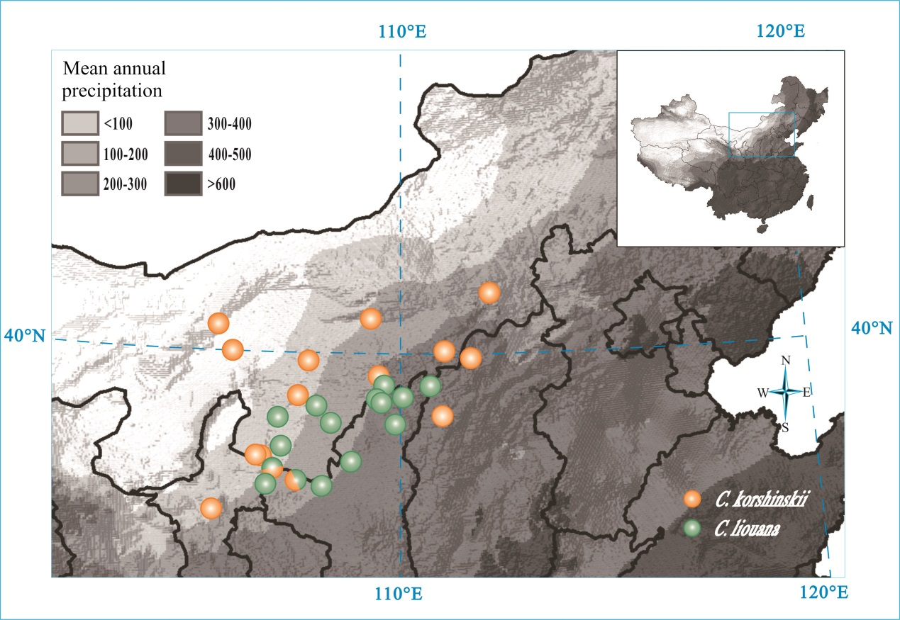
Figure S1. Locations of the sampling sites of two Caragana species in arid and semi-arid regions of northwestern China

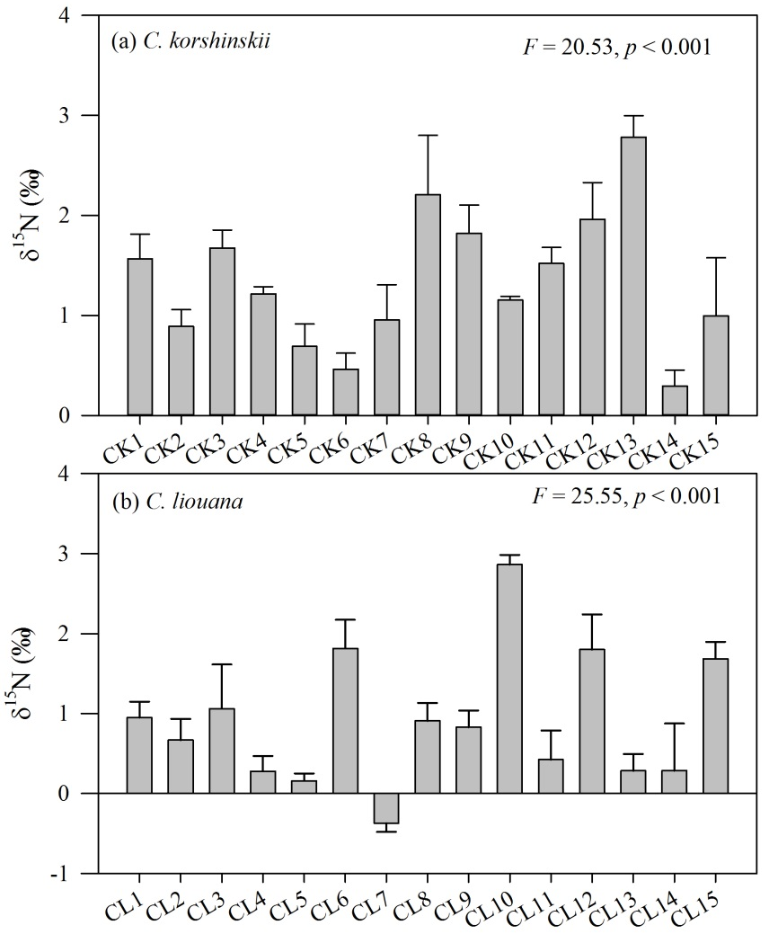
Figure S2. Variation in foliar nitrogen isotope composition (δ¹⁵N) across populations for each Caragana species (a, C. korshinskii, CK1-CK15; b, C. liouana, CL1-CL15)
Figure S3. Box plots showing the difference in foliar nitrogen isotope composition (δ¹⁵N) between the two species.

