Designing potential HDAC3 inhibitors to improve memory and learning
Sk. Abdul Amin,ª Nilanjan Adhikari,ª Tarun Jha,^{a,*} Balaram Ghosh,^{b,*}
ªNatural Science Laboratory, Division of Medicinal and Pharmaceutical Chemistry, Department of Pharmaceutical Technology, P. O. Box 17020, Jadavpur University, Kolkata 700032, West Bengal, India
^{b}Department of Pharmacy, BITS-Pilani, Hyderabad Campus, Shamirpet, Hyderabad, India, 500078
*corresponding author: balaram@hyderabad.bits-pilani.ac.in; tjupharm@yahoo.com

Supplementary Table T1. List of compounds in smile format and their HDAC3 inhibitory activities.
Cpdª | Smile | pIC₅₀ | Activity scale^{b} | Set
1 | c1cncc(c1)C(=O)Nc1c(cccc1)N | 5.444 | 0 | Training set
2 | c1cncc(c1)C(=O)Nc1c(ccc(c1)c1ccccc1)N | 4.959 | 0 | Training set
3 | c1cncc(c1)C(=O)Nc1c(ccc(c1)c1cccs1)N | 5.137 | 0 | Training set
4 | c1cccc(c1)C(=O)Nc1c(cccc1)N | 5.553 | 0 | Test set
5 | c1cccc(c1)C(=O)Nc1c(ccc(c1)c1ccccc1)N | 4.959 | 0 | Test set
6 | c1cccc(c1)C(=O)Nc1c(ccc(c1)c1cccs1)N | 4.959 | 0 | Training set
7 | c1c(ncc(c1)C(=O)Nc1c(cccc1)N)N1CCC2(CC1)C[NH2+]CC2 | 6.469 | 0 | Training set
8 | c1c(ncc(c1)C(=O)Nc1c(ccc(c1)c1cccs1)N)N1CCC2(CC1)C[NH2+]CC2 | 5.9 | 0 | Training set
9 | c1c(ncc(c1)C(=O)Nc1c(ccc(c1)c1cscc1)N)N1CCC2(CC1)C[NH2+]CC2 | 5.896 | 0 | Test set
10 | c1c(ncc(c1)C(=O)Nc1c(ccc(c1)c1cnn(c1)C)N)N1CCC2(CC1)C[NH2+]CC2 | 5.272 | 0 | Test set
11 | c1c(ncc(c1)C(=O)Nc1c(ccc(c1)c1n[nH]cc1)N)N1CCC2(CC1)C[NH2+]CC2 | 5.26 | 0 | Training set
12 | c1cncc(c1)COC(=O)NCc1ccc(cc1)C(=O)Nc1ccccc1N | 5.636 | 0 | Training set
13 | C(C(=O)Nc1c(cccc1)N)CCCCCC(=O)Nc1ccc(cc1)c1nnn(c1)Cc1ccccc1 | 5.824 | 0 | Training set
14 | C(C(=O)Nc1c(cccc1)N)CCCCCC(=O)Nc1cc(ccc1)c1nnn(c1)c1ccccc1 | 6.921 | 1 | Training set
15 | C(C(=O)Nc1c(cccc1)N)CCCCCC(=O)Nc1scc(n1)c1cc(ccc1)N | 7.22 | 1 | Training set
16 | C(C(=O)Nc1c(cccc1)N)CCCCCC(=O)Nc1scc(n1)c1cc(ccc1)NC(=O)OCC | 7.222 | 1 | Training set
17 | C(C(=O)Nc1c(cccc1)N)CCCCCC(=O)Nc1scc(n1)c1cc(ccc1)NC(=O)OC(C)(C)C | 6.796 | 0 | Test set
18 | C(C(=O)Nc1c(cccc1)N)CCCCCC(=O)Nc1scc(n1)c1cc(ccc1)NC(=O)C | 7.523 | 1 | Training set
19 | C(C(=O)Nc1c(cccc1)N)CCCCCC(=O)NOCc1ccccc1 | 6.258 | 0 | Training set
20 | C(C(=O)Nc1c(cccc1)N)CCCCCC(=O)NO | 7.676 | 1 | Test set
21 | C(C(=O)Nc1c(cccc1)N)CCCCCC(=O)Nc1ccccc1N | 6.005 | 0 | Test set
22 | c1(C(=O)Nc2c(cc3c(c2)cccc3)N)ccc(cc1)CNc1nc(ncc1)c1cccnc1 | 6.201 | 0 | Training set
23 | c1(C(=O)Nc2c(cc(cc2)OC)N)ccc(cc1)CNc1nc(ncc1)c1cccnc1 | 6.955 | 1 | Test set
24 | c1(C(=O)Nc2c(cc(cc2)O)N)ccc(cc1)CNc1nc(ncc1)c1cccnc1 | 6.143 | 0 | Training set
25 | c1(C(=O)Nc2c(cccc2)N)ccc(cc1)CNc1nc(ncc1)c1cccnc1 | 7.658 | 1 | Training set
26 | N1=C(N([C@@H](C1=O)Cc1c[nH]c2c1cccc2)C(=O)OC(C)(C)C)NCc1ccc(cc1)C(=O)Nc1c(cccc1)N | 7.398 | 1 | Test set
27 | N1=C(N([C@@H](C1=O)Cc1c[nH]c2c1cccc2)C(=O)C)NCc1ccc(cc1)C(=O)Nc1c(cccc1)N | 7.155 | 1 | Training set
28 | N1=C(N[C@@H](C1=O)Cc1c[nH]c2c1cccc2)NCc1ccc(cc1)C(=O)Nc1c(cccc1)N | 6.983 | 1 | Training set
29 | N1=C(N([C@@H](C1=O)Cc1ccccc1)C(=O)C)NCc1ccc(cc1)C(=O)Nc1c(cccc1)N | 7.081 | 1 | Test set
30 | N1=C(N[C@@H](C1=O)Cc1ccccc1)NCc1ccc(cc1)C(=O)Nc1c(cccc1)N | 7.523 | 1 | Test set
31 | N1=C(N[C@@H](C1=O)c1ccccc1)NCc1ccc(cc1)C(=O)Nc1c(cccc1)N | 7.854 | 1 | Training set
32 | N1=C(SC[C@H]1Cc1c[nH]c2c1cccc2)SCc1ccc(cc1)C(=O)Nc1c(cccc1)N | 6.051 | 0 | Training set
33 | N1=C(SC[C@H]1Cc1ccccc1)SCc1ccc(cc1)C(=O)Nc1c(cccc1)N | 6.293 | 0 | Training set
34 | N1=C(SC[C@H]1c1ccccc1)SCc1ccc(cc1)C(=O)Nc1c(cccc1)N | 7.201 | 1 | Training set
35 | N1=C(SC[C@H]1c1ccccc1)[NH2+]Cc1ccc(cc1)C(=O)Nc1c(cccc1)N | 7.921 | 1 | Training set
36 | N1=C(SC[C@@H]1c1ccccc1)[NH2+]Cc1ccc(cc1)C(=O)Nc1c(cccc1)N | 7.102 | 1 | Training set
37 | N1=C(SC[C@H]1c1ccc(cc1)[O-])[NH2+]Cc1ccc(cc1)C(=O)Nc1c(cccc1)N | 7.796 | 1 | Test set
38 | N1=C(SC[C@H]1Cc1ccccc1)[NH2+]Cc1ccc(cc1)C(=O)Nc1c(cccc1)N | 7.284 | 1 | Training set
39 | N1=C(SC[C@@H]1Cc1ccccc1)[NH2+]Cc1ccc(cc1)C(=O)Nc1c(cccc1)N | 7.444 | 1 | Training set
40 | N1=C(S[C@@H](C1)c1ccccc1)[NH2+]Cc1ccc(cc1)C(=O)Nc1c(cccc1)N | 7.638 | 1 | Training set
41 | N1=C(S[C@H](C1)c1ccccc1)[NH2+]Cc1ccc(cc1)C(=O)Nc1c(cccc1)N | 7.921 | 1 | Training set
42 | N1=C(S[C@H]([C@@H]1c1ccccc1)c1ccccc1)[NH2+]Cc1ccc(cc1)C(=O)Nc1c(cccc1)N | 6.542 | 0 | Training set
43 | N1=C(S[C@@H]([C@H]1c1ccccc1)c1ccccc1)[NH2+]Cc1ccc(cc1)C(=O)Nc1c(cccc1)N | 6.411 | 0 | Training set
44 | c1cncc(c1)c1nc(ncc1)NCc1ccc(cc1)C(=O)Nc1ccccc1N | 7.347 | 1 | Test set
45 | c1cccc(c1)[C@@H]1[NH+]=C(NC1)NCc1ccc(cc1)C(=O)Nc1ccccc1N | 7.824 | 1 | Test set
46 | c1cccc(c1)[C@@H]1N=C([NH2+]C1)SCc1ccc(cc1)C(=O)Nc1ccccc1N | 7.42 | 1 | Training set
47 | c1cccc(c1)[C@@H]1N=C(OC1)SCc1ccc(cc1)C(=O)Nc1ccccc1N | 7.18 | 1 | Training set
48 | c1cncc(c1)[C@@H]1N=C(OC1)SCc1ccc(cc1)C(=O)Nc1ccccc1N | 7.252 | 1 | Training set
49 | c1cccc(c1)C[C@@H]1N=C(OC1)SCc1ccc(cc1)C(=O)Nc1ccccc1N | 7.149 | 1 | Training set
50 | c1cccc(c1)[C@@H]1N=C(OC1)[NH2+]Cc1ccc(cc1)C(=O)Nc1ccccc1N | 7.398 | 1 | Test set
51 | c1cccc(c1)[C@H]1N=C(OC1)[NH2+]Cc1ccc(cc1)C(=O)Nc1ccccc1N | 7.481 | 1 | Test set
52 | c1c(ccc(c1)[C@@H]1N=C(OC1)[NH2+]Cc1ccc(cc1)C(=O)Nc1ccccc1N)F | 7.469 | 1 | Training set
53 | c1(cccc(c1)[C@H]1N=C(OC1)[NH2+]Cc1ccc(cc1)C(=O)Nc1ccccc1N)F | 7.62 | 1 | Test set
54 | c1c(ccc(c1)[C@H]1N=C(OC1)[NH2+]Cc1ccc(cc1)C(=O)Nc1ccccc1N)C(F)(F)F | 7.469 | 1 | Training set
55 | c1c(ccc(c1)[C@@H]1N=C(OC1)[NH2+]Cc1ccc(cc1)C(=O)Nc1ccccc1N)O | 7.745 | 1 | Training set
56 | c1cncc(c1)[C@@H]1N=C(OC1)[NH2+]Cc1ccc(cc1)C(=O)Nc1ccccc1N | 7.509 | 1 | Training set
57 | c1cccc(c1)C[C@@H]1N=C(OC1)[NH2+]Cc1ccc(cc1)C(=O)Nc1ccccc1N | 7.387 | 1 | Training set
58 | C1N=C(O[C@H]1c1ccccc1)[NH2+]Cc1ccc(cc1)C(=O)Nc1ccccc1N | 7.959 | 1 | Training set
59 | C1N=C(O[C@H]1c1ccccc1)[NH2+]Cc1ccc(cc1)C(=O)Nc1ccccc1N | 7.456 | 1 | Training set
60 | C1(N=C(OC1)[NH2+]Cc1ccc(cc1)C(=O)Nc1ccccc1N)(c1ccccc1)c1ccccc1 | 7.26 | 1 | Training set
61 | [C@@H]1(N=C(O[C@@H]1c1ccccc1)[NH2+]Cc1ccc(cc1)C(=O)Nc1ccccc1N)c1ccccc1 | 6.921 | 1 | Training set
62 | [C@H]1(N=C(O[C@H]1c1ccccc1)[NH2+]Cc1ccc(cc1)C(=O)Nc1ccccc1N)c1ccccc1 | 8.222 | 1 | Training set
63 | c1nc(c[nH]1)C[C@H]1N=C(OC1)[NH2+]Cc1ccc(cc1)C(=O)Nc1ccccc1N | 7.678 | 1 | Test set
64 | c1nc(c[nH]1)C[C@@H]1N=C(OC1)[NH2+]Cc1ccc(cc1)C(=O)Nc1ccccc1N | 7.745 | 1 | Training set
65 | c1c(ccc(c1)C(=O)Nc1c(cccc1)N)NC(=O)C | 7.337 | 1 | Training set
66 | c1c(ccc(c1)C(=O)Nc1c(ccc(c1)c1ccncc1)N)NC(=O)C | 5.682 | 0 | Training set
67 | c1c(ccc(c1)C(=O)Nc1c(ccc(c1)C)N)NC(=O)C | 5.971 | 0 | Training set
68 | c1c(ccc(c1)C(=O)Nc1c(ccc(c1)F)N)NC(=O)C | 6.975 | 1 | Training set
69 | c1c(ccc(c1)C(=O)Nc1c(cc(cc1)F)N)NC(=O)C | 7.194 | 1 | Training set
70 | c1(C(=O)Nc2c(cc(cc2)F)N)ccc(cc1)NC(=O)[C@H](C(C)C)c1ccccc1 | 6 | 0 | Training set
71 | c1(C(=O)Nc2c(cc(cc2)F)N)ccc(cc1)NC(=O)[C@@H](CC)c1ccccc1 | 6.77 | 0 | Test set
72 | c1(C(=O)Nc2c(cc(cc2)F)N)ccc(cc1)NC(=O)[C@@H](C)c1ccccc1 | 6.638 | 0 | Training set
73 | c1(C(=O)Nc2c(cc(cc2)F)N)ccc(cc1)NC(=O)[C@H](CC)c1ccccc1 | 6.959 | 1 | Test set
74 | c1(C(=O)Nc2c(cc(cc2)F)N)ccc(cc1)NC(=O)[C@H](C)c1ccccc1 | 6.678 | 0 | Training set
75 | c1c(ncc(c1)NC(=O)[C@@H](C(C)C)c1ccccc1)C(=O)Nc1c(cc(cc1)F)N | 6.523 | 0 | Training set
76 | c1c(ncc(c1)NC(=O)[C@@H](CC)c1ccccc1)C(=O)Nc1c(cc(cc1)F)N | 6.276 | 0 | Test set
77 | c1c(ncc(c1)NC(=O)[C@@H](C)c1ccccc1)C(=O)Nc1c(cc(cc1)F)N | 6.886 | 1 | Training set
78 | c1c(ncc(c1)NC(=O)[C@H](C(C)C)c1ccccc1)C(=O)Nc1c(cc(cc1)F)N | 7.097 | 1 | Training set
79 | c1c(ncc(c1)NC(=O)[C@H](CC)c1ccccc1)C(=O)Nc1c(cc(cc1)F)N | 7.222 | 1 | Training set
80 | c1c(ncc(c1)NC(=O)[C@H](C)c1ccccc1)C(=O)Nc1c(cc(cc1)F)N | 6.237 | 0 | Test set
81 | c1(C(=O)Nc2c(cc(cc2)F)N)ccc(nc1)NC(=O)[C@H](C(C)C)c1ccccc1 | 5.77 | 0 | Training set
82 | c1(C(=O)Nc2c(cc(cc2)F)N)ccc(cc1)NC(=O)Cc1ccccc1 | 6.745 | 0 | Training set
83 | c1(C(=O)Nc2c(cc(cc2)F)N)ccc(cc1)NC(=O)Cc1ccc(cc1)F | 6.699 | 0 | Training set
84 | c1(C(=O)Nc2c(cc(cc2)F)N)ccc(cc1)NC(=O)Cc1ccc(cc1)C(F)(F)F | 6.699 | 0 | Test set
85 | c1(C(=O)Nc2c(cc(cc2)F)N)ccc(cn1)NC(=O)Cc1ccccc1 | 6.284 | 0 | Training set
86 | c1(C(=O)Nc2c(cc(cc2)F)N)ccc(cn1)NC(=O)Cc1ccc(cc1)F | 6.409 | 0 | Test set
87 | c1(C(=O)Nc2c(cc(cc2)F)N)ccc(cc1)NC(=O)CCc1ccccc1 | 6.097 | 0 | Training set
88 | c1(C(=O)Nc2c(cc(cc2)F)N)ccc(cc1)NC(=O)C(C)(c1ccccc1)C | 6.456 | 0 | Training set
89 | c1(C(=O)Nc2c(cc(cc2)F)N)ccc(cc1)NC(=O)[C@H]1C[C@@H]1c1ccccc1 | 6.699 | 0 | Training set
90 | c1(C(=O)Nc2c(cc(cc2)F)N)ccc(cn1)NC(=O)[C@@H]1C[C@@H]1c1ccccc1 | 6 | 0 | Training set
91 | c1[nH]c2c(c1C[C@@H](C(=O)Nc1ccc(cc1)C(=O)Nc1ccccc1N)NC(=O)c1ccc(cc1)OC)cccc2 | 6.644 | 0 | Test set
92 | c1[nH]c2c(c1C[C@@H](C(=O)NCc1ccc(cc1)C(=O)Nc1ccccc1N)NC(=O)c1ccc(cc1)OC)cccc2 | 6.86 | 1 | Training set
93 | c1[nH]c2c(c1C[C@@H](C(=O)NCCCCCC(=O)Nc1ccccc1N)NC(=O)c1ccc(cc1)OC)cccc2 | 7.368 | 1 | Training set
94 | c1[nH]c2c(c1C[C@H](NC(=O)c1ccc(cc1)OC)COc1ccc(cc1)C(=O)Nc1ccccc1N)cccc2 | 7.046 | 1 | Training set
95 | c1[nH]c2c(c1C[C@H](NC(=O)c1ccc(cc1)OC)COc1ccc(cc1)/C=C/C(=O)Nc1ccccc1N)cccc2 | 6.583 | 0 | Training set
96 | c1[nH]c2c(c1C[C@@H](C[NH2+]Cc1ccc(cc1)C(=O)Nc1ccccc1N)NC(=O)c1ccc(cc1)OC)cccc2 | 6.652 | 0 | Training set
97 | c1[nH]c2c(c1C[C@@H](C(=O)NCCCCCC(=O)Nc1cc(ccc1N)c1cccs1)NC(=O)c1ccc(cc1)OC)cccc2 | 5.447 | 0 | Training set
98 | c1[nH]c2c(c1C[C@@H](C(=O)NCCCCCC(=O)Nc1cc(ccc1N)c1ccccc1)NC(=O)c1ccc(cc1)OC)cccc2 | 5.25 | 0 | Training set
99 | c1[nH]c2c(c1C[C@@H](C(=O)NCCCCCC(=O)Nc1ccc(cc1N)F)NC(=O)c1ccc(cc1)OC)cccc2 | 6.955 | 1 | Training set
100 | c1[nH]c2c(c1C[C@@H](C(=O)Nc1ccc(cc1)C(=O)Nc1cc(ccc1N)c1cccs1)NC(=O)c1ccc(cc1)OC)cccc2 | 4.204 | 0 | Training set
101 | c1[nH]c2c(c1C[C@@H](C(=O)Nc1ccc(cc1)C(=O)Nc1ccc(cc1N)F)NC(=O)c1ccc(cc1)OC)cccc2 | 6.777 | 0 | Test set
102 | c1[nH]c2c(c1C[C@@H](C(=O)NCc1ccc(cc1)C(=O)Nc1cc(ccc1N)c1cccs1)NC(=O)c1ccc(cc1)OC)cccc2 | 5.097 | 0 | Training set
103 | c1[nH]c2c(c1C[C@@H](C(=O)NCc1ccc(cc1)C(=O)Nc1cc(ccc1N)c1ccccc1)NC(=O)c1ccc(cc1)OC)cccc2 | 4.511 | 0 | Training set
104 | c1[nH]c2c(c1C[C@@H](C(=O)NCc1ccc(cc1)C(=O)Nc1ccc(cc1N)F)NC(=O)c1ccc(cc1)OC)cccc2 | 6.614 | 0 | Training set
105 | c1cncc(n1)C(=O)Nc1c(cccc1)N | 6.539 | 0 | Training set
106 | c1nccc(c1)C(=O)Nc1c(cccc1)N | 6.435 | 0 | Test set
107 | c1ccnc(c1)C(=O)Nc1c(cccc1)N | 6.461 | 0 | Test set
108 | c1c(ncc(c1)C(=O)Nc1c(cccc1)N)C | 6.672 | 0 | Training set
109 | n1c(ncc(c1)C(=O)Nc1c(cccc1)N)Nc1ccccc1 | 6.771 | 0 | Training set
110 | c1c(ncc(c1)C(=O)Nc1c(cccc1)N)Cl | 6.553 | 0 | Training set
111 | c1c(ccc(c1)C(=O)Nc1c(ccc(c1)c1ccccc1)N)NC(=O)C | 6.074 | 0 | Training set
112 | n1cccc(c1)C(=O)Nc1c(cc(cc1)F)N | 5.707 | 0 | Training set
113 | c1cncc(n1)C(=O)Nc1c(cc(cc1)F)N | 6.529 | 0 | Training set
ª Compound; ^{b}HDAC3 inhibitory activities (pIC₅₀) value <5.9 were considered as active and denoted as 1.

Supplementary Figure S1. Top 20 molecular fragments (G1-G20) that favor HDAC3 inhibitory activity as produced from the ECFP_6 fingerprint descriptor.
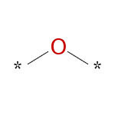  G1: 683445015  14 out of 14 good  Bayesian Score: 0.653 | 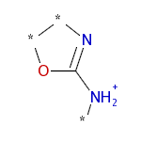  G2: 1344323508  11 out of 11 good  Bayesian Score: 0.637 | 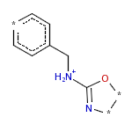  G3: -1198127490  11 out of 11 good  Bayesian Score: 0.637 | 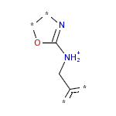  G4: 404793249  11 out of 11 good  Bayesian Score: 0.637 | 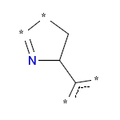  G5: -860776531  10 out of 10 good  Bayesian Score: 0.629
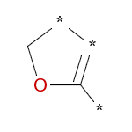  G6: -556429595  10 out of 10 good  Bayesian Score: 0.629 | 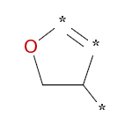  G7: -90310073  9 out of 9 good  Bayesian Score: 0.621 | 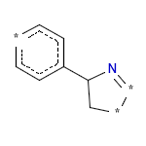  G8: 2006097921  8 out of 8 good  Bayesian Score: 0.610 | 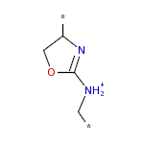  G9: 1407808221  6 out of 6 good  Bayesian Score: 0.580 | 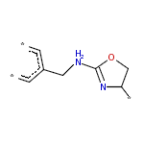  G10: 1898059402  6 out of 6 good  Bayesian Score: 0.580
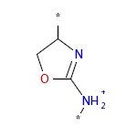  G11: 1158871309  6 out of 6 good  Bayesian Score: 0.580 | 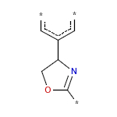  G12: -2104251029  6 out of 6 good  Bayesian Score: 0.580 | 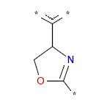  G13: -658802983  6 out of 6 good  Bayesian Score: 0.580 | 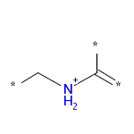  G14: 506794416  17 out of 19 good  Bayesian Score: 0.564 | 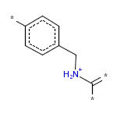  G15: 1003897717  17 out of 19 good  Bayesian Score: 0.564
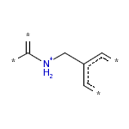  G16: -255145744  17 out of 19 good  Bayesian Score: 0.564 | 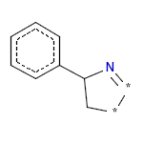  G17: -1517376329  5 out of 5 good  Bayesian Score: 0.559 | 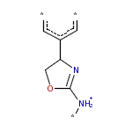  G18: -780385523  4 out of 4 good  Bayesian Score: 0.529 | 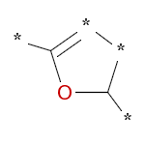  G19: -555098937  4 out of 4 good  Bayesian Score: 0.529 | 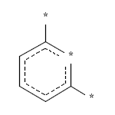  G20: 2007300961  4 out of 4 good  Bayesian Score: 0.529

Supplementary Figure S2. Top 20 molecular fragments (B1-B20) that unfavor HDAC3 inhibitory activity as produced from the ECFP_6 fingerprint descriptor.
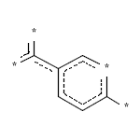  B1: -219423964  0 out of 13 good  Bayesian Score: -1.991 | 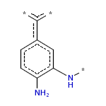  B2: -133201654  0 out of 12 good  Bayesian Score: -1.922 | 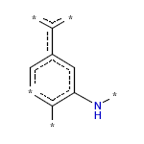  B3: -2081449927  0 out of 12 good  Bayesian Score: -1.922 | 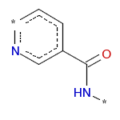  B4: 965503744  0 out of 10 good  Bayesian Score: -1.769 | 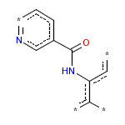  B5: 482094697  0 out of 10 good  Bayesian Score: -1.769
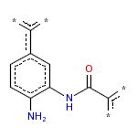  B6: -1947280506  0 out of 10 good  Bayesian Score: -1.769 | 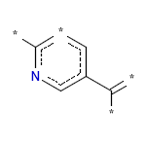  B7: 1387988013  0 out of 7 good  Bayesian Score: -1.483 | 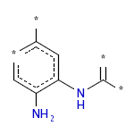  B8: -1650625813  1 out of 15 good  Bayesian Score: -1.422 | 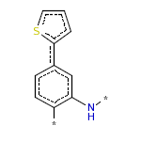  B9: -2036625672  0 out of 6 good  Bayesian Score: -1.366 | 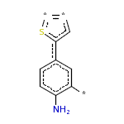  B10: -174807301  0 out of 6 good  Bayesian Score: -1.366
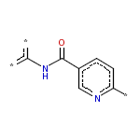  B11: -1646811292  0 out of 6 good  Bayesian Score: -1.366 | 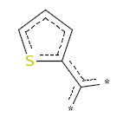  B12: 132687137  0 out of 6 good  Bayesian Score: -1.366 | 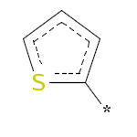  B13: -670594271  0 out of 6 good  Bayesian Score: -1.366 | B14: 2010302257  0 out of 6 good  Bayesian Score: -1.366 | B15: -399596564  0 out of 6 good  Bayesian Score: -1.366
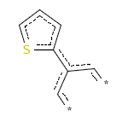  B16: 2089622584  0 out of 6 good  Bayesian Score: -1.366 | 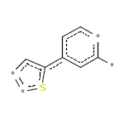  B17: 1624419609  0 out of 6 good  Bayesian Score: -1.366 | 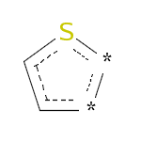  B18: 1996740348  0 out of 6 good  Bayesian Score: -1.366 | 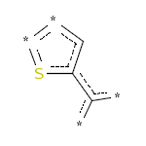  B19: -427424984  0 out of 6 good  Bayesian Score: -1.366 | 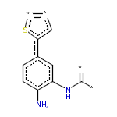  B20: -920025573  0 out of 6 good  Bayesian Score: -1.366

