**Electronic and Fluorescent studies on the interaction of DNA and BSA with a new ternary praseodymium complex containing 2,9-dimethyl 1,10-phenanthroline and antibacterial activities testing**

Zohreh Moradi, Mozhgan Khorasani-Motlagh, Ali Reza Rezvani, Meissam Noroozifar

Department of Chemistry, University of Sistan and Baluchestan, Zahedan, Iran

**Supplementary Scheme Caption**

Supplementary Scheme 1. Chemical structure of [Pr(dmp)2Cl3.OH2] complex

**Supplementary Figure Captions**

Figure 1S. FT-IR spectra of (A) dmp ligand, (B) Pr(III) complex.

Figure 2S.(A) Electronic absorption spectra of the Pr(III) complex in the region of 220- 420 nm, B) Electronic absorption spectra of title complex in the region of 400- 1100 nm, and (C)TG-DTA curve of the complex from 25 to 800 ˚C.

Figure 3S. (A) The influence of concentration of [Pr(dmp)2Cl3.OH2] complex on fluorescence intensity in the range of 10-3 –10-9 M. (B) The influence of solvent of title complex, [Pr(III) complex]: 1.0×10-5 M in three solvent (a)H2O,(b) CH3OH,(c) CH3CN.

Figure 4S. Determination of the average aggregation number of BSA (<J>) in the presence of

Pr(III) complex.(. λexcitation = 280 nm, λemission=350nm)

Supplementary Information



Scheme 1S



B

A

Figure 1S

B

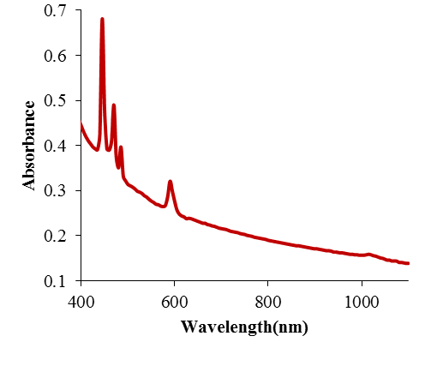

3H4→3P2

1I6 3H4→3P1 ,

3H4→3P0

3H4→1D2

C

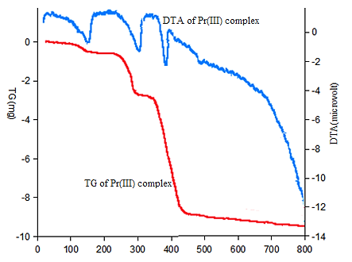

C

Figure 2S

Figure 3S

Figure 4S