Supplementary Material
Figure 1S. Averaged coherence values (not tresholded) of the 10 selected electrodes (F3, F4, C3, C4, P3, P4, T7, T8, O1, O2) for each Type of performance during each effort period in alpha band
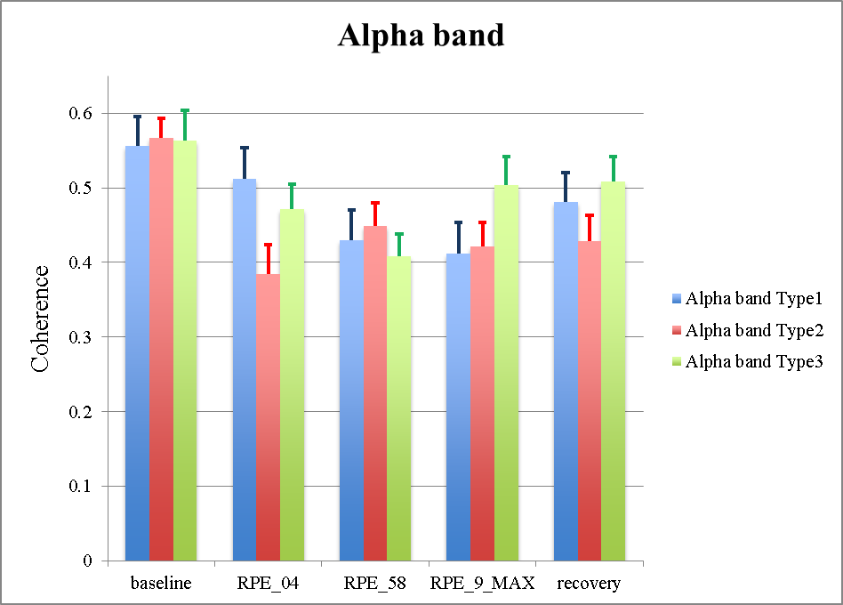

Figure 2S. Averaged coherence values (not tresholded) of the 10 selected electrodes (F3, F4, C3, C4, P3, P4, T7, T8, O1, O2) for each Type of performance during each effort period in beta 1 band
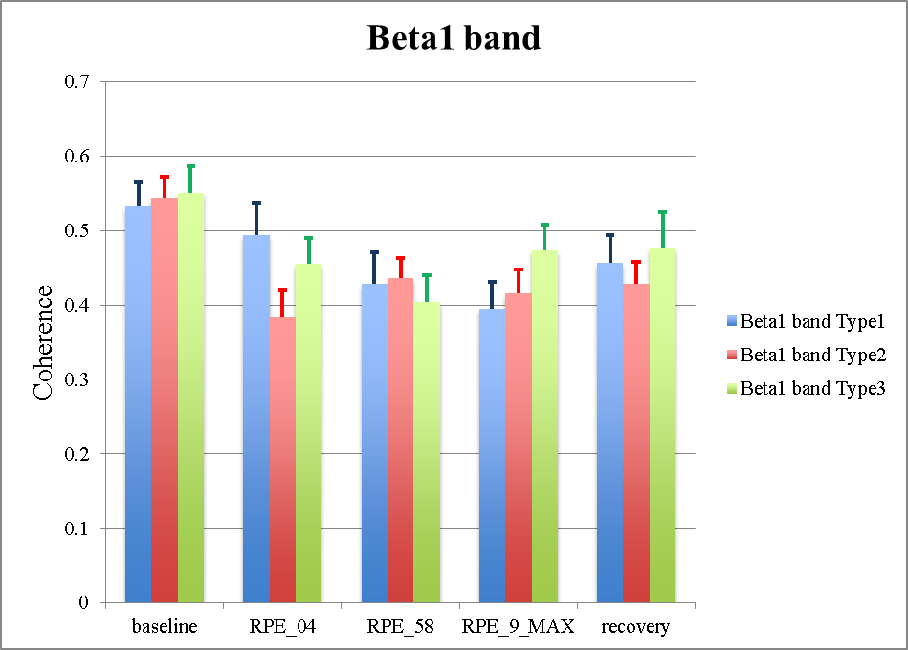

Figure 3S. Averaged coherence values (not tresholded) of the 10 selected electrodes (F3, F4, C3, C4, P3, P4, T7, T8, O1, O2) for each Type of performance during each effort period in beta 2 band
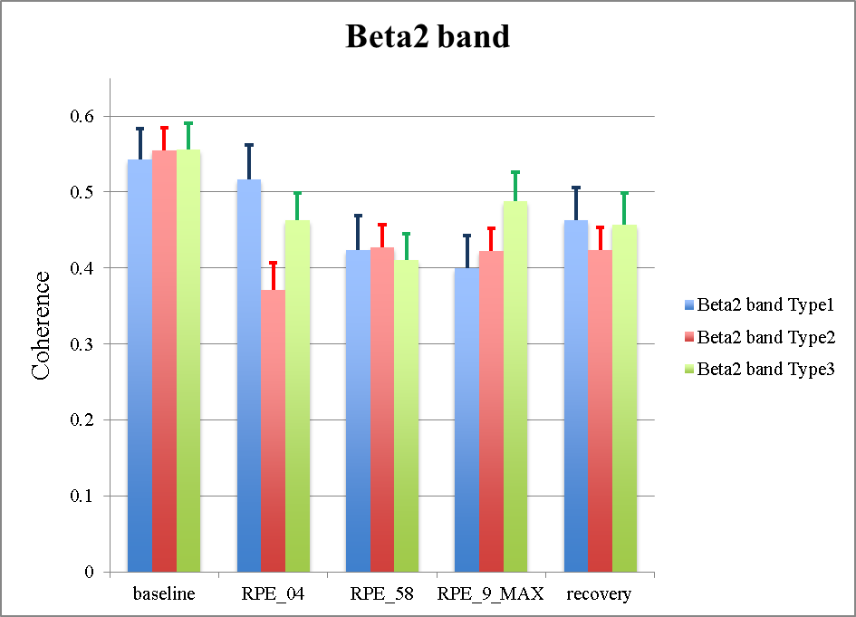

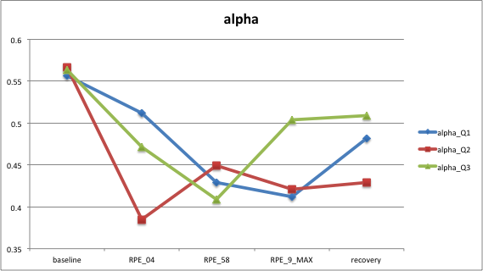
Figure 4S. Averaged coherence values (not tresholded) of the 10 selected electrodes (F3, F4, C3, C4, P3, P4, T7, T8, O1, O2) for each Type of performance during each effort period in beta 3 band
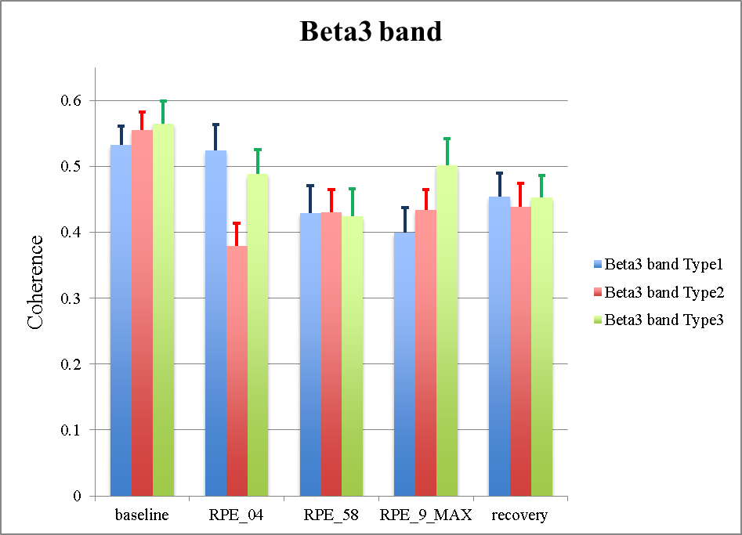

Table 1S. RM-ANOVA 3 (performance) × 5 (effort level) results for the alpha band using Greenhouse Geisser correction (*p < 0.05)
Electrode Pairs |  | Factors | df | F | p | η_{p}² | Power
F3-F4 | Performance |  | 1,67 | 1.69 | 0.215 | 0.145 | 0.284
F3-P3 |  |  | 1,92 | 0.48 | 0.614 | 0.047 | 0.117
F4-P4 |  |  | 1,74 | 0.34 | 0.068 | 0.033 | 0.094
T7-T8 |  |  | 1,98 | 0.11 | 0.894 | 0.011 | 0.065
T7-P3 |  |  | 1,59 | 1.73 | 0.209 | 0.148 | 0.283
C3-C4 |  |  | 1,89 | 1.72 | 0.206 | 0.147 | 0.309
C3-P3 |  |  | 3,52 | 1.36 | 0.211 | 0.135 | 0.405
C4-P4 |  |  | 1,43 | 0.68 | 0.473 | 0.064 | 0.132
T8-P4 |  |  | 1,25 | 0.04 | 0.879 | 0.005 | 0.055
P3-P4 |  |  | 1,73 | 0.03 | 0.965 | 0.004 | 0.055
P3-O1 |  |  | 1,98 | 0.04 | 0.955 | 0.005 | 0.056
P4-O2 |  |  | 1,71 | 0.89 | 0.412 | 0.082 | 0.171
O1-O2 |  |  | 1,62 | 1.39 | 0.271 | 0.123 | 0.238
F3-F4 | Effort lev |  | 3,02 | 3.17 | 0.038* | 0.241 | 0.678
F3-P3 |  |  | 3,14 | 4.57 | 0.008* | 0.314 | 0.855
F4-P4 |  |  | 2,47 | 4.97 | 0.011* | 0.332 | 0.816
T7-T8 |  |  | 2,51 | 3.83 | 0.027* | 0.277 | 0.706
T7-P3 |  |  | 2,19 | 4.55 | 0.020* | 0.313 | 0.738
C3-C4 |  |  | 3,36 | 3.74 | 0.017* | 0.272 | 0.792
C3-P3 |  |  | 2,58 | 4.81 | 0.011* | 0.325 | 0.816
C4-P4 |  |  | 2,61 | 6.51 | 0.003* | 0.394 | 0.924
T8-P4 |  |  | 2,88 | 3.15 | 0.041* | 0.240 | 0.659
P3-P4 |  |  | 2,87 | 5.43 | 0.005* | 0.352 | 0.893
P3-O1 |  |  | 2,92 | 2.66 | 0.068 | 0.210 | 0.582
P4-O2 |  |  | 2,68 | 4.80 | 0.010* | 0.325 | 0.820
O1-O2 |  |  | 3,03 | 2.61 | 0.068 | 0.207 | 0.586
F3-F4 | Perf × Effort lev |  | 4,28 | 0.82 | 0.523 | 0.076 | 0.358
F3-P3 |  |  | 3,01 | 1.12 | 0.353 | 0.101 | 0.274
F4-P4 |  |  | 4,32 | 1.37 | 0.258 | 0.332 | 0.816
T7-T8 |  |  | 3,60 | 1.14 | 0.347 | 0.103 | 0.308
T7-P3 |  |  | 4,20 | 1.84 | 0.135 | 0.156 | 0.527
C3-C4 |  |  | 3,53 | 1.92 | 0.135 | 0.161 | 0.492
C3-P3 |  |  | 3,52 | 1.36 | 0.211 | 0.135 | 0.405
C4-P4 |  |  | 4,47 | 0.88 | 0.491 | 0.081 | 0.272
T8-P4 |  |  | 4,76 | 1.24 | 0.303 | 0.111 | 0.393
P3-P4 |  |  | 4,28 | 1.04 | 0.403 | 0.094 | 0.308
P3-O1 |  |  | 3,38 | 1.64 | 0.193 | 0.141 | 0.415
P4-O2 |  |  | 4,38 | 1.07 | 0.382 | 0.097 | 0.325
O1-O2 |  |  | 4,52 | 1.38 | 0.251 | 0.122 | 0.421

Table 2S. RM-ANOVA 3 (performance) × 5 (effort level) results for the beta1 band using Greenhouse Geisser correction (*p < 0.05)
Electrode Pairs |  | Factors | df | F | p | η_{p}² | power
F3-F4 | Performance |  | 1,85 | 0.42 | 0.645 | 0.041 | 0.107
F3-P3 |  |  | 1,57 | 0.27 | 0.714 | 0.026 | 0.083
F4-P4 |  |  | 1,90 | 0.84 | 0.441 | 0.078 | 0.170
T7-T8 |  |  | 1,92 | 0.01 | 0.985 | 0.001 | 0.052
T7-P3 |  |  | 1,51 | 0.43 | 0.602 | 0.041 | 0.102
C3-C4 |  |  | 1,67 | 1.39 | 0.273 | 0.122 | 0.240
C3-P3 |  |  | 1,77 | 2.50 | 0.110 | 0.204 | 0.422
C4-P4 |  |  | 1,47 | 0.09 | 0.850 | 0.010 | 0.061
T8-P4 |  |  | 1,51 | 0.07 | 0.885 | 0.007 | 0.058
P3-P4 |  |  | 1,85 | 0.11 | 0.880 | 0.011 | 0.064
P3-O1 |  |  | 1,39 | 0.11 | 0.829 | 0.011 | 0.062
P4-O2 |  |  | 1,58 | 1.40 | 0.270 | 0.123 | 0.235
O1-O2 |  |  | 1,57 | 1.05 | 0.356 | 0.095 | 0.186
F3-F4 | Effort lev |  | 2,92 | 3.78 | 0.021* | 0.275 | 0.752
F3-P3 |  |  | 3,08 | 4.87 | 0.006* | 0.328 | 0.873
F4-P4 |  |  | 2.32 | 3.24 | 0.050* | 0.245 | 0.600
T7-T8 |  |  | 2,45 | 1.60 | 0.218 | 0.138 | 0.336
T7-P3 |  |  | 2,78 | 3.39 | 0.034* | 0.254 | 0.682
C3-C4 |  |  | 2,47 | 2.67 | 0.115 | 0.185 | 0.461
C3-T3 |  |  | 2,25 | 5.10 | 0.012* | 0.338 | 0.798
C4-P4 |  |  | 2,76 | 5.77 | 0.004* | 0.366 | 0.902
T8-P4 |  |  | 2,91 | 2.68 | 0.060 | 0.212 | 0.585
P3-P4 |  |  | 2,54 | 4.85 | 0.011* | 0.327 | 0.816
P3-O1 |  |  | 2,91 | 2.96 | 0.050* | 0.228 | 0.631
P4-O2 |  |  | 2,47 | 3.95 | 0.025* | 0.283 | 0.713
O1-O2 |  |  | 3,21 | 3.98 | 0.014* | 0.285 | 0.805
F3-F4 | Perf × Effort lev |  | 3,20 | 1.06 | 0.380 | 0.097 | 0.274
F3-P3 |  |  | 3,62 | 0.90 | 0.418 | 0.090 | 0.269
F4-P4 |  |  | 3,77 | 1.54 | 0.211 | 0.134 | 0.419
T7-T8 |  |  | 4,86 | 1.25 | 0.300 | 0.111 | 0.400
T7-P3 |  |  | 4,61 | 1.29 | 0.285 | 0.114 | 0.339
C3-C4 |  |  | 4,56 | 1.56 | 0.193 | 0.135 | 0.476
C3-P3 |  |  | 4,40 | 1.03 | 0.403 | 0.094 | 0.314
C4-P4 |  |  | 4,15 | 1.72 | 0.160 | 0.147 | 0.492
T8-P4 |  |  | 3,96 | 2.34 | 0.072 | 0.190 | 0.623
P3-P4 |  |  | 4,51 | 0.85 | 0.514 | 0.078 | 0.262
P3-O1 |  |  | 3,61 | 1.55 | 0.212 | 0.134 | 0.409
P4-O2 |  |  | 4,98 | 1.61 | 0.175 | 0.139 | 0.514
O1-O2 |  |  | 4,63 | 1.02 | 0.409 | 0.093 | 0.321

Table 3S. RM-ANOVA 3 (performance) × 5 (effort level) results for the beta 2 band using Greenhouse Geisser correction (*p < 0.05)
Electrode Pairs |  | Factors | df | F | p | η_{p}² | power
F3-F4 | Performance |  | 1,63 | 2.74 | 0.102 | 0.215 | 0.426
F3-P3 |  |  | 1,76 | 3.33 | 0.064 | 0.250 | 0.524
F4-P4 |  |  | 1,97 | 0.40 | 0.668 | 0.039 | 0.106
T7-T8 |  |  | 1,73 | 0.19 | 0.801 | 0.018 | 0.073
T7-P3 |  |  | 1,13 | 0.19 | 0.801 | 0.018 | 0.073
C3-C4 |  |  | 1,69 | 2.17 | 0.150 | 0.179 | 0.355
C3-P3 |  |  | 1,94 | 2.19 | 0.139 | 0.180 | 0.388
C4-P4 |  |  | 1,65 | 0.89 | 0.408 | 0.083 | 0.168
T8-P4 |  |  | 1,54 | 0.04 | 0.918 | 0.005 | 0.056
P3-P4 |  |  | 1,75 | 0.01 | 0.975 | 0.002 | 0.052
P3-O1 |  |  | 1,72 | 0.76 | 0.463 | 0.071 | 0.152
P4-O2 |  |  | 1,34 | 0.70 | 0.458 | 0.066 | 0.131
O1-O2 |  |  | 1,50 | 1.15 | 0.320 | 0.104 | 0.196
F3-F4 | Effort lev |  | 2,57 | 4.95 | 0.010* | 0.331 | 0.828
F3-P3 |  |  | 2,72 | 6.36 | 0.003* | 0.389 | 0.926
F4-P4 |  |  | 2,08 | 4.17 | 0.029* | 0.294 | 0.68
T7-T8 |  |  | 2,52 | 2.25 | 0.116 | 0.184 | 0.463
T7-P3 |  |  | 2,61 | 2.94 | 0.058 | 0.227 | 0.592
C3-C4 |  |  | 2,59 | 5.76 | 0.005* | 0.336 | 0.886
C3-T3 |  |  | 2,51 | 5.94 | 0.005* | 0.373 | 0.888
C4-P4 |  |  | 2,53 | 4.70 | 0.013* | 0.320 | 0.800
T8-P4 |  |  | 2,60 | 4.32 | 0.017* | 0.302 | 0.773
P3-P4 |  |  | 2,88 | 4.31 | 0.013* | 0.301 | 0.805
P3-O1 |  |  | 3,21 | 3.58 | 0.022* | 0.264 | 0.758
P4-O2 |  |  | 2,72 | 3.11 | 0.047* | 0.238 | 0.634
O1-O2 |  |  | 3,23 | 2.66 | 0.061 | 0.210 | 0.616
F3-F4 | Perf × Effort lev |  | 4,12 | 1.04 | 0.398 | 0.094 | 0.304
F3-P3 |  |  | 4,36 | 2.18 | 0.081 | 0.179 | 0.62
F4-P4 |  |  | 3,19 | 1.67 | 0.191 | 0.143 | 0.407
T7-T8 |  |  | 4,69 | 1.43 | 0.232 | 0.125 | 0.445
T7-P3 |  |  | 3,17 | 1.30 | 0.289 | 0.116 | 0.323
C3-C4 |  |  | 4,53 | 1.56 | 0.194 | 0.135 | 0.473
C3-P3 |  |  | 3,99 | 1.02 | 0.406 | 0.093 | 0.293
C4-P4 |  |  | 4,54 | 2.45 | 0.063 | 0.197 | 0.686
T8-P4 |  |  | 5,02 | 1.51 | 0.347 | 0.103 | 0.375
P3-P4 |  |  | 4,4 | 0.43 | 0.799 | 0.042 | 0.147
P3-O1 |  |  | 4,00 | 0.51 | 0.724 | 0.049 | 0.160
P4-O2 |  |  | 4,43 | 1.91 | 0.118 | 0.161 | 0.561
O1-O2 |  |  | 4,28 | 1.22 | 0.310 | 0.109 | 0.364

Table 4S. RM-ANOVA 3 (performance) × 5 (effort level) results in beta 3 band using Greenhouse Geisser correction (*p < 0.05)
Electrode Pairs | Factors | df | F | p | η_{p}² | power
F3-F4 | Performance | 1,6 | 1.86 | 0.191 | 0.157 | 0.301
F3-P3 |  | 1,9 | 2.25 | 0.134 | 0.184 | 0.393
F4-P4 |  | 1,98 | 0.56 | 0.578 | 0.053 | 0.130
T7-T8 |  | 1,98 | 0.20 | 0.815 | 0.020 | 0.077
T7-P3 |  | 1,14 | 0.75 | 0.421 | 0.070 | 0.129
C3-C4 |  | 1,87 | 0.70 | 0.499 | 0.066 | 0.148
C3-P3 |  | 1,94 | 1.98 | 0.165 | 0.166 | 0.356
C4-P4 |  | 1,56 | 0.142 | 0.819 | 0.014 | 0.067
T8-P4 |  | 1,60 | 0.090 | 0.869 | 0.010 | 0.061
P3-P4 |  | 1,52 | 0.91 | 0.396 | 0.084 | 0.165
P3-O1 |  | 1,83 | 1.47 | 0.254 | 0.128 | 0.264
P4-O2 |  | 1,59 | 0.63 | 0.508 | 0.060 | 0.130
O1-O2 |  | 1,31 | 0.88 | 0.393 | 0.081 | 0.152
F3-F4 | Effort lev | 2,81 | 4.85 | 0.009* | 0.327 | 0.486
F3-P3 |  | 2,76 | 11.30 | 0.001* | 0.531 | 0.997
F4-P4 |  | 2,19 | 2.64 | 0.089 | 0.209 | 0.491
T7-T8 |  | 2,64 | 3.11 | 0.048* | 0.238 | 0.624
T7-P3 |  | 2,80 | 3.35 | 0.036* | 0.251 | 0.678
C3-C4 |  | 2,24 | 4.07 | 0.027* | 0.289 | 0.694
C3-P3 |  | 1,87 | 3.83 | 0.043* | 0.277 | 0.605
C4-P4 |  | 2,61 | 6.02 | 0.004* | 0.376 | 0.901
T8-P4 |  | 1,87 | 4.44 | 0.028* | 0.308 | 0.674
P3-P4 |  | 2,13 | 3.04 | 0.066 | 0.233 | 0.544
P3-O1 |  | 2,45 | 2.88 | 0.066 | 0.224 | 0.562
P4-O2 |  | 2,50 | 3.88 | 0.026* | 0.280 | 0.710
O1-O2 |  | 2,77 | 3.97 | 0.020* | 0.285 | 0.757
F3-F4 | Perf × Effort lev | 4,01 | 1.14 | 0.352 | 0.102 | 0.325
F3-P3 |  | 4,29 | 1.72 | 0.158 | 0.147 | 0.501
F4-P4 |  | 3,65 | 0.99 | 0.415 | 0.091 | 0.273
T7-T8 |  | 4,81 | 1.18 | 0.330 | 0.106 | 0.377
T7-P3 |  | 3,84 | 0.91 | 0.462 | 0.084 | 0.258
C3-C4 |  | 4,77 | 2.62 | 0.038* | 0.208 | 0.742
C3-P3 |  | 3,32 | 1.24 | 0.311 | 0.110 | 0.316
C4-P4 |  | 4,81 | 1.89 | 0.115 | 0.159 | 0.582
T8-P4 |  | 3,67 | 1.75 | 0.164 | 0.149 | 0.463
P3-P4 |  | 4,55 | 0.65 | 0.649 | 0.061 | 0.207
P3-O1 |  | 4,83 | 1.07 | 0.387 | 0.097 | 0.342
P4-O2 |  | 4,72 | 2.70 | 0.064 | 0.213 | 0.754
O1-O2 |  | 3,86 | 1.13 | 0.356 | 0.102 | 0.316

