Synthesis of New silica xerogels based on bi-functional 1,3,4-Thiadiazole and 1,2,4-triazole adducts

Afifa Hafidh^{(a)}*, Fathi Touati^{(b)}, Ahmed Hichem Hamzaoui^{(c)}

^{(a)} University of Tunis, Department of Chemistry, Materials and Environment Laboratory, Preparatory Institute for Engineering Studies of Tunis, Tunisia. Afifa.hafidh@ipeit.rnu.tn
^{(b)} Laboratory of Materials Treatment and Analysis, National Institute for Physico-Chemical Research and Analysis, Technopole Sidi Thabet – 2020 Tunis, Tunisia.
^{(c)} Useful Material Valorization Laboratory, National Center for Research in Materials Sciences, CNRSM, Technopole Borj Cédria, BP 73, 8027 Soliman, Tunisia

Supporting information

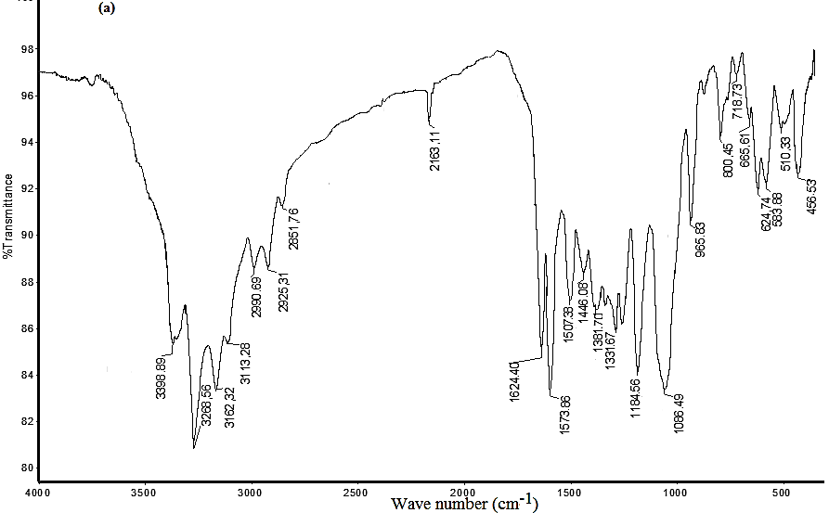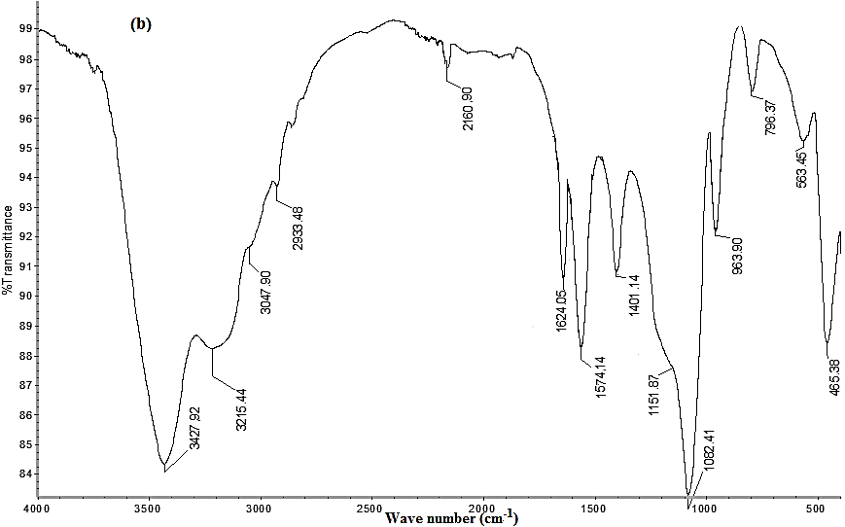

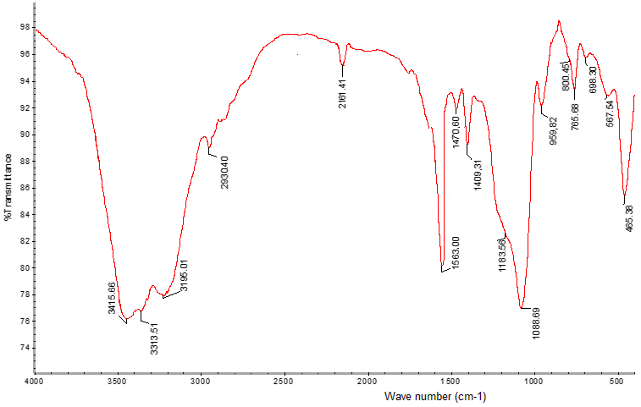
(c)
Figure S1 FT-IR spectra of xerogels HM₁ (a), HM₂ (b) and HM₃ (c)
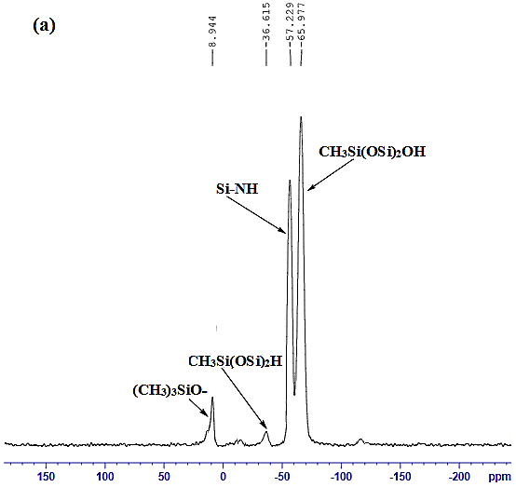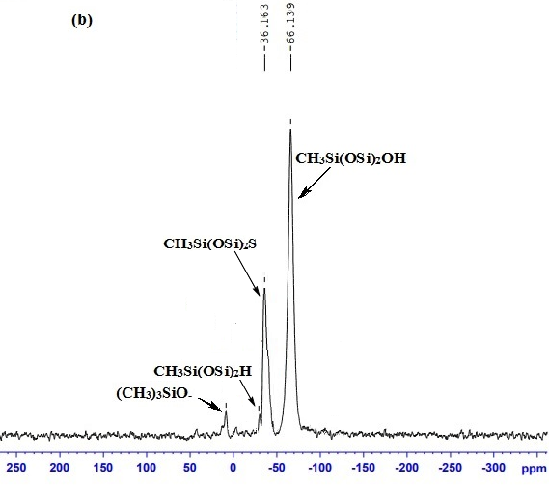

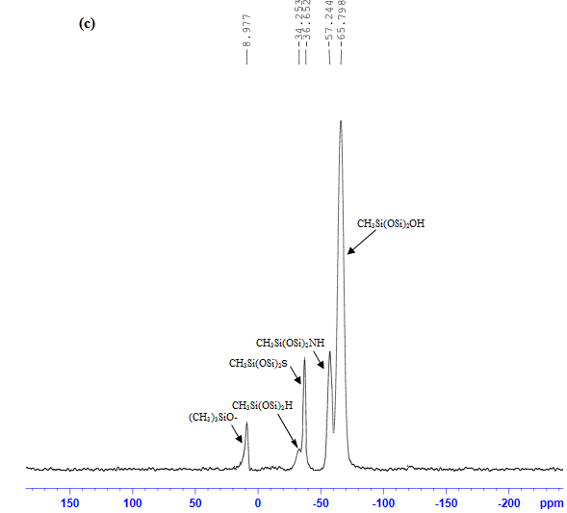
Figure S2 ²⁹Si CP MAS NMR spectra of MH₁ (a), MH₂ (b) and MH₃ (c)
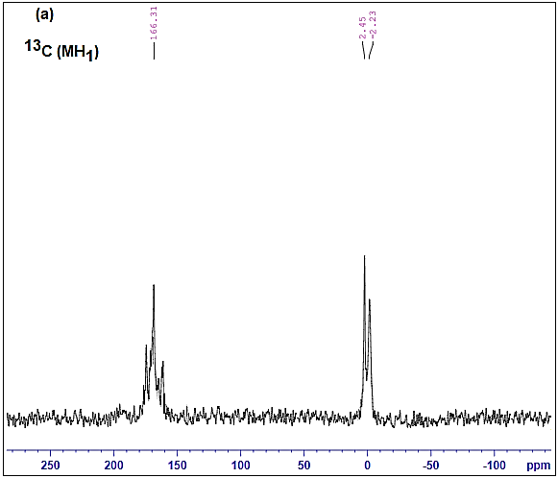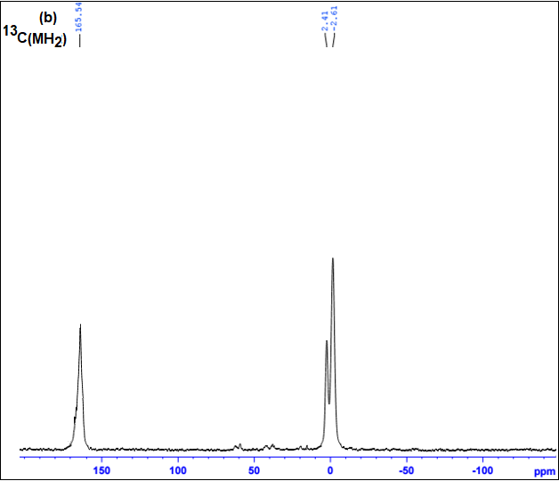
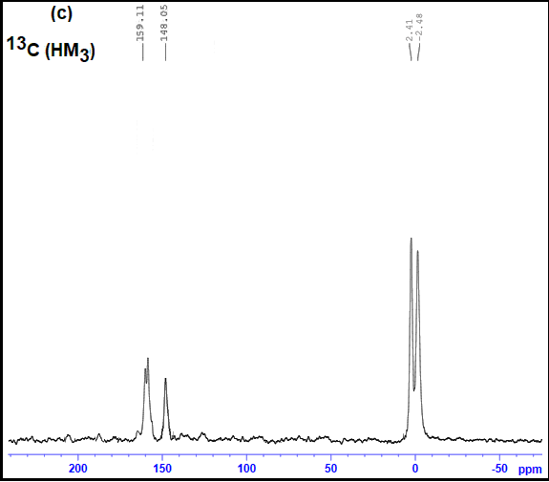
Figure S3 ¹³C CP MAS NMR spectra of (a) MH₁, (b) MH₂ and (c) MH₃

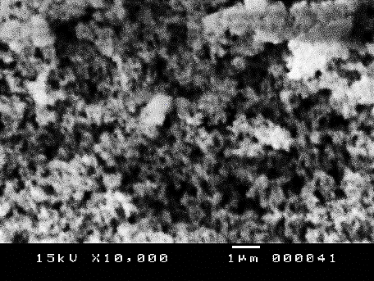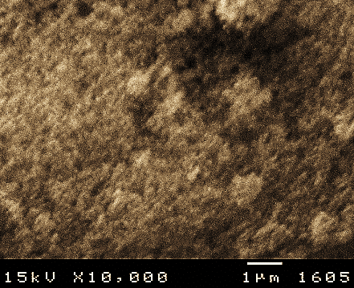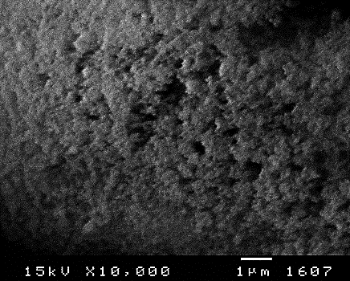
(c)

(b)
(a)

Figure S4 SEM images of HM₁ (a), HM₂ (b) and HM₃ (c).

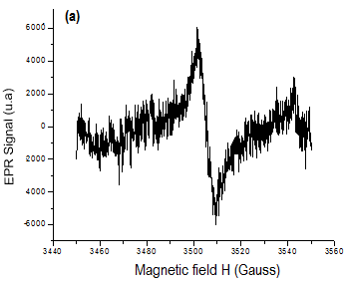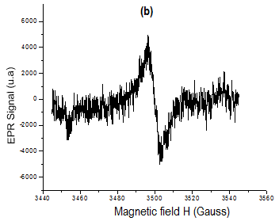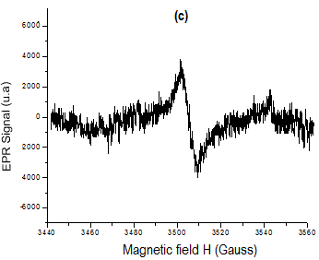

Figure S5 EPR spectra of hybrid xerogels HM₁ (a), HM₂ (b) and HM₃ (c)

