Supplementary material
Appendix 1: Dimensions, components and indicators of the IDEA method (see www.idea.chlorofil.fr for a detailed presentation) and adaptations made to fit the Saïs context
Dimensions  (3) | Components (10) | Indicators  (42) |  | Score changed | Other adaptations
 |  | Code | Description
Agroecological (3 components and 18 indicators) | Diversity | A1 | Diversity of annual and temporary crops | x
 |  | A2 | Diversity of perennial crops | - | Item linked to permanent grassland removed
 |  | A3 | Animal diversity | x
 |  | A4 | Animal biodiversity | x
 | Organization of space | A5 | Crop rotation | - | Threshold values adjusted
 |  | A6 | Scale of fields | x | Threshold values adjusted
 |  | A7 | Management of organic waste | - | -
 |  | A8 | Ecological buffer zones | x | -
 |  | A9 | Contribution to environmental challenges of the territory | - | Deleted
 |  | A10 | Land improvement | - | -
 |  | A11 | Fodder area management | - | Item linked to permanent grassland removed
 | Farming practices | A12 | Fertilization | x
 |  | A13 | Manure management | x
 |  | A14 | Pesticides | x
 |  | A15 | Veterinary products | x
 |  | A16 | Soil protection | -
 |  | A17 | Water management | x
 |  | A18 | Energy dependency | x
Socio-territorial  (3 components and 18 indicators) | Quality of products and the land | B1 | Quality process | x | Replaced by products recognizable by their territorial quality
 |  | B2 | Enhancement of buildings and landscape heritage | x
 |  | B3 | Non-organic waste management | x
 |  | B4 | Access to the property | x
 |  | B5 | Social involvement | x
 | Employment and services | B6 | Short value chains | -
 |  | B7 | Autonomy and enhancement of local resources | x
 |  | B8 | Services and multiple activities | x
 |  | B9 | Contribution to employment | -
 |  | B10 | Collective work | - | Replaced by sharecropping
 |  | B11 | Expected farm sustainability | -
 | Ethics and human development | B12 | Dependence on commercial concentrates | x
 |  | B13 | Animal welfare | -
 |  | B14 | Training-education | -
 |  | B15 | Labor intensity | x
 |  | B16 | Quality of life | x
 |  | B17 | Isolation | -
 |  | B18 | Quality of buildings | x
Economic  (4 components and 6 indicators) | Viability | C1 | Economic viability | x | Threshold values adjusted
 |  | C2 | Economic specialization rate | x
 | Independence | C3 | Financial autonomy | -
 |  | C4 | Sensitivity to public subsidies | - | Modified to « possibility of financing investments »
 | Transferability | C5 | Transferability | - | Threshold values adjusted  Item linked to income potential added
 | Efficiency | C6 | Efficiency of the productive process | - | Item linked to value added by man-work unit (MWU) added

Appendix 2: Calculated indicators and method of calculation
Indicators |  | Calculation | Explanation
Code | Name
A10 | Land improvement | Stocking rate = LU*Main_forage_area⁻¹ | Land improvement is considered as related with the presence of both herd and forage crops in the farm. The intensity of this presence is measured by the stocking rate.  LU: livestock unit
A12 | Fertilization | The annual nitrogen farm-gate balance (NB)= (N_{in} - N_{out})* UAA⁻¹ ª | Fertilization practices are assessed by the nitrogen balance at farm level over one year. A positive ratio indicates that nitrogen inputs overtake crops requirements, which induces a risk of nitrogen pollution (increase of nitrate concentration in groundwater). A negative ratio indicates that crop requirements are not fulfilled.  N_{in} = total amount of nitrogen in purchased inputs: mineral fertilizers and manure, cattle feed and animals.  N_{out} = sum of nitrogen outputs included in products sold such as crops, animal, milk or animal manure.  The nitrogen concentration exported per crop and livestock product was taken from: Vertes F., 2005. Outil de calcul du Bilan apparent. http://documents.tips/embed/bilan-apparent-v-30.html
A14 | Pesticides | Pollution pressure (PP)= (applied dose* authorized dose⁻¹) * (treated surface*UAA⁻¹) *weighting coefficient | Authorized dose corresponds to the maximum dose allowed by the National Food Safety Authority.  A weighting coefficient is used if the treatment is done manually in order to penalize the direct exposure of the applicator to phytosanitary products, especially in the absence of protection. Thus, the impact on the applicator’s health is taken into account as well as the environmental one.
A18 | Energy dependency | Fuel equivalent per ha (FEH) = ((fuel + units of nitrogen + electricity + gas + purchased feed concentrates)*40⁻¹*UAA⁻¹ | This indicator calculates the energy balance of the farm by taking into account energy imports (fuel, electricity, gas) and input imports (nitrogen balance and animal feeds)  expressed in megajoules (MJ). FEH is expressed in fuel liter* ha⁻¹ per year.  1 liter fuel = 40 MJ; 1 unit of nitrogen = 56 MJ; 1 kwh electricity = 9.5 MJ; 1 kg of gas = 51 MJ; 1 kg purchased feed concentrate = 4 MJ
C1 | Economic viability (EV) | EV= (GOS^{b} – FN^{c})*Family_MWU^{-1 d} | EV reflects the capacity of the farm in financing investments and the farm economic sustainability. Viability can be limited by low income or by important depreciation related to investments on the farm. Indeed, FN includes equipment depreciation and maintenance.
C3 | Financial autonomy | Financial dependence (FD) = (Sum annuities*GOS⁻¹)*100 | Financial dependence indicates the level of debt or dependence of the farm (%).
C5 | Transferability | Capital to purchase = Farm capital*Family_MWU⁻¹  +  EV= (GOS – 1.5 depreciation)*Family_MWU⁻¹ | Transferability expresses the appraisal of the reversal amount for a potential new owner who could be from the younger generation. The objective is to allow the new owner benefiting from a minimum income based on an amount of reversal. A good balance between capital and viability improves the transferability of the farm.
C6 | Efficiency of the production process | Efficiency = (Product – Inputs)*Product⁻¹  +  Capacity to generate value added (CVA) = (Products-Inputs)*Total_ MWU⁻¹ | Efficiency of a production process is estimated based on the balance between economic efficiency of inputs used and capacity to generate added value per worker.
ª Utilized Agricultural Area
^{b} Gross Operating Surplus
^{c} Financing Need
d Man-Work Unit

Appendix 3. Multivariate analysis of the three components of the agroecological dimension of sustainability and the coordinates of the 36 observations. The two PCA axes explain 88% of the variance. Axis 1 explains 52% of the variance. It is represented by the “diversity” and “organization of space” components. The “farming practices” component contributes greatly to axis 2, which explains 36% of the variance. The three clusters identified by the AHC (GA1, GA2, GA3) are shown on the PCA graph by the three ellipses. This statistical method was used to discriminate the farms into three groups and to allocate the groups accordingly.
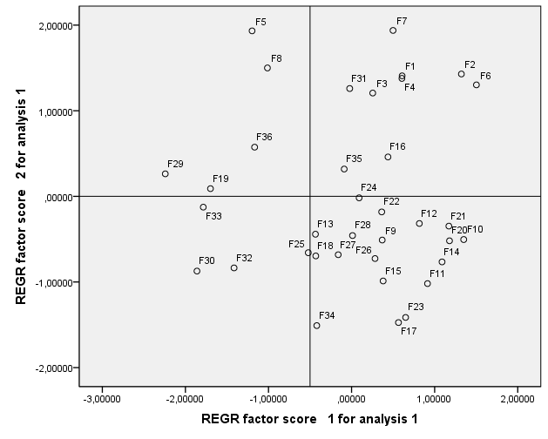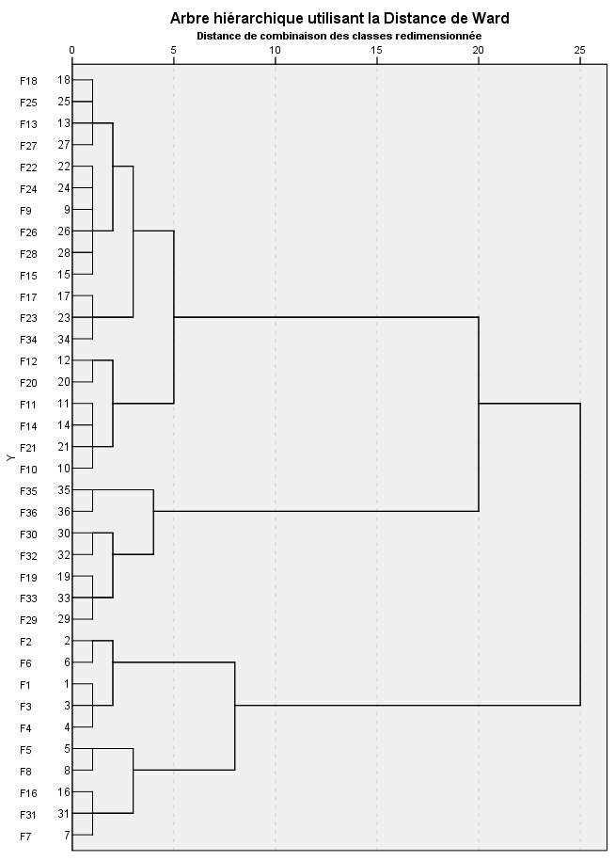
GA2
GA3
GA1
GA1
GA3
GA2
Farming practices
Diversity
Organization of space
Appendix 4. Multivariate analysis of the four components of the economic dimension of sustainability and the coordinates of the 36 observations. The “viability”, “transmissibility”, and “efficiency” components respectively contribute 39%, 38% and 34% on axis 1, which explains 61% of the variance. The “independence” component is well represented on axis 2, which explains 25% of the variance. The two axes explain 87% of the variance. The three clusters identified by the AHC (GE1, GE2, GE3) are shown on the PCA graph by the three ellipses. This statistical method was used to discriminate the farms into three groups and to allocate the groups accordingly.
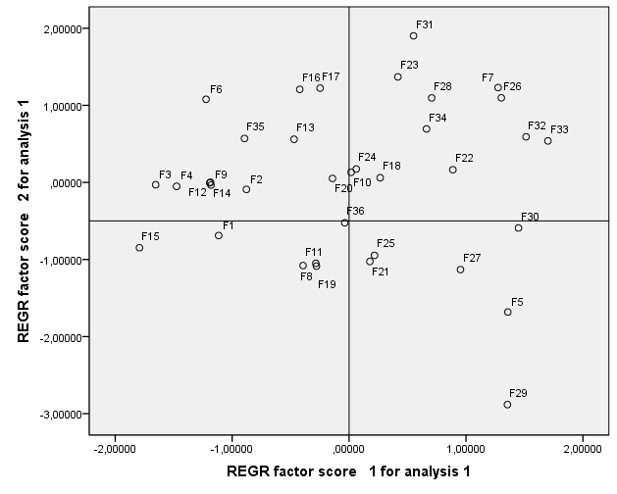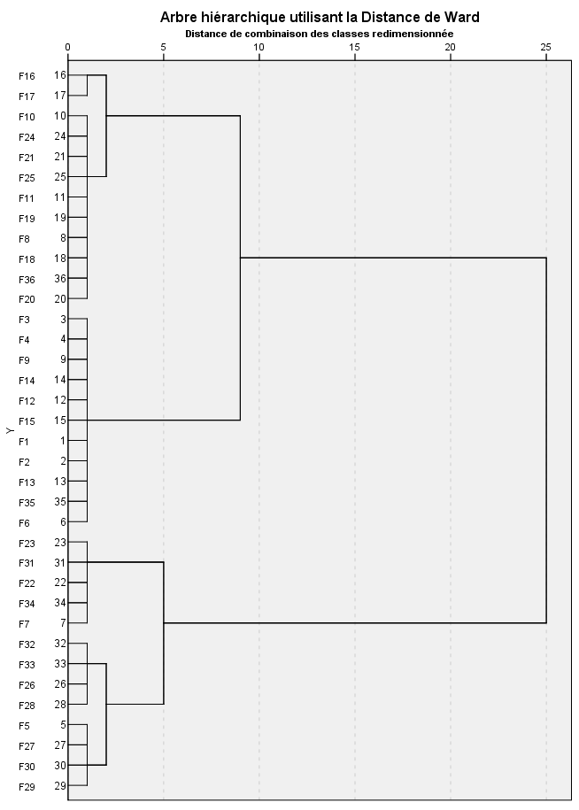
GE2
GE3
GE1
Independence
Viability
Transferability
GE2
GE3
GE1

Appendix 5. Multivariate analysis of the three components of the socio-territorial dimension of sustainability and the coordinates of the 36 observations. The two PCA axes explain 79% of the variance. The “quality of products and the land” and “employment and services” components respectively contribute 66% and 56% to axis 1, which explains 48% of the variance. The “ethics and human development” component contributes greatly to axis 2, which explains 31% of the variance. The three clusters identified by the AHC (GS1, GS2, GS3) are shown on the PCA graph by the three ellipses. This statistical method was used to discriminate the farms into three groups and to allocate the groups accordingly.
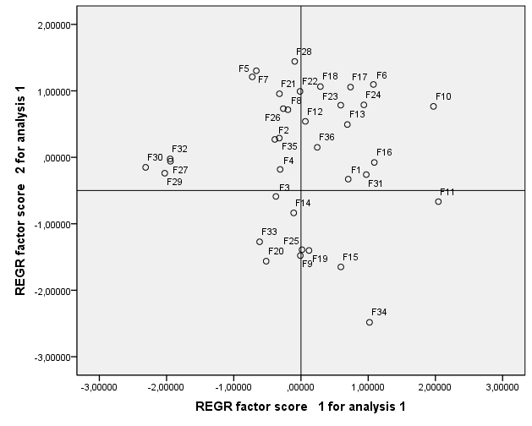
GS3
GS1
Ethics and human development
Employment and services
Quality of products and the land
GS2

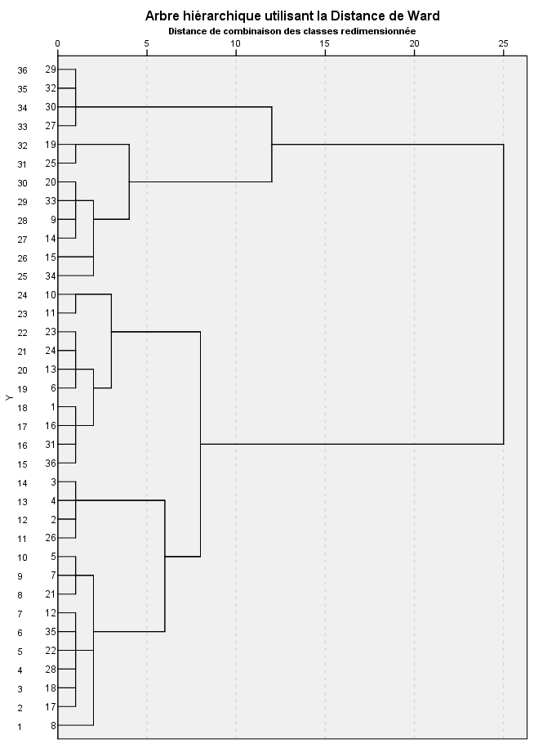
GS1
GS3
GS2
Appendix 6: Multivariate analysis of the three dimensions of sustainability and the coordinates of the 36 observations. The two PCA axes explain 89% of the variance. The “socio-territorial” and “agroecological” dimensions respectively contribute 72% and 44% to axis 1, which explains 61% of the variance. The "economic” dimension contributes 83% to axis 2, which explains 28% of the variance. The four clusters identified by the AHC (GD1, GD2, GD3, GD4) are shown on the PCA graph by the four ellipses. This statistical method was used to discriminate the farms into three groups and to allocate the groups accordingly.
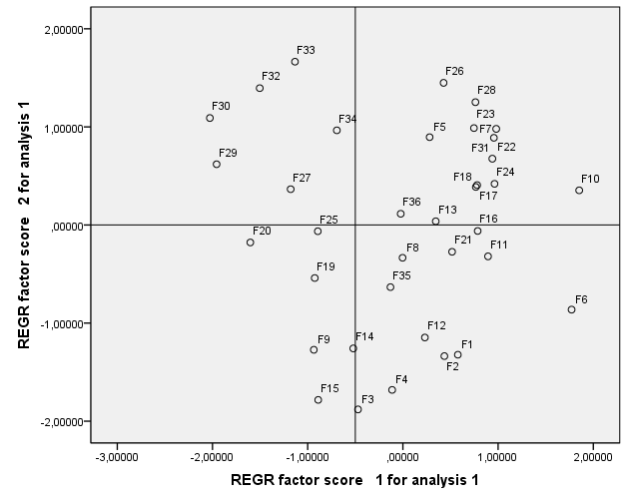
GD3
GD2
GD1
GD4
Economic dimension
socio-territorial dimension
Agroecological dimension
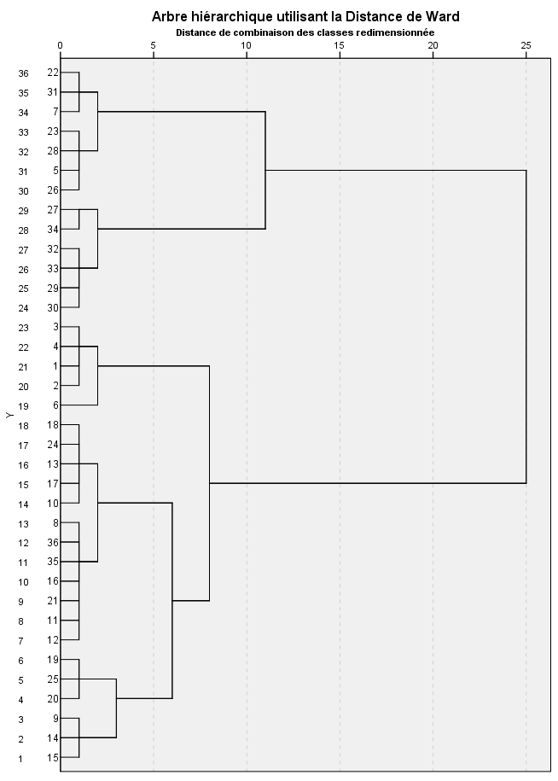
GD2
GD3
GD4
GD1

