On-line only Data Supplement

Content
Table I: Database search strategies – updated until June 2017 2
Table II: Characteristics of included studies. 11
Table III: Risk of bias in individual studies. 13
Table IV: Baseline National Institute of Health Stroke Scale (NIHSS) 15
Table V: Time from symptom onset to hospital admission 16

Figure I: PRISMA diagram 17
Figure II: Mean age in years by Gross National Income (GNI), 2016 values 18
Figure III: Percent of patients diagnosed with a hemorrhagic stroke, by country income group. 19
Figure IV: Percent of patients with hypertension, by country income group. 20
Figure V: Percent of smokers, by country income group. 21
Figure VI: Percent of patients with diabetes, by country income group. 22
Figure VII: Percent of patients with previous stroke, by country income group. 23
Figure VIII: Percent of patients with atrial fibrillation, by country income group. 24
Figure IX: Percent of patients with loss of conscinouness at presentation, by country income group. 25
Figure X: Percent of patients who received CT scan, by country income group. 26
Figure XI: Percent of patients who received an MRI, by country income group. 27
Figure XII: Percent of patients who received rt-PA treatment, by country income group. 28
Figure XIII: Percent of patients who received anti-platelte therapy, by country income group. 29
Figure XIV: Percent of patients admitted to the ICU, by country income group. 30

References ……………………………………….………………………………………..…….31

Tables
Table I: Database search strategies – updated until June 2017
Ovid MEDLINE <1946 to June Week 1 2017>
Search Date: June 8, 2017

1 exp Stroke/
2 (stroke or strokes or poststroke).tw.
3 (apople* or cerebrovascular accident* or cerebral accident*).tw.
4 exp Brain Ischemia/
5 ((brain or cerebr* or cerebell* or intracran* or intracerebral or infratentorial or supratentorial) adj5 (infarct* or isch?emi* or thrombo* or emboli* or occlus* or hypoxi*)).tw. (88654)
6 isch?emi* attack*.tw.
7 or/1-6
8 exp Patient Care Management/
9 ((stroke or strokes or poststroke or poststrokes) adj3 (care or management or treatment or treatments or therapy or therapies or rehabilitation)).tw.
10 (hospital or hospitals or clinic or clinics or care center or care centers or care facility or care facilities).tw.
11 ((stroke or strokes) adj3 (center or centers or facility or facilities or unit or units)).tw.
12 exp Emergency Medical Services/
13 ((emergency or trauma) adj3 (care or service* or facility or facilities or unit or units or department or departments)).tw.
14 (prehospital or emergicenter* or ambulance or ambulances).tw.
15 practice guideline/
16 Practice Guidelines as Topic/
17 guideline*.tw.
18 Rehabilitation/
19 rehabilitation.tw.
20 or/8-19
21 Developing Countries/
22 ((developing or underdeveloped or "under developed" or "less developed" or "least developed" or impoverished or "poverty stricken") adj (country or countries or nation or nations or population* or world or economy or economies)).tw.
23 (("low income*" or "middle income*") adj (country or countries or nation or nations or population* or world or economy or economies)).tw.
24 (low* adj (gdp or gnp or gross domestic or gross national)).tw.
25 (lmic or lmics or "third world" or "lami countr*").tw.
26 "transitional countr*".tw.
27 (Africa or Asia or Caribbean or "West Indies" or "South America" or "Latin America" or "Central America").tw.
28 (Afghanistan or Afghani or Albania or Albanian or Algeria or Algerian or "American Samoa" or Angola or Angolan or Argentina or Argentinian or Armenia or Armenian or Azerbaijan or Azeri or Bangladesh or Bangladheshi or Belarus or Belorussia or Byelorussian or Belorussian or Belize or Belizean or Benin or Bhutan or Bolivia or Bolivian or Bosnia or Bosnian or Herzegovina or Hercegovina or Botswana or Brazil or Brasil or Brazilian or Brasilian or Bulgaria or Bulgarian or "Burkina Faso" or Burundi or "Cabo Verde" or Cambodia or Cambodian or Kampuchea or Cameroon or Cameroons or Cameron or Camerons or "Central African Republic" or Chad or China or Chinese or Colombia or Colombian or Comoros or Congo or "Costa Rica" or "Costa Rican" or "Cote d'Ivoire" or "Ivory Coast" or Cuba or Cuban or Djibouti or Dominica or "Dominican Republic" or Dominican or Ecuador or Ecuadorean or Egypt or Egyptian or "El Salvador" or Salvadoran or "Equatorial Guinea" or Eritrea or Eritrean or Ethiopia or Ethiopian or Fiji or Gabon or Gambia or Gambian or Georgia or Georgian or Ghana or Ghanaian or Grenada or Guatemala or Guatemalan or Guinea or "Guinea-Bissau" or Guyana or Guiana or Haiti or Haitian or Honduras or Honduran or India or Indonesia or Indonesian or Iran or Iranian or Iraq or Iraqi or Jamaica or Jamaican or Jordan or Jordanian or Kazakhstan or Kenya or Kenyan or Kiribati or Korea or Korean or Kosovo or "Kyrgyz Republic" or Kyrgyzstan or Kirghiz or Kirgizstan or Lao or Laos or Lebanon or Lebanese or Lesotho or Liberia or Liberian or Libya or Libyan or Macedonia or Macedonian or Madagascar or Malawi or Malaysia or Malaysian or Maldives or Mali or "Marshall Islands" or Mauritania or Mauritius or Mexico or Mexican or Micronesia or Micronesian or Moldova or Moldovan or Mongolia or Mongolian or Montenegro or Morocco or Moroccan or Mozambique or Myanmar or Namibia or Namibian or Nepal or Nepalese or Nicaragua or Nicaragua or Niger or Nigeria or Nigerian or Pakistan or Pakistani or Palau or Panama or Panamanian or "Papua New Guinea" or Paraguay or Paraguayan or Peru or Peruvian or Philippines or Filipino or Romania or Romanian or Russia or Russian or Rwanda or Rwandan or Samoa or Samoan or "Sao Tome and Principe" or Senegal or Serbia or Serbian or "Sierra Leone" or "Solomon Islands" or Somalia or Somali or "South Africa" or "South African" or "South Sudan" or "Sri Lanka" or "St. Lucia" or "St. Vincent and the Grenadines" or Sudan or Sudanese or Suriname or Swaziland or Syria or Syrian or Tajikistan or Tajik or Tanzania or Tanzanian or Thailand or Thai or "Timor-Leste" or "East Timor" or " East Timur" or Timorese or Togo or Tonga or Tongan or Tunisia or Tunisian or Turkey or Turk or Turkmenistan or Turkmen or Tuvalu or Uganda or Ugandan or Ukraine or Ukrainian or Uzbekistan or Uzbek or Vanuatu or Venezuela or Venezuelan or Vietnam or Vietnamese or "West Bank" or Gaza or Palestine or Palestinian or Yemen or Yemeni or Zambia or Zambian or Zimbabwe or Zimbabwean).tw.
29 or/21-28
30 mortality/ or "cause of death"/ or fatal outcome/ or hospital mortality/ or mortality, premature/ or survival rate/
31 (mortality or ((fatality or death) adj rate*)).tw.
32 cohort studies/ or longitudinal studies/ or follow-up studies/ or prospective studies/ or retrospective studies/
33 (cohort or longitudinal or prospective or retrospective).tw.
34 Cross-Sectional Studies/ or (cross-sectional or transversal).tw.
35 Registries/
36 (registry or registries).tw.
37 (hospital adj3 (database or databases)).tw.
38 Sentinel Surveillance/
39 (sentinel adj2 (event* or surveillance)).tw.
40 or/30-38
41 "Global Burden of Disease"/
42 (burden or disability adjusted life year* or daly or dalys).tw.
43 Health Services Research/
44 limit 43 to yr="2010 - 2016"
45 41 or 42 or 44
46 40 or 45
47 7 and 20 and 29 and 46
48 limit 47 to yr="2005 -Current"
49 limit 48 to humans

Ovid MEDLINE In-Process & Other Non-Indexed Citations <June 07, 2017>, Ovid MEDLINE Epub Ahead of Print <June 07, 2017>
Search Date: June 8, 2017

1 exp Stroke/
2 (stroke or strokes or poststroke).tw.
3 (apople* or cerebrovascular accident* or cerebral accident*).tw.
4 exp Brain Ischemia/
5 ((brain or cerebr* or cerebell* or intracran* or intracerebral or infratentorial or supratentorial) adj5 (infarct* or isch?emi* or thrombo* or emboli* or occlus* or hypoxi*)).tw. (9049)
6 isch?emi* attack*.tw.
7 or/1-6
8 exp Therapeutics/
9 exp Patient Care Management/
10 ((stroke or strokes or poststroke or poststrokes) adj3 (care or management or treatment or treatments or therapy or therapies or rehabilitation)).tw.
11 (hospital or hospitals or clinic or clinics or care center or care centers or care facility or care facilities).tw.
12 ((stroke or strokes) adj3 (center or centers or facility or facilities or unit or units)).tw. (560)
13 exp Emergency Medical Services/
14 ((emergency or trauma) adj3 (care or service* or facility or facilities or unit or units or department or departments)).tw.
15 (prehospital or emergicenter* or ambulance or ambulances).tw.
16 practice guideline/
17 Practice Guidelines as Topic/
18 guideline*.tw.
19 Mechanical Thrombolysis/
20 exp Thrombolytic Therapy/
21 (thrombolysis or thrombolytic or fibrinolytic).tw.
22 exp Tissue Plasminogen Activator/
23 tissue plasminogen activator*.tw.
24 exp Endovascular Procedures/
25 ((endovascular or intravascular) adj (procedure* or therapy or therapies or surger*)).tw.
26 exp Anticoagulants/ or anticoagulant*.tw. or anticoagulation.tw.
27 Aspirin/
28 (aspirin or acetylsalicylic acid or heparin or warfarin).tw.
29 Tomography, X-Ray Computed/
30 (ct scan* or cat scan* or cerebral tomography).tw.
31 Rehabilitation/
32 rehabilitation.tw.
33 or/8-32
34 Developing Countries/
35 ((developing or underdeveloped or "under developed" or "less developed" or "least developed" or impoverished or "poverty stricken") adj (country or countries or nation or nations or population* or world or economy or economies)).tw.
36 (("low income*" or "middle income*") adj (country or countries or nation or nations or population* or world or economy or economies)).tw.
37 (low* adj (gdp or gnp or gross domestic or gross national)).tw.
38 (lmic or lmics or "third world" or "lami countr*").tw.
39 "transitional countr*".tw.
40 (Africa or Asia or Caribbean or "West Indies" or "South America" or "Latin America" or "Central America").tw.
41 (Afghanistan or Afghani or Albania or Albanian or Algeria or Algerian or "American Samoa" or Angola or Angolan or Argentina or Argentinian or Armenia or Armenian or Azerbaijan or Azeri or Bangladesh or Bangladheshi or Belarus or Belorussia or Byelorussian or Belorussian or Belize or Belizean or Benin or Bhutan or Bolivia or Bolivian or Bosnia or Bosnian or Herzegovina or Hercegovina or Botswana or Brazil or Brasil or Brazilian or Brasilian or Bulgaria or Bulgarian or "Burkina Faso" or Burundi or "Cabo Verde" or Cambodia or Cambodian or Kampuchea or Cameroon or Cameroons or Cameron or Camerons or "Central African Republic" or Chad or China or Chinese or Colombia or Colombian or Comoros or Congo or "Costa Rica" or "Costa Rican" or "Cote d'Ivoire" or "Ivory Coast" or Cuba or Cuban or Djibouti or Dominica or "Dominican Republic" or Dominican or Ecuador or Ecuadorean or Egypt or Egyptian or "El Salvador" or Salvadoran or "Equatorial Guinea" or Eritrea or Eritrean or Ethiopia or Ethiopian or Fiji or Gabon or Gambia or Gambian or Georgia or Georgian or Ghana or Ghanaian or Grenada or Guatemala or Guatemalan or Guinea or "Guinea-Bissau" or Guyana or Guiana or Haiti or Haitian or Honduras or Honduran or India or Indonesia or Indonesian or Iran or Iranian or Iraq or Iraqi or Jamaica or Jamaican or Jordan or Jordanian or Kazakhstan or Kenya or Kenyan or Kiribati or Korea or Korean or Kosovo or "Kyrgyz Republic" or Kyrgyzstan or Kirghiz or Kirgizstan or Lao or Laos or Lebanon or Lebanese or Lesotho or Liberia or Liberian or Libya or Libyan or Macedonia or Macedonian or Madagascar or Malawi or Malaysia or Malaysian or Maldives or Mali or "Marshall Islands" or Mauritania or Mauritius or Mexico or Mexican or Micronesia or Micronesian or Moldova or Moldovan or Mongolia or Mongolian or Montenegro or Morocco or Moroccan or Mozambique or Myanmar or Namibia or Namibian or Nepal or Nepalese or Nicaragua or Nicaragua or Niger or Nigeria or Nigerian or Pakistan or Pakistani or Palau or Panama or Panamanian or "Papua New Guinea" or Paraguay or Paraguayan or Peru or Peruvian or Philippines or Filipino or Romania or Romanian or Russia or Russian or Rwanda or Rwandan or Samoa or Samoan or "Sao Tome and Principe" or Senegal or Serbia or Serbian or "Sierra Leone" or "Solomon Islands" or Somalia or Somali or "South Africa" or "South African" or "South Sudan" or "Sri Lanka" or "St. Lucia" or "St. Vincent and the Grenadines" or Sudan or Sudanese or Suriname or Swaziland or Syria or Syrian or Tajikistan or Tajik or Tanzania or Tanzanian or Thailand or Thai or "Timor-Leste" or "East Timor" or " East Timur" or Timorese or Togo or Tonga or Tongan or Tunisia or Tunisian or Turkey or Turk or Turkmenistan or Turkmen or Tuvalu or Uganda or Ugandan or Ukraine or Ukrainian or Uzbekistan or Uzbek or Vanuatu or Venezuela or Venezuelan or Vietnam or Vietnamese or "West Bank" or Gaza or Palestine or Palestinian or Yemen or Yemeni or Zambia or Zambian or Zimbabwe or Zimbabwean).tw.
42 or/34-41
43 mortality/ or "cause of death"/ or fatal outcome/ or hospital mortality/ or mortality, premature/ or survival rate/
44 (mortality or ((fatality or death) adj rate*)).tw.
45 cohort studies/ or longitudinal studies/ or follow-up studies/ or prospective studies/ or retrospective studies/
46 (cohort or longitudinal or prospective or retrospective).tw.
47 Cross-Sectional Studies/ or (cross-sectional or transversal).tw.
48 Registries/
49 (registry or registries).tw.
50 (hospital adj3 (database or databases)).tw.
51 Sentinel Surveillance/
52 (sentinel adj2 (event* or surveillance)).tw.
53 or/43-51
54 "Global Burden of Disease"/
55 (burden or disability adjusted life year* or daly or dalys).tw.
56 Health Services Research/
57 limit 56 to yr="2010 - 2016"
58 54 or 55 or 57
59 53 or 58
60 7 and 33 and 42 and 59
61 limit 60 to yr="1997 -Current"

EMBASE (Elsevier)
Search Date: June 8, 2017

No.

#58 #57 AND [humans]/lim
#57 #55 AND #56 AND [2005-2017]/py
#56 [embase]/lim NOT [medline]/lim
#55 #7 AND #33 AND #42 AND #54
#54 #43 OR #44 OR #45 OR #46 OR #47 OR #48 OR #49 OR #50 OR #51 OR #52 OR #53
#53 burden:ab,ti OR 'disability adjusted life year*':ab,ti OR daly:ab,ti OR dalys:ab,ti
#52 'global disease burden'/de
#51 (sentinel NEAR/2 (event* OR surveillance)):ab,ti
#50 'sentinel surveillance'/de
#49 (hospital NEAR/3 (database OR databases)):ab,ti
#48 registry:ab,ti OR registries:ab,ti
#47 'register'/de
#46 'cross-sectional study'/de OR 'cross-sectional':ab,ti OR transversal:ab,ti
#45 cohort:ab,ti OR longitudinal:ab,ti OR prospective:ab,ti OR retrospective:ab,ti
#44 'cohort analysis'/de OR 'longitudinal study'/de OR 'follow up'/de OR 'prospective study'/exp OR 'retrospective study'/de
#43 'mortality'/exp OR 'mortality rate'/exp OR 'cause of death'/de OR 'fatality'/de OR 'hospital mortality'/exp OR 'premature mortality'/exp OR 'survival rate'/de
#42 #34 OR #35 OR #36 OR #37 OR #38 OR #39 OR #40 OR #41
#41 afghanistan:ab,ti OR afghani:ab,ti OR albania:ab,ti OR albanian:ab,ti OR algeria:ab,ti OR algerian:ab,ti OR 'american samoa':ab,ti OR angola:ab,ti OR angolan:ab,ti OR argentina:ab,ti OR argentinian:ab,ti OR armenia:ab,ti OR armenian:ab,ti OR azerbaijan:ab,ti OR azeri:ab,ti OR bangladesh:ab,ti OR bangladheshi:ab,ti OR belarus:ab,ti OR belorussia:ab,ti OR byelorussian:ab,ti OR belorussian:ab,ti OR belize:ab,ti OR belizean:ab,ti OR benin:ab,ti OR bhutan:ab,ti OR bolivia:ab,ti OR bolivian:ab,ti OR bosnia:ab,ti OR bosnian:ab,ti OR herzegovina:ab,ti OR hercegovina:ab,ti OR botswana:ab,ti OR brazil:ab,ti OR brasil:ab,ti OR brazilian:ab,ti OR brasilian:ab,ti OR bulgaria:ab,ti OR bulgarian:ab,ti OR 'burkina faso':ab,ti OR burundi:ab,ti OR 'cabo verde':ab,ti OR cambodia:ab,ti OR cambodian:ab,ti OR kampuchea:ab,ti OR cameroon:ab,ti OR cameroons:ab,ti OR cameron:ab,ti OR camerons:ab,ti OR 'central african republic':ab,ti OR chad:ab,ti OR china:ab,ti OR chinese:ab,ti OR colombia:ab,ti OR colombian:ab,ti OR comoros:ab,ti OR congo:ab,ti OR 'costa rica':ab,ti OR 'costa rican':ab,ti OR 'cote divoire':ab,ti OR 'ivory coast':ab,ti OR cuba:ab,ti OR cuban:ab,ti OR djibouti:ab,ti OR dominica:ab,ti OR 'dominican republic':ab,ti OR dominican:ab,ti OR ecuador:ab,ti OR ecuadorean:ab,ti OR egypt:ab,ti OR egyptian:ab,ti OR 'el salvador':ab,ti OR salvadoran:ab,ti OR 'equatorial guinea':ab,ti OR eritrea:ab,ti OR eritrean:ab,ti OR ethiopia:ab,ti OR ethiopian:ab,ti OR fiji:ab,ti OR gabon:ab,ti OR gambia:ab,ti OR gambian:ab,ti OR georgia:ab,ti OR georgian:ab,ti OR ghana:ab,ti OR ghanaian:ab,ti OR grenada:ab,ti OR guatemala:ab,ti OR guatemalan:ab,ti OR guinea:ab,ti OR 'guinea-bissau':ab,ti OR guyana:ab,ti OR guiana:ab,ti OR haiti:ab,ti OR haitian:ab,ti OR honduras:ab,ti OR honduran:ab,ti OR india:ab,ti OR indonesia:ab,ti OR indonesian:ab,ti OR iran:ab,ti OR iranian:ab,ti OR iraq:ab,ti OR iraqi:ab,ti OR jamaica:ab,ti OR jamaican:ab,ti OR jordan:ab,ti OR jordanian:ab,ti OR kazakhstan:ab,ti OR kenya:ab,ti OR kenyan:ab,ti OR kiribati:ab,ti OR korea:ab,ti OR korean:ab,ti OR kosovo:ab,ti OR 'kyrgyz republic':ab,ti OR kyrgyzstan:ab,ti OR kirghiz:ab,ti OR kirgizstan:ab,ti OR lao:ab,ti OR laos:ab,ti OR lebanon:ab,ti OR lebanese:ab,ti OR lesotho:ab,ti OR liberia:ab,ti OR liberian:ab,ti OR libya:ab,ti OR libyan:ab,ti OR macedonia:ab,ti OR macedonian:ab,ti OR madagascar:ab,ti OR malawi:ab,ti OR malaysia:ab,ti OR malaysian:ab,ti OR maldives:ab,ti OR mali:ab,ti OR 'marshall islands':ab,ti OR mauritania:ab,ti OR mauritius:ab,ti OR mexico:ab,ti OR mexican:ab,ti OR micronesia:ab,ti OR micronesian:ab,ti OR moldova:ab,ti OR moldovan:ab,ti OR mongolia:ab,ti OR mongolian:ab,ti OR montenegro:ab,ti OR morocco:ab,ti OR moroccan:ab,ti OR mozambique:ab,ti OR myanmar:ab,ti OR namibia:ab,ti OR namibian:ab,ti OR nepal:ab,ti OR nepalese:ab,ti OR nicaragua:ab,ti OR niger:ab,ti OR nigeria:ab,ti OR nigerian:ab,ti OR pakistan:ab,ti OR pakistani:ab,ti OR palau:ab,ti OR panama:ab,ti OR panamanian:ab,ti OR 'papua new guinea':ab,ti OR paraguay:ab,ti OR paraguayan:ab,ti OR peru:ab,ti OR peruvian:ab,ti OR philippines:ab,ti OR filipino:ab,ti OR romania:ab,ti OR romanian:ab,ti OR russia:ab,ti OR russian:ab,ti OR rwanda:ab,ti OR rwandan:ab,ti OR samoa:ab,ti OR samoan:ab,ti OR 'sao tome and principe':ab,ti OR senegal:ab,ti OR serbia:ab,ti OR serbian:ab,ti OR 'sierra leone':ab,ti OR 'solomon islands':ab,ti OR somalia:ab,ti OR somali:ab,ti OR 'south africa':ab,ti OR 'south african':ab,ti OR 'south sudan':ab,ti OR 'sri lanka':ab,ti OR 'st. lucia':ab,ti OR 'st. vincent and the grenadines':ab,ti OR sudan:ab,ti OR sudanese:ab,ti OR suriname:ab,ti OR swaziland:ab,ti OR syria:ab,ti OR syrian:ab,ti OR tajikistan:ab,ti OR tajik:ab,ti OR tanzania:ab,ti OR tanzanian:ab,ti OR thailand:ab,ti OR thai:ab,ti OR 'timor-leste':ab,ti OR 'east timor':ab,ti OR 'east timur':ab,ti OR timorese:ab,ti OR togo:ab,ti OR tonga:ab,ti OR tongan:ab,ti OR tunisia:ab,ti OR tunisian:ab,ti OR turkey:ab,ti OR turk:ab,ti OR turkmenistan:ab,ti OR turkmen:ab,ti OR tuvalu:ab,ti OR uganda:ab,ti OR ugandan:ab,ti OR ukraine:ab,ti OR ukrainian:ab,ti OR uzbekistan:ab,ti OR uzbek:ab,ti OR vanuatu:ab,ti OR venezuela:ab,ti OR venezuelan:ab,ti OR vietnam:ab,ti OR vietnamese:ab,ti OR 'west bank':ab,ti OR gaza:ab,ti OR palestine:ab,ti OR palestinian:ab,ti OR yemen:ab,ti OR yemeni:ab,ti OR zambia:ab,ti OR zambian:ab,ti OR zimbabwe:ab,ti OR zimbabwean:ab,ti
#40 africa:ab,ti OR asia:ab,ti OR caribbean:ab,ti OR 'west indies':ab,ti OR 'south america':ab,ti OR 'latin america':ab,ti OR 'central america':ab,ti
#39 'transitional countr*':ab,ti
#38 lmic:ab,ti OR lmics:ab,ti OR 'third world':ab,ti OR 'lami countr*':ab,ti
#37 (low* NEAR/1 (gdp OR gnp OR 'gross domestic' OR 'gross national')):ab,ti
#36 (('low income*' OR 'middle income*') NEAR/1 (country OR countries OR nation OR nations OR population* OR world OR economy OR economies)):ab,ti
#35 ((developing OR underdeveloped OR 'under developed' OR 'less developed' OR 'least developed' OR impoverished OR 'poverty stricken') NEAR/1 (country OR countries OR nation OR nations OR population* OR world OR economy OR economies)):ab,ti
#34 'developing country'/de
#33 #9 OR #10 OR #11 OR #12 OR #13 OR #14 OR #15 OR #16 OR #17 OR #31 OR #32
#32 rehabilitation:ab,ti
#31 'rehabilitation'/de
#17 guideline*:ab,ti
#16 'practice guideline'/exp
#15 prehospital:ab,ti OR emergicenter*:ab,ti OR ambulance:ab,ti OR ambulances:ab,ti
#14 ((emergency OR trauma) NEAR/3 (care OR service* OR facility OR facilities OR unit OR units OR department OR departments)):ab,ti
#13 'emergency health service'/exp
#12 ((stroke OR strokes) NEAR/3 (center OR centers OR facility OR facilities OR unit OR units)):ab,ti
#11 hospital:ab,ti OR hospitals:ab,ti OR clinic:ab,ti OR clinics:ab,ti OR 'care center':ab,ti OR 'care centers':ab,ti OR 'care facility':ab,ti OR 'care facilities':ab,ti
#10 ((stroke OR strokes OR poststroke OR poststrokes) NEAR/3 (care OR management OR treatment OR treatments OR therapy OR therapies OR rehabilitation)):ab,ti
#9 'patient care'/exp
#7 #1 OR #2 OR #3 OR #4 OR #5 OR #6
#6 'isch*emi* attack*':ab,ti
#5 ((brain OR cerebr* OR cerebell* OR intracran* OR intracerebral OR infratentorial OR supratentorial) NEAR/5 (infarct* OR isch?emi*OR thrombo* OR emboli* OR occlus* OR hypoxi*)):ab,ti
#4 'brain ischemia'/exp
#3 apople*:ab,ti OR 'cerebrovascular accident*':ab,ti OR 'cerebral accident*':ab,ti
#2 stroke:ab,ti OR strokes:ab,ti OR poststroke:ab,ti
#1 'cerebrovascular accident'/exp

Global Health Database (EBSCOhost)
Search Date: June 8, 2017

# Query Limiters/Expanders
S29 S27 Limiters - Publication Year: 2005-2017 Narrow by Subject: - human diseases
S28 S27 Limiters - Publication Year: 2005-2017
S27 S6 AND S17 AND S26
S26 S18 OR S19 OR S20 OR S21 OR S22 OR S23 OR S24 OR S25
S25 AB ( (Afghanistan or Afghani or Albania or Albanian or Algeria or Algerian or "American Samoa" or Angola or Angolan or Argentina or Argentinian or Armenia or Armenian or Azerbaijan or Azeri or Bangladesh or Bangladheshi or Belarus or Belorussia or Byelorussian or Belorussian or Belize or Belizean or Benin or Bhutan or Bolivia or Bolivian or Bosnia or Bosnian or Herzegovina or Hercegovina or Botswana or Brazil or Brasil or Brazilian or Brasilian or Bulgaria or Bulgarian or "Burkina Faso" or Burundi or "Cabo Verde" or Cambodia or Cambodian or Kampuchea or Cameroon or Cameroons or Cameron or Camerons or "Central African Republic" or Chad or China or Chinese or Colombia or Colombian or Comoros or Congo or "Costa Rica" or "Costa Rican" or "Cote d'Ivoire" or "Ivory Coast" or Cuba or Cuban or Djibouti or Dominica or "Dominican Republic" or Dominican or Ecuador or Ecuadorean or Egypt or Egyptian or "El Salvador" or Salvadoran or "Equatorial Guinea" or Eritrea or Eritrean or Ethiopia or Ethiopian or Fiji or Gabon or Gambia or Gambian or Georgia or Georgian or Ghana or Ghanaian or Grenada or Guatemala or Guatemalan or Guinea or "Guinea-Bissau" or Guyana or Guiana or Haiti or Haitian or Honduras or Honduran or India or Indonesia or Indonesian or Iran or Iranian or Iraq or Iraqi or Jamaica or Jamaican or Jordan or Jordanian or Kazakhstan or Kenya or Kenyan or Kiribati or Korea or Korean or Kosovo or "Kyrgyz Republic" or Kyrgyzstan or Kirghiz or Kirgizstan or Lao or Laos or Lebanon or Lebanese or Lesotho or Liberia or Liberian or Libya or Libyan or Macedonia or Macedonian or Madagascar or Malawi or Malaysia or Malaysian or Maldives or Mali or "Marshall Islands" or Mauritania or Mauritius or Mexico or Mexican or Micronesia or Micronesian or Moldova or Moldovan or Mongolia or Mongolian or Montenegro or Morocco or Moroccan or Mozambique or Myanmar or Namibia or Namibian or Nepal or Nepalese or Nicaragua or Nicaragua or Niger or Nigeria or Nigerian or Pakistan or Pakistani or Palau or Panama or Panamanian or "Papua New Guinea" or Paraguay or Paraguayan or Peru or Peruvian or Philippines or Filipino or Romania or Romanian or Russia or Russian or Rwanda or Rwandan or Samoa or Samoan or "Sao Tome and Principe" or Senegal or Serbia or Serbian or "Sierra Leone" or "Solomon Islands" or Somalia or Somali or "South Africa" or "South African" or "South Sudan" or "Sri Lanka" or "St. Lucia" or "St. Vincent and the Grenadines" or Sudan or Sudanese or Suriname or Swaziland or Syria or Syrian or Tajikistan or Tajik or Tanzania or Tanzanian or Thailand or Thai or "Timor-Leste" or "East Timor" or " East Timur" or Timorese or Togo or Tonga or Tongan or Tunisia or Tunisian or Turkey or Turk or Turkmenistan or Turkmen or Tuvalu or Uganda or Ugandan or Ukraine or Ukrainian or Uzbekistan or Uzbek or Vanuatu or Venezuela or Venezuelan or Vietnam or Vietnamese or "West Bank" or Gaza or Palestine or Palestinian or Yemen or Yemeni or Zambia or Zambian or Zimbabwe or Zimbabwean) ) OR TI ( (Afghanistan or Afghani or Albania or Albanian or Algeria or Algerian or "American Samoa" or Angola or Angolan or Argentina or Argentinian or Armenia or Armenian or Azerbaijan or Azeri or Bangladesh or Bangladheshi or Belarus or Belorussia or Byelorussian or Belorussian or Belize or Belizean or Benin or Bhutan or Bolivia or Bolivian or Bosnia or Bosnian or Herzegovina or Hercegovina or Botswana or Brazil or Brasil or Brazilian or Brasilian or Bulgaria or Bulgarian or "Burkina Faso" or Burundi or "Cabo Verde" or Cambodia or Cambodian or Kampuchea or Cameroon or Cameroons or Cameron or Camerons or "Central African Republic" or Chad or China or Chinese or Colombia or Colombian or Comoros or Congo or "Costa Rica" or "Costa Rican" or "Cote d'Ivoire" or "Ivory Coast" or Cuba or Cuban or Djibouti or Dominica or "Dominican Republic" or Dominican or Ecuador or Ecuadorean or Egypt or Egyptian or "El Salvador" or Salvadoran or "Equatorial Guinea" or Eritrea or Eritrean or Ethiopia or Ethiopian or Fiji or Gabon or Gambia or Gambian or Georgia or Georgian or Ghana or Ghanaian or Grenada or Guatemala or Guatemalan or Guinea or "Guinea-Bissau" or Guyana or Guiana or Haiti or Haitian or Honduras or Honduran or India or Indonesia or Indonesian or Iran or Iranian or Iraq or Iraqi or Jamaica or Jamaican or Jordan or Jordanian or Kazakhstan or Kenya or Kenyan or Kiribati or Korea or Korean or Kosovo or "Kyrgyz Republic" or Kyrgyzstan or Kirghiz or Kirgizstan or Lao or Laos or Lebanon or Lebanese or Lesotho or Liberia or Liberian or Libya or Libyan or Macedonia or Macedonian or Madagascar or Malawi or Malaysia or Malaysian or Maldives or Mali or "Marshall Islands" or Mauritania or Mauritius or Mexico or Mexican or Micronesia or Micronesian or Moldova or Moldovan or Mongolia or Mongolian or Montenegro or Morocco or Moroccan or Mozambique or Myanmar or Namibia or Namibian or Nepal or Nepalese or Nicaragua or Nicaragua or Niger or Nigeria or Nigerian or Pakistan or Pakistani or Palau or Panama or Panamanian or "Papua New Guinea" or Paraguay or Paraguayan or Peru or Peruvian or Philippines or Filipino or Romania or Romanian or Russia or Russian or Rwanda or Rwandan or Samoa or Samoan or "Sao Tome and Principe" or Senegal or Serbia or Serbian or "Sierra Leone" or "Solomon Islands" or Somalia or Somali or "South Africa" or "South African" or "South Sudan" or "Sri Lanka" or "St. Lucia" or "St. Vincent and the Grenadines" or Sudan or Sudanese or Suriname or Swaziland or Syria or Syrian or Tajikistan or Tajik or Tanzania or Tanzanian or Thailand or Thai or "Timor-Leste" or "East Timor" or " East Timur" or Timorese or Togo or Tonga or Tongan or Tunisia or Tunisian or Turkey or Turk or Turkmenistan or Turkmen or Tuvalu or Uganda or Ugandan or Ukraine or Ukrainian or Uzbekistan or Uzbek or Vanuatu or Venezuela or Venezuelan or Vietnam or Vietnamese or "West Bank" or Gaza or Palestine or Palestinian or Yemen or Yemeni or Zambia or Zambian or Zimbabwe or Zimbabwean) )
S24 AB ( (Africa or Asia or Caribbean or "West Indies" or "South America" or "Latin America" or "Central America") ) OR TI ( (Africa or Asia or Caribbean or "West Indies" or "South America" or "Latin America" or "Central America") )
S23 AB "transitional countr*" OR TI "transitional countr*"
S22 AB ( (lmic or lmics or "third world" or "lami countr*") ) OR TI ( (lmic or lmics or "third world" or "lami countr*") )
S21 ( (low* N1 (gdp or gnp or gross domestic or gross national)) ) OR ( (low* N1 (gdp or gnp or gross domestic or gross national)) )
S20 AB ( (("low income*" or "middle income*") N1 (country or countries or nation or nations or population* or world or economy or economies)) ) OR TI ( (("low income*" or "middle income*") N1 (country or countries or nation or nations or population* or world or economy or economies)) )
S19 AB ( ((developing or underdeveloped or "under developed" or "less developed" or "least developed" or impoverished or "poverty stricken") N1 (country or countries or nation or nations or population* or world or economy or economies)) ) OR TI ( ((developing or underdeveloped or "under developed" or "less developed" or "least developed" or impoverished or "poverty stricken") N1 (country or countries or nation or nations or population* or world or economy or economies)) )
S18 DE "Developing Countries" OR DE "Argentina" OR DE "Aruba" OR DE "Bahamas" OR DE "Bahrain" OR DE "Barbados" OR DE "Belize" OR DE "Bermuda" OR DE "Bolivia" OR DE "Bonaire" OR DE "Brazil" OR DE "British Virgin Islands" OR DE "Brunei Darussalam" OR DE "Cameroon" OR DE "Cayman Islands" OR DE "Chile" OR DE "China" OR DE "Christmas Island" OR DE "Cocos Islands" OR DE "Colombia" OR DE "Congo" OR DE "Cook Islands" OR DE "Costa Rica" OR DE "Cote d'Ivoire" OR DE "Crozet Islands" OR DE "Cuba" OR DE "Curacao" OR DE "Cyprus" OR DE "Dominica" OR DE "Dominican Republic" OR DE "Easter Island" OR DE "Ecuador" OR DE "Egypt" OR DE "El Salvador" OR DE "Falkland Islands" OR DE "Federated States of Micronesia" OR DE "Fiji" OR DE "French Guiana" OR DE "Gabon" OR DE "Gambier Islands" OR DE "Ghana" OR DE "Grenada" OR DE "Guadeloupe" OR DE "Guam" OR DE "Guatemala" OR DE "Guyana" OR DE "Honduras" OR DE "India" OR DE "Indonesia" OR DE "Iran" OR DE "Iraq" OR DE "Jamaica" OR DE "Jordan" OR DE "Kenya" OR DE "Kerguelen Archipelago" OR DE "Korea Democratic People's Republic" OR DE "Korea Republic" OR DE "Kuwait" OR DE "Least Developed Countries" OR DE "Lebanon" OR DE "Libya" OR DE "Malaysia" OR DE "Marquesas Islands" OR DE "Marshall Islands" OR DE "Martinique" OR DE "Mauritius" OR DE "Mayotte" OR DE "Mexico" OR DE "Midway Islands" OR DE "Mongolia" OR DE "Montserrat" OR DE "Morocco" OR DE "Namibia" OR DE "New Britain" OR DE "New Caledonia" OR DE "New Ireland" OR DE "Nicaragua" OR DE "Nigeria" OR DE "Niue" OR DE "Northern Mariana Islands" OR DE "Oman" OR DE "Pakistan" OR DE "Panama" OR DE "Papua New Guinea" OR DE "Paraguay" OR DE "Peru" OR DE "Philippines" OR DE "Algeria" OR DE "Puerto Rico" OR DE "Qatar" OR DE "Reunion" OR DE "Saba" OR DE "Saint Helena" OR DE "Saint Kitts and Nevis" OR DE "Saint Lucia" OR DE "Saint Vincent and the Grenadines" OR DE "Saudi Arabia" OR DE "Senegal" OR DE "Seychelles" OR DE "Singapore" OR DE "South Africa" OR DE "Sri Lanka" OR DE "Suriname" OR DE "Swaziland" OR DE "Syria" OR DE "Tahiti" OR DE "Thailand" OR DE "Tokelau" OR DE "Tonga" OR DE "Angola" OR DE "Anguilla Island" OR DE "Trinidad and Tobago" OR DE "Tuamotu" OR DE "Tubuai Islands" OR DE "Tunisia" OR DE "Turkey" OR DE "Turks and Caicos Islands" OR DE "United Arab Emirates" OR DE "Uruguay" OR DE "Venezuela" OR DE "Vietnam" OR DE "Wallis and Futuna" OR DE "Western Sahara" OR DE "Zimbabwe" OR DE "Antigua and Barbuda"
S17 S7 OR S8 OR S9 OR S10 OR S11 OR S12 OR S13 OR S14 OR S15 OR S16
S16 AB rehabilitation OR TI rehabilitation
S15 DE "rehabilitation"
S14 AB guideline* OR TI guideline*
S13 DE "guidelines"
S12 AB ( (prehospital or emergicenter* or ambulance or ambulances) ) OR TI ( (prehospital or emergicenter* or ambulance or ambulances) )
S11 AB ( ((emergency or trauma) N3 (care or service* or facility or facilities or unit or units or department or departments)) ) OR TI ( ((emergency or trauma) N3 (care or service* or facility or facilities or unit or units or department or departments)) )
S10 AB ( ((stroke or strokes) N3 (center or centers or facility or facilities or unit or units)) ) OR TI ( ((stroke or strokes) N3 (center or centers or facility or facilities or unit or units)) )
S9 AB ( (hospital or hospitals or clinic or clinics or "care center" or "care centers" or "care facility" or "care facilities") ) OR TI ( (hospital or hospitals or clinic or clinics or "care center" or "care centers" or "care facility" or "care facilities") )
S8 AB ( ((stroke or strokes or poststroke or poststrokes) N3 (care or management or treatment or treatments or therapy or therapies or rehabilitation)) ) OR TI ( ((stroke or strokes or poststroke or poststrokes) N3 (care or management or treatment or treatments or therapy or therapies or rehabilitation)) )
S7 DE "patient care" OR DE "hospital care" OR DE "intensive care" OR DE "long term care" OR DE "postoperative care" OR DE "preoperative care"
S6 (S1 OR S2 OR S3 OR S4 OR S5)
S5 AB isch#emi* attack* OR TI isch#emi* attack*
S4 AB ( ((brain or cerebr* or cerebell* or intracran* or intracerebral or infratentorial or supratentorial) N5 (infarct* or isch#emi* or thrombo* or emboli* or occlus* or hypoxi*)) ) OR TI ( ((brain or cerebr* or cerebell* or intracran* or intracerebral or infratentorial or supratentorial) N5 (infarct* or isch#emi* or thrombo* or emboli* or occlus* or hypoxi*)) )
S3 AB ( apople* or cerebrovascular accident* or cerebral accident* ) OR TI ( apople* or cerebrovascular accident* or cerebral accident* )
S2 AB ( stroke or strokes or poststroke ) OR TI ( stroke or strokes or poststroke )
S1 DE "stroke"

Table II: Characteristics of included studies.
Study ID | Country | Country income | Recruitment period | Selection criteria | Sample size | Ischemic stroke, % | Hemorrhagic stroke, % | Male, % | Mean age, years (SD)
East Asia & Pacific
Chan 2007 [1] | Cambodia | LrMIC | 2000- 2001 | Stroke patients with neuroimaging results | 100 | 57% | 43% | 55% | 61 (11)
Tirschwell 2012 [2] | Vietnam | LrMIC | 2010-2011 | Stroke patients | 754 | 100% | 0 | 61% | 65 (15)
Pham 2016[3] | Vietnam | LrMIC | 2012 | First ever stroke patients admitted to stroke unit | 441 | 76% | 24% | 52% | 65 (6)
Wang 2011 [4] | China | UMIC | 2002-2008 | Ischemic stroke patients | 2619 | 100% | 0 | 59% | 62 (12)
Fang 2011 [5] | China | UMIC | 2006-2008 | Stroke patients | 3635 | 58% | 42% | 59% | NR
Bian 2012 [6] | China | UMIC | 2007- 2008 | Hemorrhagic stroke patients (SAH) | 651 | 0 | 100% | 44% | 57 (13)
Zhang 2015 [7] | China | UMIC | 2012-2013 | Ischemic stroke patients who received rt-PA | 646 | 100% | 0 | 71% | Mean age not reported; 53% ages 60-79 years
Aziz 2015 [8] | Malaysia | UMIC | 2010-2014 | Stroke patients | 7668 | 79% | 18% | 55% | 63 (13)
Nilanont 2014 [9] | Thailand | UMIC | 2008-2010 | Ischemic stroke patients | 1222 | 100% | 0 | 55% | 65 (13)
Tung 2015 [10] | Taiwan | UMIC | 2010 | Ischemic stroke patients | 31274 | 100% | 0 | 60% | 69 (13)
Europe and Central Asia
Bogosavljevic 2011 [11] | Serbia | UMIC | 2005 | Ischemic stroke patients who received rt-PA | 123 | 100% | 0 | 71% | 55 (4)
Latin America & Caribbean
Sposato 2008 [12] | Argentina | UMIC | 2004-2006 | Ischemic stroke patients | 1991 | 100% | 0 | 55% | 69 (13)
Cabral 2009 [13] | Brazil | UMIC | 2005 | Stroke patients | 759 | 80% | 20% | 51% | 65 (14)
De Carvalho 2011 [14] | Brazil | UMIC | 2009-2010 | Stroke patients | 2407 | 73% | 21 | 48% | 68 (14)
Cantu-Brito 2010 [15] | Mexico | UMIC | 2007-2008 | Stroke patients | 309 | 62% | 28% | 51% | 70 (7)
Cantu-Brito 2011 [16] | Mexico | UMIC | 2002-2004 | Stroke patients with neuroimaging results | 2000 | 52% | 40% | 45% | Women 62 (8); Men 63 (7)
Middle East & North Africa
Dehghani Firoozabadi 2013 [17] | Iran | LrMIC | 2002-2008 | Stroke patients | 1219 | 85% | 15% | 48% | 70 (13)
El Sayed 2014 [18] | Lebanon | LrMIC | 2009-2010 | Stroke patients | 87 | 100% | 0 | 58% | 72 (12)
Chtaou 2016 [19] | Morocco | LrMIC | 2010- 2013 | Ischemic stroke patients who received rt-PA | 52 | 100% | 0 | 50% | 63 (NR)
Sawalha 2009 [20] | Palestine | LrMIC | 2006-2007 | Ischemic stroke | 153 | 100% | 0 | 46% | 68 (11)
South Asia
Miah 2009 [21] | Bangladesh | LrMIC | 2007 | Stroke patients | 122 | 49% | 51% | 70% | 59 (15)
Bhowmik 2016 [22] | Bangladesh | LrMIC | 2011- 2013 | First ever ischemic stroke patients with neuroimaging results | 679 | 100% | 0 | 68% | 61 (NR)
Nagaraja 2009 [23] | India | LrMIC | 2005 | Stroke patients with neuroimaging results | 1174 | 74% | 15% | 67% | 55 (17)
Khurana 2017 [24] | India | LrMIC | 2011-2015 | Ischemic stroke patients | 189 | 100% | 0 | 66% | 60 (7)
Marulaiah 2017 [25] | India | LrMIC | 2013-2015 | Ischemic stroke patients | 198 | 100% | 0 | 62% | 51 (14)
Ali 2008 [26] | Pakistan | LrMIC | 2006- 2007 | Stroke patients | 100 | 64% | 32% | 58% | 60 (12)
Khealani 2014 [27] | Pakistan | LrMIC | 2007 | Ischemic stroke patients with neuroimaging results | 874 | 100% | 0 | 61% | 60 (NR)
Sub-Saharan Africa
Deresse 2015 [28] | Ethiopia | LIC | 2013-2014 | Stroke patients | 163 | 50% | 50% | 66% | 53 (17)
Garbusinski 2005 [29] | Gambia | LIC | 2000-2001 | Stroke patients | 148 | 30% | 46% | 49% | 62 (21)
Damasceno 2010 [30] | Mozambique | LIC | 2005-2006 | Stroke patients | 651 | 58% | 42% | 47% | 59 (13)
Mapoure 2014 [31] | Cameroon | LrMIC | 2010-2012 | Stroke patients with neuroimaging results | 325 | 52% | 48% | 68% | 59 (14)
Gebremariam 2016 [32] | Ethiopia | LrMIC | 2012-2014 | Stroke patients and TIA | 142 | 56% | 38% | 54% | 63 (16)
Agyemang 2012 [33] | Ghana | LrMIC | 2006-2007 | Stroke patients | 1054 | NR | NR | 51% | 64 (NR)
Okokhere 2013 [34] | Nigeria | LrMIC | 2008-2010 | Stroke patients | 99 | NR | NR | 51% | 66 (13)
Okeng'o 2017 [35] | Tanzania | LrMIC | 2013 | Ischemic stroke patients with neuroimaging results | 186 | 100% | 0 | 49% | 61 (25)
Bryer 2013 [36] | South Africa | UMIC | 2000-2001 | Ischemic stroke patients who received rt-PA | 42 | 100% | 0 | 55% | 60 (12)
*Ischemic and hemorrhagic strokes do not add up to 100% in all studies due to inclusion of transient ischemic attacks or undetermined strokes.
NR: not reported; LIC: Low-income country; LrMIC: Lower-middle income country, UMIC: Upper-middle income country; TIA: transient ischemic attach

Studies that reported values as median and interquartile range were converted to mean and standard deviation using methods from S.P. Hozo, et al [37]

Table III: Risk of bias in individual studies.
Author | Selection bias: All subjects, a random sample, or consecutive sampling? | Detection bias: pre-defined stroke criteria? | Detection bias: objective outcome assessment? | Attrition bias: complete follow up (at least 90% or comparison with lost to follow up? | Length of follow-up
Chan 2007 [1] | Consecutive sampling | Unclear | Hospital medical records | NA | Hospital discharge
Tirschwell 2012 [2] | Unclear | WHO criteria | Patients or family were contacted by personnel. | 5% lost to follow-up; missing data were imputed | 28 days
Pham 2016 [3] | Consecutive sampling | Unclear | Telephone interview | 6% lost to follow-up | 3 months
Wang 2011 [4] | Consecutive sampling | WHO criteria | Telephone interview or letter inquiries | 17% lost to follow-up | 12 months
Fang 2011 [5] | Unclear | WHO criteria | Hospital medical records | NA | Hospital discharge
Bian 2012 [6] | Unclear | WHO criteria | Telephone interview | 15% lost to follow-up and excluded from analyses | 1 year (28 day and 3-, 6-, 12-month follow-up)
Zhang 2015 [7] | Unclear | AHA/ASA criteria | Hospital medical records | Unclear | 3 months post-treatment
Aziz 2015 [8] | Unclear | WHO criteria | Electronic report forms | 26% lost to follow up | 6 months
Nilanont 2014 [9] | Consecutive sampling | WHO criteria | Hospital medical records | NA | Hospital discharge
Tung 2015 [10] | Unclear | Unclear | Hospital medical records | Unclear | 30 days after stroke hospitalization
Bogosavljevic 2011 [11] | Consecutive sampling | TOAST criteria | Senior neurologist during outpatient visits or by telephone. | 2% lost to follow-up | 3 months
Sposato 2008 [12] | Consecutive sampling | WHO criteria | Hospital medical records | Unclear | Unclear
Cabral 2009 [13] | Unclear | TOAST criteria | Telephone interview | Unclear | 30 days after discharge
de Carvalho 2011 [14] | Consecutive sampling | WHO definition | Hospital medical records | NA | Hospital discharge
Cantu-Brito 2010 [15] | Unclear | Unclear | Hospital medical records | NA | Hospital discharge
Cantu-Brito 2011 [16] | Consecutive sampling | WHO criteria | Hospital medical records | Unclear | 30 days after stroke event
Dehghani Firoozabadi 2013 [17] | Consecutive sampling | WHO criteria | Hospital medical records | NA | Hospital discharge
El Sayed 2014 [18] | Unclear | Unclear | Hospital medical records | NA | Hospital discharge
Chtaou 2016 [19] | Unclear | Unclear | Hospital medical records | Unclear | 3 months follow up
Sawalha 2008 [20] | Unclear | Unclear | Hospital medical records | NA | Hospital discharge
Miah 2009 [21] | Consecutive sampling | WHO criteria | Hospital medical records | NA | 3 months
Bhowmik 2016 [22] | Consecutive sampling | TOAST criteria | Telephone interview | Unclear | 4 weeks after discharge
Nagaraja 2009 [23] | Unclear | WHO criteria | Hospital medical records | 38% lost to follow-up | 28 days after discharge
Khurana 2017 [24] | Unclear | Unclear | Hospital medical records | NA | Hospital discharge
Marulaiah 2017 [25] | Consecutive sampling | Unclear | Hospital medical records | Unclear | 3 months
Ali 2008 [26] | Consecutive sampling | WHO criteria | Hospital medical records | NA | Hospital discharge
Khealani 2014 [27] | Convenience sampling | TOAST criteria | Hospital medical records | NA | Hospital discharge
Deresse 2015 [28] | Consecutive sampling | TOAST criteria | Hospital medical records | NA | Hospital discharge
Garbunsinki 2005 [29] | Consecutive sampling | WHO criteria | Follow up in patients' homes | NR | 12 months
Damasceno 2010 [30] | Unclear | WHO criteria | Prescheduled outpatients visit or by phone call | 0 lost to follow-up | 28 days after stroke
Mapoure 2014 [31] | Consecutive sampling | Unclear | Hospital medical records | NA | Hospital discharge
Gebremariam 2016 [32] | Convenience sampling | Unclear | Hospital medical records | NA | Hospital discharge
Agyemang 2012 [33] | Unclear | Unclear | Hospital medical records | NA | Hospital discharge
Okokhere 2013 [34] | Unclear | WHO criteria | Hospital medical records | NA | Hospital discharge
Okeng'o 2017 [35] | Unclear | WHO criteria | Outpatient clinic follow-up or telephone interview | 17% lost to follow up | 1 month
Bryer 2012 [36] | Unclear | Unclear | Hospital medical records | NA | Hospital discharge
NA: not applicable; WHO: World Health Organization; TOAST criteria: Trial of Acute Stroke Treatment.

Table IV: Baseline National Institute of Health Stroke Scale (NIHSS)
Study ID | Country | Country income | Region | Baseline NIHSS, median (IQR)
Deresse 2015 | Ethiopia | LIC | Sub-Saharan Africa | 10 (7-15)
Garbunsinki 2005 | Gambia | LIC | Sub-Saharan Africa | Median NR; mean (SD): 12 (6)
Bhowmik 2016 | Bangladesh | LrMIC | South Asia | Median NR; 18% scored greater than 14
Khurana 2017 | India | LrMIC | South Asia | Median NR;  NIHSS 0-7= 32%; 8-12= 23%, 13-25=37%, more than 25=8%
Chtaou 2016 | Morocco | LrMIC | Middle East & North Africa | 14 (NR)
khealani 2014 | Pakistan | LrMIC | South Asia | Median NR; 34% scored 14 or more
Wang 2011 | China | UMIC | East Asia & Pacific | 5 (NR) in patients <80 years; 7 (NR) in patients >80 years
Zhang 2015 | China | UMIC | East Asia & Pacific | Median NR; 17% scored 0-4, 60% scored 5-10, 23% scored 11 or higher
Cantu-Brito 2010 | Mexico | UMIC | Latin America & Caribbean | 11 (7-17)
Bogosavljevic 2011 | Serbia | UMIC | Europe & Central Asia | Belgrade: 13 (8-17);  Lille: 12 (7-17)
Nilanont 2014 | Thailand | UMIC | East Asia & Pacific | 7 (3-12)
Bryer 2013 | South Africa | UMIC | Sub-Saharan Africa | 14 (11-17)
NR=not reported; IQR=interquartile range; UMIC=upper middle-income country; LrMIC=lower middle-income country; LIC= low income country

Table V: Time from symptom onset to hospital admission
Study ID | Country | Country Income | Region |  | Mean (SD) hours
Studies that limited inclusion criteria to patients who received rt-PA in minutes
Chtaou 2016 | Morocco | LrMIC | Middle East & North Africa | 3.5 (NR) hours
Zhang 2015 | China | UMIC | East Asia & Pacific | 16% arrived within 3.0 hours of symptom onset
Bogosavljevic 2011 | Serbia | UMIC | Europe & Central Asia | 1.0 (0.2) hours
Bryer 2013 | South Africa | UMIC | Sub-Sahara Africa | 2.7 (NR) hours
Studies that did not include rt-PA in hours
Khurana 2017 | India | LrMIC | South Asia | 3 (1) hours
Mapoure 2014 | Cameroon | LrMIC | Sub-Saharan Africa | 47 (19) hours
Okokhere 2013 | Nigeria | LrMIC | Sub-Saharan Africa | 41% arrived to the hospital after 24 hours
de Carvalho 2011 | Brazil | UMIC | Latin America & Caribbean | 36 (116) hours
SD=standard deviation; NR=not reported; UMIC=upper middle-income country; LrMIC=lower middle-income country
Studies that reported values as median and interquartile range were converted to mean and standard deviation using methods from Hozo, et al. [37]

Figure I: PRISMA diagram
Records identified through database searching
(n = 6,596)

Screening

Included

Eligibility

Identification
Additional records identified through other sources
(n = 4)
Records after duplicates removed
(n = 5,674)
Records screened
(n = 5,674)
Records excluded
(n = 5,500)
Full-text articles assessed for eligibility
(n = 174)
Full-text articles excluded, with reasons
(n = 138)
Reasons for exclusion:
Abstracts = 71
Incomplete results = 47
Wrong population = 13
Duplicate data = 4
Reviews = 3
Studies included in qualitative synthesis
(n = 36)
Studies included in quantitative synthesis (meta-analysis)
(n = 36)

Figure II: Mean age in years by Gross National Income (GNI), 2016 values
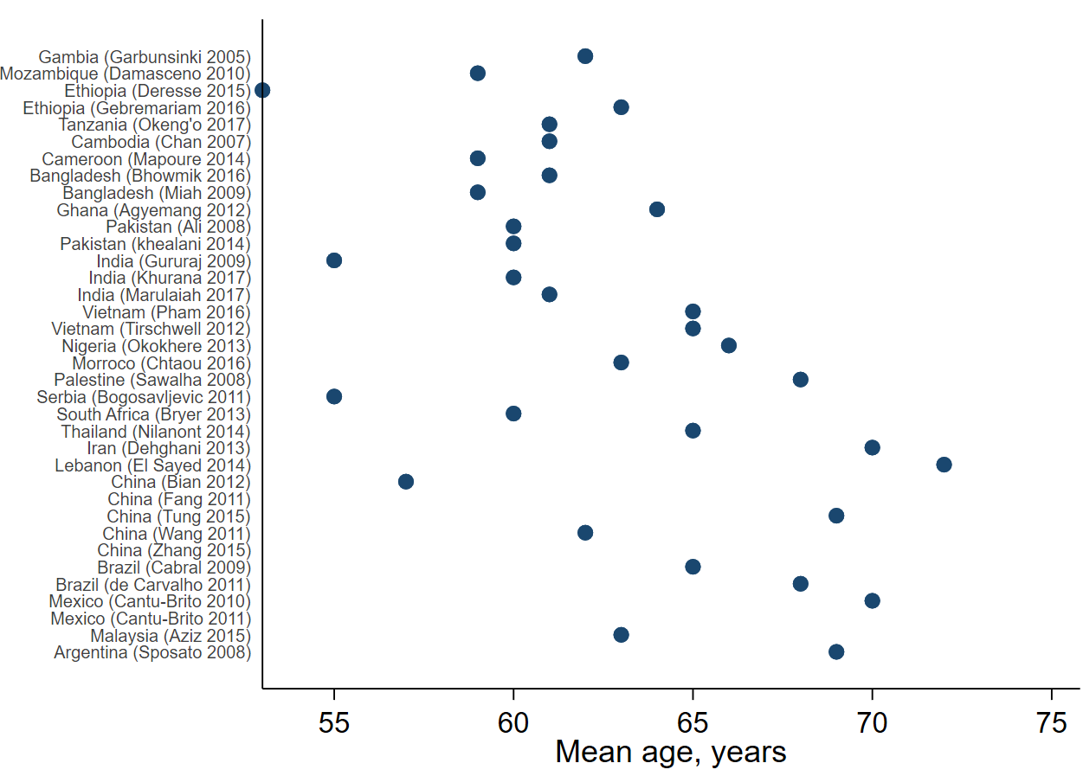
UMIC
LrMIC
LIC

UMIC=upper middle-income country; LrMIC=lower middle-income country; LIC=Low income country

Figure III: Percent of patients diagnosed with a hemorrhagic stroke, by country income group.

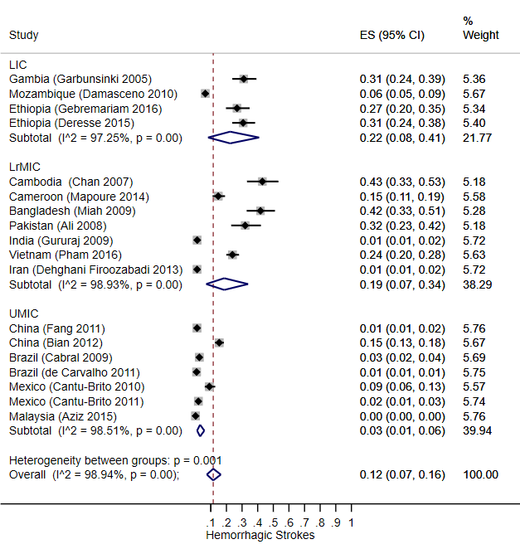

Pooled estimate among studies that did not restrict inclusion criteria to type of stroke

Figure IV: Percent of patients with hypertension, by country income group.
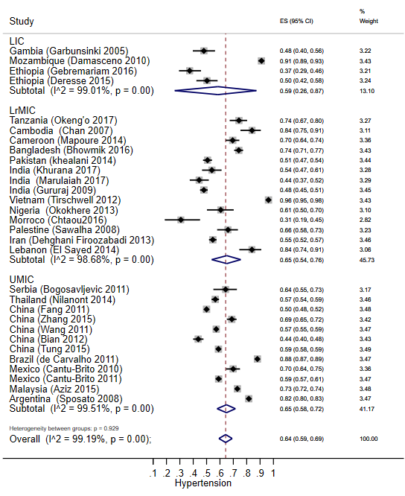

Figure V: Percent of smokers, by country income group.
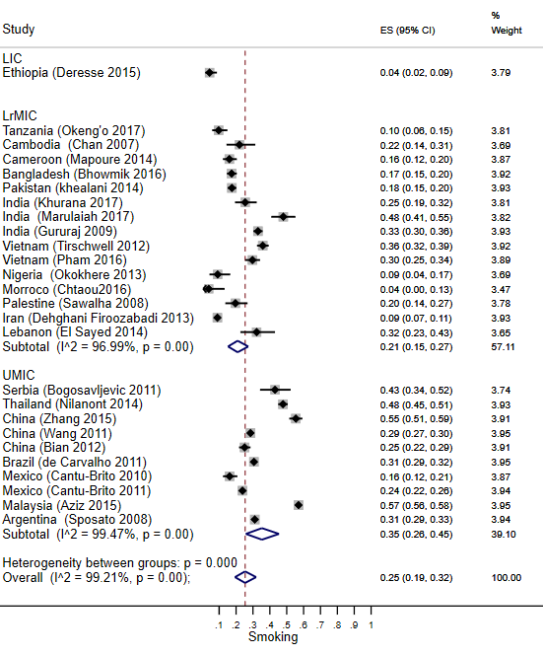

Figure VI: Percent of patients with diabetes, by country income group.
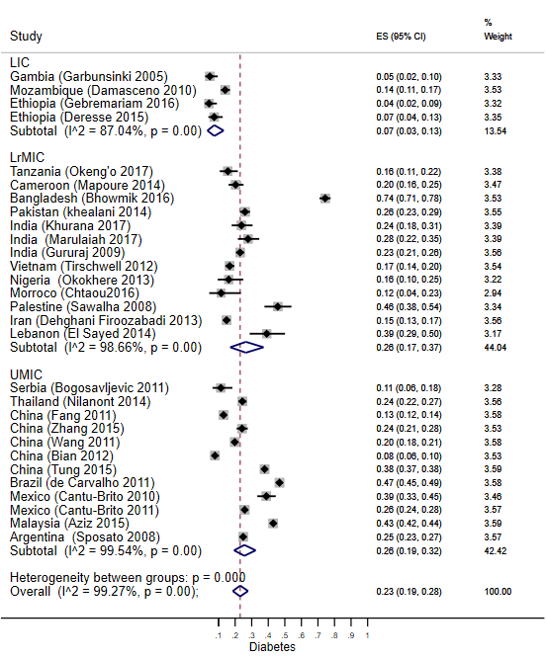

Figure VII: Percent of patients with previous stroke, by country income group.
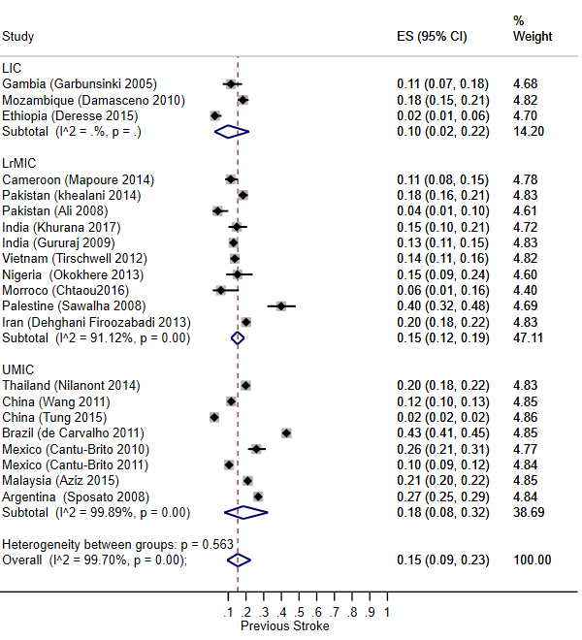

Figure VIII: Percent of patients with atrial fibrillation, by country income group.
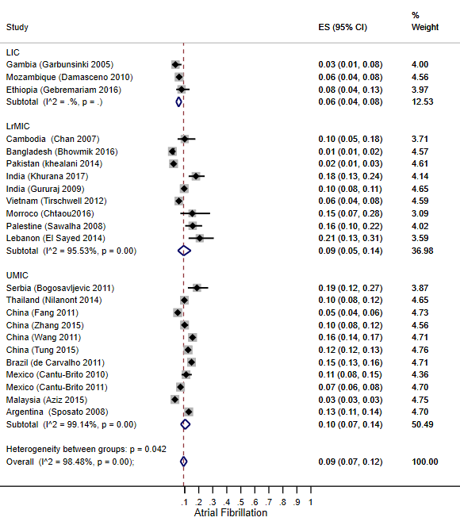

Figure IX: Percent of patients with loss of conscinouness at presentation, by country income group.
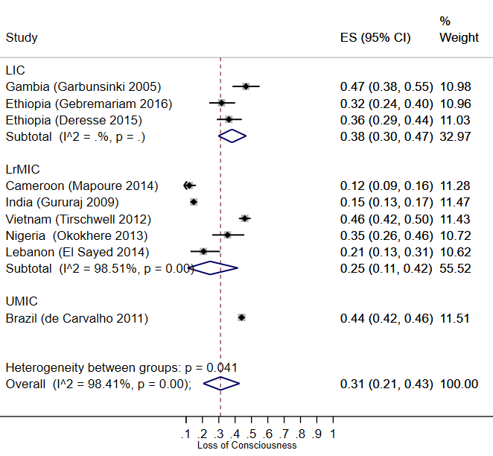

Figure X: Percent of patients who received CT scan, by country income group.
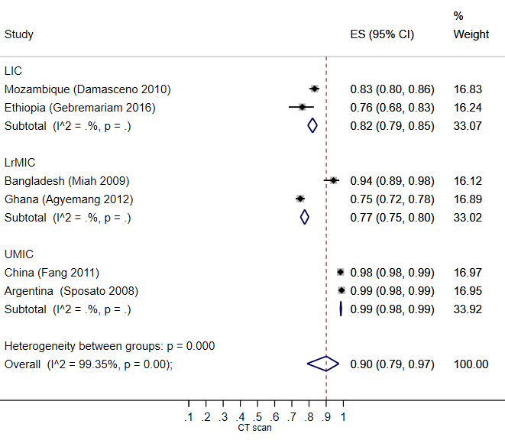
Reported among studies that did a CT scan only without an MRI or other more advanced neuroimaging

Figure XI: Percent of patients who received an MRI, by country income group.
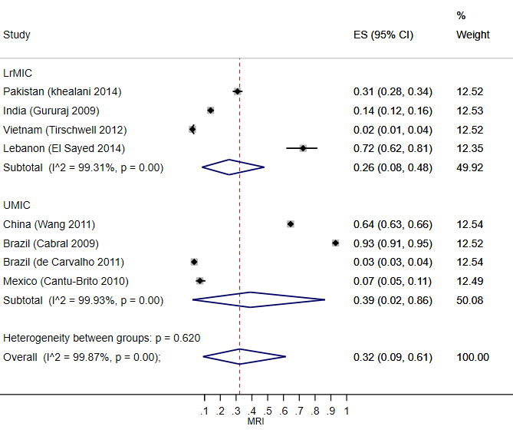

Figure XII: Percent of patients who received rt-PA treatment, by country income group.
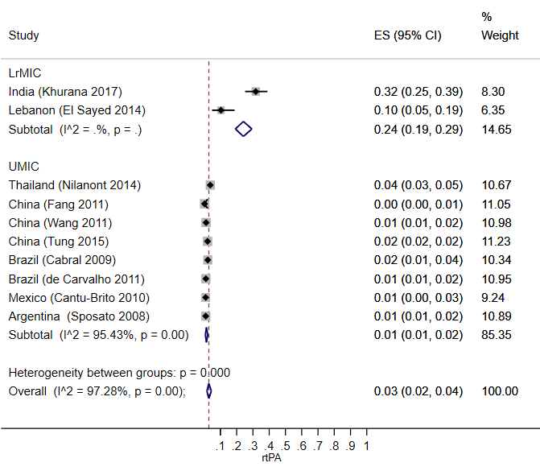
Excludes studies that limited the inclusion criteria to rt-PA treatment only.

Figure XIII: Percent of patients who received anti-platelte therapy, by country income group.
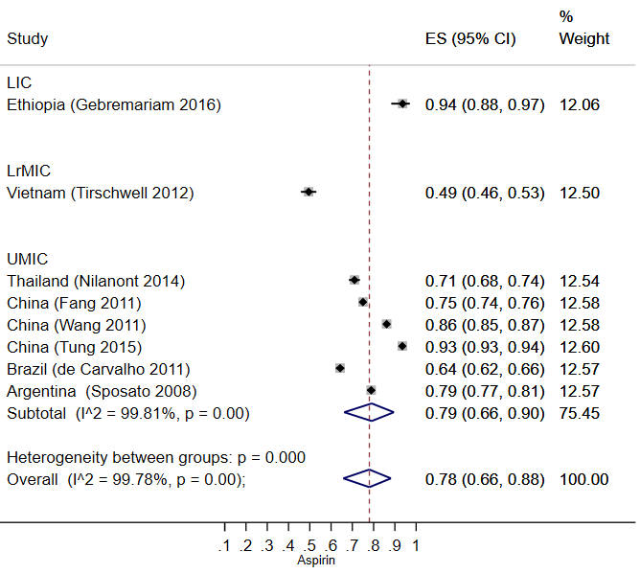

Figure XIV: Percent of patients admitted to the ICU, by country income group.
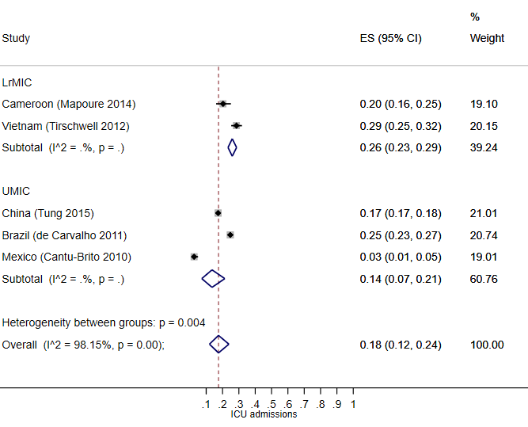

References
- Chan S, Ros S, You KY, Nhem S, Salle JY, Dudognon P, Daviet JC: [The management of stroke in Phnom Penh, Cambodia]. Bulletin de la Societe de pathologie exotique 2007;100:32-35.
- Tirschwell DL, Ton TG, Ly KA, Van Ngo Q, Vo TT, Pham CH, Longstreth WT, Jr., Fitzpatrick AL: A prospective cohort study of stroke characteristics, care, and mortality in a hospital stroke registry in Vietnam. BMC Neurol 2012; 12:150.
- Pham TL, Blizzard L, Srikanth V, Thrift AG, Lien NT, Thang NH, Gall SL: Case-fatality and functional status three months after first-ever stroke in Vietnam. J Neurol Sci 2016;365:65-71.
- Wang D, Hao Z, Tao W, Kong F, Zhang S, Wu B, Lin S, Liu M: Acute ischemic stroke in the very elderly Chinese: risk factors, hospital management and one-year outcome. Clin Neurol Neurosurg 2011;113:442-446.
- Fang J, Zhuo-Ga C, Zhao Y, Kong F, Si Y, Liu M, Zhou D: Characteristics of stroke in Tibet autonomous region in china: a hospital-based study of acute stroke. Eur Neurol 2011;66:151-158.
- Bian LH, Liu YF, Nichols LT, Wang CX, Wang YL, Liu GF, Wang WJ, Zhao XQ: Epidemiology of subarachnoid hemorrhage, patterns of management, and outcomes in China: a hospital-based multicenter prospective study. CNS Neurosci Ther 2012;18:895-902.
- Zhang PL, Wang YX, Chen Y, Zhang CH, Li CH, Dong Z, Yin H, Zhang FF, Wang JH: Use of Intravenous Thrombolytic Therapy in Acute Ischemic Stroke Patients: Evaluation of Clinical Outcomes. Cell Biochem Biophys 2015;72:11-17.
- Aziz ZA, Lee YY, Ngah BA, Sidek NN, Looi I, Hanip MR, Basri HB: Acute Stroke Registry Malaysia, 2010-2014: Results from the National Neurology Registry. J Stroke Cerebrovasc 2015;24:2701-2709.
- Nilanont Y, Nidhinandana S, Suwanwela NC, Hanchaiphiboolkul S, Pimpak T, Tatsanavivat P, Saposnik G, Poungvarin N: Quality of acute ischemic stroke care in Thailand: a prospective multicenter countrywide cohort study. J Stroke Cerebrovasc 2014; 23:213-219.
- Tung YC, Jeng JS, Chang GM, Chung KP: Processes and outcomes of ischemic stroke care: the influence of hospital level of care. Int J Qual Health Care 2015;27:260-266.
- Bogosavljevic V, Bodenant M, Beslac-Bumbasirevic L, Cordonnier C, Jovanovic DR, Budimkic M, Leys D: Intravenous thrombolysis for acute cerebral ischemia in Belgrade, Serbia: comparison with Lille, France. Eur Neurol 2011;66:30-36.
- Sposato LA, Esnaola MM, Zamora R, Zurru MC, Fustinoni O, Saposnik G: Quality of ischemic stroke care in emerging countries: the Argentinian National Stroke Registry (ReNACer). Stroke 2008;39:3036-3041.
- Cabral NL, Goncalves AR, Longo AL, Moro CH, Costa G, Amaral CH, Souza MV, Eluf-Neto J, Fonseca LA: Trends in stroke incidence, mortality and case fatality rates in Joinville, Brazil: 1995-2006. J Neurol Neurosurg Psychiatry 2009; 80:749-754.
- de Carvalho JJ, Alves MB, Viana GA, Machado CB, dos Santos BF, Kanamura AH, Lottenberg CL, Neto MC, Silva GS: Stroke epidemiology, patterns of management, and outcomes in Fortaleza, Brazil: a hospital-based multicenter prospective study. Stroke 2011;42:3341-3346.
- Cantu-Brito C, Majersik JJ, Sanchez BN, Ruano A, Quinones G, Arzola J, Morgenstern LB: Hospitalized stroke surveillance in the community of Durango, Mexico: the brain attack surveillance in Durango study. Stroke 2010;41:878-884.
- Cantú-Brito C, Ruiz-Sandoval J, Chiquete E,Arauz A,León-Jiménez C, Murillo-Bonilla M, et al: Factores de riesgo, causas y pronóstico de los tipos de enfermedad vascular cerebral en México. Revista Mexicana de Neurociencia 2011;12:224-234.
- Dehghani Firoozabadi M, Kazemi T, Sharifzadeh G, Dadbeh S, Dehghan P: Stroke in birjand, iran: a hospital-based study of acute stroke. Iranian Red Crescent Med J 2013;15:264-268.
- El Sayed MJ, El Zahran T, Tamim H: Acute stroke care and thrombolytic therapy use in a tertiary care center in Lebanon. Emerg Med Int 2014;2014:438737.
- Chtaou N, Rachdi L, Midaoui AE, Souirti Z, Wahlgren N, Belahsen MF: Intravenous thrombolysis with rt-PA in stroke: experience of the Moroccan stroke unit. Pan Afr Med J 2016;24:207.
- Sawalha A: Characterization of hospitalized ischemic stroke patients in Palestine. Libyan J Med 2009;4:37-40.
- Miah MT: The Glasgow Coma Scale following Acute Stroke and In-hospital Outcome: An Observational Study. Journal of Medicine 2009;10.
- Bhowmik NB, Abbas A, Saifuddin M, Islam MR, Habib R, Rahman A, Haque MA, Hassan Z, Wasay M: Ischemic Strokes: Observations from a Hospital Based Stroke Registry in Bangladesh. Stroke Res Treat 2016;2016:5610797.
- Nagaraja D, Gururaj G, Girish N, Panda S, Roy AK, Sarma GR, Srinivasa R: Feasibility study of stroke surveillance: data from Bangalore, India. Indian J Med Res 2009;130:396-403.
- Khurana D, Das B, Kumar A, Kumar SA, Khandelwal N, Lal V, Prabhakar S: Temporal Trends in Intravenous Thrombolysis in Acute Ischemic Stroke: J Stroke Cerebrovasc: 2017;26:1266-1273.
- Marulaiah SK, Reddy MP, Basavegowda M, Ramaswamy P, Adarsh LS: Admission hyperglycemia an independent predictor of outcome in acute ischemic stroke: A longitudinal study from a tertiary care hospital in South India. Niger J Clin Pract 2017;20:573-580.
- Ali M, Khan Y, Khan H: Complications of cerebrovascular accident in two tertiary care hospitals of Peshawar, Pakistan. Iranian Red Crescent Med J 2008;10:261-266.
- Khealani BA, Khan M, Tariq M, Malik A, Siddiqi AI, Awan S, Wasay M: Ischemic strokes in Pakistan: observations from the national acute ischemic stroke database. J stroke Cerebrovasc: the official journal of National Stroke Association 2014;23:1640-1647.
- Deresse B, Shaweno D: Epidemiology and in-hospital outcome of stroke in South Ethiopia. J Neurol Sci 2015;355:138-142.
- Garbusinski JM, van der Sande MA, Bartholome EJ, Dramaix M, Gaye A, Coleman R, Nyan OA, Walker RW, McAdam KP, Walraven GE: Stroke presentation and outcome in developing countries: a prospective study in the Gambia. Stroke 2005;36:1388-1393.
- Damasceno A, Gomes J, Azevedo A, Carrilho C, Lobo V, Lopes H, Madede T, Pravinrai P, Silva-Matos C, Jalla S et al: An epidemiological study of stroke hospitalizations in Maputo, Mozambique: a high burden of disease in a resource-poor country. Stroke 2010; 41:2463-2469.
- Mapoure NY, Tchaleu Nguenkam CB, Mbatchou Ngahane HB, Dzudie A, Coulibaly A, Mounjouopou NG, Vaissaba E, Luma NH, Mouelle SA, Njamnshi AK: Predictors of in-hospital mortality for stroke in douala, cameroon. Stroke Res Treat 2014; 2014:681209.
- Gebremariam SA, Yang HS: Types, risk profiles, and outcomes of stroke patients in a tertiary teaching hospital in northern Ethiopia. eNeurologicalSci 2016;3(Supplement C):41-47.
- Agyemang C, Attah-Adjepong G, Owusu-Dabo E, De-Graft Aikins A, Addo J, Edusei AK, Nkum BC, Ogedegbe G: Stroke in Ashanti region of Ghana. Ghana Med J 2012;46(Suppl 2):12-17.
- Okokhere PO, Bankole IA, Erohubie CA: Characteristics, risk factors and case fatality rate of stroke in hospitalized patients in semi-urban South-South Nigeria. SAGE open medicine 2013;1:2050312113516112.
- Okeng'o K, Chillo P, Gray WK, Walker RW, Matuja W: Early Mortality and Associated Factors among Patients with Stroke Admitted to a Large Teaching Hospital in Tanzania. J Stroke Cerebrovasc 2017;26:871-878.
- Wasserman S, Bryer A: Early outcomes of thrombolysis for acute ischaemic stroke in a South African tertiary care centre. S Afr Med J 2012;102:541-544.
- Hozo SP, Djulbegovic B, Hozo I: Estimating the mean and variance from the median, range, and the size of a sample. BMC Med Res Methodol 2005;5:13.

