**APPENDIX A.**

**Figure A.1 Changes in Liberal Democracy Index Scores from 2007 to 20017 for all 178 Countries in the V-Dem Dataset.**

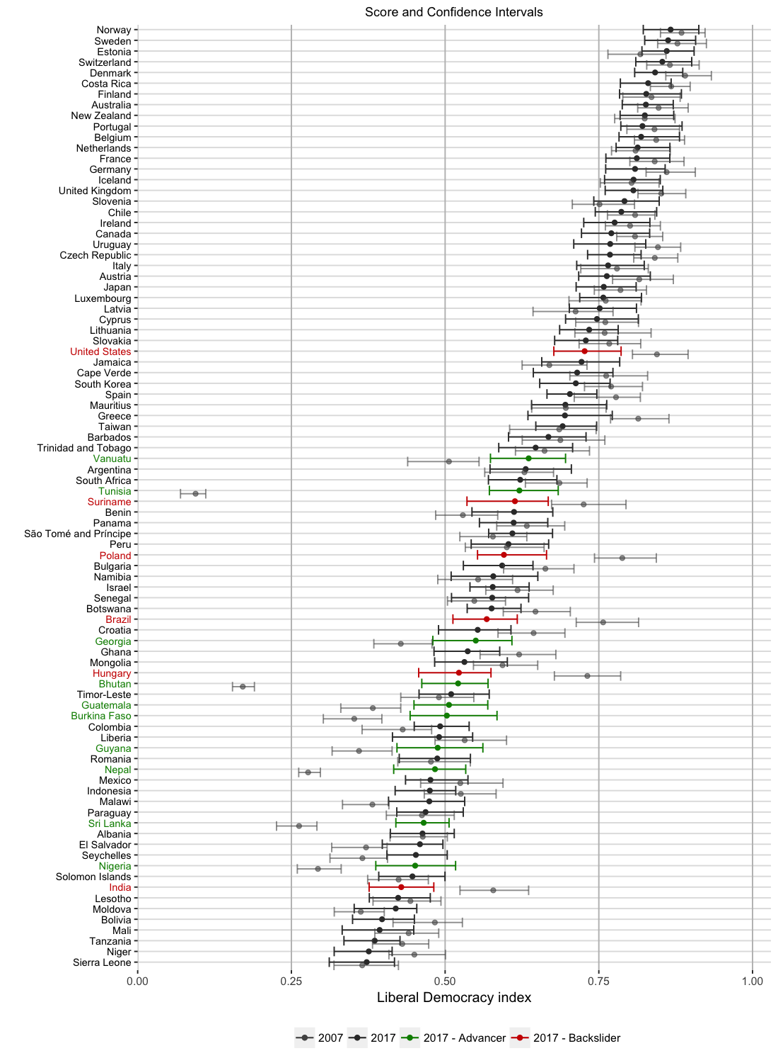

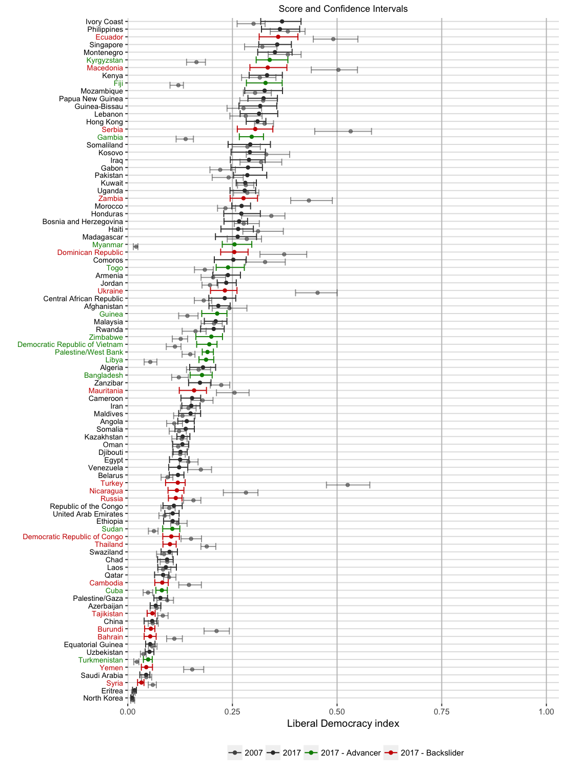

Green country names and dots with confidence interval bars indicate significant advancers, while red names, dots, and bars designate the significant backsliders. Note that few of the latter are extremely undemocratic countries in all respects with high degree of certainty and therefore small substantive changes register as significant. There are also countries in grey because the confidence intervals overlap, while the substantive changes are large and those should be noted.

**Appendix B.**

**Different Patterns of Autocratization**

Another important finding in the annual Democracy Report 2018 from the V-Dem Institute is that there are different patterns of decline in more democratic countries compared to the less democratic ones. V-Dem is the first dataset to capture not only liberal and electoral aspects of democracy, but also to measure egalitarian, participatory and deliberative components of democracy. The figure below depicts that breadth across the spectrum of democracy aspects and provides an overview of which subcomponents registers significant changes – without overlapping confidence intervals - over the last ten years, comparing scores 2007 to 2017. Countries are sorted first by Regimes of the World-type and second, within each category on how many aspects have changed, from many to few based on the summary scores in the right-most columns. The tinted colours indicate cases where the index did not change, but one or more of its sub-indicators did.

The figure enables comparison across categories, from liberal- and electoral democracy to electoral- and closed autocracies, with regard to the number of changes that occurred in each and whether such changes represented advances or backsliding. One can also compare within categories to see if countries tended to advance or backslide and in which aspects of democracy these changes registered. The figure also provides column summary scores, making it easy to identify the subcomponents of the different varieties affected the most, and the least, by positive or negative development over the past ten years.

Our first observation is that volatility – the number aspects that are improving or declining – is overall lower in both of the democratic regime categories, than in the autocratic. More democratic countries tend to be more stable. One third of all liberal democracies record some significant changes, and the same is true for about half of all electoral democracies. Conversely, some volatility is registered in two thirds of countries in the electoral- and closed autocratic regime categories.[1] Second, most countries that underwent significant change only registered volatility in one or a couple of subcomponents. There are only nine countries that have changed significantly in more than five areas of democracy during the last ten years. These include the positive changes in Tunisia, Bhutan, Myanmar, and Libya, as well as drastic deteriorations in Burundi, Yemen, Turkey, Venezuela and Thailand. Somalia exhibits a high level of volatility as the textbook example of a fragile state.

Other countries have changed significantly only with regards to selected aspects of democracy, whereas most components are relatively stable. For instance, in the United States it is mainly the legislative constraints on the executive that have weakened significantly along with the quality of public reasoning. As another example, in Greece the main negative developments are in the area of freedom of expression and local elections. In sum, most democratic change, whether positive or negative, is gradual and affecting only an area or two at a time even in this medium-term, ten-year perspective.



One observation that stands out is that not a single democracy – neither in the liberal nor in the electoral category – have recorded significant declines in the purely electoral aspects of democracy or in freedom of association. These highly visible and symbolically important aspects are not affected by the current global trend of autocratization. Rather, positives changes tend to be found in these aspects. Instead, among *liberal democracies*, most declines are found on the quality of public debates – namely in the United States, Albania and Ghana – and freedom of expression (Greece and Spain). Additionally, legislative constraints on the executive are evidently under stress in the United States, as is the rule of law in Australia.

In *electoral democracies* the picture is similar with regards to five countries declining in terms of freedom of expression and four on public deliberation. Judicial constraints on the executive has declined significantly in Poland, Haiti, Macedonia and Suriname, whereas legislative constraints on the executive have improved significantly in Bhutan and Peru. In short, the declines among democracies take place in areas that are less visible and can be derailed significantly before the threat to democracy becomes obvious to the extent that other countries and international bodies react. At the same time, degeneration of the democratic quality in such areas threatens to undermine the viability and meaningfulness of core institutions, such as elections and freedom of association.

In *electoral autocracies*, patterns of autocratization reflect a much more direct, widespread attack on core democratic institutions and freedoms. Freedom of expression and the quality of public debates are on a downward trajectory in many countries, and this is also true for freedom of association and the liberal subcomponents of democracy. In four countries elections are now significantly less free and fair than ten years ago – Burundi, Turkey, Venezuela, Zambia, and Comoros. Among the 56 countries that are classified as electoral autocracies in 2017, six of them still qualified as electoral democracies in 2007 – Turkey, Ukraine, Nicaragua, Serbia, Comoros, Honduras and Iraq. Hence, these are countries that we can now, unfortunately, identify as instances of democratic breakdown. Yet, we should also note that there are five countries in this regime category with significant improvements in several areas, such as Myanmar, Zimbabwe, Fiji, and Gambia. However, on balance there are still many more countries with more negative changes than positive in this category of regimes. The trend of autocratization in the world seems to affect electoral autocracies considerably.



Even in *closed autocracies*, some rulers seem to make an attempt at improving the outlook of (mainly legislative) elections, as indicated by the seven countries with positive significant changes on subcomponents related to elections. This further illustrates the current trends in the world. Even in countries with among the most authoritarian political systems, rulers try to improve their image by making the symbolic elections look a little more democratic. We also note that in Uzbekistan, freedom of expression and quality of deliberation have improved slightly - but remain at very low levels. Among the more substantial changes, we note that in Yemen, Bahrain, and Thailand even the very limited freedom of expression and association is under attack, and the rule of law and quality of deliberation have also declined. However, in this regime category the numbers have to interpreted with care. The confidence intervals tend to be much narrower for countries in this regime category than for countries in the other categories. This is simply because the V-Dem country experts tend to have a high degree of agreement between them that the situation in closed autocracies score extremely low on most indicators. Thus, with tight confidence intervals around point estimates, even small changes become significant but are not always substantially noteworthy.

**APPENDIX C.**

**A More Detailed Analysis of Inclusion**

Figure C1 displays the number of countries that have improved or declined significantly over the last ten years for range of inclusion-related indicators. Those depicted above the diagonal line reflect net improvement: more countries that have improved than have declined, while the reverse is true for the indicators below the diagonal line. In terms of gender inclusion, all but one indicator – freedom of discussion for women – have seen net improvements. By contrast, all indicators concerning inclusion of lower income groups register net declines. This corroborates the analysis above that while gender inclusion is in some ways advancing, socio-economic inequality remains a major basis of political exclusion. The findings about changes in power distribution by social group are mixed.

Figure C1. By Indicator of Political Inclusion: Number of Countries with Significant Changes, 2007-2017



*Note*: We consider changes as significant when they fall outside of the confidence intervals reported in the V-Dem data set.

Only six countries improved on equality in the political distribution of power by socio-economic status between 2007 and 2017, while 14 countries declined significantly. The countries with the largest backsliding on this measure are Burundi, Mauritania, Iraq, Yemen, and Panama. The ability to participate in political activities (such as voting and engaging in political parties) has declined significantly along with unequal access to healthcare and to education in 16 and 15 countries respectively, while improving in only five (health) and four (education). Healthcare equality declined the most in Venezuela, likely as a result of deep economic crisis. In terms of educational equality, several post-communist countries experienced significant declines over the last ten years – Ukraine, Romania, Bulgaria, and Armenia. Countries in current or recent conflict have also registered substantive declines – Syria, Afghanistan, and Central African Republic.

**APPENDIX D.**

**Figure D1. The Inclusion Gap for Power Distribution by Social Group by Regime Category, 2017**



*Note:* Country names with labels are either over- or under-performers in terms of inclusion (highest and lowest quintile per regime category). High scores correspond to more or less equal distribution of power, while the lowest scores indicate a monopoly of power.

**Figure D1. The Inclusion Gap for Power Distribution by Gender by Regime Category, 2017**



*Note:* Country names with labels are either over- or under-performers in terms of inclusion (highest and lowest quintile per regime category). High scores correspond to more or less equal distribution of power, while the lowest scores indicate a monopoly of power. To enhance legibility of the graph, we have not labelled two smaller polities.

1. The picture is only slightly different when looking at the regime categories based on countries’ status in 2007: one third of countries that qualified as liberal democracy in 2007 experienced significant changes by 2017, compared to 58 percent of electoral democracies, 64 percent of electoral autocracies and 71 percent of closed autocracies.